
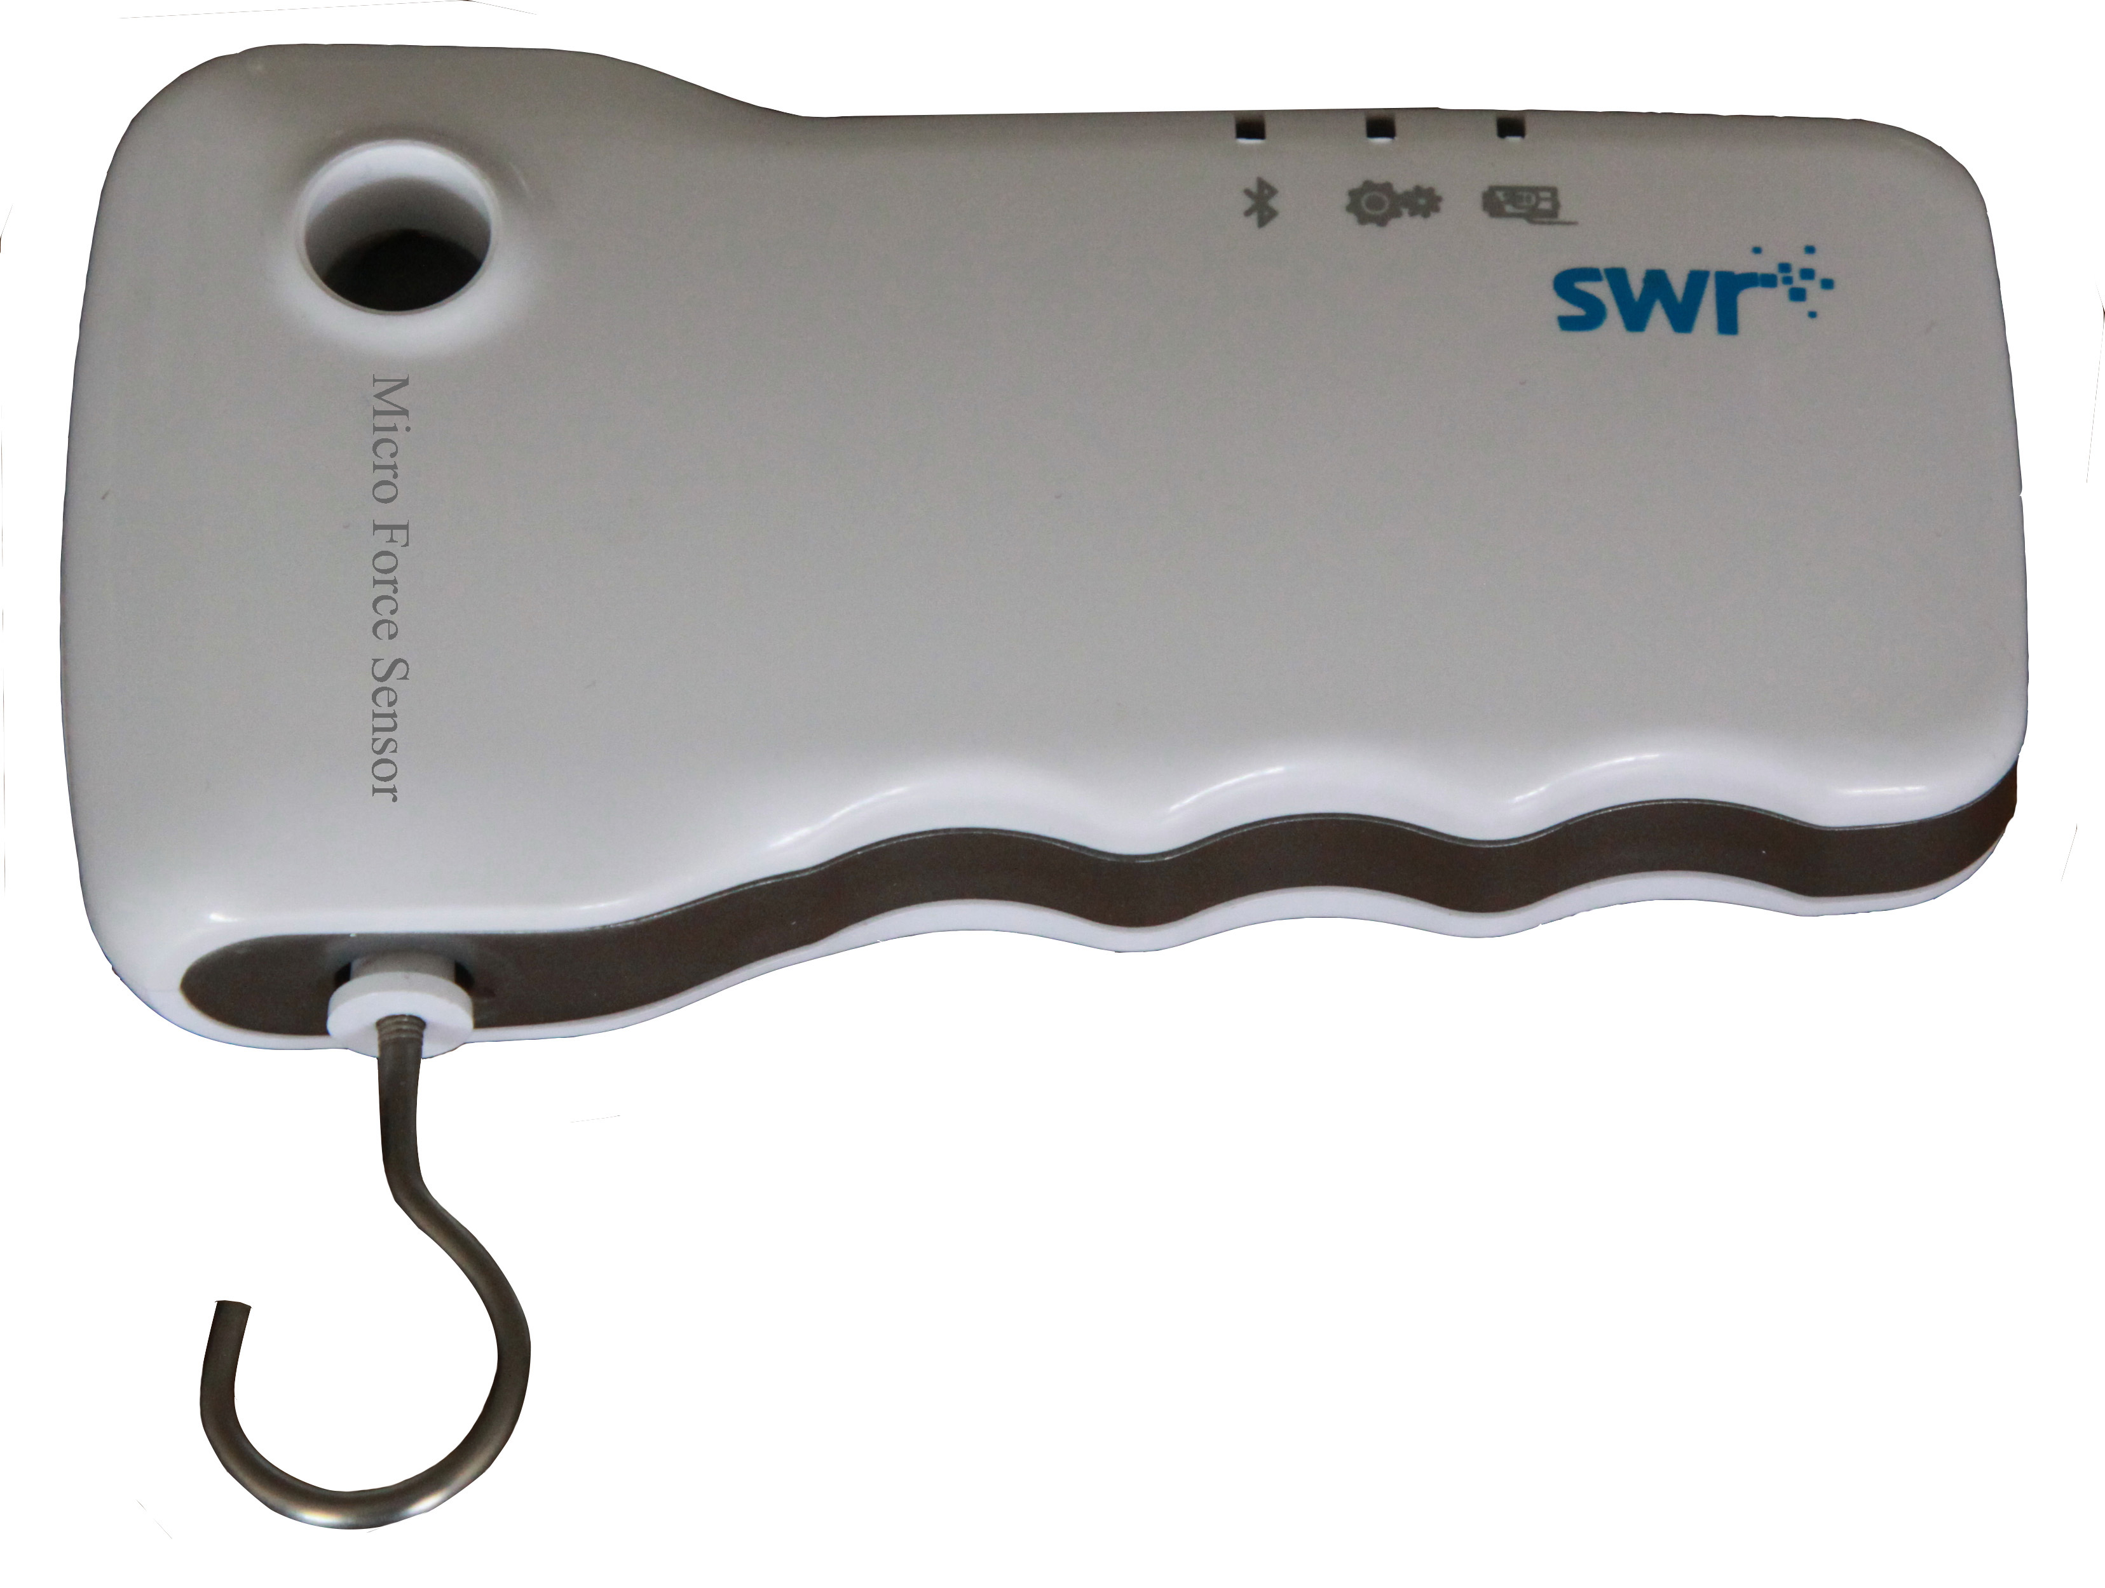
Micro Force Sensor
Product No.: ZC0028
Measuring range: -10～+10N/-2~+2N
Resolution: 0.001N/0.005N
Accuracy: ± 1%

Address: No.14 Junnong Road, Qinhuai District, Nanjing, China.
Website: //www.sinoswr.com
Post Code: 210007
Tel: +86-400-828-8387

Introduction:
The sensing component of Micro Force Sensor is resistive strain gage. It is attached on metal bar to measure amplitude of force by the deformation of metal bar.
Micro Force Sensor can be used to measure pulling force and pressure. When pulling force is applied on metal hook, positive value is displayed. When pressure is applied on the metal hook, negative value is displayed. During using, make sure the force direction is vertical to the front surface of sensor otherwise the measured value will not be accurate.
Calibration:
Micro Force Sensor needs to be calibrated before using. Open SWR iLab after connecting sensor and datalogger. Place Micro Force Sensor level or vertical. Do not hang anything on hook. Click ‘Calibration’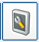. Select Micro Force Sensor. Click ‘calibrate’. Click ‘calibrate’, ‘OK’, ‘OK’ and ‘Exit’.
The metal itself has weight. Even if there is nothing hang on the hook, no matter place it level or vertical, the data display will be different. There will be slightly error occurs.
Usage:
Micro Force Sensor has two measuring range which are 10N and 2N. It can be switched automatically during using. It can be connected to computer via USB cable or Bluetooth to transmit data without external datalogger.
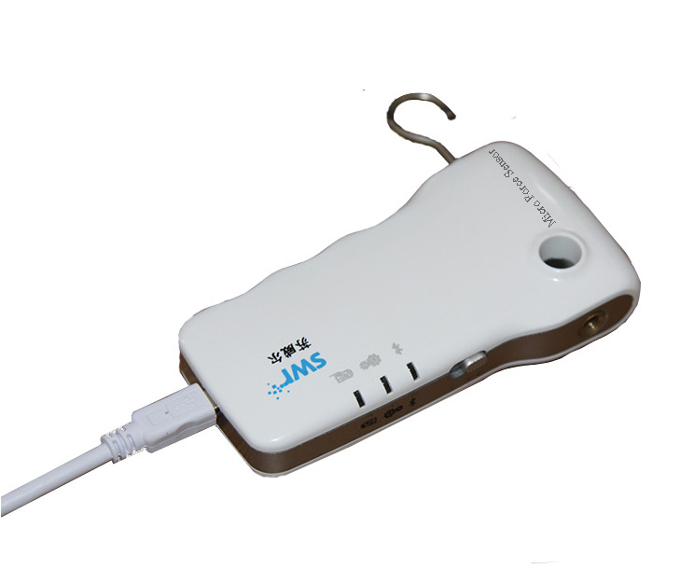
Typical experiment:
- Newton’s third law
- Explore the Hooke’s law
- Metal expands by heat and contracts by cold
- Composition and resolution of force
Notes:
- Micro Force Sensor needs to be calibrated before using.
- During using, make sure the force direction is vertical to the front surface of sensor otherwise the measured value will not be accurate.
- Try not to get the sensor wet.
- Please keep the force applied to the sensor not exceeding measuring range during measuring. Otherwise it may damage the Micro Force Sensor.

