
Address: No.14 Junnong Road, Qinhuai District, Nanjing, China.
Website: //www.sinoswr.com
Post Code: 210007
Tel: +86-400-828-8387
Light Distribution Sensor
Product No: ZC0023
Range: 125Dot/mm
Resolution: 8μm
Accuracy: 8μm

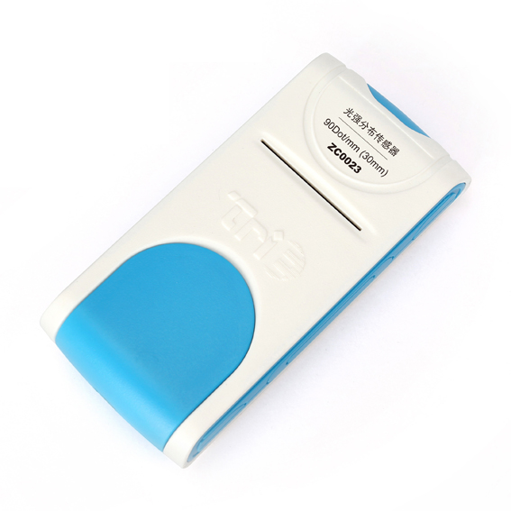

Introduction:
ZC0023 Light Distribution Sensor can be used to measure the distribution of light on a straight line. There is a rectangular window designed in the front of sensor. When the light to be measured arrive CCD element inside the sensor, it integrates 2048 sensitivity specks in an area which is 28mm long and 1mm width. Every sensitivity speck can measure light intensity independently. The distance between each sensitivity speck is 14μm. The system is able to measure light intensity distribution which are equal-distance.
The sensor designed with electric shutter. It automatically turns off CCD after each extremely short time exposure so that it can not collect photon. Sensor reads light intensity value from each sensitivity speck. Thus, the measured light distribution is simultaneous.
Calibration:
ZC0023 Light Distribution Sensor needs no calibration.
Usage:
- Connect Light Distribution Sensor to computer.
2. Open SWR iLab v8.0. Enter CCD light distribution.
Typical experiment:
Interference of light
Diffraction of light
Polarization of light
Experimental case:
Case 1: Interference of light
Experimental procedures:
1. Mount laser and double slits. Adjust the position of light beam so that outgoing beam works under best condition. You can use white light barrier to observe the phenomenon of interference.
2. Open SWR iLab v8.0. Click CCD light distribution. Make sure the CCD window is placed in the center of interference light spot.
3. Click ‘Start’ and observe light distribution graph. Adjust position of CCD window to optimize the light beam.
4. Click ‘Stop’ when curve looks perfect.
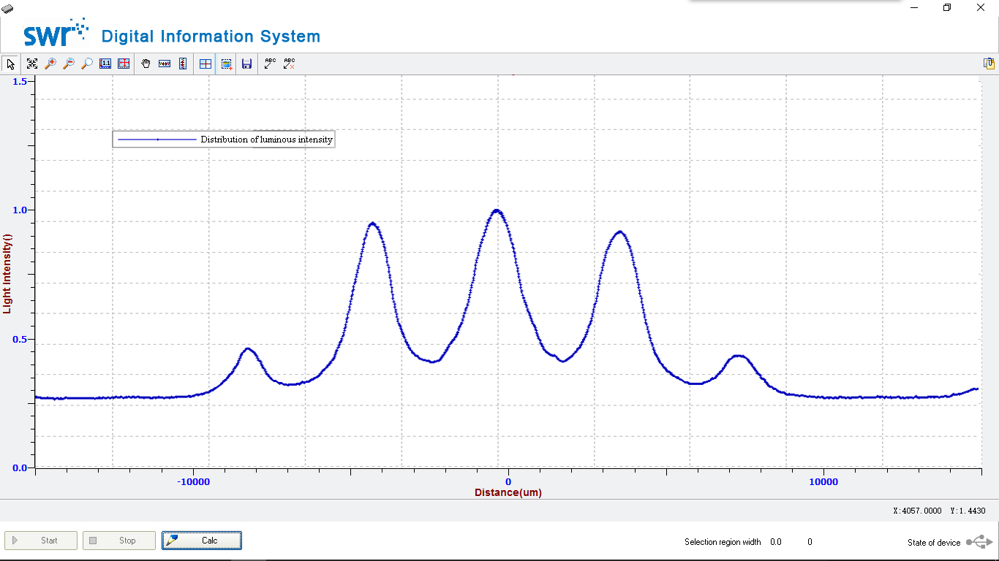
Case 2: Diffraction of light
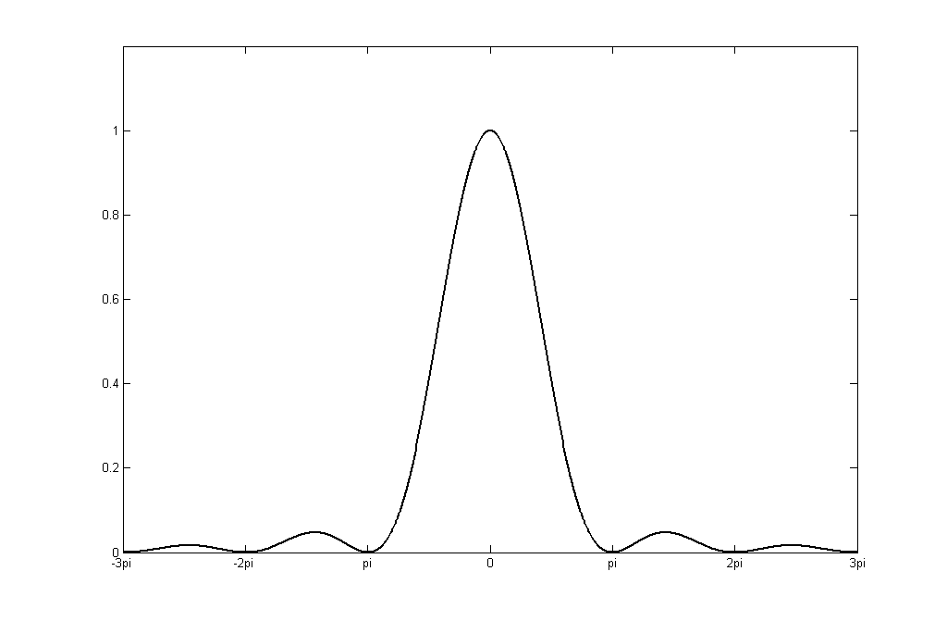
Experimental procedures:
1. Mount laser and single slit. Adjust the position of light beam so that outgoing beam works under best condition. You can use white light barrier to observe the phenomenon of diffraction.
2. Open SWR iLab v8.0. Click CCD light distribution. Make sure the CCD window is placed in the center of diffraction light spot.
3. Click ‘Start’ and observe light distribution graph. Adjust position of CCD window to optimize the light beam.
4. Click ‘Stop’ when curve looks perfect.
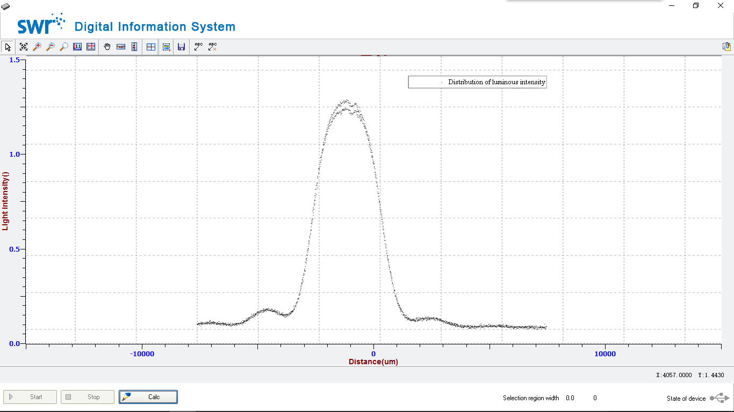
CCD introduction:
CCD is a kind of semi-conductor, which has a very thin layer of silicon dioxide on N-type or P-type silicon slice. Deposit metal electrode in sequence on silicon dioxide layer. Such MOS capacitor array with input and output diodes designed on both ends is CCD chip. CCD can convert optical signal to electric pulse signal. Each pulse can only reflect light-receiving condition for one photosensitive unit. The amplitude of pulse reflects strength of light-receiving condition. The sequence of output pulse reflects position of photosensitive unit.
Notes:
1. The measured light intensity value is relative value. It is only able to show the relationship of light intensity at different position within that space. It is not able to display the real intensity.
2. During usage, make sure the measured light spot illuminates on the window. Observe the shape of curve on screen. Adjust the position of window to optimize the experiment result.

