
Address: No.14 Junnong Road, Qinhuai District, Nanjing, China.
Website: //www.sinoswr.com
Post Code: 210007
Tel: +86-400-828-8387

Thermal Radiation Sensor
Product No.：ZC0010
Measuring Range：-70℃～380℃
Resolution： 0.1℃
Accuracy：±0.5℃
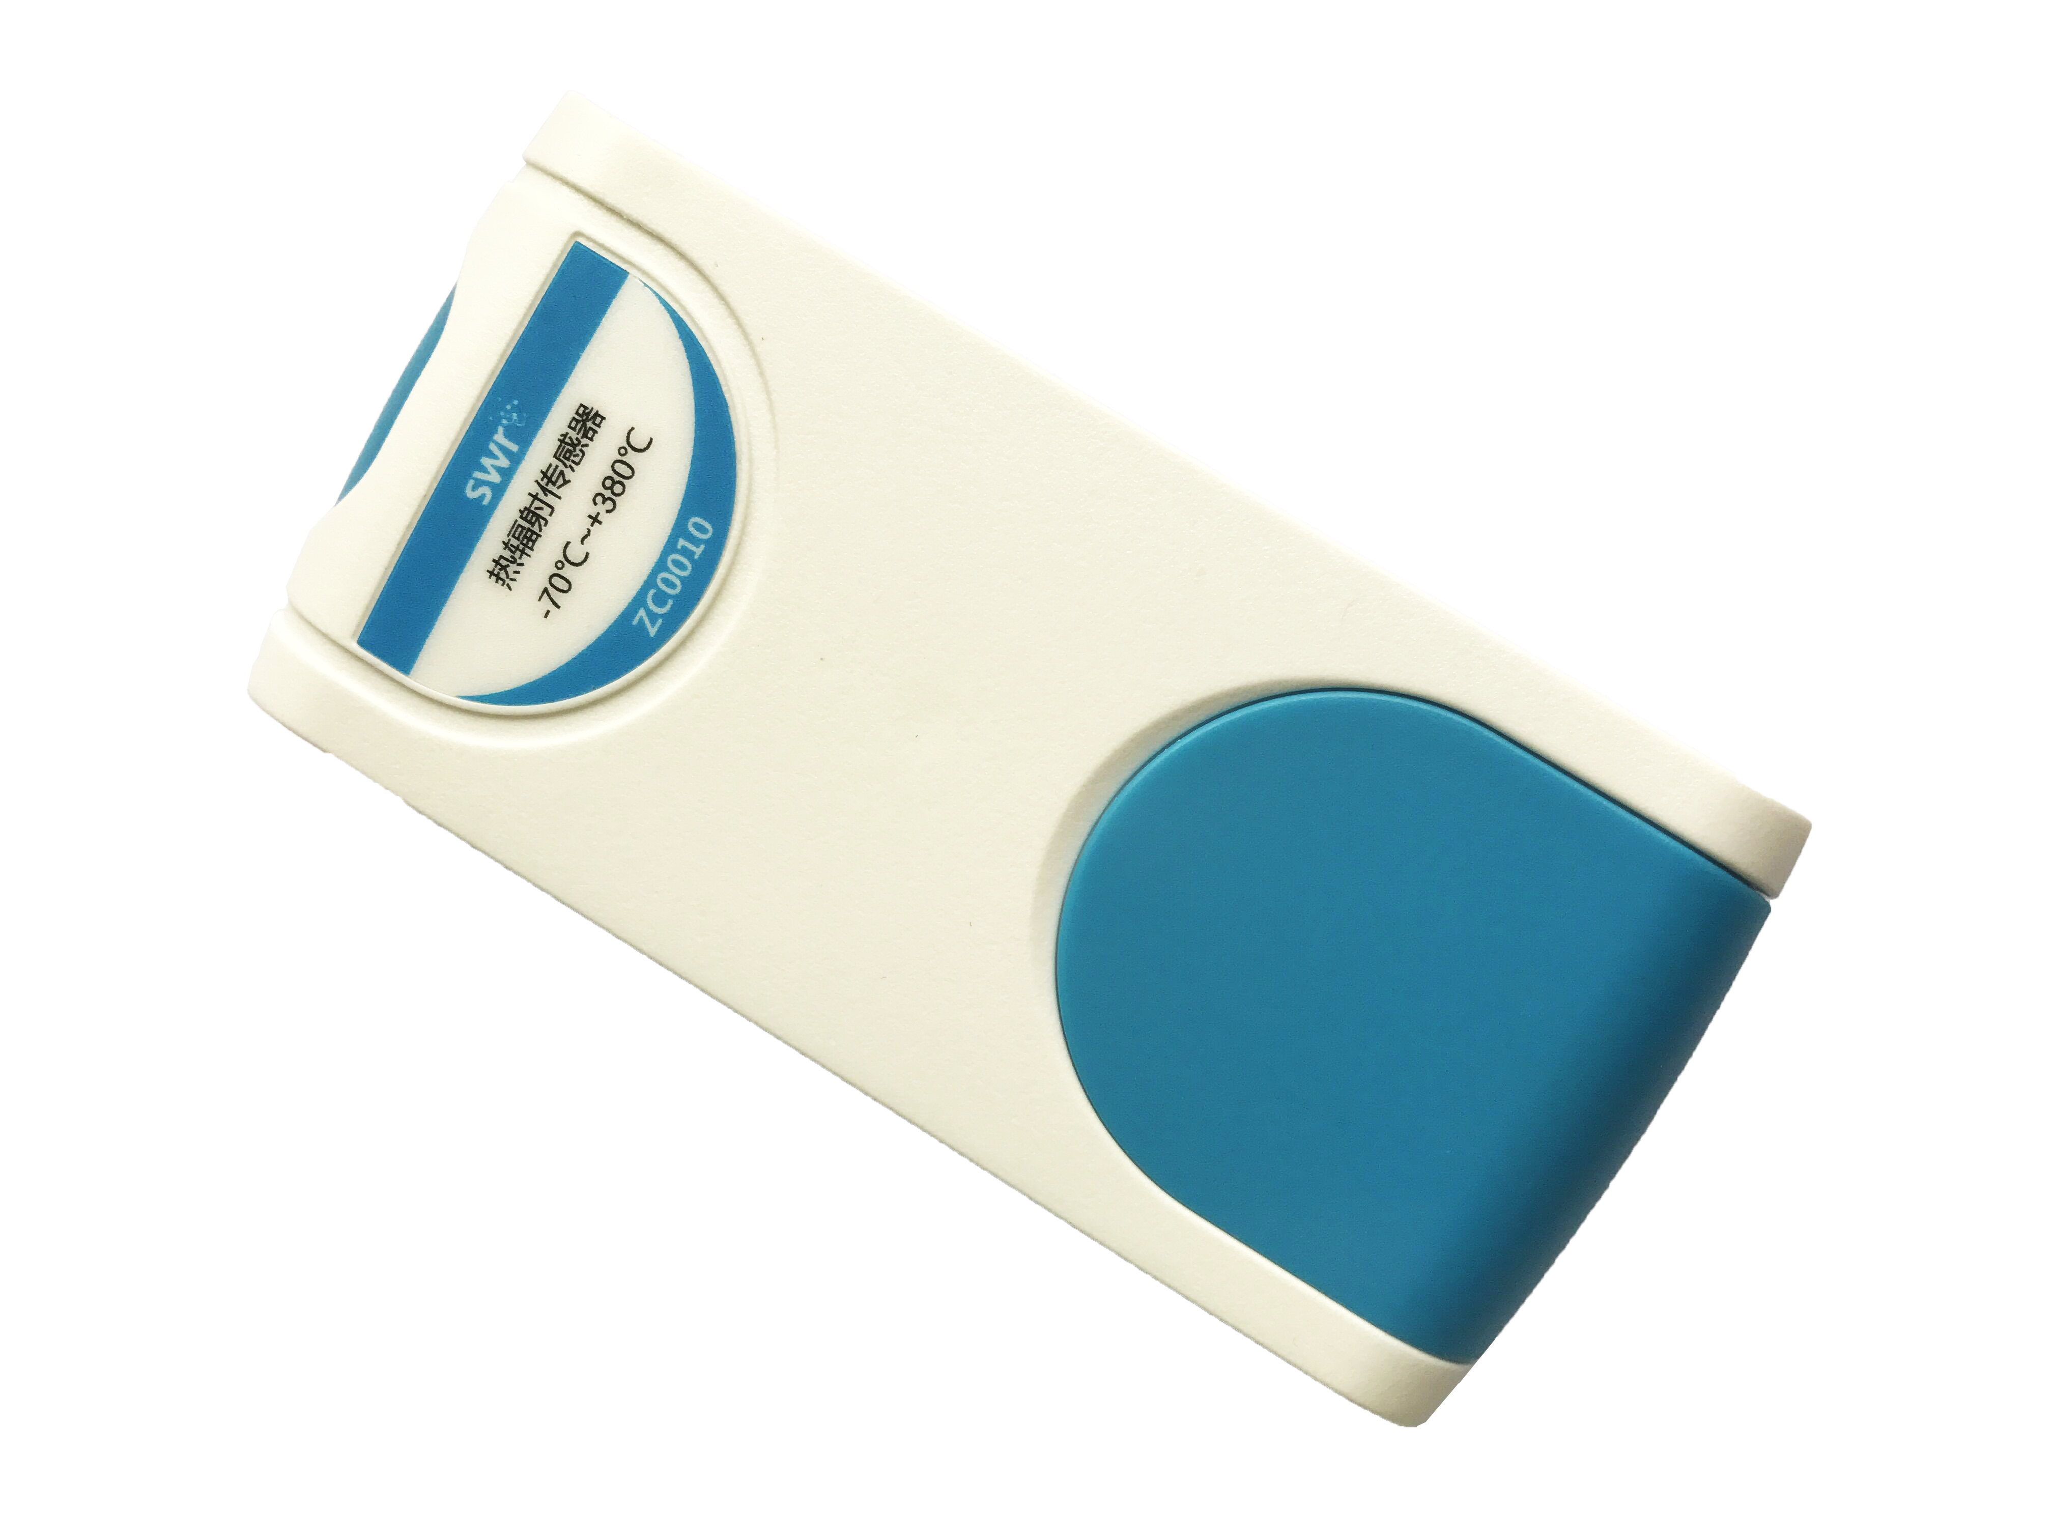
Introduction:
There are three main forms of thermal transfer which are thermal conduction, thermal convection and thermal radiation. Thermal conduction is occurred by collision of huge amount of molecules and atoms so that the internal energy in objects transfer from high temperature part to low temperature part. Thermal conduction is the major way of thermal transfer for solid. It occurs with thermal convection simultaneously in liquid and gas.
Thermal convection is occurred by flow of liquid or gas so that internal energy transfer from high temperature to low temperature. It is the major way of thermal transfer for liquid and gas. Furthermore, it happens in gas is more obvious than in liquid.
Thermal radiation is occurred by thermal. It generates energy outward directly in the form of electromagnetic wave. It is different from thermal conduction and convection because it does not require temperature difference or touching by hot or cold objects. Objects radiate thermal in any case.
Objects release energy by means of thermal radiation and gain energy by thermal radiation which given by other objects. For the same object, the ability of thermal radiation and gain thermal radiation are same, which means a good radiator is also a good absorber. The ability of thermal radiation of object is determined by its temperature, variety, surface condition (color, roughness). In general, the ability of thermal radiation for high temperature object is higher than low temperature object and dark color is higher than tint color.
The amount and wavelength of energy generated by thermal radiation of object is affected by its surface temperature. The thermal radiation sensor measure infrared radiation of object by using its built-in infrared probe so that its surface temperature can be measured. It performs non-touching measurement and responds quickly.
Thermal Radiation Sensor consists of optical system, photoelectric detector, signal amplifier, signal processing and output. Optical system converges infrared radiated energy of objects in its field of view. The infrared energy gets converged and focus on photoelectric detector so that it becomes electric signal. The signal will be converted to temperature value by amplifier, signal processing circuit, algorithm in instrument and target emissivity.
Calibration:
ZC0010 Thermal Radiation Sensor has been calibrated during manufacture. It does not require calibration.
Usage:
The amount and wavelength of energy generated by thermal radiation of object is affected by its surface temperature. The thermal radiation sensor measures infrared radiation of object by using its built-in infrared probe. The infrared energy gets converged and focus on photoelectric detector so that it becomes electric signal. The signal will be converted to temperature value by amplifier, signal processing circuit, algorithm in instrument and target emissivity.
When distance between sensor and radiator (target object) increases, the amount of infrared ray which enter sensor receiver decreases. Now there will be some error occurred because the measured temperature is slightly different from real temperature. To ensure high accuracy, it is suggested to keep the distance within 2cm.
Typical experiment:
- Measure heat radiation of black object.
- The Lesley tube experiment.
- Measure heat radiation of the sun
- Simulate non-touching temperature sensor.
Experimental case:
Simulate non-touching temperature sensor.
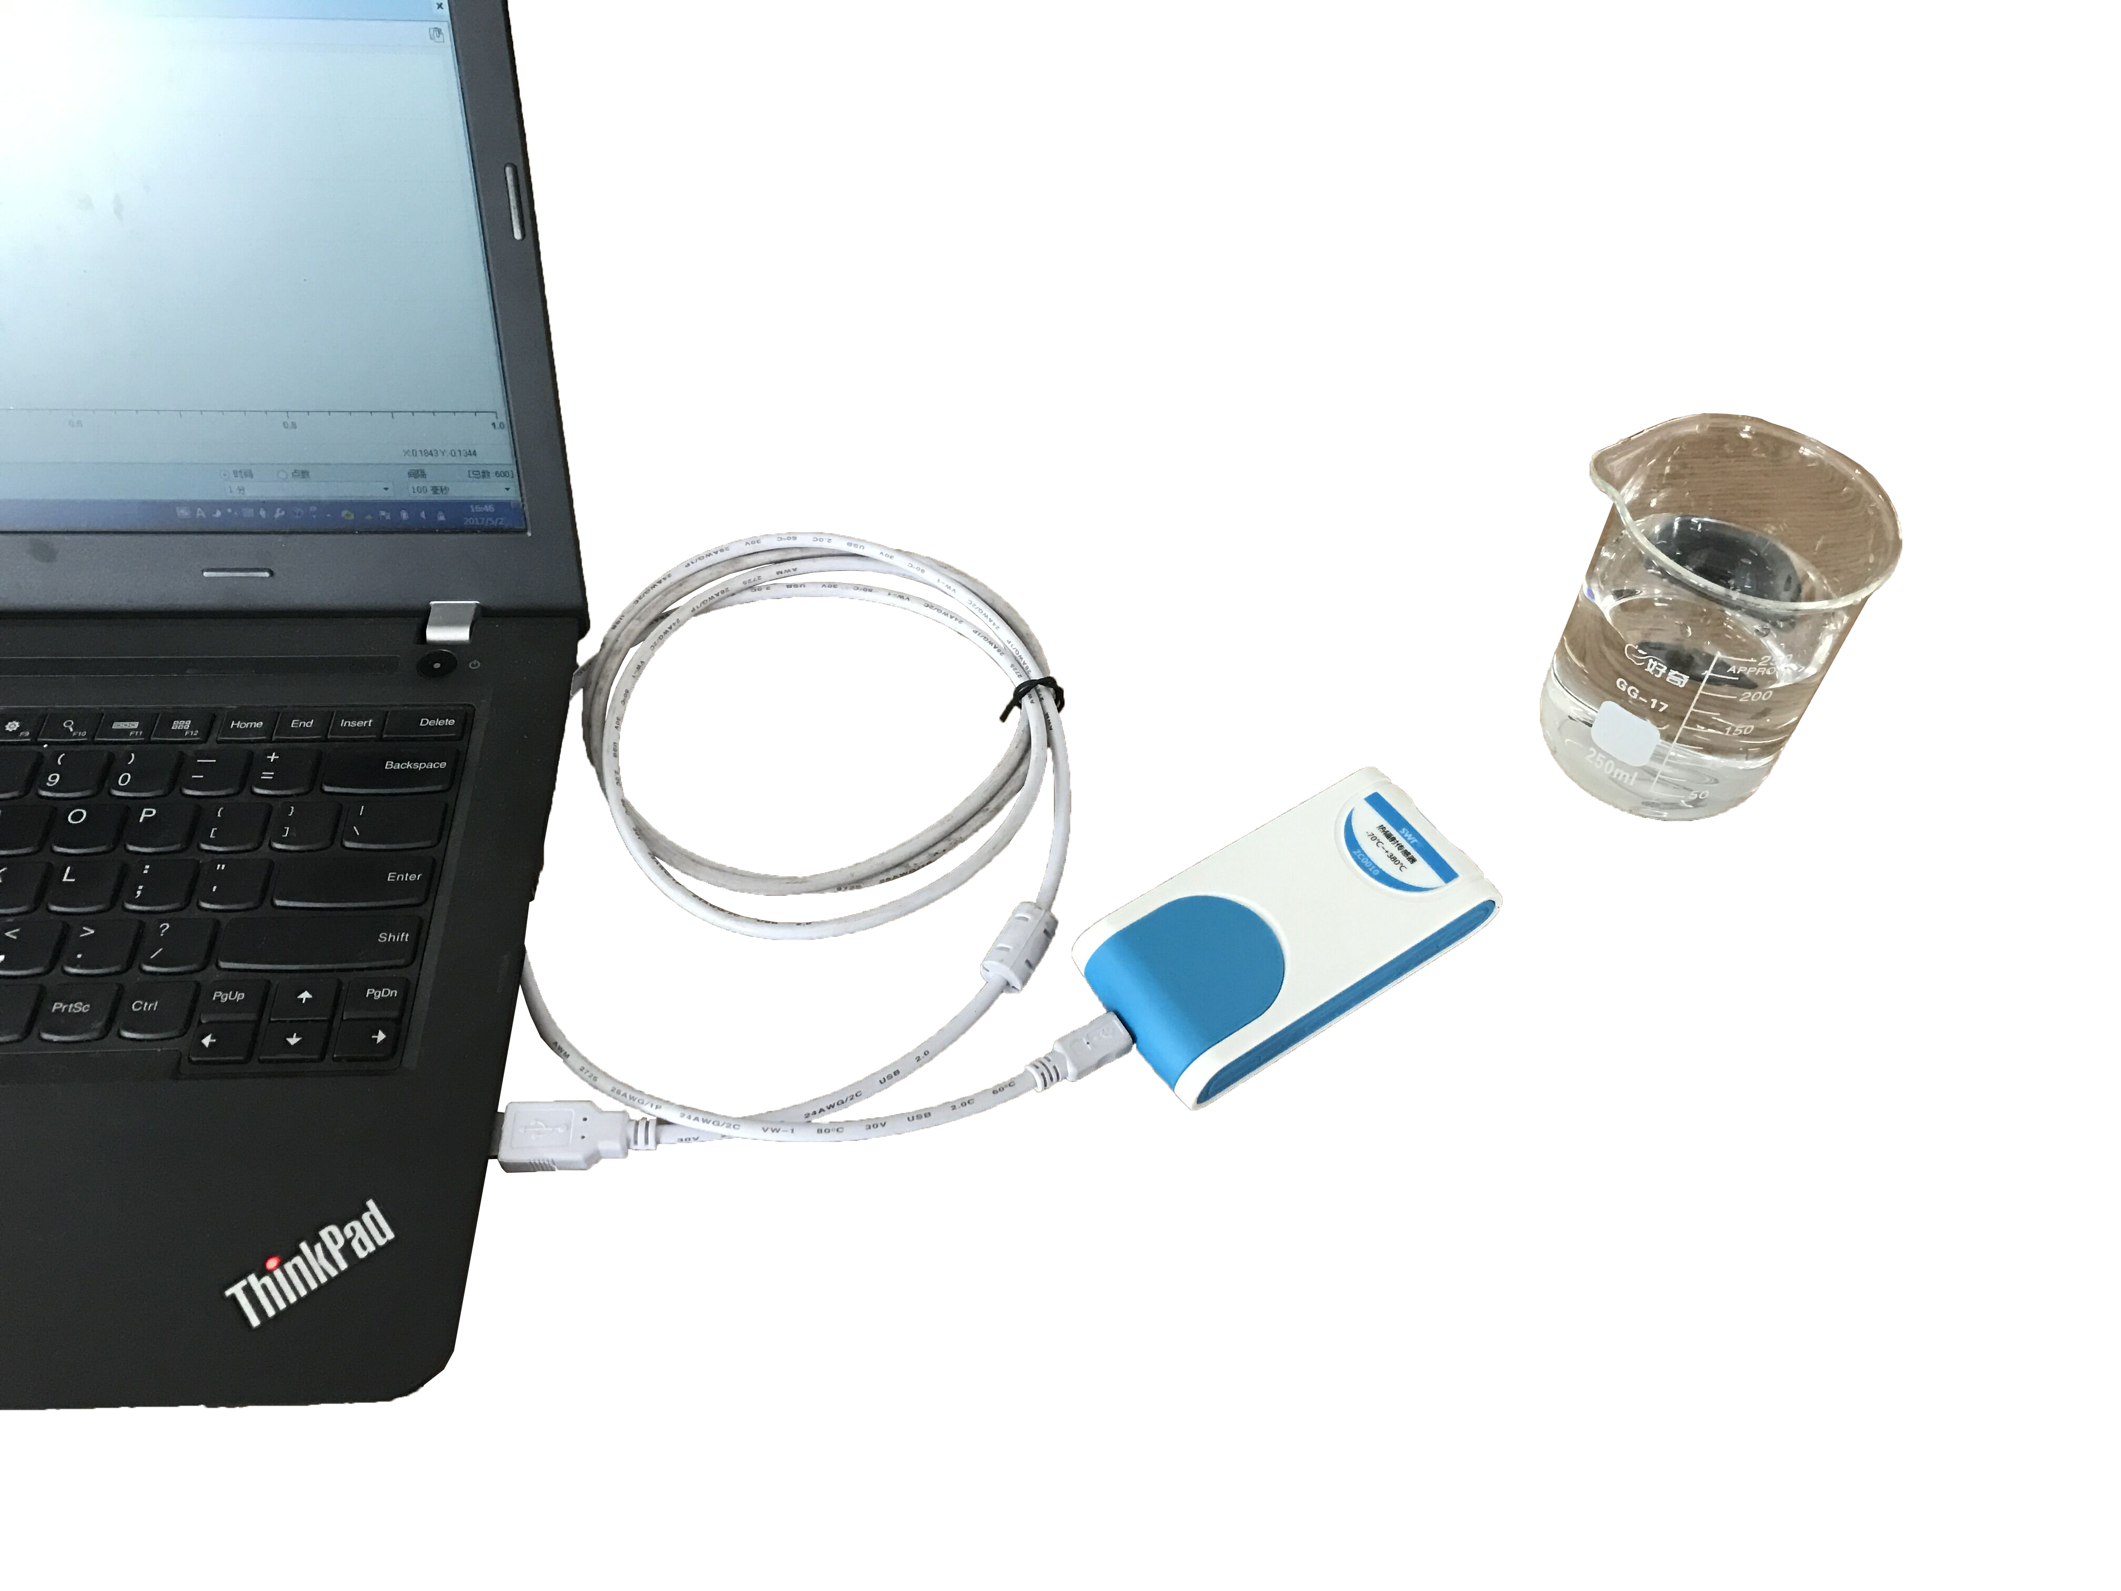
Product Assembly Diagram
- Connect experiment apparatus.
- Open SWR iLab v8.0. Click ‘New’ to create new experimental template.
- Click ‘New page’ to create new folder.
- Click ‘add line’ to add ‘Temperature-Time’ coordinate. Set proper collecting time and acquisition interval.
- Pour some water into beaker.
- Click ‘Start’.
- Observe the experimental result after experiment.
- Clear up experimental apparatus.
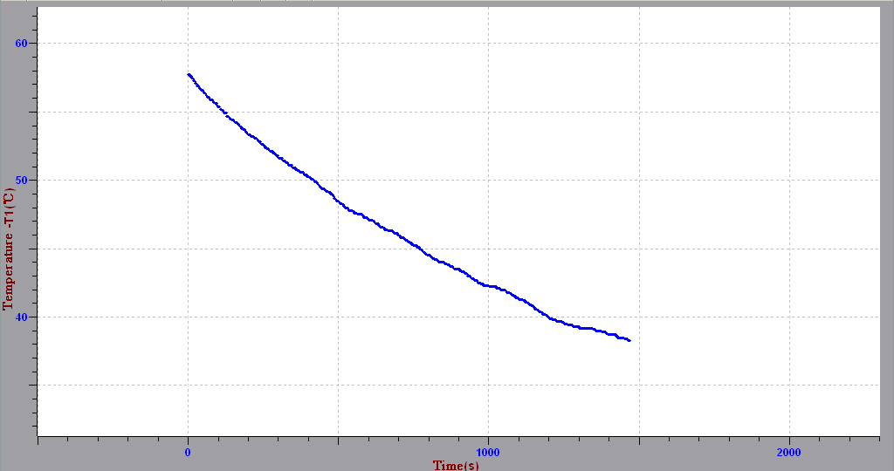
Temperature-Time Changing Diagram
Notes:
- Do not place any part of sensor on open fire or heating plate.
- During measuring, to ensure the accuracy, it is suggested to keep the distance between sensor and object within 2cm.

