
Nitrate Ion Sensor
Product No.: TS2229
Measuring range: 0.6～6200ppm
Resolution: 1ppm

Address: No.14 Junnong Road, Qinhuai District, Nanjing, China.
Website: //www.sinoswr.com
Post Code: 210007
Tel: +86-400-828-8387

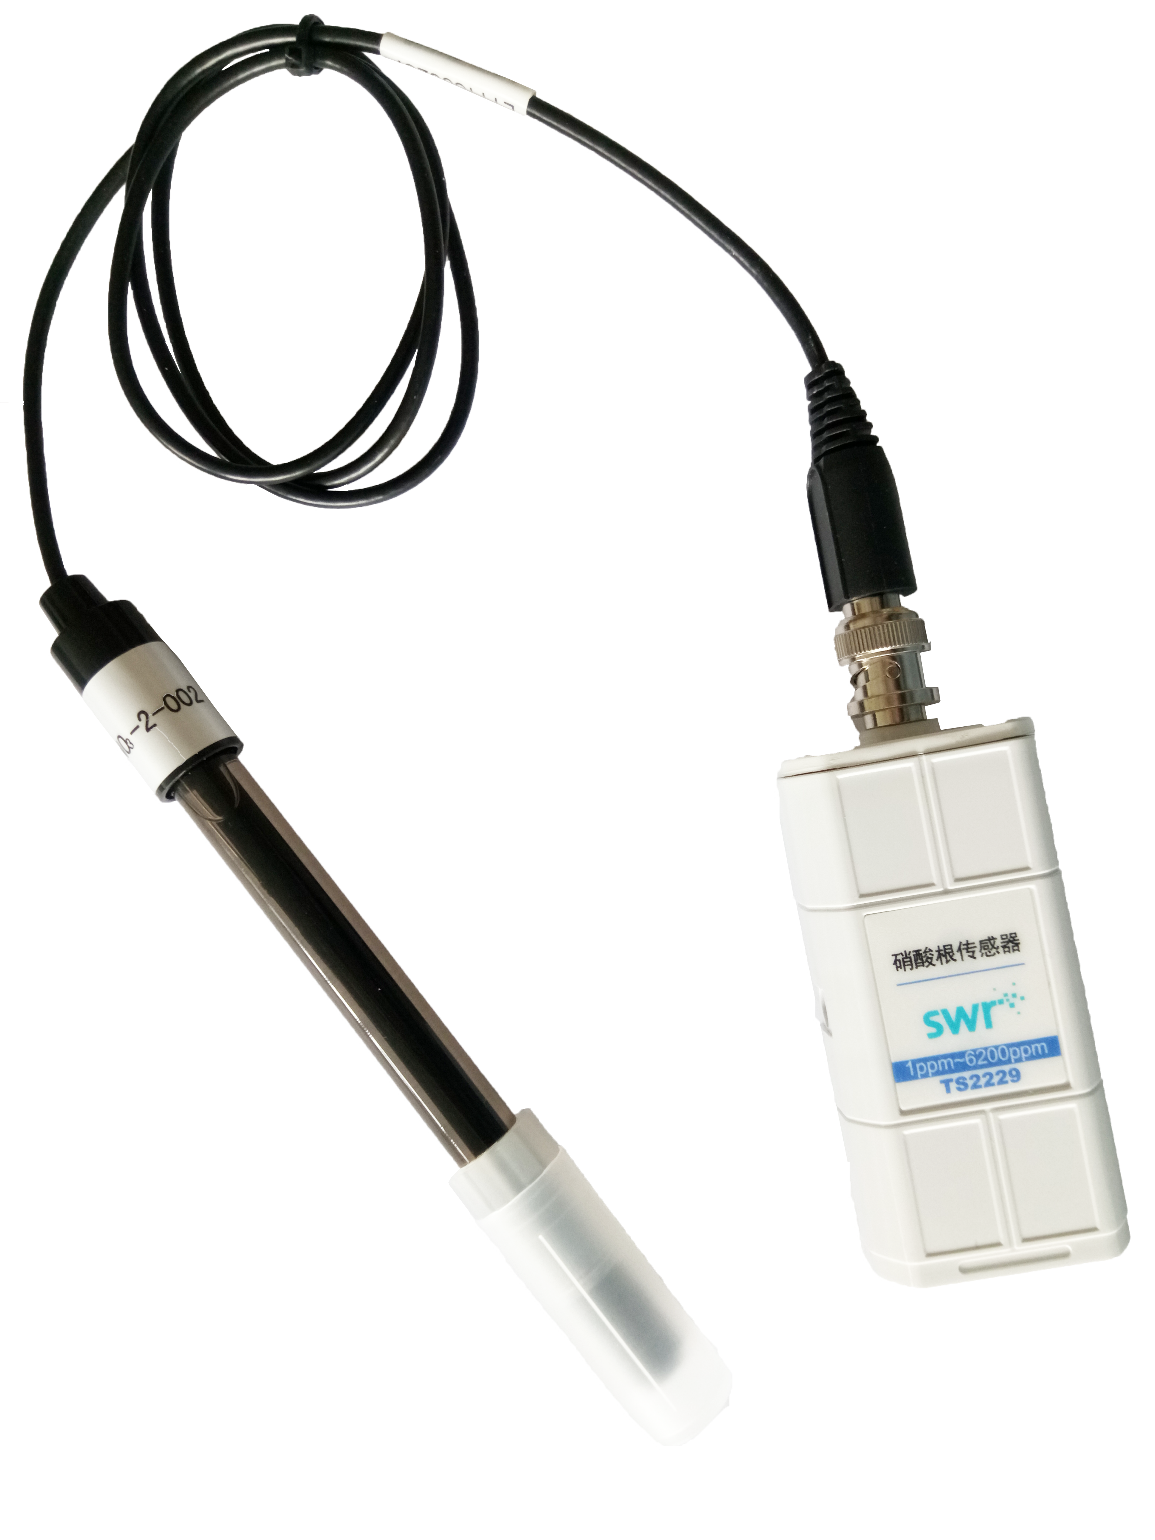
Introduction:
The sensor is designed with ion selective electrode. It is a kind of electrochemistry sensor which measures ion activity and concentration in solution using membrane potential. When it touches the solution with ion to be measured, membrane potential will be generated between its membrane and solution. Ion selective electrode is also called membrane electrode. There is a layer of special electrode membrane on the electrode which response to specific ion. The relationship between potential of electrode membrane and ion to be measured compliance with Nernst formula. The circuit of sensor convert potential to analog signal.
Usage:
1. Take out the electrode cover. Rinse the electrode using distilled water. Dry it using filter paper.
2. Connect electrode to sensor, datalogger and computer.
3. Open SWR iLab. Nitrate Ion Sensor has been calibrated before manufacturing. Immerse the electrode into solution. Collect data when the electrode becomes stable.
4. When the experiment is completed, rinse the electrode using distilled water immediately. Dry it using filter paper. Cover the electrode and preserve it in bag.
Typical experiment:
Detect the concentration of nitrate in fertilizer
Notes:
1. Preserve electrode in dry and ventilated ordinary pressure room with temperature between 5-45℃ and relative humidity not more than 85%. There is not corrosive gas in the air.
2. When change the sample to test, rinse the electrode using distilled water first. Dry it using filter paper. Immerse the electrode into next solution. It will prevent cross-contamination.
3. The pH value of sample should be within 4-9.
4. Keep the plug of electrode dry and clean. Try to avoid corrosion and contamination occur on it.
5. Try to avoid friction and strong vibration occur on electrode during using.
6. Do not dry the electrode using gauze or tissue. It may damage sensing membrane.

