
Sodium Ion Sensor
Product No.: TS2223
Measuring range: 0.2～2300ppm
Resolution: 0.2ppm
Operating temperature: 0～50℃
PH range>10
Address: No.14 Junnong Road, Qinhuai District, Nanjing, China.
Website: //www.sinoswr.com
Post Code: 210007
Tel: +86-400-828-8387

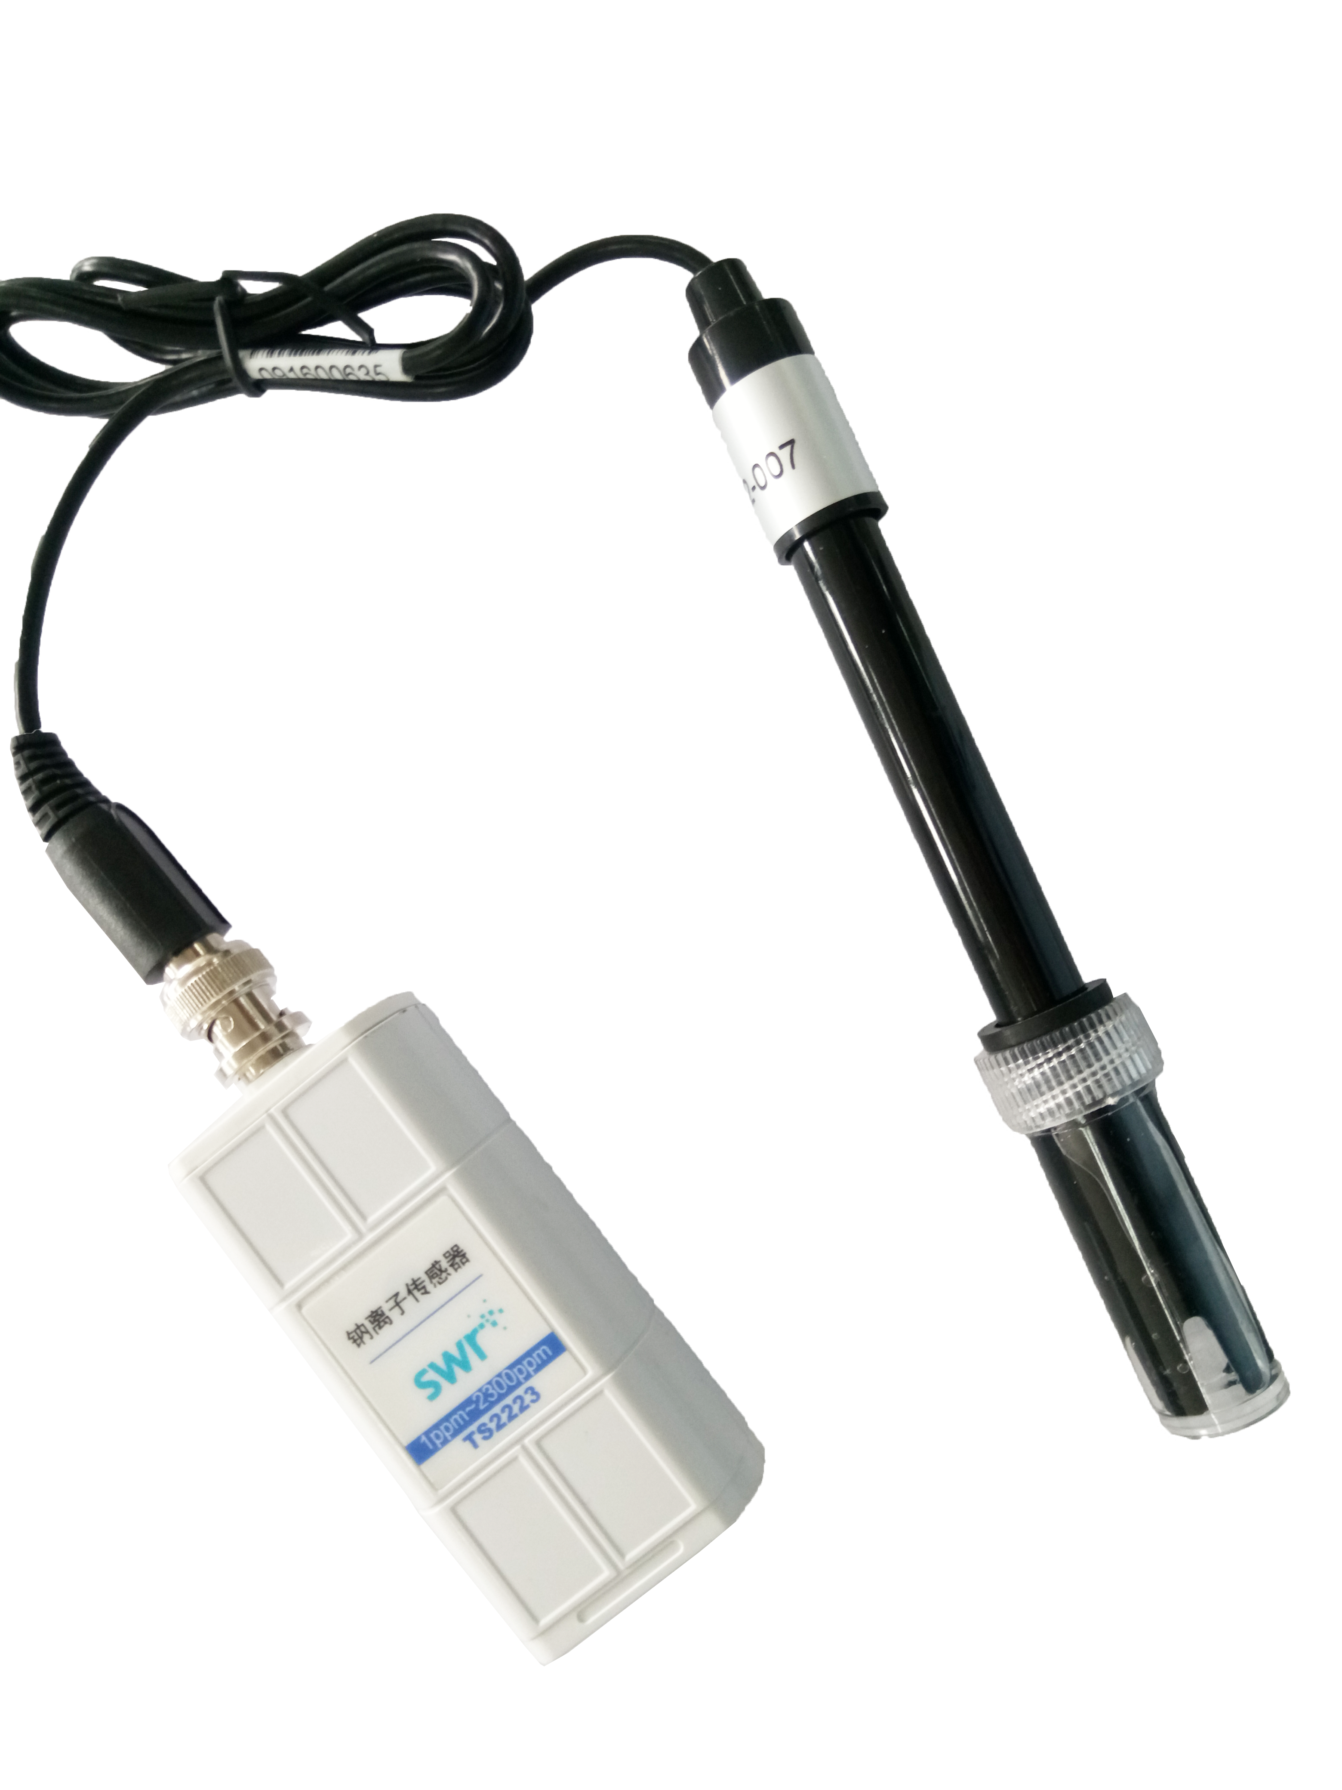
Introduction:
The sensor is designed with ion selective electrode. It is a kind of electrochemistry sensor which measures ion activity and concentration in solution using membrane potential. When it touches the solution with ion to be measured, membrane potential will be generated between its membrane and solution. Ion selective electrode is also called membrane electrode. There is a layer of special electrode membrane on the electrode which response to specific ion. The relationship between potential of electrode membrane and ion to be measured compliance with Nernst formula. The circuit of sensor converts potential to analog signal.
Sodium Ion Sensor is used to measure concentration of sodium ion in solution. It measures using datalogger and software.
Usage:
1. Take out electrode cover. Rinse it using distilled water. Dry it using filter paper.
2. Connect electrode to sensor, datalogger and computer.
3. Open SWR iLab. The sensor has been calibrated before manufacturing. Immerse the electrode into solution to collect data. Wait until the electrode is stable to record data.
4. Rinse the electrode using distilled water after measuring. Dry the electrode using filter paper. Cover the electrode and preserve it in bag.
Typical experiment:
Detect concentration of Sodium Ion in saline solution
Experimental case:
Detect concentration of Sodium Ion in saline solution

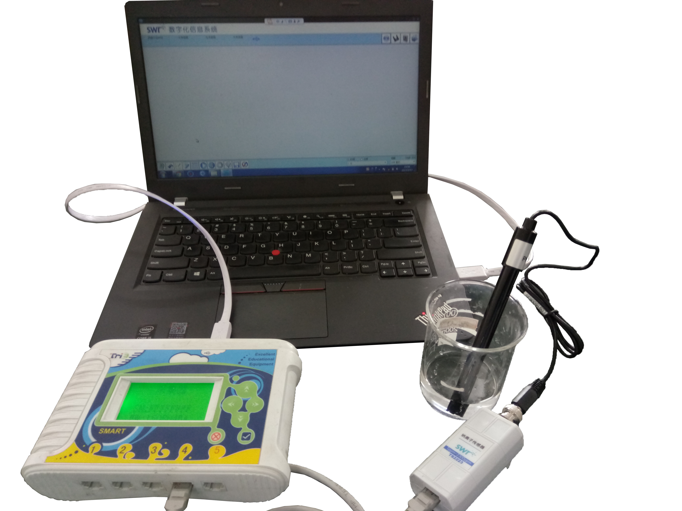
Product General Assembly
1. Take out electrode cover. Rinse it using distilled water. Dry it using filter paper.
2. Connect electrode to sensor, datalogger and computer.
3. Open SWR iLab. The sensor has been calibrated before manufacturing. Immerse the electrode into solution to collect data.
4. Open SWR iLab v8.0 to create new experiment. Click ‘Start’ to collect data and ‘Stop’ to finish the experiment.
5. Click ‘Curve manager’. Select ‘curve duplication’ in ‘analysis’ and immerse the electrode into liquid with unknown concentration. Click ‘Stop’. Repeat the method for the other solution and compare the result.
6. Rinse the electrode using distilled water after measuring. Dry the electrode using filter paper. Cover the electrode and preserve it in bag.

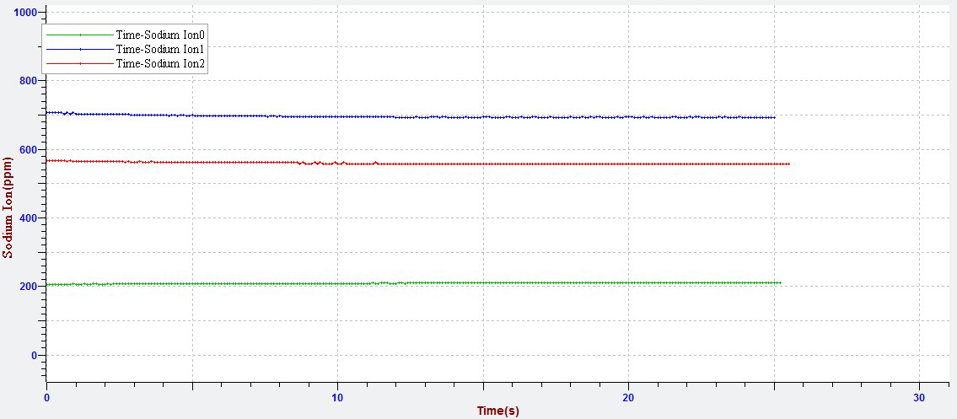
Detect Concentration of Sodium Ion in Saline Solution.
From the figure above, we can observe the concentration of sodium ion for all 3 solution which are 691ppm, 558ppm, 209ppm.
Notes:
H⁺, K⁺ and NH₄⁺ are able to interrupt the electrode. Be careful when measuring.
Use 0.2mol/L diisopropylamine to adjust the pH value of solution to 10. It can prevent the interruption from H⁺.
If it is left unused for a long time and electrode can not touch internal solution, you should swing the electrode so that internal solution flows back to top of electrode. Immerse the electrode in solution with pNa=4 for more than 8h.
Immerse the electrode completely in the solution to be measured during measuring.
Keep the electrode wire and insulation part clean and dry.

