
Split Motion Sensor
Product No.: TS2130
Measuring range: 0cm~200cm
Resolution: 1mm
Accuracy: ±1cm
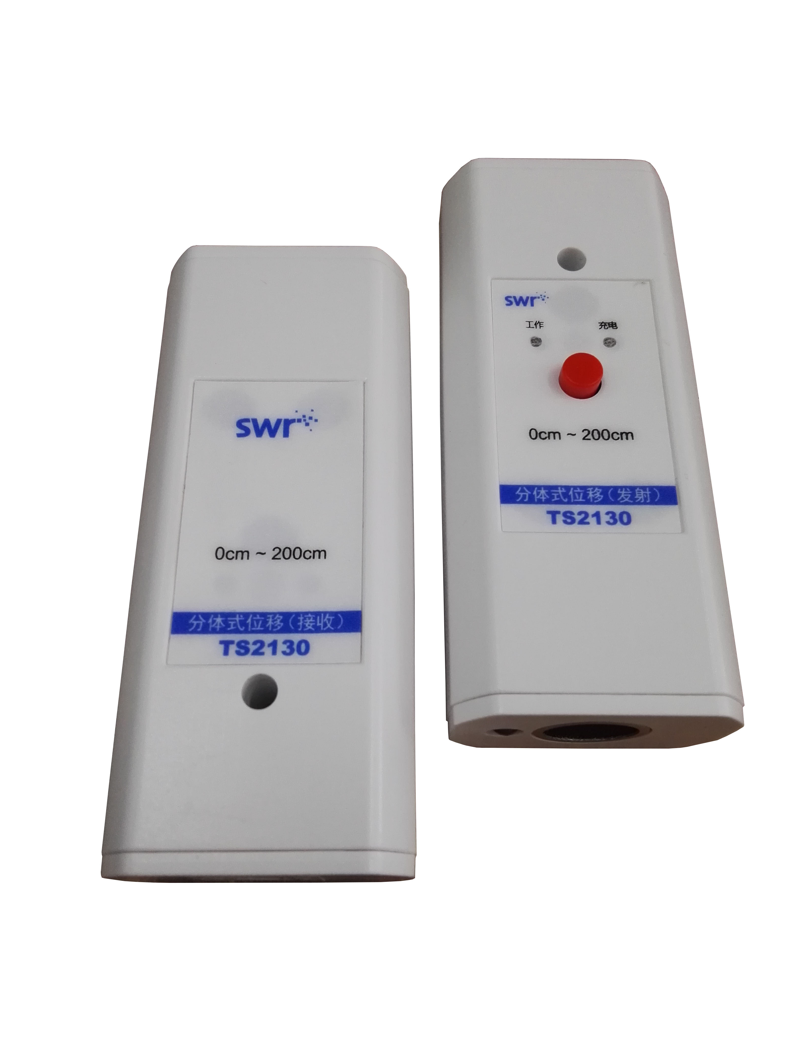

Address: No.14 Junnong Road, Qinhuai District, Nanjing, China.
Website: //www.sinoswr.com
Post Code: 210007
Tel: +86-400-828-8387

Introduction:
There are two parts in Split Motion Sensor which are transmitter and receiver. The working principle is: the speed of light and sound are differ by several orders of magnitude. In a short time period, we can assume the time required for light transmission is 0. Transmitter transmits infrared ray signal to receiver and inform it the time of ultrasonic transmission. It sends ultrasonic signal at the same time. Receiver starts recording time once it gets the signal. Receiver stops recording time once it receives ultrasonic signal. It calculates the distance between transmitter and receiver according to the formula: distance = speed of sound × time.
Transmitter of Split Motion Sensor send narrow voltage impulse to piezoelectric transducer first. The piezoelectric transducer starts vibrating and transmits ultrasonic impulse. At the same time, transmitter uses light source send signal to receiver to start recording time. Receiver calculates the time T that impulse gets sent from transmitter and received by receiver once it receives the impulse.
There is threaded hole at side of sensor (M6). You can mount the sensor on the device you need by using it.
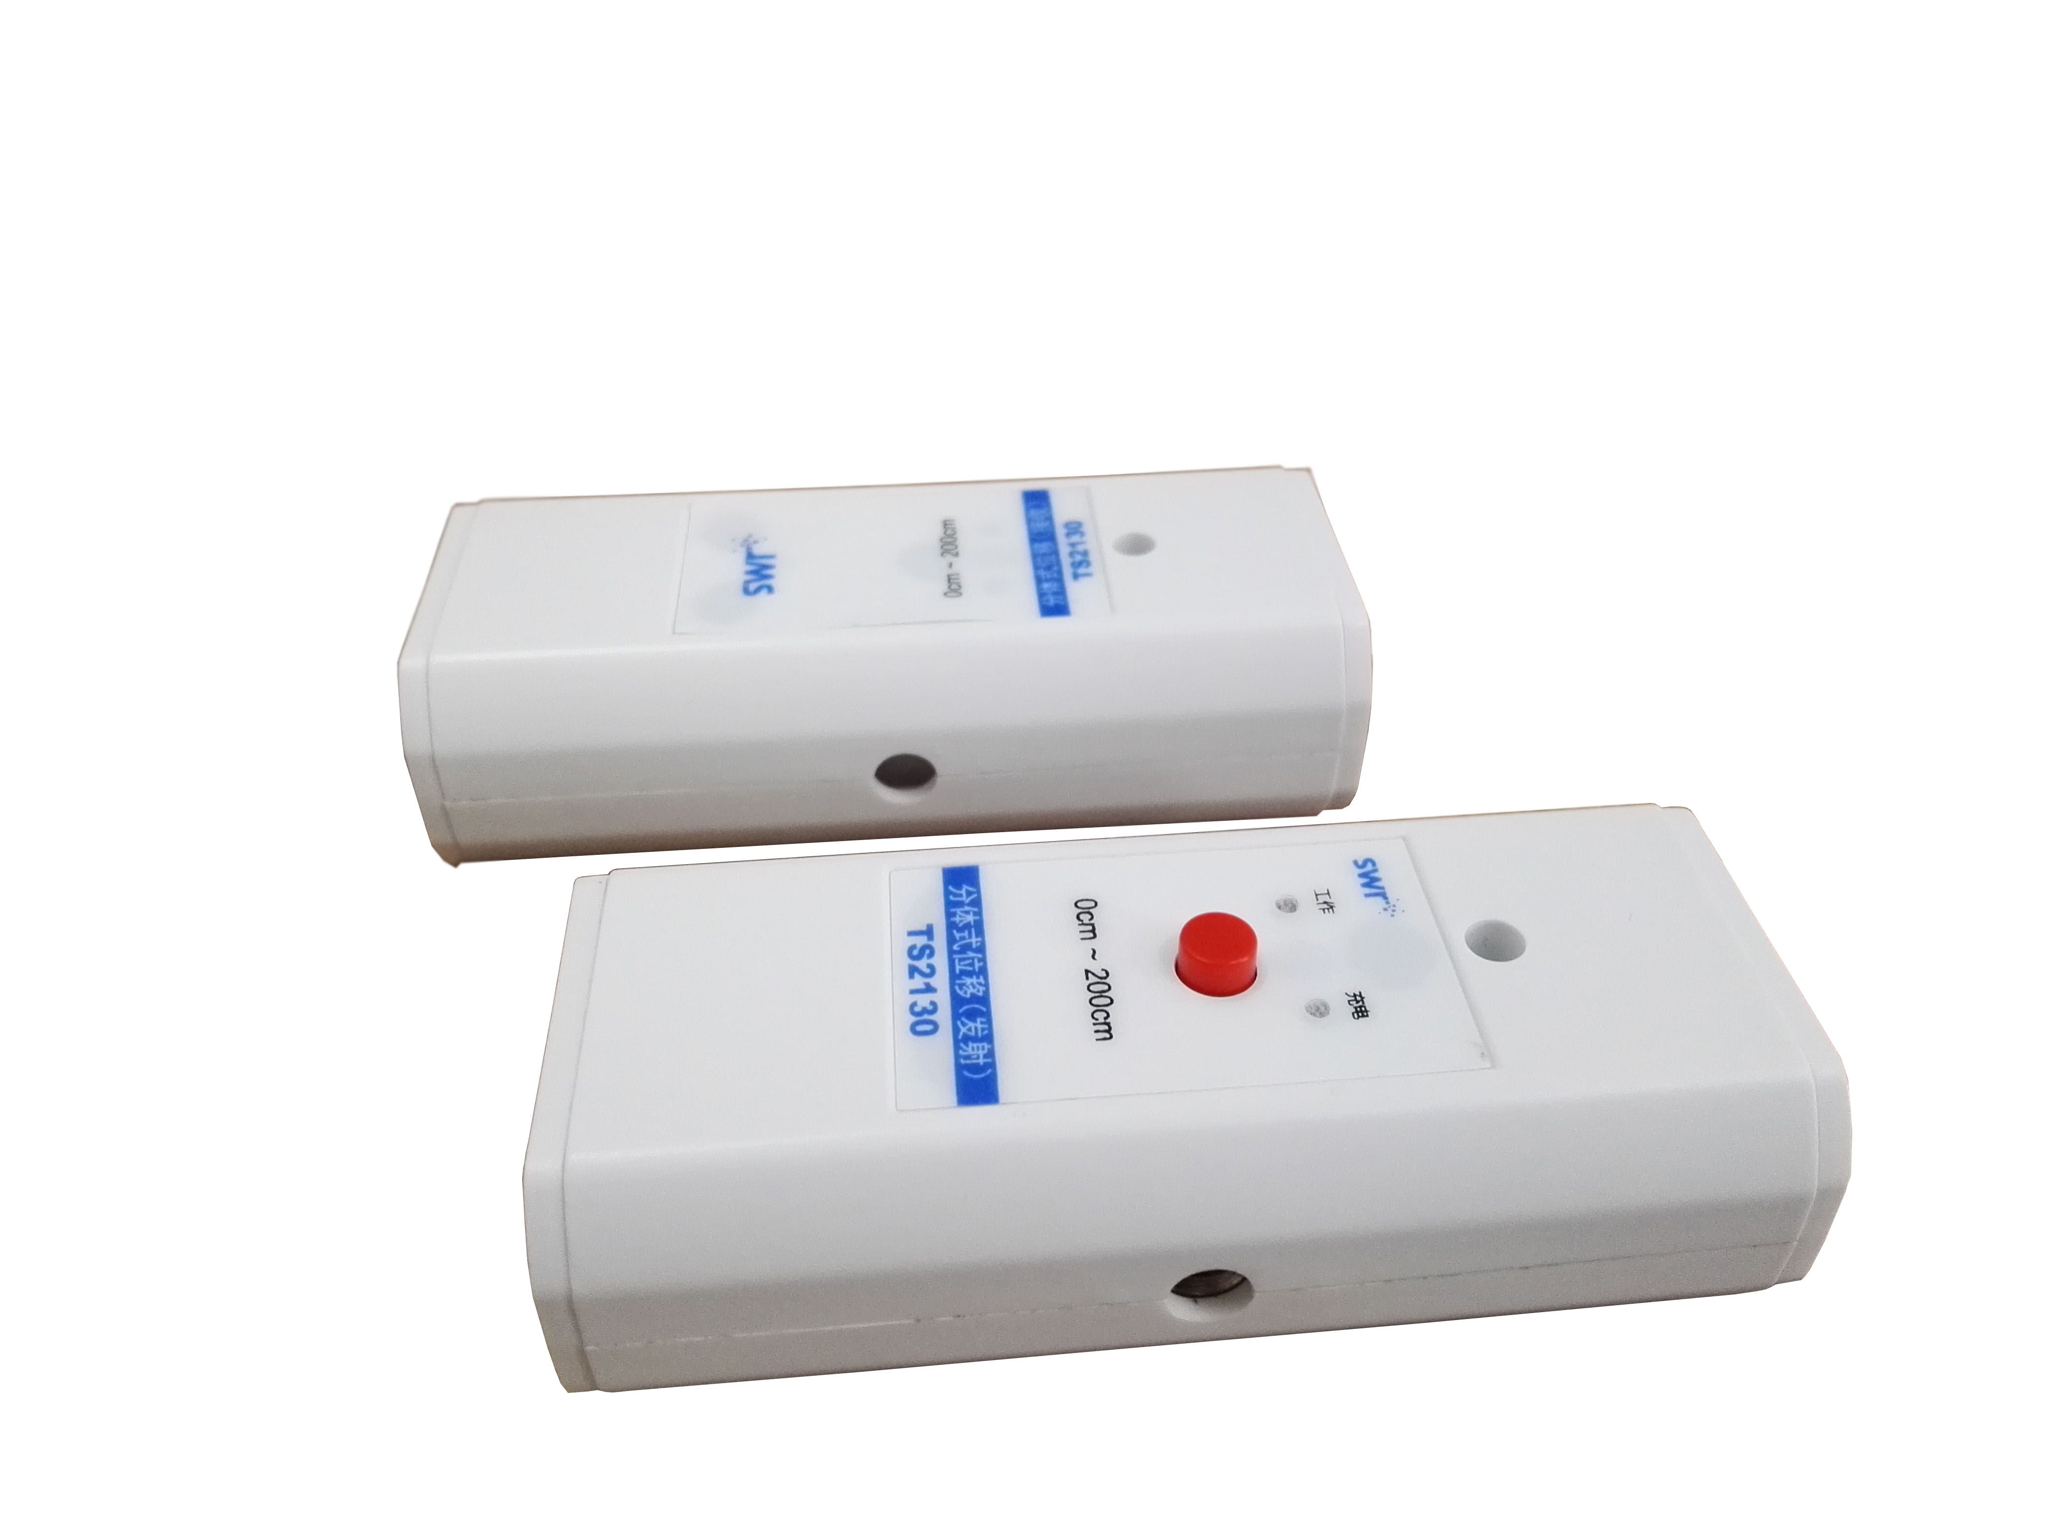
Threaded hole
Calibration:
Split Motion Sensor does not require to be calibrated during using. You can calibrate if obvious error is occurred. Click ‘Calibrate’ in software template：
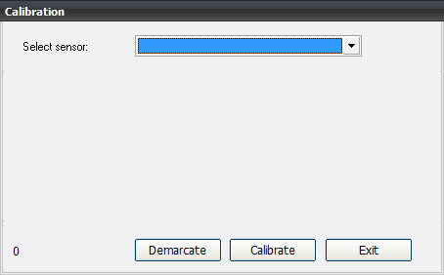
Click ‘Calibrate’ to select Split Motion Sensor.
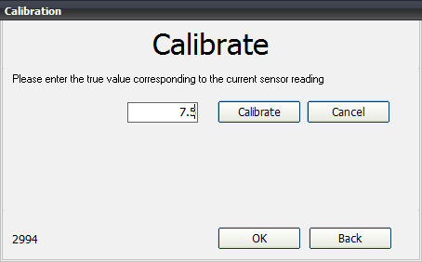
The distance between transmitter and receiver should be a fixed value such as 7.5cm. Insert 7.5 and click calibrate (do not use 0 as calibrate value).
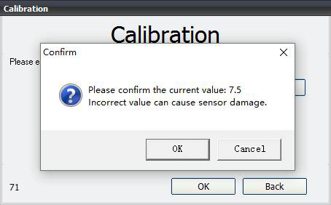
Click ‘OK’ and ‘OK’.
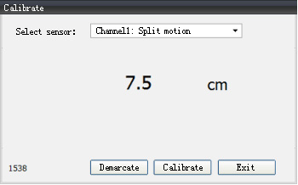
Usage:
There are transmitter and receiver in the sensor. Built-in lithium battery is designed in transmitter. Press the red button and indicator is light up. The transmitter is turned on. It should be mounted on the measured object during using. The receiver should be connected to datalogger using data cable. Connect datalogger to computer using blue data cable.
Typical experiment:
- Simple harmonic motion
- Forced vibration
- Explore uniform linear motion and uniformly accelerated rectilinear motion
Experimental case:
Uniformly accelerated rectilinear motion:
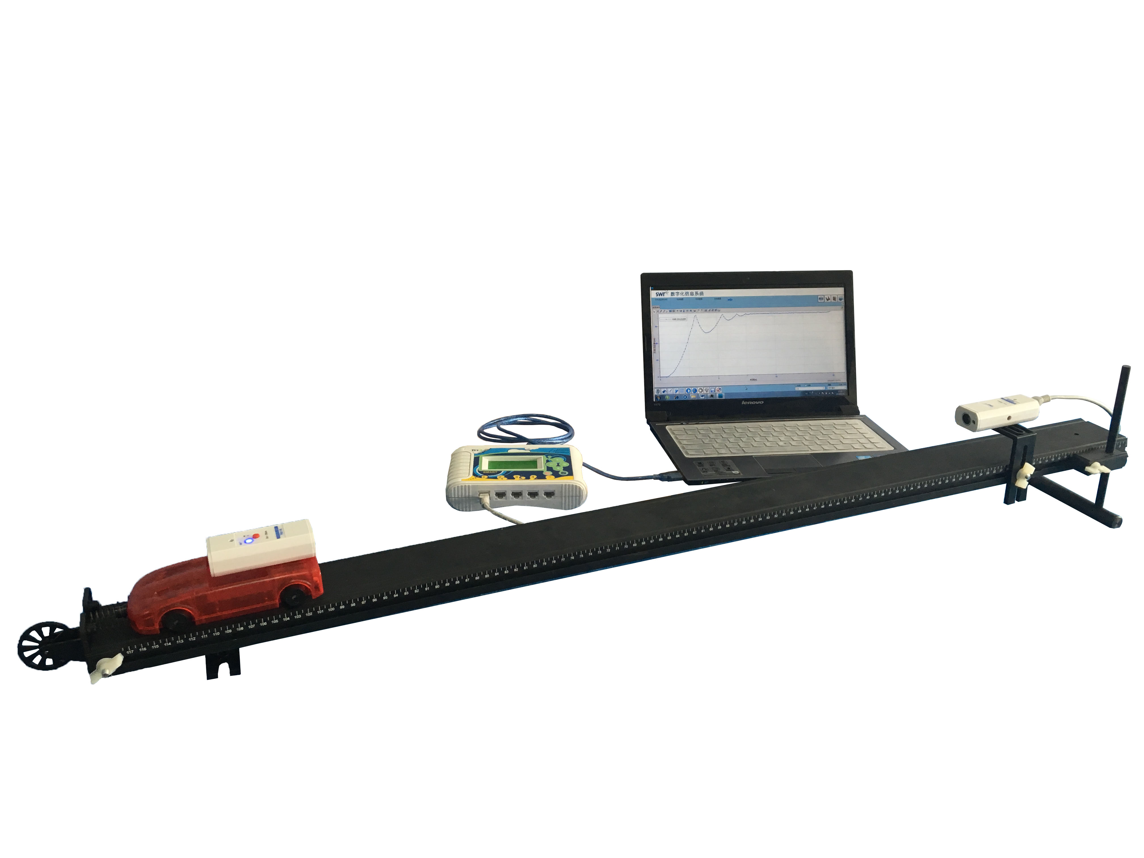
Fig.1: General Assembly Diagram
- Setup the apparatus according to Fig.1.
- Open SWR iLab. Click ‘New’ to create a new experiment template.
- Click ‘New page’ to open a new folder.
- Click ‘add line’ to add ‘Motion-Time’ coordinate. Set proper collecting time and acquisition interval such as 1min, 100ms.
- Place the small cart on the upper side and keep it still.
- Click ‘Start’ and release the cart.
- Click ‘Stop’ when the cart stops moving.
- Observe and analyze the experimental result after collecting.
- Clean up the apparatus.
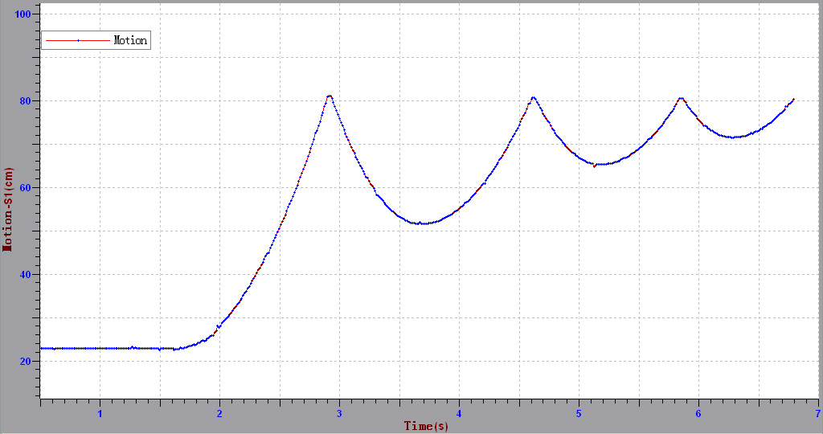
Fig.2: Motion Change with Respect to Time
Notes:
- The transmitter and receiver of Split Motion Sensor must be placed on the same line. Place the infrared transmitter and receiver face to face.
- Charge the transmitter before using in case it stops working due to low battery.

