
Address: No.14 Junnong Road, Qinhuai District, Nanjing, China.
Website: //www.sinoswr.com
Post Code: 210007
Tel: +86-400-828-8387

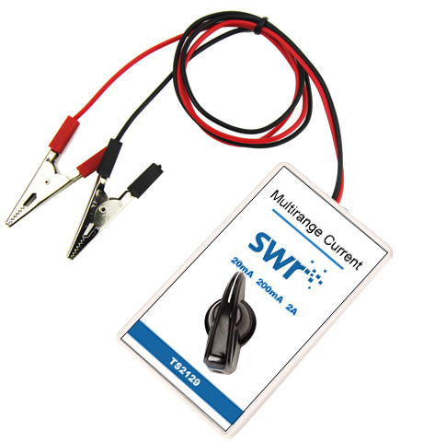
Multirange Current Sensor
Product No.: TS2129
Measuring range 1:-2A～+2A
Resolution: 0.001A
Accuracy: ±1%F.S
Internal resistance: 50mΩ
Measuring range 1: -200mA～+200mA
Resolution: 0.1mA
Accuracy: ±1%F.S
Internal resistance: 500mΩ
Measuring range 1:-20mA～+20mA
Resolution: 0.01mA
Accuracy: ±1%F.S
Internal resistance: 5.1Ω
Introduction:
Multirange Current Sensor is used to measure the current in circuit. Sensitive sampling resistor is designed in the sensor. When current passes through resistor, it will form a tiny electric potential difference at both ends of the resistor. After circuit amplifying, it can accurately measure the current in DC circuit or low-voltage AC circuit.
Multirange Current Sensor should be series connected to the circuit during using. It can be used to measure the amplitude and direction of current. Internal resistance of Multirange Current Sensor is extremely low. Thus, the resistance it brings to circuit is low. Connecting Multirange Current Sensor will not affect circuit.
Calibration:
TS2129 Multirange Current Sensor needs to be calibrated before using. Connect sensor to datalogger. Open SWR iLab. Short connect red and black alligator clips to calibrate it.
Usage:
During using, series connect Multirange Current Sensor in circuit. Make sure the current flowing through it from the red wire and flows out from black wire. The measured current value is positive under this condition as shown below:
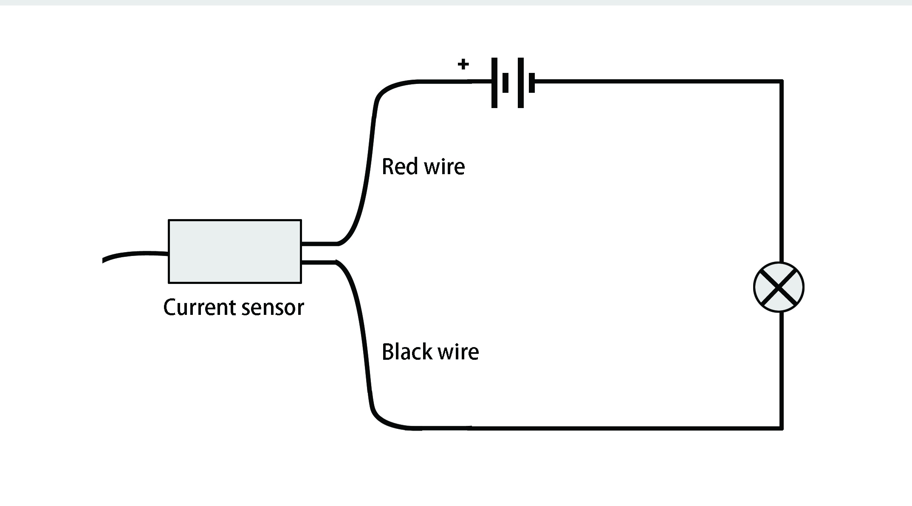
Typical experiment:
Measure the electrodynamic potential and internal resistance of battery
VA characteristics of small bulb, diode and conductor
Ohm’s law
Series and parallel connection of resistor
Electromagnetic induction phenomenon
LC Oscillation
Series-parallel connection, charging and discharging of capacitor

Experimental case:
VA characteristics of small bulb:
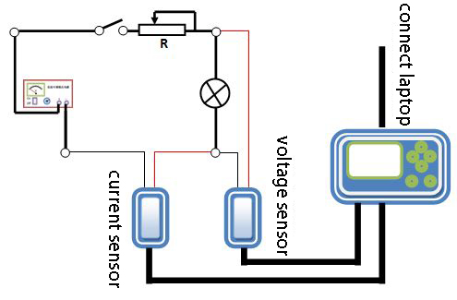
Product General Assembly
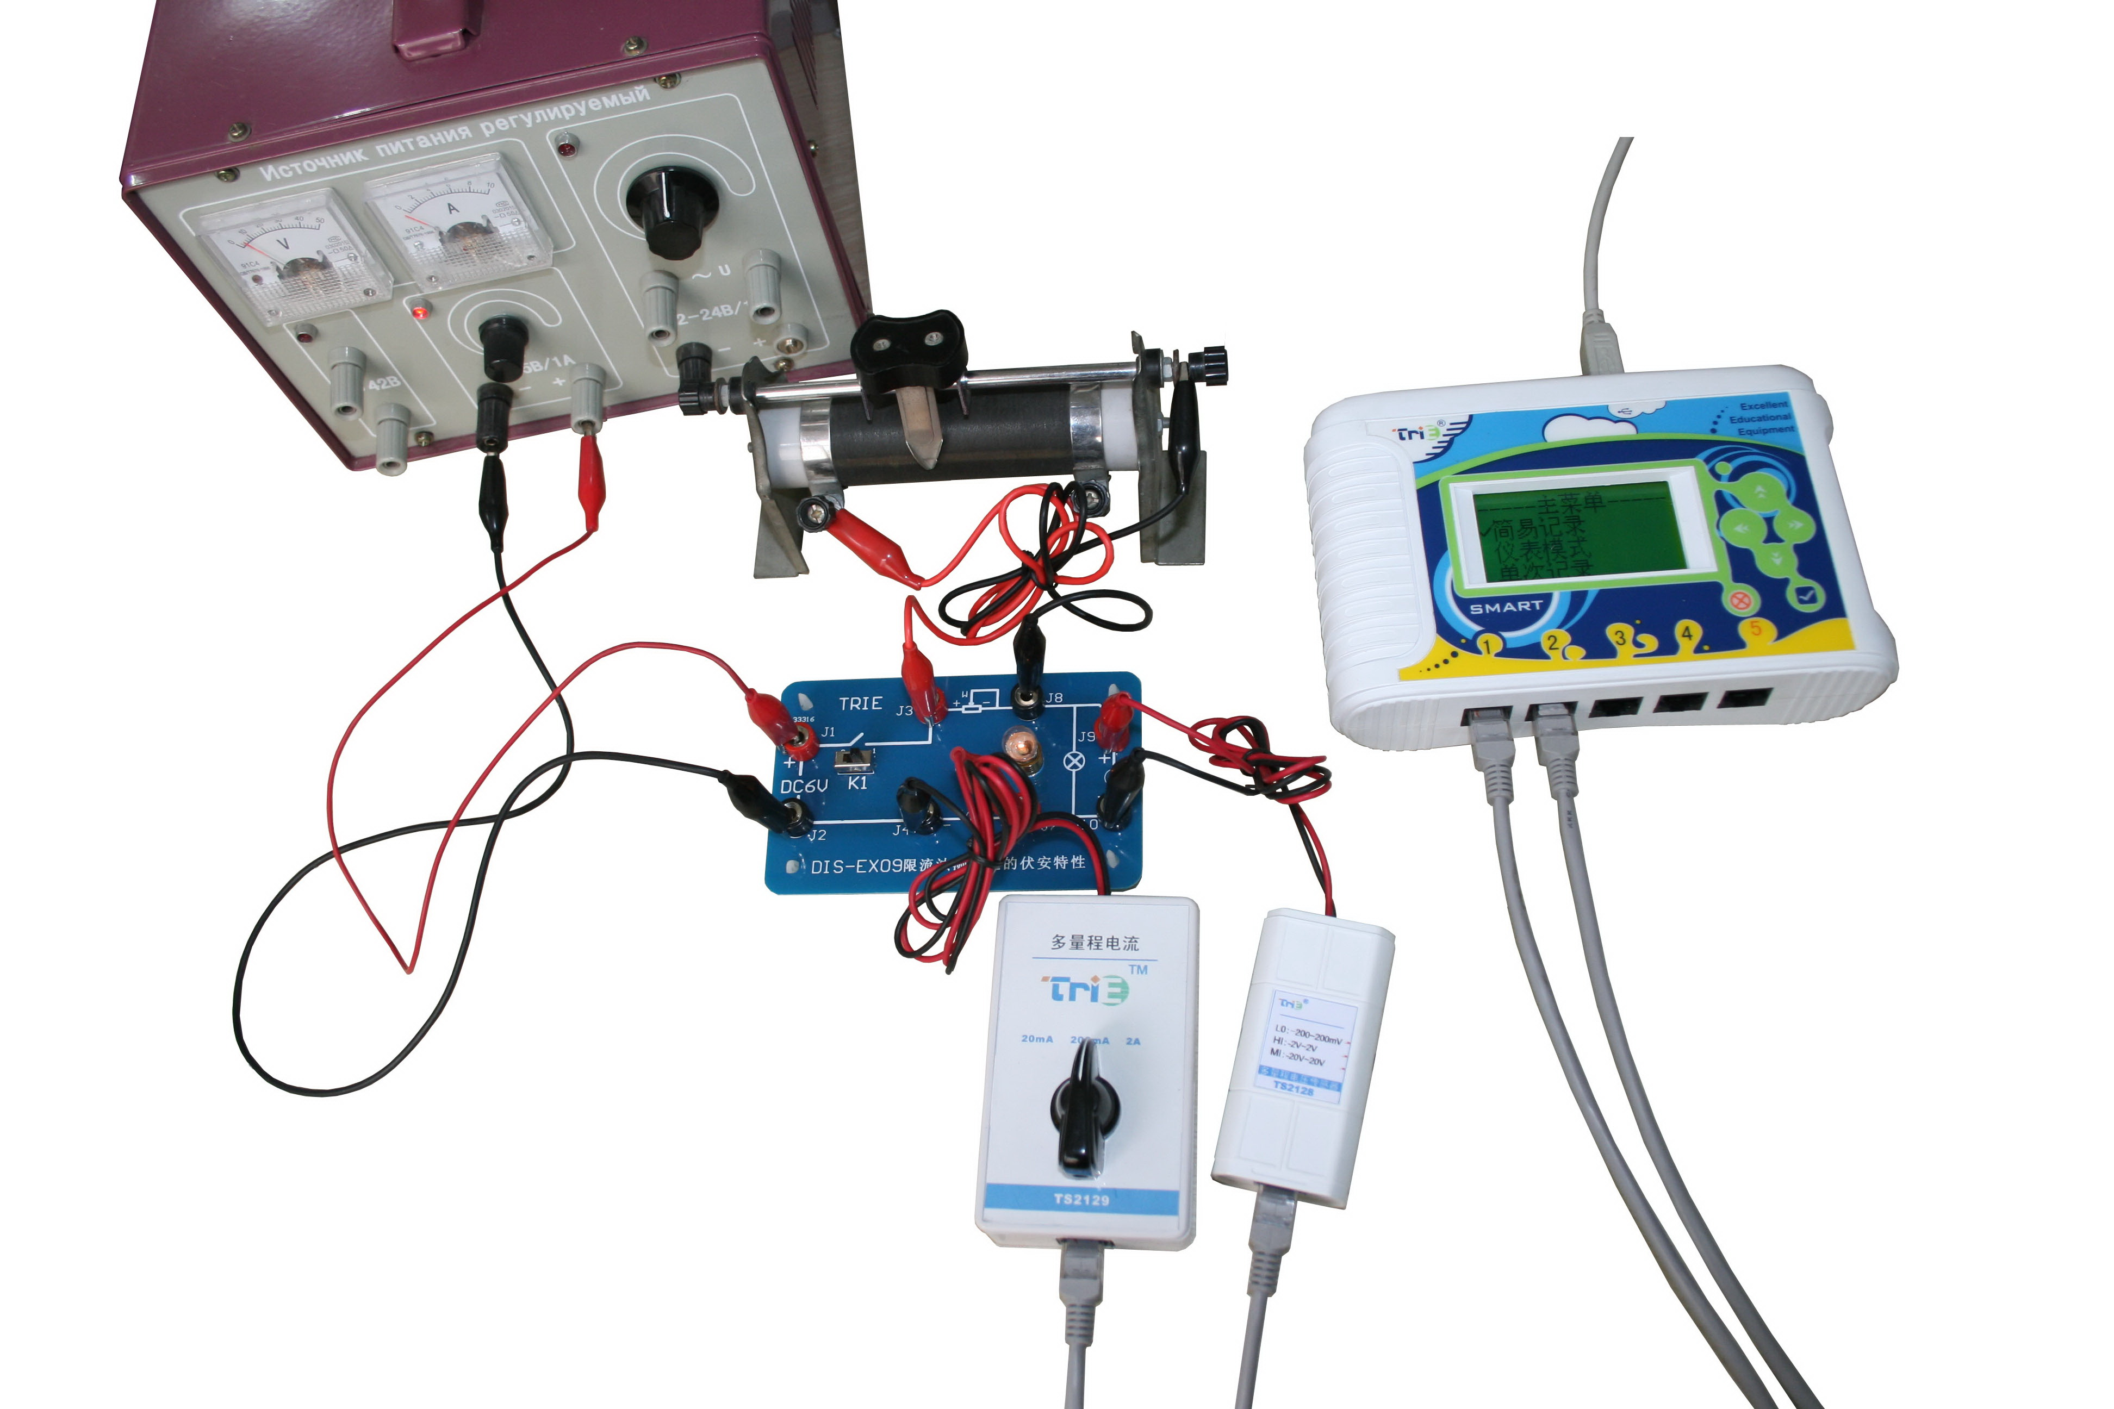
Experimental procedures:
- Connect apparatus as shown above. Calibrate voltage and current Sensor.
- Open the SWR iLab V8.0. Click ‘new’ to create new experimental template.
- Click ‘add line’ to add ‘U-I’ curve. Set x-axis to voltage and y-axis to current.
- Set proper experiment time and acquisition interval and click ‘Start’.
- Adjust resistance of sliding rheostat to change current passes through small bulb.
- Click ‘Stop’ when collecting is completed. Observe the figure.
- Observe and analyze the experimental result.
- Clear up the apparatus.
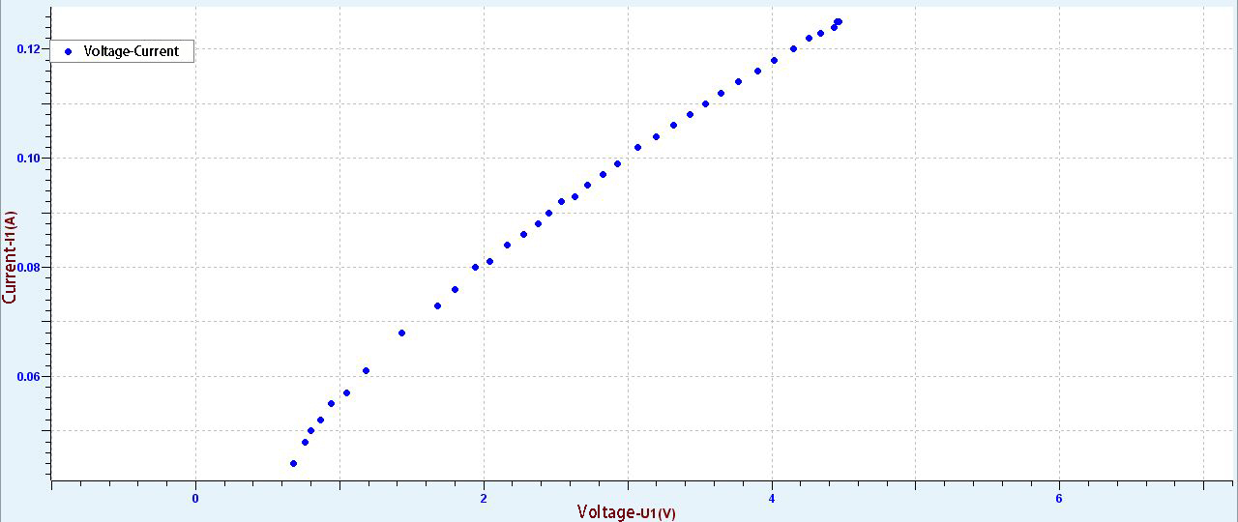
VA Curve
Notes:
1. Multirange Current Sensor should be series connected to the circuit during using. Sensor needs to be calibrated before using.
2. When measuring, please do not make the measured current exceeding the range of the sensor.
3. If possible, ground the negative pole (black alligator clip) to ensure high accuracy.

