
Address: No.14 Junnong Road, Qinhuai District, Nanjing, China.
Website: //www.sinoswr.com
Post Code: 210007
Tel: +86-400-828-8387

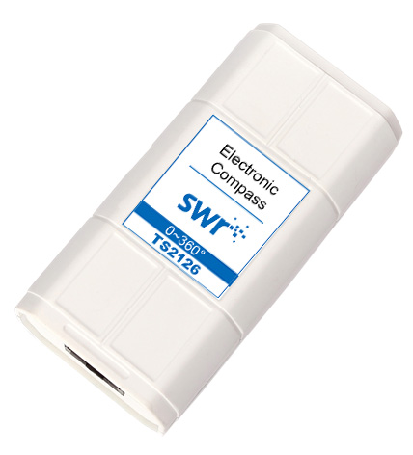
Electronic Compass
Product No.: TS2126
Measuring range: 0~360°
Resolution: 0.1°
Accuracy: ±0.3°

Introduction:
Electronic Compass is called digital compass. It is used to detect north and south pole for geomagnetic field. Normally Electronic Compass are made by magnetoresistive sensor and fluxgate. Electronic Compass can be divided into two kinds which are 2-D Electronic Compass and 3-D Electronic Compass. It is required to keep 2-D Electronic Compass level during using. Otherwise, it will not work properly even if it shows direction changing. If user can keep the Electronic Compass carrier level, it will be a very cost effective product. TS2126 Electronic Compass is a 2-D Electronic Compass.
Usage:
TS2126 Electronic Compass is designed with two vertical placed sensor to detect the changing of direction. It shows the angle between the direction and north or south pole after circuit processing. Keep the sensor level during using otherwise error will be occurred.
Calibration:
Calibration is not required.
Typical experiment
Simulate the usage of compass
Experimental case:
Simulate the usage of compass
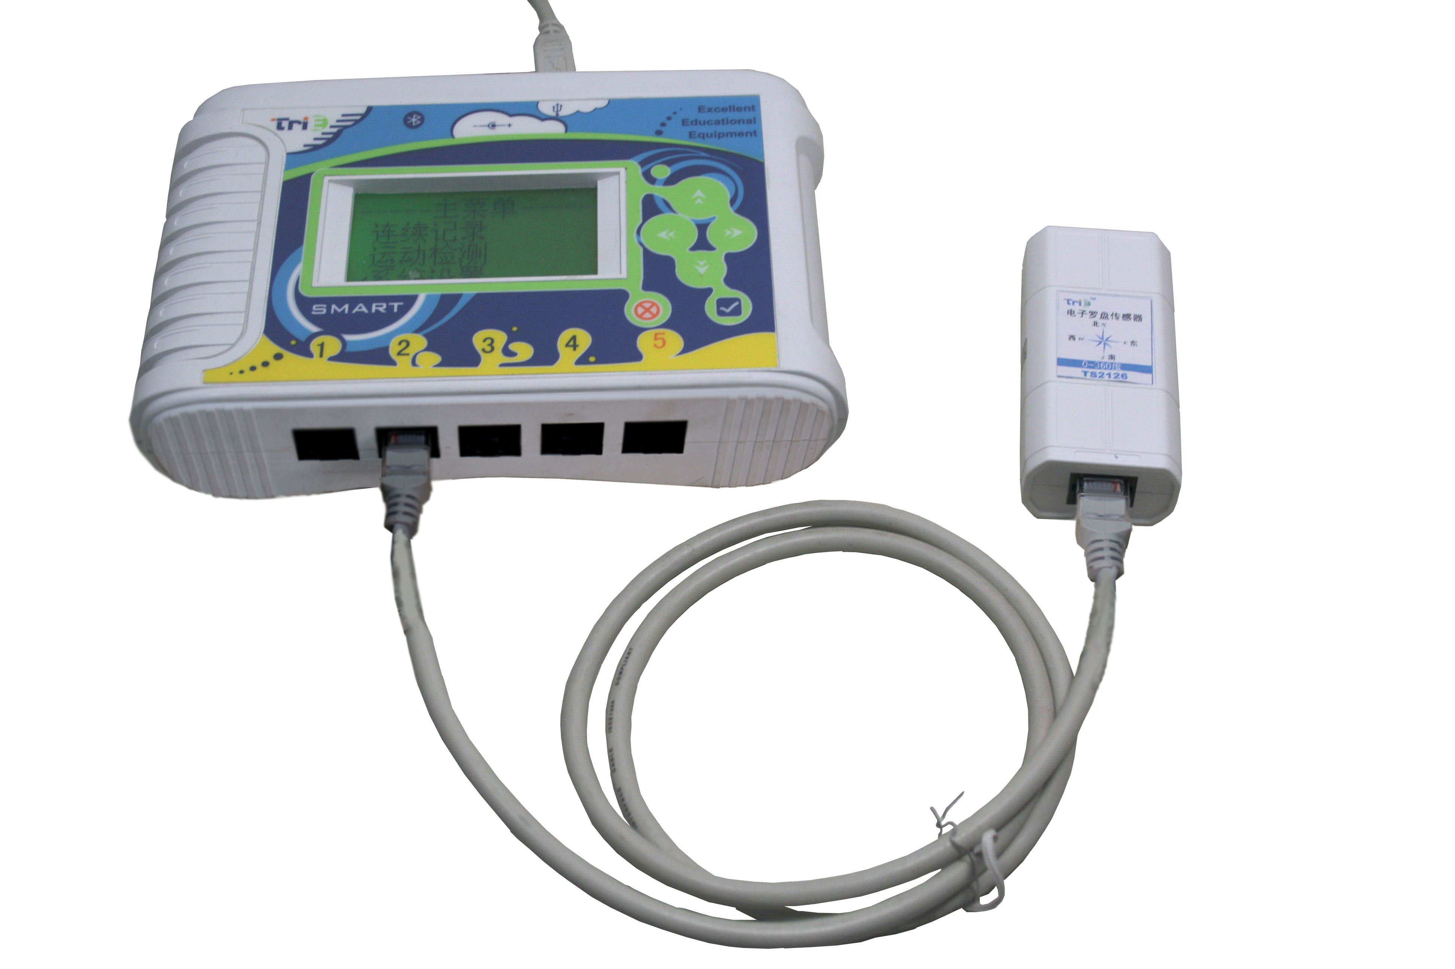
Product Assembly Diagram
- Connect experiment apparatus.
- Open SWR iLab v8.0. Click ‘New’ to create new experimental template.
- Click ‘New page’ and select the fifth template to create new folder.
- Set proper collecting time and acquisition interval.
- Click ‘Start’ and observe the data changing.
- Click ‘Stop’ to stop collecting.
- Clear up experimental apparatus.
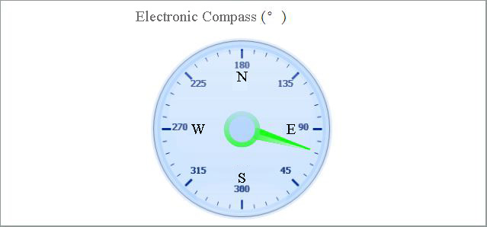
Notes:
Keep the sensor level during using.
If there is strong magnetic field exist near the sensor, it will affect the accuracy.
Keep the sensor stable when rotating it. There will be a delay for sensor reading.

