
Address: No.14 Junnong Road, Qinhuai District, Nanjing, China.
Website: //www.sinoswr.com
Post Code: 210007
Tel: +86-400-828-8387

Surface Temperature Sensor
Product No.: TS2125
Measuring range: -30～+150℃
Resolution: 0.1℃
Accuracy: ±0.5℃

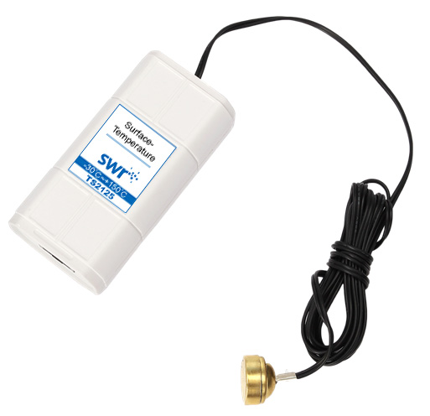

Introduction:
The sensing component of Surface Temperature Sensor is NTC thermistor. It is sealed with an empty metal container. When it touches to object need to be measured, it has very quick response.
NTC thermistor consists of manganese, cobalt, nickel and copper. It is manufactured by ceramics. All those metallic oxide are semiconductors because they are same as germanium and silicon in conducting modes. When the temperature is low, the quantity of carrier on those materials is low. Thus, its resistance is high. When temperature rises up, quantity of carrier increases and resistance drops. NTC thermistor can be widely used to measure, compensate temperature and restrain surge current.
Calibration:
Calibration is not required.
Usage:
NTC thermistor is mounted on the top of sensor probe. It is the sensing component of measuring temperature, which means it is key component. Make sure the sensor NTC thermistor touching completely to the surface of measured object to ensure the accuracy of measuring result. The sensor is mainly used to measure the temperature of metal surface and liquid or gas in sealed container or tube.
Typical experiment
Conversion between work and energy
Comparison on heat conduction performance of different substances
Experimental case:
Conversion between work and energy
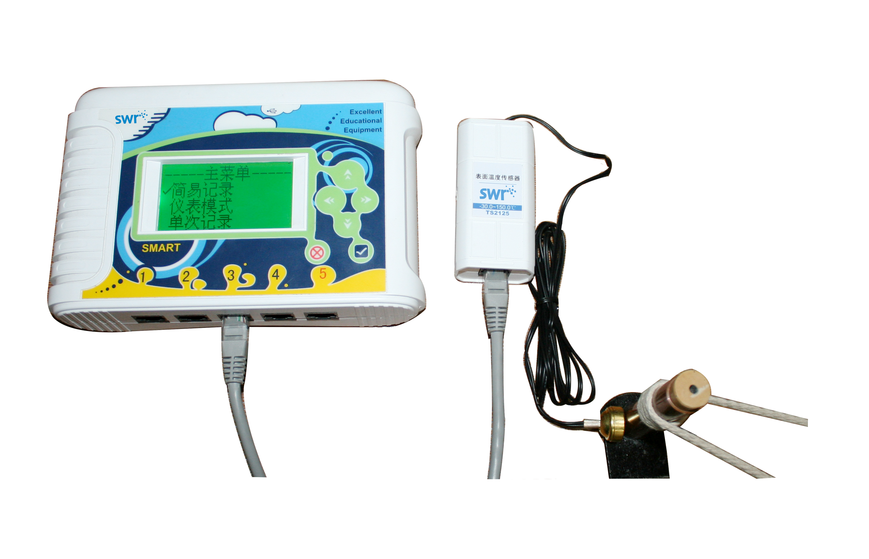
Product Assembly Diagram
Experiment procedures:
- Connect experiment apparatus.
- Open SWR iLab v8.0. Click ‘New’ to create new experimental template.
- Click ‘New page’ to create new folder.
- Click ‘add line’ to add ‘Temperature-Time’ coordinate. Set proper collecting time and acquisition interval such as 2min, 100ms.
- Attach Surface Temperature Sensor probe on the copper pipe.
- Click ‘Start’ and pull the cotton cord.
- Observe the curve of temperature change with respect to time after collecting.
- Clear up experimental apparatus.
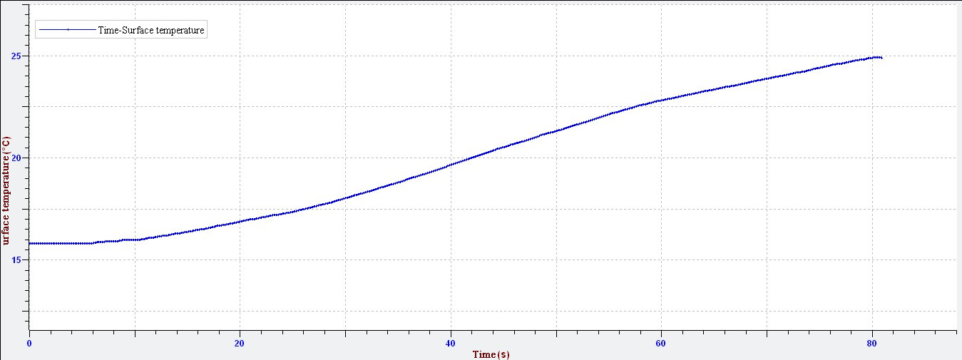
Temperature Change with Respect to Time
Notes:
The probe should be touching tightly to the surface of object to be measured.
Do not measure the temperature exceeding the measuring range.

