Dissolved Carbon Dioxide Sensor
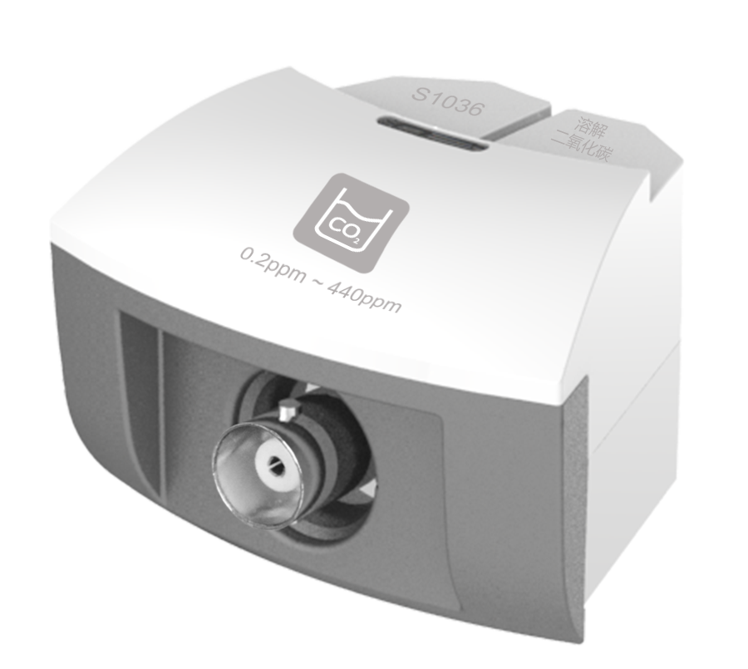
S1036 Dissolved Carbon Dioxide Sensor
Measuring range: 0.2ppm ~ 440ppm
Resolution: 0.1ppm
Dissolved Carbon Dioxide Sensor is used to detect concentration of CO₂ in solution. It can measure the concentration using datalogger and experiment software. The dissolved CO₂ in sample diffuses in the thin liquid layer between pH electrode and gas-permeable membrane. The reaction will occur until partial pressure of sample and thin liquid layer are same.
CO₂+H₂O H⁺+HCO₃⁻
The change of pH of thin liquid layer is measured by combination electrode. The measured potential value and concentration of CO₂ in external solution are compliance with Nernst formula.
Component
No. | Model | Name | Picture
1 | S1036 | Dissolved Carbon Dioxide Sensor | 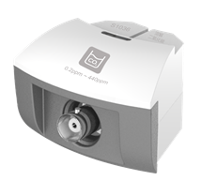
2 |  | Dissolved Carbon Dioxide Sensor electrode | 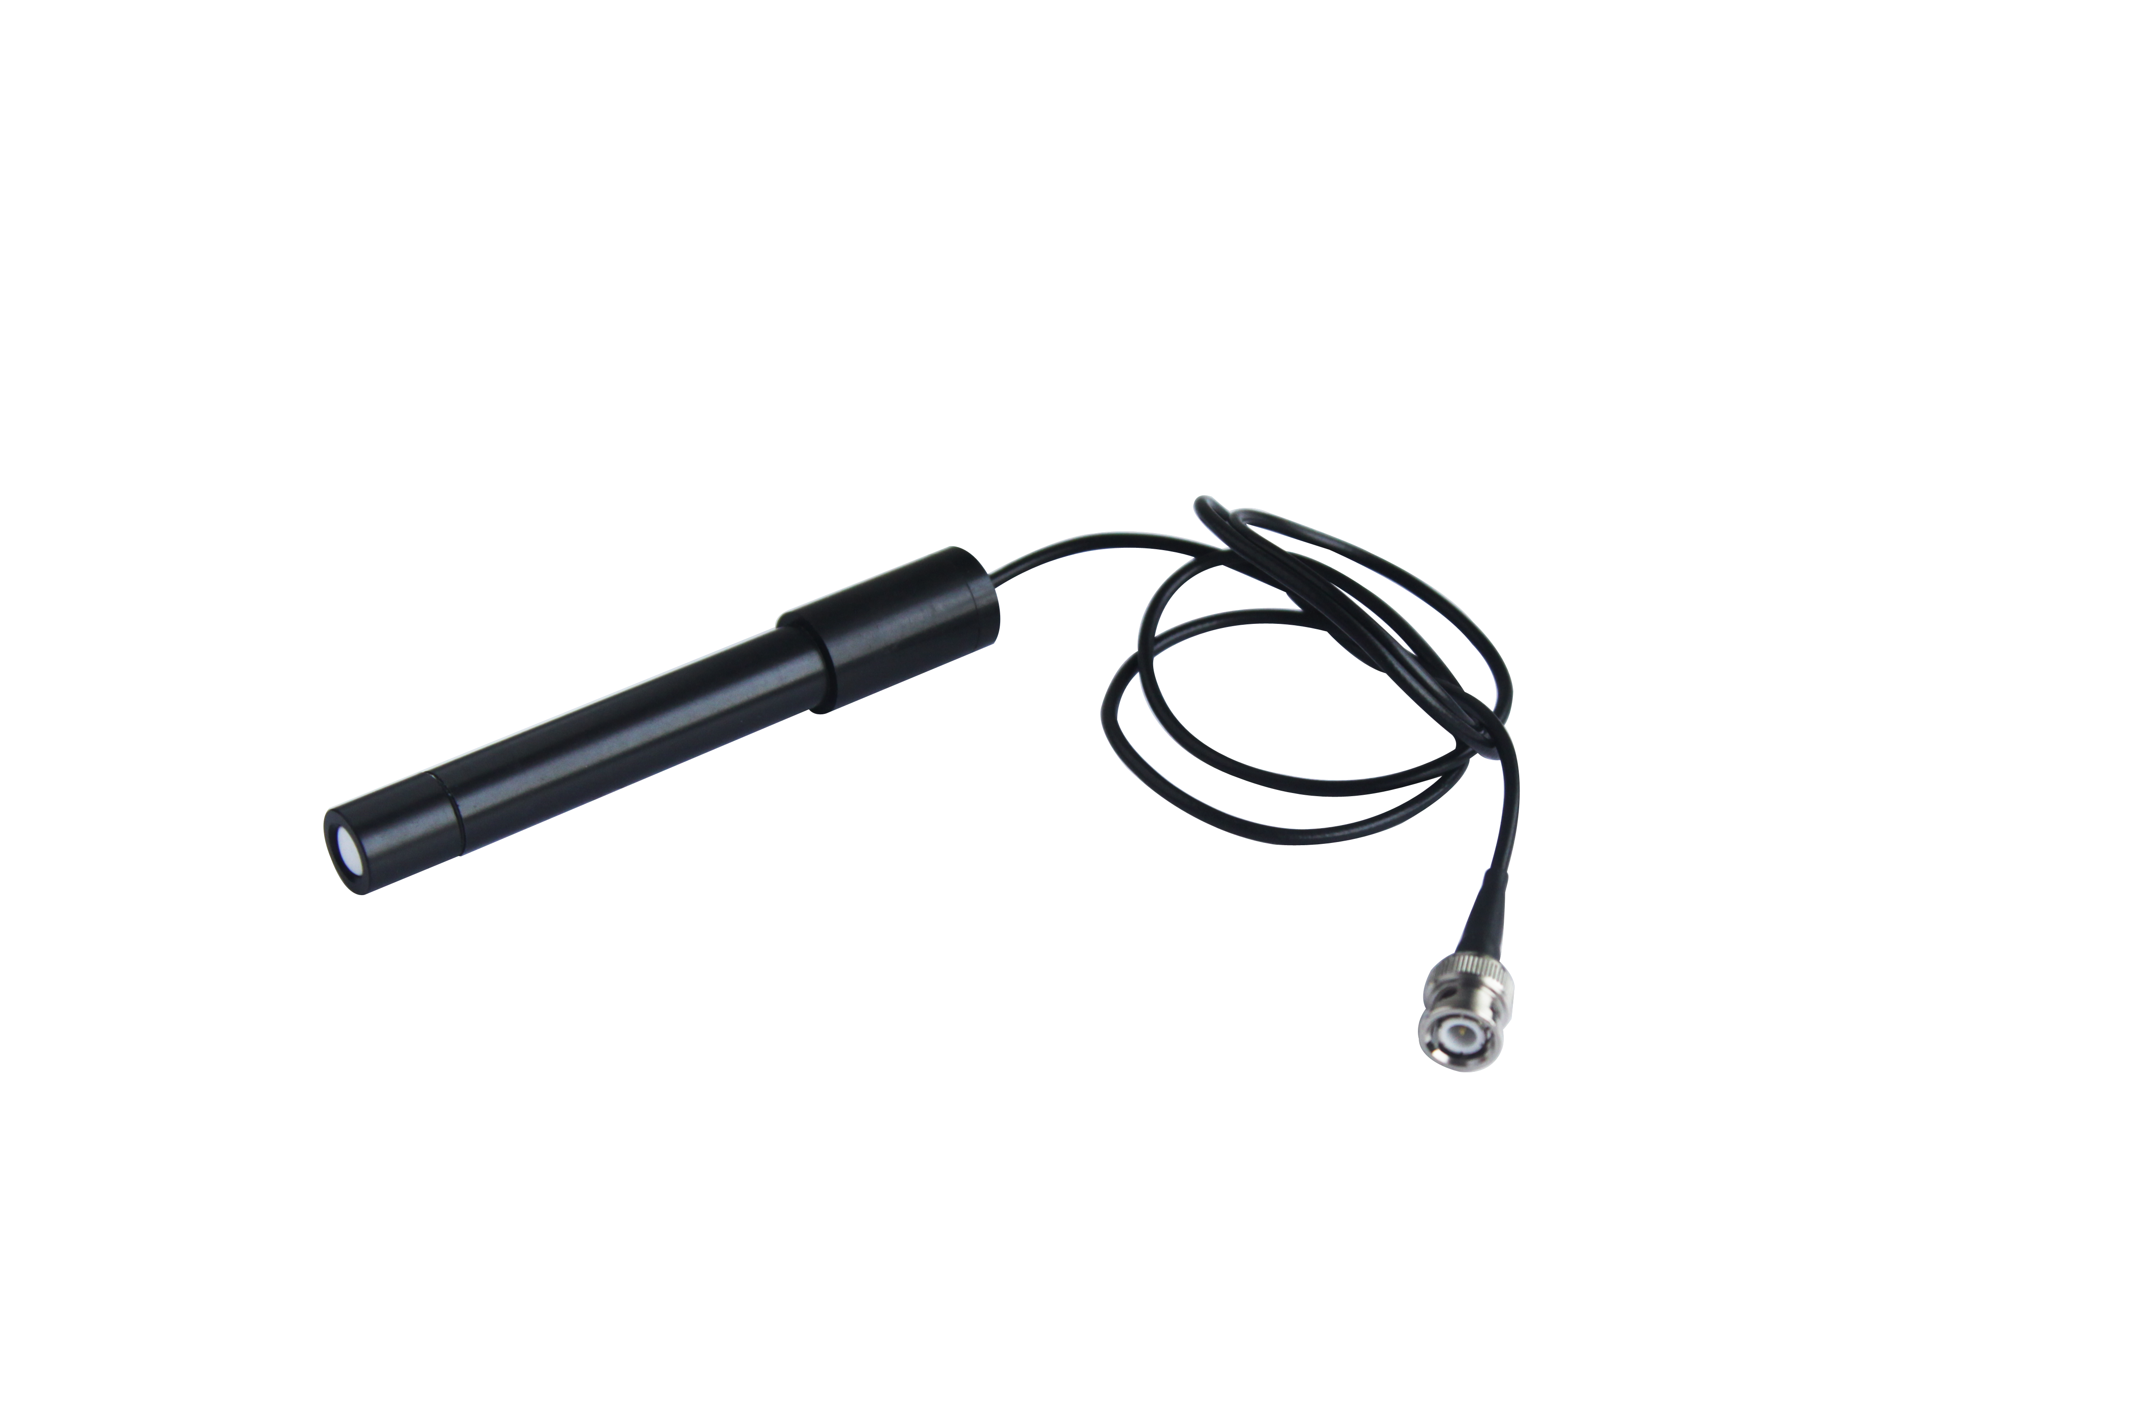
Usage
Connect Dissolved Carbon Dioxide Sensor to any port in SenseDisc.
Connect electrode to Dissolved Carbon Dioxide Sensor.
Immerse the probe into solution. Collect data when the electrode becomes stable.
When the experiment is completed, rinse the probe using distilled water immediately. Dry it using filter paper. Cover the probe and preserve it in bag.
Typical experiment
Solubleness of carbon dioxide
Absorb carbon dioxide by photosynthesis of aquatic plant
Notes
Before experiment, make sure the position of gas-permeable membrane and pH electrode are placed properly. If they are touching too tight, the liquid layer maybe too thin to connect so that the potential will not be stable. If they are touching too separately, the time required to be stable will be too long.
After every time of using, rinse the electrode using deionized water to keep the potential at -450mV.
During experiment, it should start from dilute to concentrated solution. It should be carried out in small beaker without sealing. In order to prevent effusion of carbon dioxide, it is suggested to add acid and stir the solution after immersing electrode in solution and then start measuring data.
The internal resistance of apparatus using with electrode should have at least 3×10¹¹Ω to make sure the electrode is insulated.
pH value range: 0-4.
Respond time: 1×10-2～1×10-4mol/L, less than 4minutes (25℃).
1×10-4～5×10-5mol/L, less than 7minutes (25℃).
Main interruption: NO₂, SO₂, HAC and CH₂O.

