NO Sensor
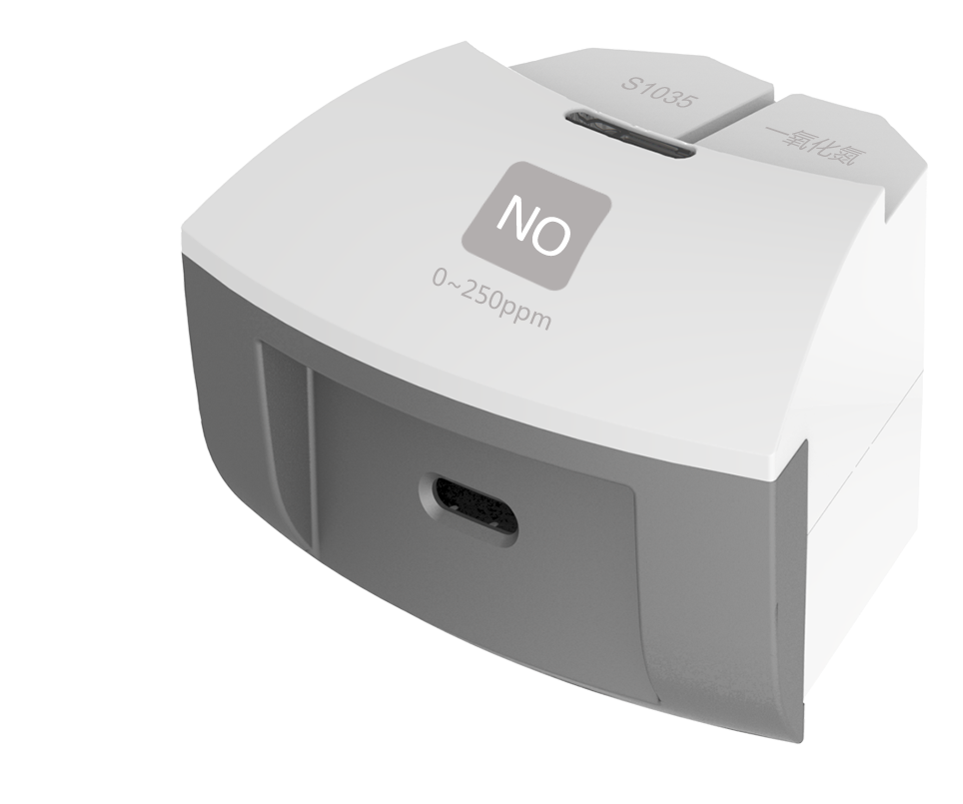
S1035 NO Sensor
Measuring range: 0 ~ 250ppm
Accuracy: ±1%F.S
Resolution: 0.1ppm
The working principle of NO Sensor is measuring concentration of gas by using electrochemistry. The probe consists of electrode and electrolyte. The electrolyte is separated by a selective gas-permeable membrane. The gas diffusing in sensor occurs redox reaction on the surface of electrode. Current is generated in the electrode. The value of current is corresponding to the concentration of gas. Sensor converts the signal in electrode into analog signal.
Component
No. | Model | Name | Picture
1 | S1035 | NO Sensor
2 |  | NO Sensor electrode
Usage
Connect NO Sensor to any port in SenseDisc.
Expose NO Sensor electrode in the air with NO to collect data.
Typical experiment
Produce NO using copper and dilute nitric acid
Reaction of NO and O₂
Verify if NO is soluble
Notes
NO is a kind of colorless, odourless, poisonous and insoluble gas. Be careful when using it.
The electrode is gas-permeable membrane electrode. Try not to break the membrane when using the device.

