NO₂ Sensor
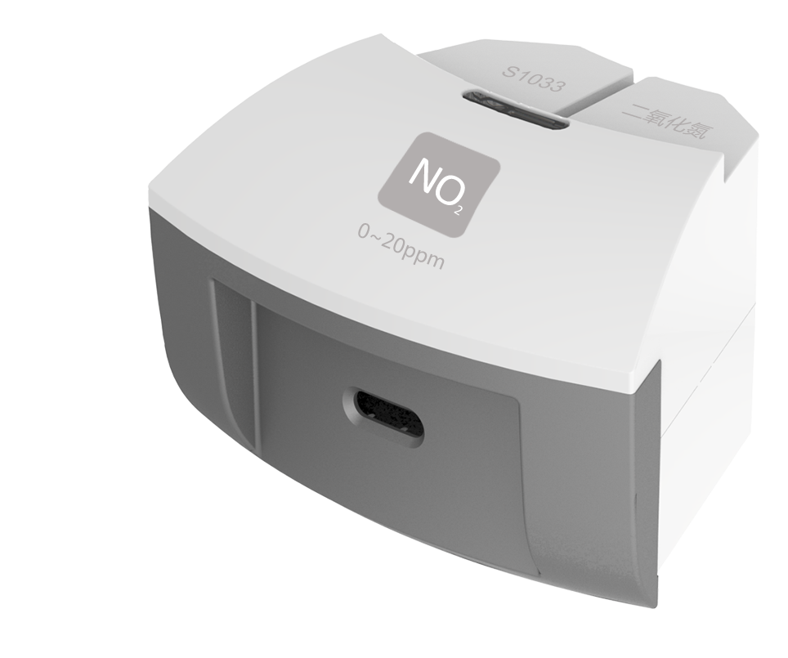
S1033 NO₂ Sensor
Measuring range: 0 ~ 20ppm
Accuracy: ±1%F.S
Resolution: 0.1ppm
The working principle of NO₂ Sensor is measuring concentration of gas by using electrochemistry. The probe consists of electrode and electrolyte. The electrolyte is separated by a selective gas-permeable membrane. The gas diffusing in sensor occurs redox reaction on the surface of electrode. Current is generated in the electrode. The value of current is corresponding to the concentration of gas. Sensor converts the signal in electrode into analog signal.
Component
No. | Model | Name | Picture
1 | S1033 | NO₂ Sensor
2 |  | NO₂ Sensor electrode
Usage
Connect NO₂ Sensor to any port in SenseDisc.
Expose NO₂ Sensor electrode in the air with NO₂ to collect data.
Typical experiment
Detect the concentration of NO₂ in automobile exhaust.
Absorb NO₂ using sodium hydroxide.
Notes
NO₂ is pungent odour rufous gas under ambient temperature. It is poisonous and has irritant and corrosivity to human’s lung. It is also able to pollute surface water, soil, atmosphere and drinking water. Be careful when using it.
The electrode is gas-permeable membrane electrode. Try not to break the membrane when using the device.

