# H2S Sensor

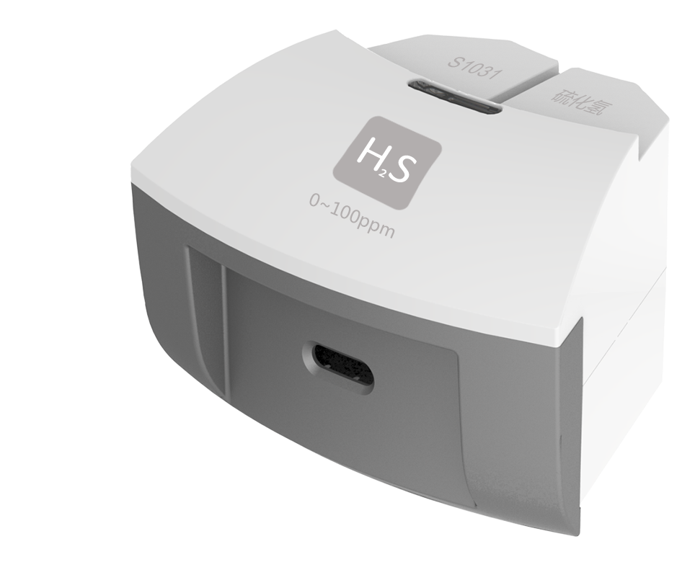

**S1031 H2S Sensor**

Measuring range: 0 ~ 100ppm

Accuracy: ±1%F.S

Resolution: 0.1ppm

The working principle of H2S Sensor is measuring concentration of gas by using electrochemistry. The probe consists of electrode and electrolyte. The electrolyte is separated by a selective gas-permeable membrane. The gas diffusing in sensor occurs redox reaction on the surface of electrode. Current is generated in the electrode. The value of current is corresponding to the concentration of gas. Sensor converts the signal in electrode into analog signal.

**Component**

|  |  |  |  |
| --- | --- | --- | --- |
| No. | Model | Name | Picture |
| 1 | S1031 | H2S Sensor | C:\Users\Administrator\Desktop\圆盘传感器玥玥\S1031 硫化氢.pngS1031 硫化氢 |
| 2 |  | H2S Sensor electrode | C:\Users\Administrator\Desktop\圆盘传感器玥玥\气体类探头.png气体类探头 |

**Usage**

Connect H2S Sensor to any port in SenseDisc.

Expose H2S Sensor electrode in the air with hydrogen sulfide to collect data.

**Typical experiment**

Produce hydrogen sulfide using ferrous sulfide and dilute sulphuric acid.

Eliminate hydrogen sulfide using precipitability.

**Notes**

Hydrogen sulfide is a kind of colorless rotten egg smell poisonous gas. It is suggested to use Kipp gas generator and put on respirator during experiment.

The electrode is gas-permeable membrane electrode. Try not to break the membrane when using the device.

Add small quantity of ferrous sulfide in narrow mouthed flask. Add two drops of dilute sulphuric acid. Small quantity of hydrogen sulfide will be produced.