O₃ Sensor
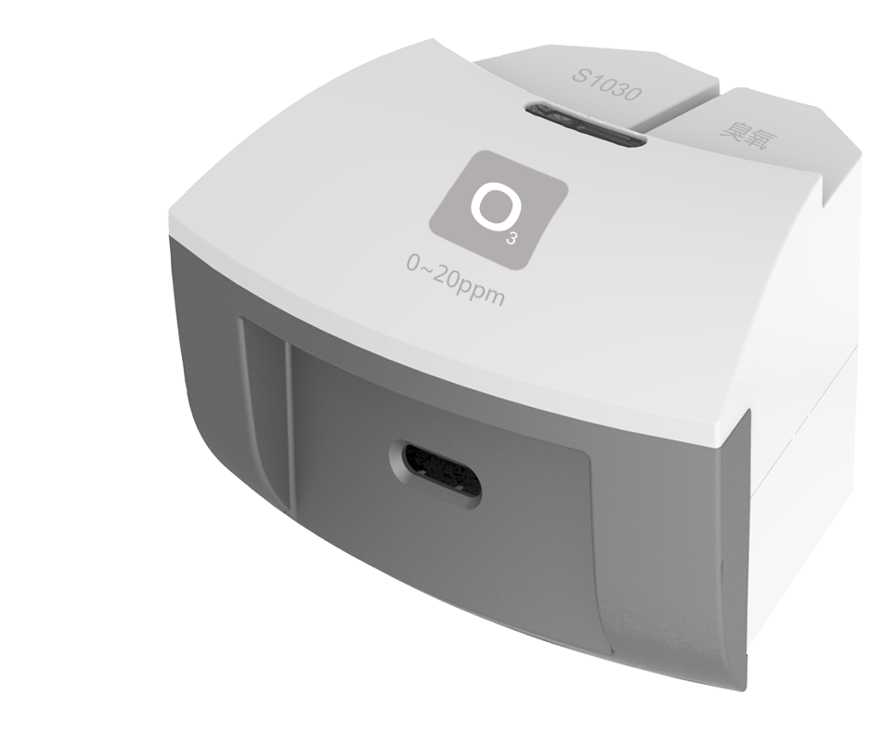
S1030 O₃ Sensor
Measuring range: 0～20ppm
Accuracy: ±1%F.S
Resolution: 0.02ppm
The working principle of O₃ Sensor is measuring concentration of gas by using electrochemistry. The probe consists of electrode and electrolyte. The electrolyte is separated by a selective gas-permeable membrane. The gas diffusing in sensor occurs redox reaction on the surface of electrode. Current is generated in the electrode. The value of current is corresponding to the concentration of gas. Sensor converts the signal in electrode into analog signal.
Component
No. | Model | Name | Picture
1 | S1030 | O₃ Sensor
2 |  | O₃ Sensor electrode | 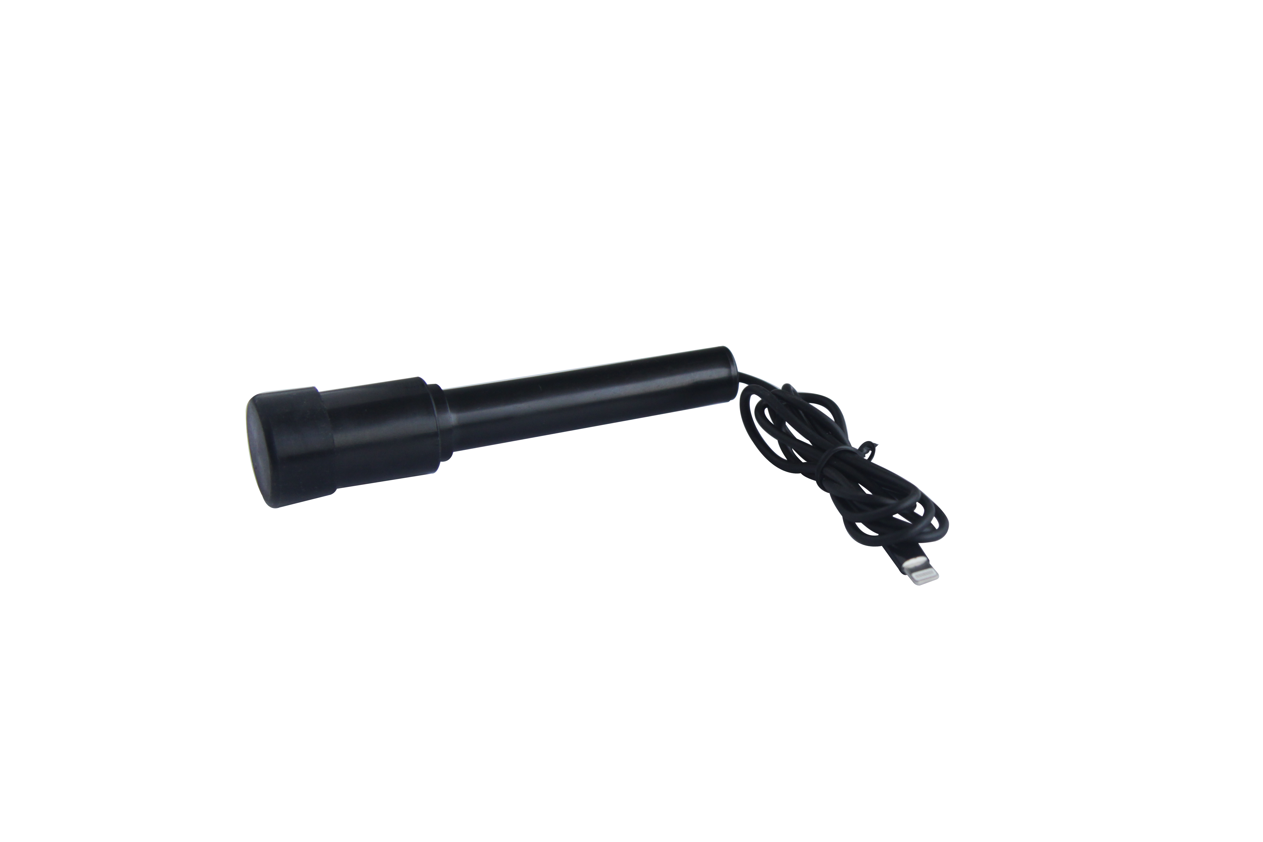
Usage
Connect O₃ Sensor to any port in SenseDisc.
Connect electrode to O₃ Sensor.
Place O₃ Sensor in the environment to be measured to collect data.
Typical experiment
Detect concentration of O₃ in water
Detect concentration of O₃ in air
Notes
The electrode is gas-permeable membrane electrode. Try not to break the membrane when assembling the device.
During using, wait until the reading becomes stable. Take out the electrode from solution and rinse it using distilled water. Dry it using filter paper and cover it.
Do not wipe the electrode using cleanser or gauze. It may damage the cover.
Take precautions when dealing with water or solution with O₃.

