# NH3 Sensor

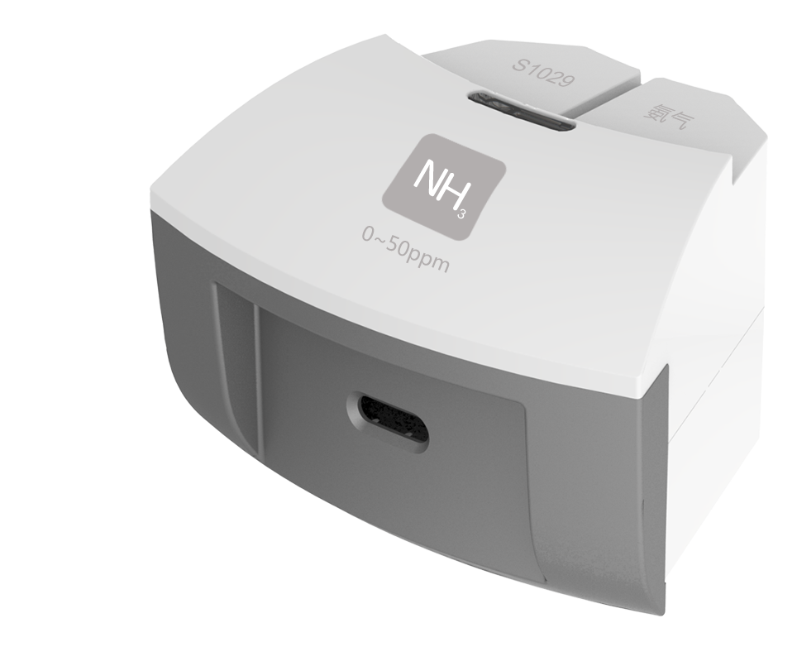

**S1029 NH3 Sensor**

Measuring range: 0 ~ 50ppm

Accuracy: ±1%F.S

Resolution: 0.1ppm

The working principle of NH3 Sensor is measuring concentration of gas by using electrochemistry. The probe consists of electrode and electrolyte. The electrolyte is separated by a selective gas-permeable membrane. The gas diffusing in sensor occurs redox reaction on the surface of electrode. Current is generated in the electrode. The value of current is corresponding to the concentration of gas. Sensor converts the signal in electrode into analog signal.

**Component**

|  |  |  |  |
| --- | --- | --- | --- |
| No. | Model | Name | Picture |
| 1 | S1029 | NH3 Sensor | C:\Users\Administrator\Desktop\圆盘传感器玥玥\S1029 氨气.pngS1029 氨气 |
| 2 |  | NH3 Sensor electrode | C:\Users\Administrator\Desktop\圆盘传感器玥玥\气体类探头.png气体类探头 |

**Usage**

Connect NH3 Sensor to any port in SenseDisc.

Expose NH3 Sensor electrode in the air with NH3 to collect data.

**Typical experiment**

Detect concentration of ammonia gas

**Notes**

The electrode is gas-permeable membrane electrode. Try not to break the membrane when assembling the device.

NH3 is poisonous. Be careful and take precautions during using.