H₂ Sensor
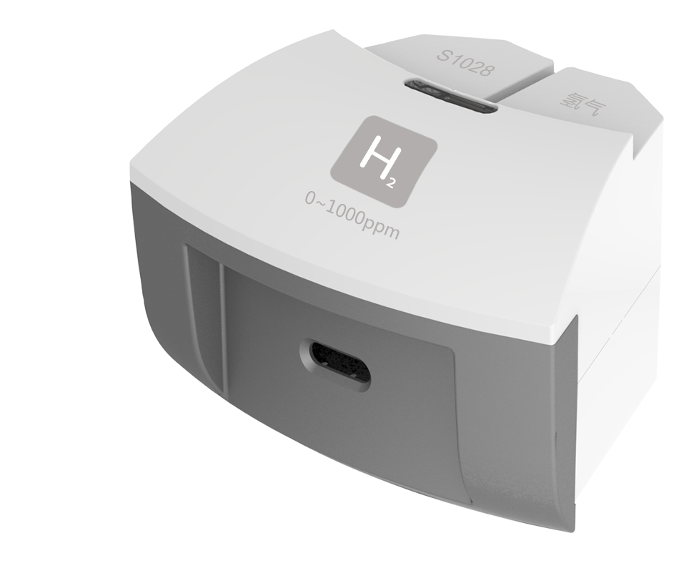
S1028 H₂ Sensor
Measuring range: 0 ~ 1000ppm
Accuracy: ±1%F.S
Resolution: 1ppm
H₂ Sensor is a kind of constant potential electrolytic type sensor. H₂ and O₂ produce charge and form current by redox reaction. The amplitude of current is direct proportional to concentration of hydrogen. We can determine the concentration of hydrogen is high or low by detecting current.
Component
No. | Model | Name | Picture
1 | S1028 | H₂ Sensor
 |  | H₂ Sensor electrode | 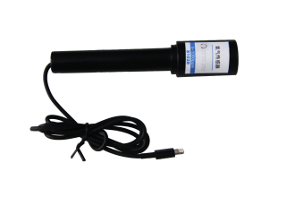
Usage
Connect H₂ Sensor to any port in SenseDisc.
Preheat the H₂ Sensor electrode for few minutes. Place it into the environment to be measured.
Typical experiment
Detect concentration of hydrogen produced by Kipp gas generator.
Notes
The H₂ Sensor electrode needs preheating to reach to working temperature.
Do not touch it to liquid or other organic matter. Use and preserve it in dry place. Otherwise, those matters could damage the electrode.
Hydrogen is kind of flammable and combustible gas. It can form explosive mixture with air and explode when it meets open fire or high temperature. Be careful during using.
Operation temperature range: -20～40℃. Preserve temperature: 5～20℃.

