Chlorine Gas Sensor
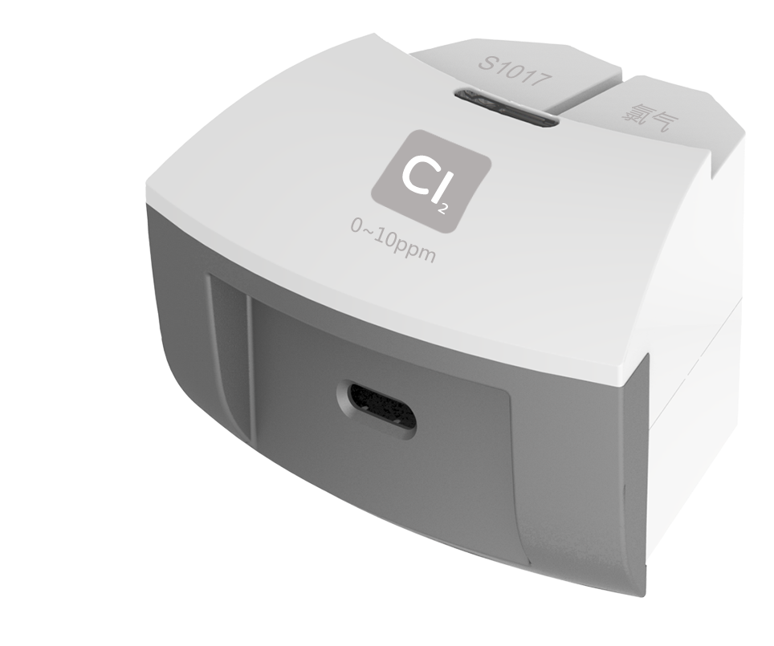
S1017 Chlorine Gas Sensor
Measuring range: 0 ~ 10ppm
Accuracy: ±1%F.S
Resolution: 0.1ppm
The working principle of Chlorine Gas Sensor is measuring concentration of chlorine by using electrochemistry. The probe consists of electrode and electrolyte. The electrolyte is separated by a selective gas-permeable membrane. The gas diffusing in sensor occurs redox reaction on the surface of electrode. Current is generated in the electrode. The value of current is corresponding to the concentration of chlorine gas. Sensor converts the signal in electrode into analog signal.
Component
No. | Model | Name | Picture
1 | S1017 | Chlorine Gas Sensor
2 |  | Chlorine Gas Sensor electrode
Usage
Connect Chlorine Gas Sensor to any port in SenseDisc.
Expose the Chlorine Gas Sensor electrode in the environment with chlorine to measure data.
Typical experiment
Generate chlorine gas by heating manganese dioxide and concentrated hydrochloric acid.
Notes
The electrode is gas-permeable membrane electrode. Try not to break the membrane when assembling the device.
Chlorine gas is poisonous. Be careful and take precautions during using.

