Alcohol Gas Sensor

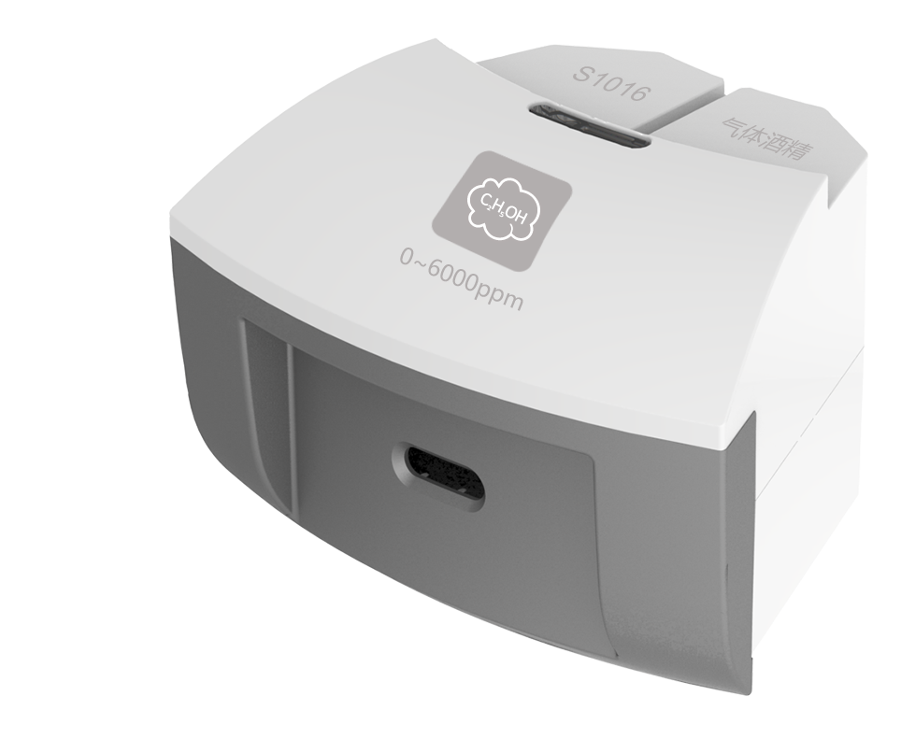
S1016 Alcohol Gas Sensor
Measuring range: 0 ~ 6000 ppm
Accuracy: ±3% F.S
Resolution: 1.5 ppm
The sensing component of Alcohol Gas Sensor is made of the metallic oxide semiconductor on the aluminum oxide plate. When there is alcohol gas exists in the environment, conductivity of sensor will be increasing with concentration of alcohol gas. The sensor converts changing of conductivity into concentration of alcohol gas.
Component
No. | Model | Name | Picture
1 | S1016 | Alcohol Gas Sensor
2 |  | Alcohol Gas Sensor electrode | 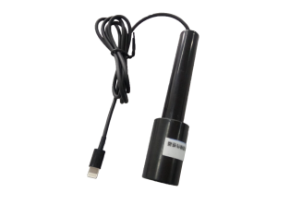
Usage
Connect Alcohol Gas Sensor to any port in SenseDisc.
Place the Alcohol Gas Sensor into the place with alcohol gas to measure.
Typical experiment
Detect the content of alcohol gas
Notes
Do not immerse the sensor into liquid alcohol. It will damage the probe.
Preheating is required. The initial value could be wrong.

