Infrared Thermometer
S0010 Infrared Thermometer
Measuring range: -70℃~380℃
Resolution: 0.1℃
Accuracy:
-70℃~0℃ ±8℃
0℃~60℃ ±5℃
60℃~120℃ ±8℃
120℃~180℃ ±10℃
180℃~240℃ ±12℃
240℃~380℃ ±14℃
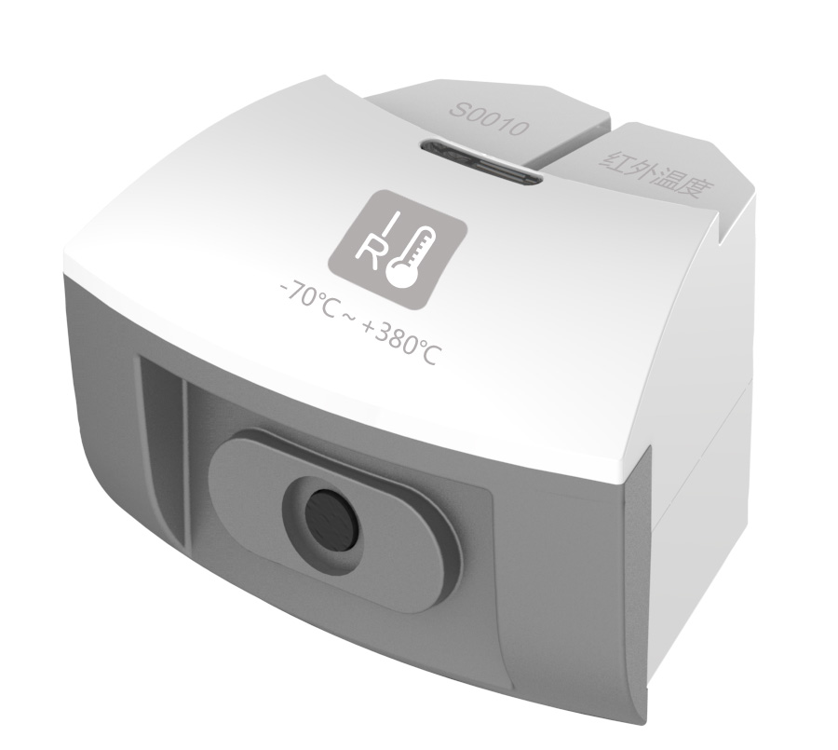
The working principle of Infrared Thermometer is non-touching temperature measurement via infrared radiation. Any object which temperature is higher than thermodynamic zero degree (-273℃) will radiate infrared ray to surrounding place. Higher the temperature of the object, more infrared energy it radiates. Temperature of Infrared Thermometer increases when it gets radiated so that sensor detects temperature changing via thermoelectric conversion.
Component
No. | Model | Name | Picture
1 | S0010 | Infrared Thermometer
2 |  | Infrared Thermometer probe | 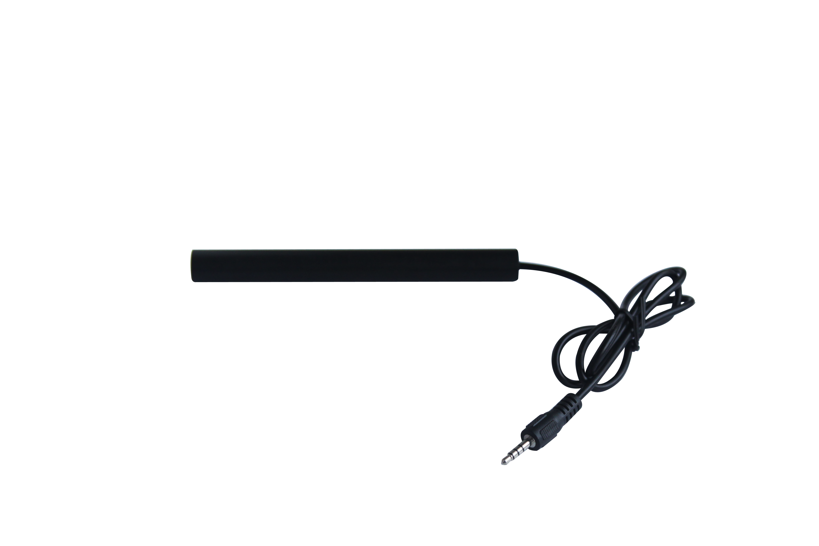
Usage
Connect Infrared Thermometer to any port in SenseDisc.
Insert Infrared Thermometer probe into Infrared Thermometer.
Aim the probe to the center of object to be measured.
Typical experiment
Measure infrared radiation effect of objects under different temperature or with different color.
Notes
Touching the object to be measured is not required when using Infrared Thermometer. Because the measuring principle is using infrared radiation of object with different temperature. Thus, use black object can minimize the measuring error. White object provides least effect.
During measuring, keep the probe still and aim it to the center of object to be measured. Place it near to the object as possible and read the data when it becomes stable.
Keep certain distance between Infrared Thermometer and object with high temperature. Do not measure it for long time.

