Instruction Manual for Ampere Force Demonstrator
Product No.：TP6014
- Description
Ampere force demonstrator consists of ampere force demonstrator I, ampere force demonstrator Ⅱ and high-precision micro force sensor. It is used to operate and demonstrate Ampere force. The product does not include power supply.
- Product Specification
No. | Name | Picture | Quantity | Remark
1 | Ampere force demonstrator Ⅰ | 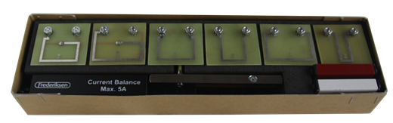 | 1 set | 6 wires with different length, 1 wireframe holder,1 magnet holder
2 | Ampere force demonstrator Ⅱ | 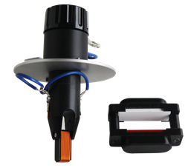 | 1 set | One rotatable coil and a magnet. Use with wireframe holder.
3 | High-precision micro force sensor |  | 1 set | Include sensor and holder
4 | Wires | 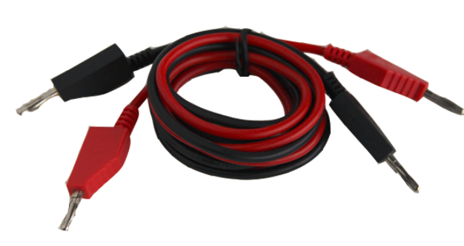 | 2 pieces | 1 black and 1 red
5 | Iron stand | 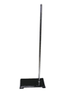 | 1 set | 600mm
6 | USB cable | 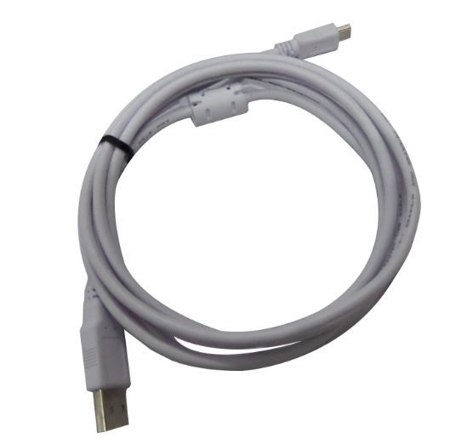 | 1 piece
Tab.1
- Product General Assembly Figure
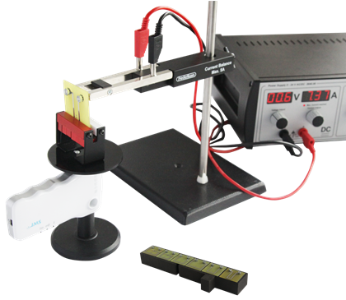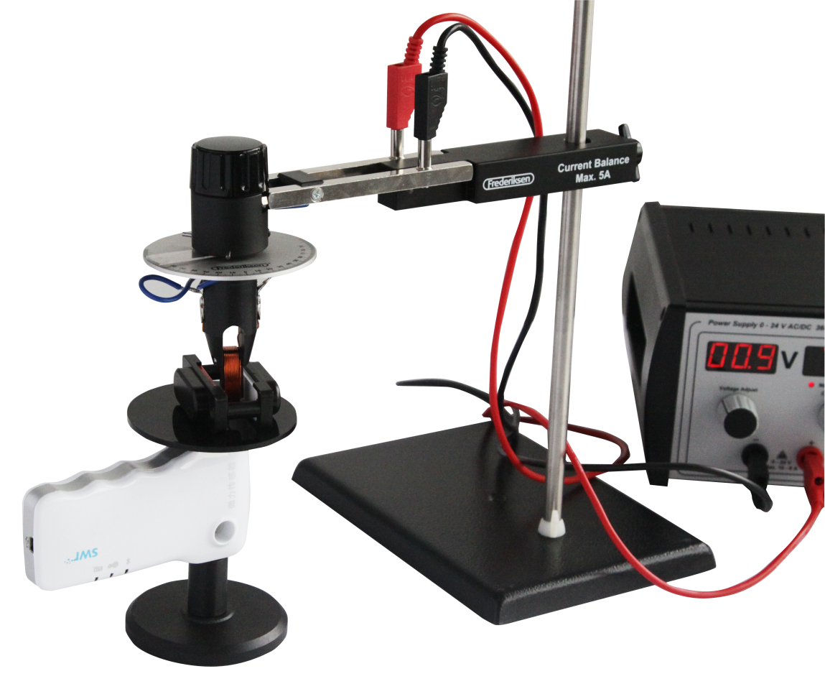
Fig.1 Fig. 2

- Product General Assembly Procedures
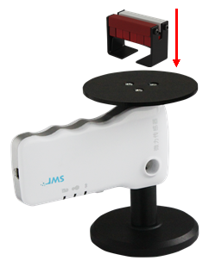
Fig.3
Screw the high-precision micro force sensor tightly on the holder and pallet. Place the magnet holder on the pallet as shown in Fig.3. It is used to explore the relationship between Ampere force and current, magnetic field and length.
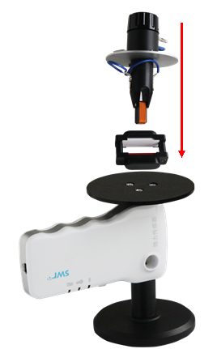
Fig.4
Screw the high-precision micro force sensor tightly on the bracket and pallet. Place the square magnet holder on the pallet as shown in Fig.4. It is used to explore the relationship between Ampere force and angel.
Turn on the student power supply and ampere force will act on the coil. The changing of Ampere force can be reflected through the reading variation of the high-precision micro force sensor.
- Notes
1. The student power source is required during the experiment and its voltage shouldn’t be too high.
2. Different coils can be used alternatively in the experiment.
- Maintenance
The device should be placed in a cardboard box if not in use. Use a damp cloth to wipe out the dust on the surface lightly. Avoid scratches caused by sharp articles on the surface.

