  Spirometer  ZC1012  Product specification: |   ZC1012 Spirometer is used to measure the amount of the air that is inbreathed, breathed out and the rate that air is expelled from the lung.    Data cable (USB interface)  Datalogger  Computer installed with SWR iLab v8.0 and above    1. Connect the sensor to computer by USB cable.  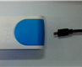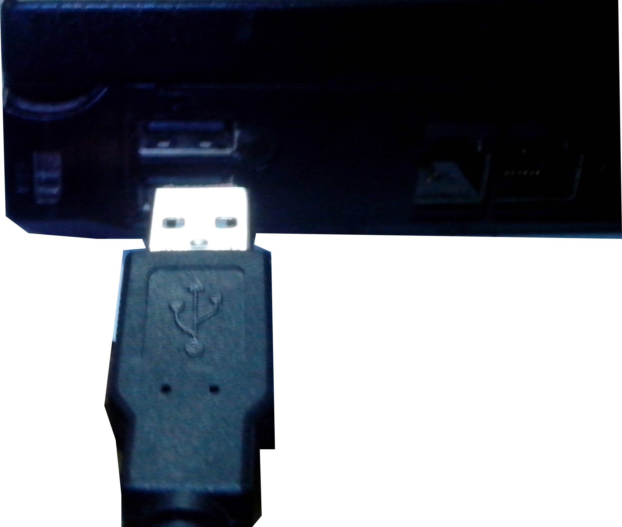  2. Open the SWR iLab v8.0.  3. Click  to create new experimental template.
  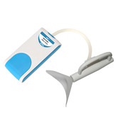
  Measuring range: | -315~315 L/min
  Resolution: | 0.01L/s
  Sensing component: | The sensing component is installed in the sensor.
  Usage:   | - Assemble the filter, airflow header and this sensor before using.  - Breath calmly in order to get used to the sensor when breath becomes stable. The gas exhaled from lung is positive airflow and the gas inhaled is the negative airflow.  - The Spirometer is only suitable for teaching. It can not be used for medicine or diagnosis.
Address: No.14 Junnong Road, Qinhuai District, Nanjing, China
Website: //www.sinoswr.com Post Code: 210007
Tel: +86-400-828-8387

  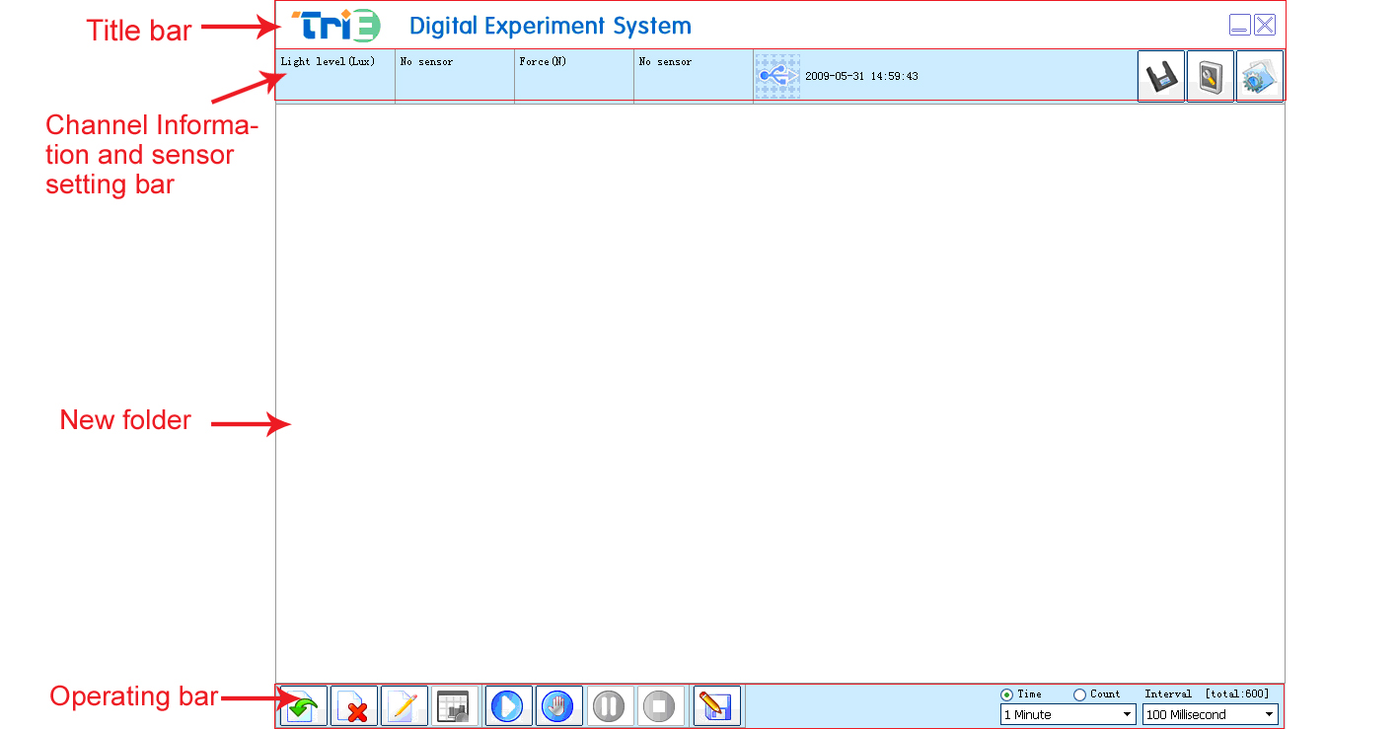 |   Measure the respiratory rate of human  Measure vital capacity    - Set up the experimental apparatus.  - Open the experiment software. Set the ‘Respiratory rate-Time’ coordinate. Set the collecting time to 5 minutes and acquisition interval to 100ms.  - Click the ‘Start’ button to collect data. Keep your mouth close to the blowtorch and blow hardly (do not exhale through nose).  - Click the ‘Stop’ button. The curve acquired is the airflow rate of the airflow that passes through the airflow header in corresponding time.  - Click the ‘Select’ button on the interface and select the curve that the expiration is acquired. Click the ‘Integration’ from the pull-down menu of the curve edit from ‘Analysis’. The shaded area in figure is the integral area. Value shown in the shaded area shows the vital capacity (as shown in Fig.1).  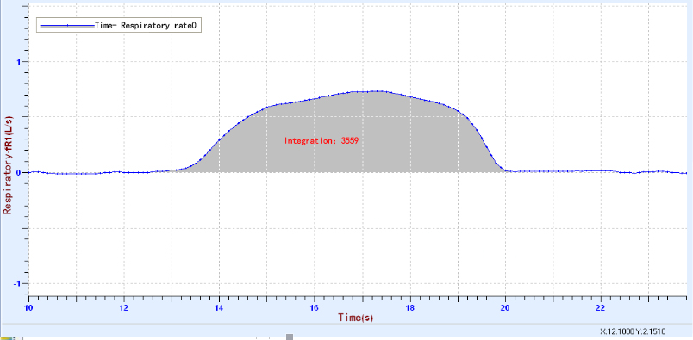
  Device status: | The icon shows blue. It means that the sensor has been recognized by the software.
  Rapid experiment: | Click thebutton. The system will automatically create the experimental template.
  Start: | Click the button. The system will start collecting data.
  Stop: | Click the button to stop data acquisition.
  Zone select: | Click the button to select the data area need to be analyzed.
  This sensor needs no calibration or demarcation. If the measuring value is not accurate, user can calibrate or reset it. The method is: Connect sensor to computer and open software. Click the calibration button to calibrate it.  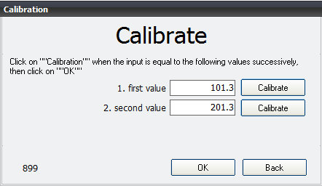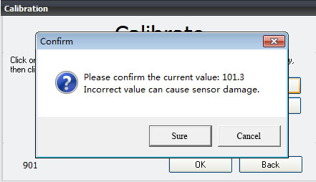  1. Click ‘Calibrate’ 2. Click ‘Sure’  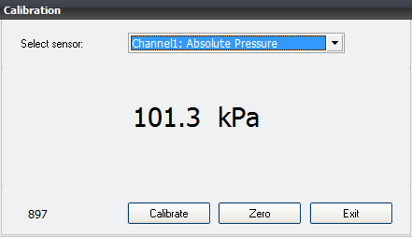  3. Click ‘OK’  Click ‘Exit’. |   1. Follow the local safety behavior policy when using this product. The instructor has responsibility to confirm the user has the medical history of respiratory or cardiovascular and cerebrovascular diseases.  2. The airflow header provided contains a filter, which can filter most of virus, fungus and bacteria.  3. Every student should only use their own airflow header to prevent cross-infection.  4. The fixed airflow header is not required to replace every time as long as the outlet is protected by the airflow header. If the fixed airflow header is used carelessly by someone, it should be replaced immediately.  5. When using the Spirometer, the tester should not be nervous. Teacher should make sure students under testing are healthy and has no medical history of the cardiovascular disease, or has no respiratory problems (such as asthma). The Spirometer may possibly make some testers feel uncomfortable when it is used. Calm testers as much as possible. If the tester feels really uncomfortable, stop experiment immediately.  6. Cleanliness: The outer casing can be cleaned by a soft and wet cloth and the cloth should be painted with the disinfectant at the standard medical level or the Milton hypochlorite solution (refer to the explanatory packaging on the bottle). Do not use alcohol. Otherwise it may break the plastic.  7. In any cases, do not immerse the Spirometer or other airflow header into any cleaning solution. Do not disinfect or sterilize it with hot water, steam or hot air.

