  Humidity Sensor  ZC1008  Product specification: |   ZC1008 Humidity Sensor is used to detect relative humidity of air.    Data cable (USB interface)  Datalogger  Computer installed with SWR iLab v8.0 and above.    1. Connect the sensor to computer using USB cable.  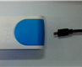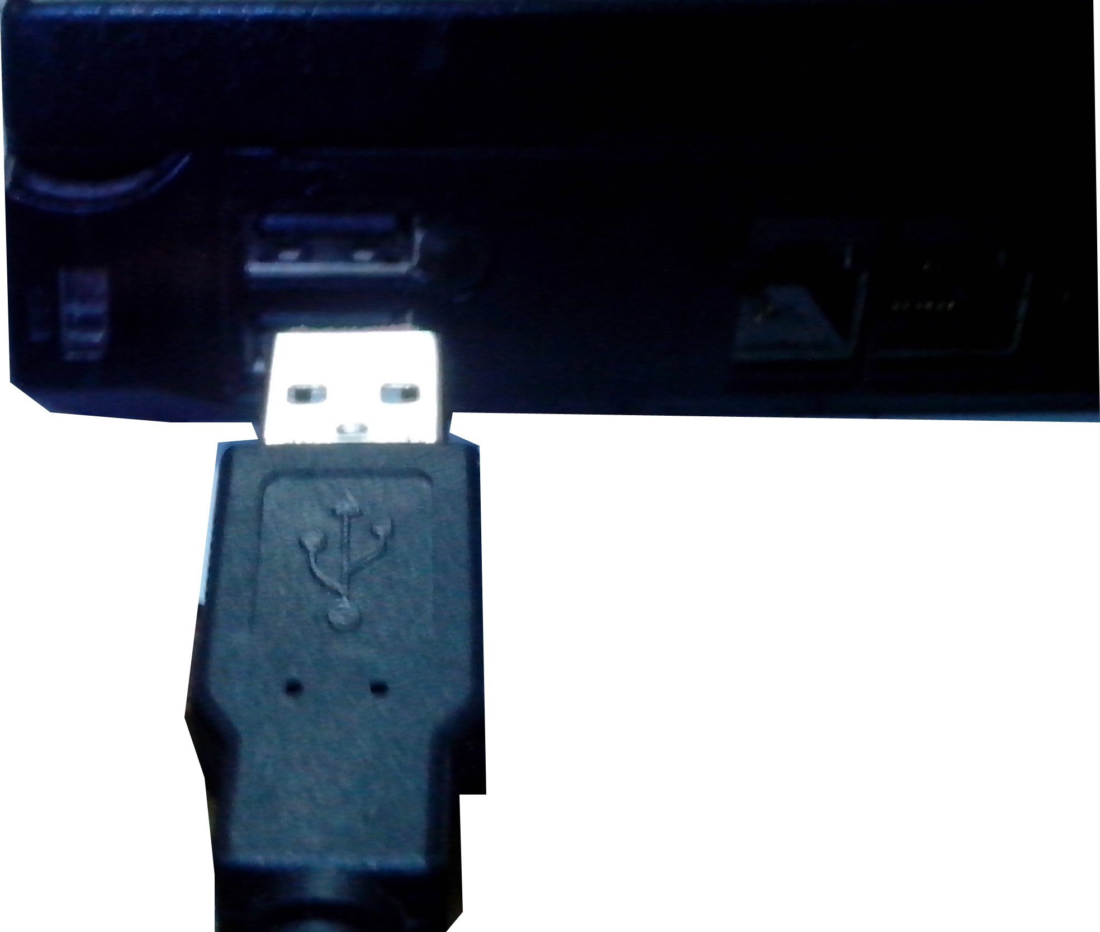  2. Open the SWR iLab v8.0.  3. Click  to create new experimental template.
  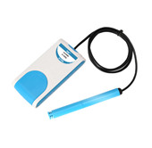
  Measuring rang: | 0%~100%RH
  Resolution: | 0.02%RH
  Accuracy: | ±2%
  Sensing component: | The sensing component is installed in the front of probe.
  Usage:   | - The sensor can be used once it is connected to related devices.  - The Humidity Sensor can not be immersed into liquid.  - Its sensitivity is high when it gets placed in flowing air.  - If the environment under the measurement is very dirty or unclean, it should be covered by nylon cloth to avoid pollution.  - Do not expose the sensor in chemical air (such as acetone, organic solvent or chlorine), otherwise the sensor will be damaged.
Address: No.14 Junnong Road, Qinhuai District, Nanjing, China
Website: //www.sinoswr.com Post Code: 210007
Tel: +86-400-828-8387

  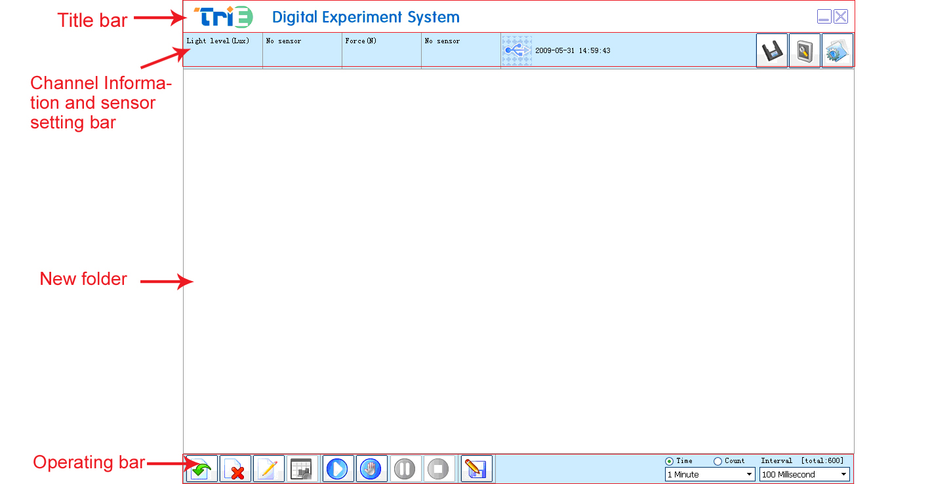 |   Measure the change of environmental humidity  Hydroscopicity of the concentrated sulfuric acid  Design and make the vivarium and observe its stability    - Connect the sensor to datalogger and computer. Set up the experimental apparatus.  - Open SWR iLab v8.0 and set the ‘Humidity-Time’ coordinate.  - Cover the holed rubber plug onto the probe of the Humidity Sensor and then seal it with vaseline. Put it into a large test tube.  - Click the ‘Start’ button to measure the humidity in test tube. Click ‘Stop’ button after the experiment.  - Select curve operating in curve manager on the right side. Select ‘curve duplication’ function and pour appropriate amount of the concentrated sulfuric acid into the large test tube. Put on the bottle plug and click the ‘Start’ button.  - Click ‘Stop’ button and analyze the curve after data acquisition.  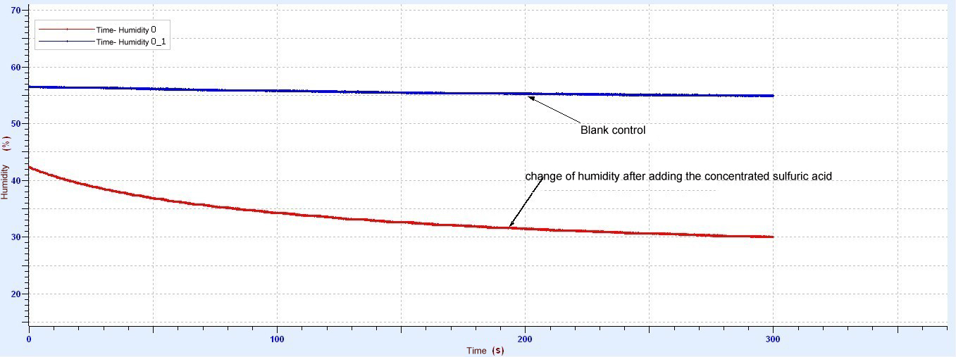  1
  Device status: | The icon shows blue. It means that the sensor has been recognized by the software.
  Rapid experiment: | Click thebutton. The system will automatically create the experimental template.
  Start: | Click the button. The system will start collecting data.
  Stop: | Click the button to stop data acquisition.
  Zone select: | Click the button to select the data area need to be analyzed.
  This sensor needs no calibration or demarcation. |   - The total air circulation impacts significantly on the response time of sensor. The response time of sensor is directly proportional to air moving speed. Under a certain humidity, if the probe of sensor is condensate with water drop, it will not offer accurate reading when measuring lower humidity before vaporizing. In order to quicken the vaporization of water drop, you can swing the sensor or use fan.  - The internal circuit of sensor is not completely isolated from external air. If the steam in the environment under measurement is possible to condensate (high humidity), you must prevent liquid flowing into circuit.  - The total air circulation impacts hugely on the response time of Humidity Sensor, i.e., its response speed in flowing air will be quicken accordingly.  - If the environment under the measurement is very dirty or unclean, it should be covered by nylon cloth to avoid pollution.  - The Humidity Sensor is insensitive to light.

