  CO₂ Sensor  ZC1007  Product specification: |   ZC1007 CO₂ Sensor is an infrared gas absorbing detecting sensor. It can detect the CO₂ content in real time.    Data cable  Computer installed with SWR iLab v8.0 and above.    1. Connect the computer to computer by USB cable.  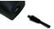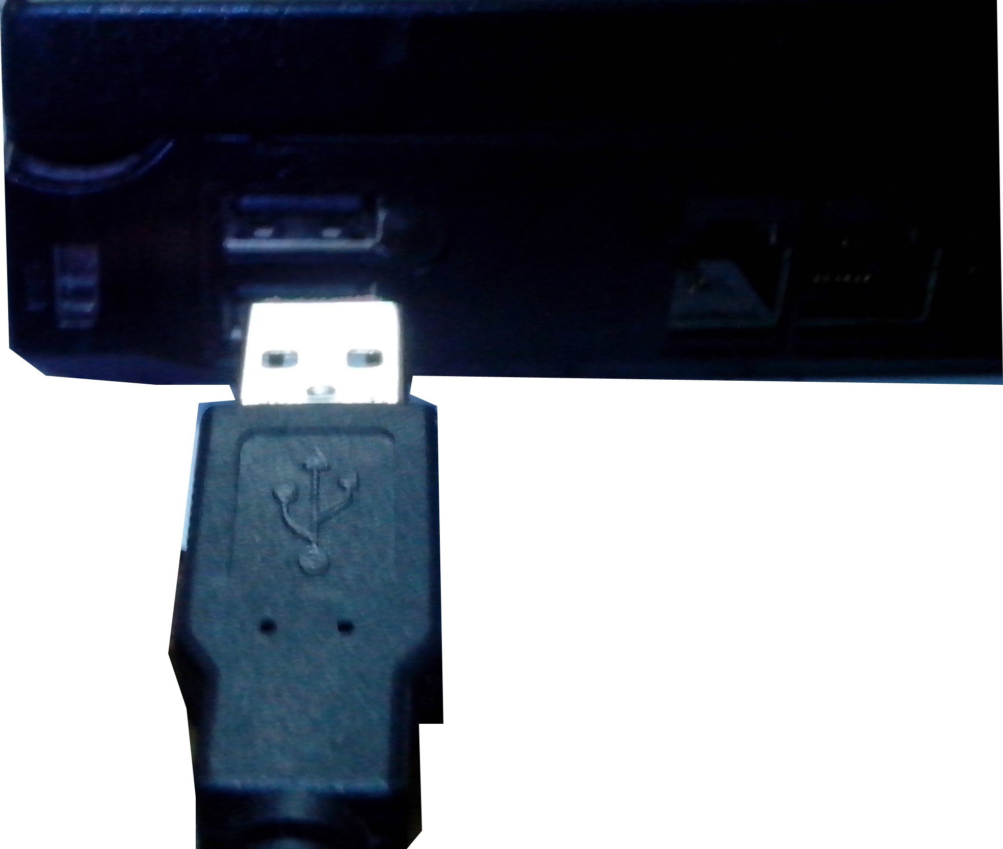  2. Open the SWR iLab v8.0.  3. Click  to create new experiment template.
  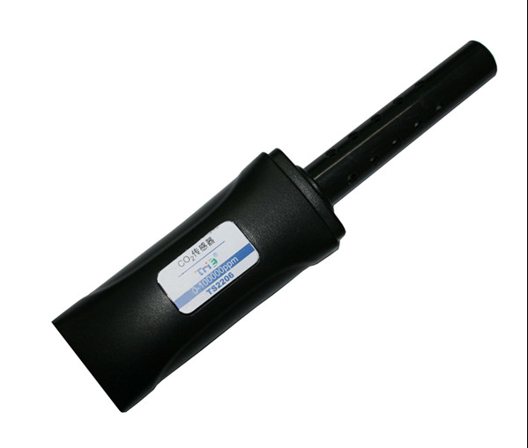
  Measuring range: | 0~100000ppm
  Resolution: | ≤ 10ppm
  Accuracy: | ≤ ±8000ppm
  Response time: | 2s
  Sensing component: | The measuring component is the vents on the wall of probe tube.
  Usage:   | - CO₂ Sensor can be used once connected to related device and software opened.  - It has good selectivity, high sensitivity, no oxygen dependence, long service life, low power consumption without preheating by comparing with the chemical sensor.  - The gas diffusion is a slow process. Therefore the reading will be delay.
Address: No.14 Junnong Road, Qinhuai District, Nanjing, China
Website: //www.sinoswr.com Post Code: 210007
Tel: +86-400-828-8387

  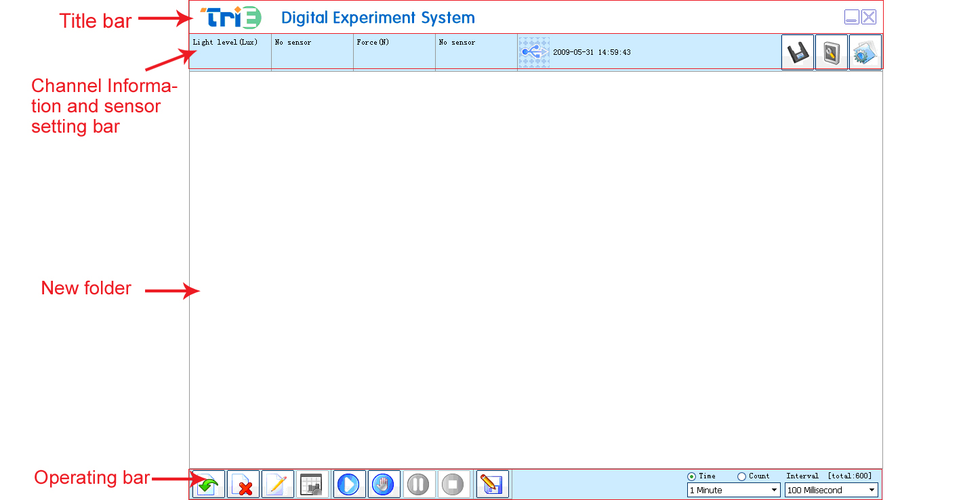 |   Plant's photosynthesis  Explore breathing regulation of saccharomycetes  Assessment of air quality  Generation velocity of CO₂ gas in chemical reaction  Compare gas exhaled by human with the environmental gas    - Set up experimental apparatus.  - Open SWR iLab v8.0. Set ‘CO₂-Time’ and ‘Oxygen-Time’ coordinate.  - Click the ‘Start’ button. Place oxygen and CO₂ Sensor’s probe at the outlet of airflow head respectively. Exhale air and then observe the change of the content of oxygen and CO₂ acquired by the software.  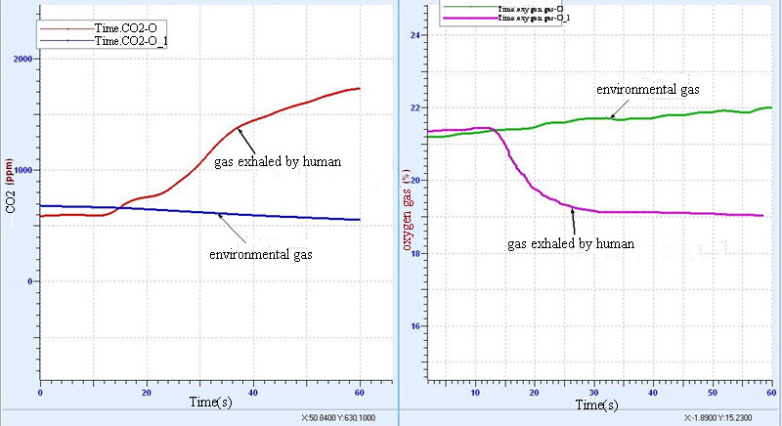
  Device status: | The icon shows blue. It means that the sensor has been recognized by the software.
  Rapid experiment: | Click thebutton. The system will automatically create the experimental template.
  Start: | Click the button. The system will start collecting data.
  Stop: | Click the button to stop data acquisition.
  Zone select: | Click the button to select the data area need to be analyzed.
  Due to long-term continuously use, the CO₂ Sensor’s measuring value may have deviation. You can calibrate it when obvious error occurs.  The calibration method is:  Calibrate it when the sensor is placed in clean air (Sunshine is good with free flow air outdoor. The CO₂ value is commonly between 350 to 450 ppm). When output concentration is stable, its value has great difference with actual concentration (such as: customer thinks the actual concentration is about 400 ppm, but the measuring value is 1000 ppm). Manual calibration function is to calibrate the measuring value to the program default value 400 ppm. The calibration method is: the output concentration of the testing sensor in the clean air is stable (wait for about 5 minutes). Use pinpoint hold against the sensor reset button for 5 seconds. Generally, reset is not required.  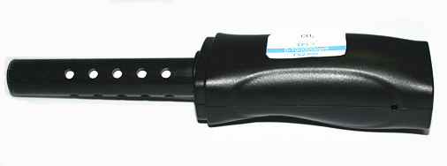  Reset button |   1.Calibrate the sensor periodically which should not be greater than 3 month.  2.Impact due to temperature and humidity to the sensor is very small. It can be used properly under condition where relative humidity is 95%.  3.Try not to impact testing result by exhaled CO₂.  4.If liquid flows into the probe, it will destroy the sensor completely. Try not to use the sensor under condition which is full of dust.  5. CO₂ is heavier than air so that it will sink to bottom of bottle. Use container as small as possible when doing experiment because it will be easier to collect CO₂.  6. Reserve the probe in a place without CO₂ due to the working principle of probe. When it is placed inside room, it can be stored by 2 years.  7.The carbon dioxide sensor is an infrared gas absorption detector named infrared carbon dioxide sensor. It has good selectivity, high sensitivity, no oxygen dependence, long life, low power consumption without preheating by comparing with the chemical sensor.  Additional remarks for the sensor resolution:  Additional remarks for the sensor accuracy:
  Measuring range | Resolution
  0～2000ppm | 1ppm
  0～5000ppm | 1ppm
  0～8000ppm | 1ppm
  0～1%VOL | 1ppm
  0～5%VOL | 10ppm
  0～10%VOL | 10ppm
  Measuring range | Accuracy
  0～1000ppm | ±60ppm
  0～1500ppm | ±95ppm
  0～2000ppm | ±125ppm
  0～3000ppm | ±175ppm
  0～5000ppm | ±280ppm
  0～50000ppm | ±3000ppm
  0～100000ppm | ±8000ppm

