  DO/O₂ Sensor  ZC1005  Product specification: |   ZC1005 DO/O₂ Sensor can be used to measure concentration of O₂ in air and solution.    Data cable (USB interface)  Computer installed with SWR iLab v8.0 and above    1. Connect the DO/O₂ Sensor to computer by USB cable.  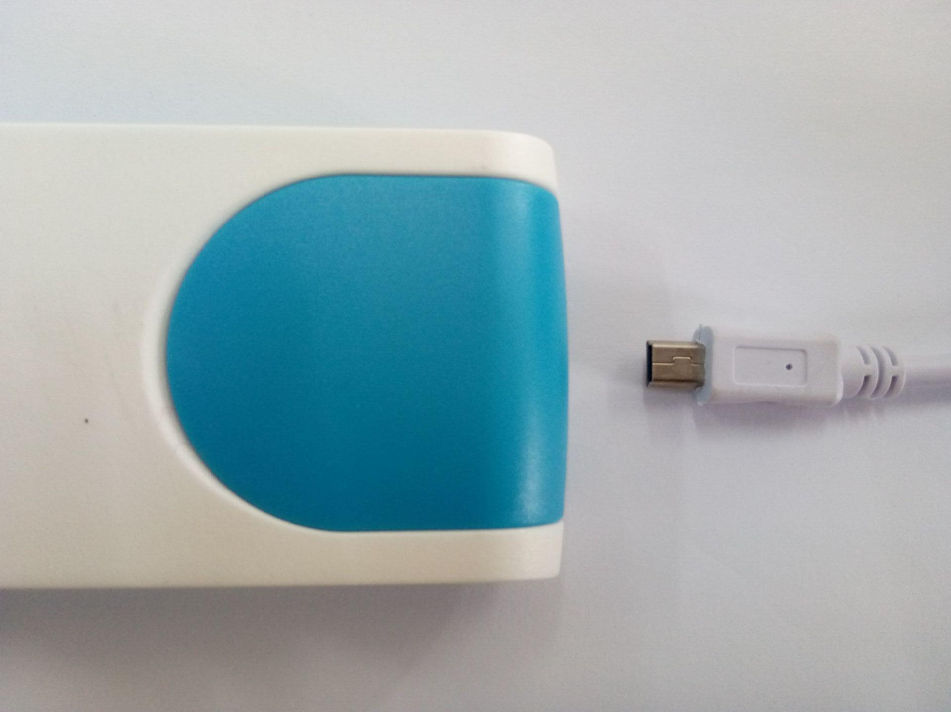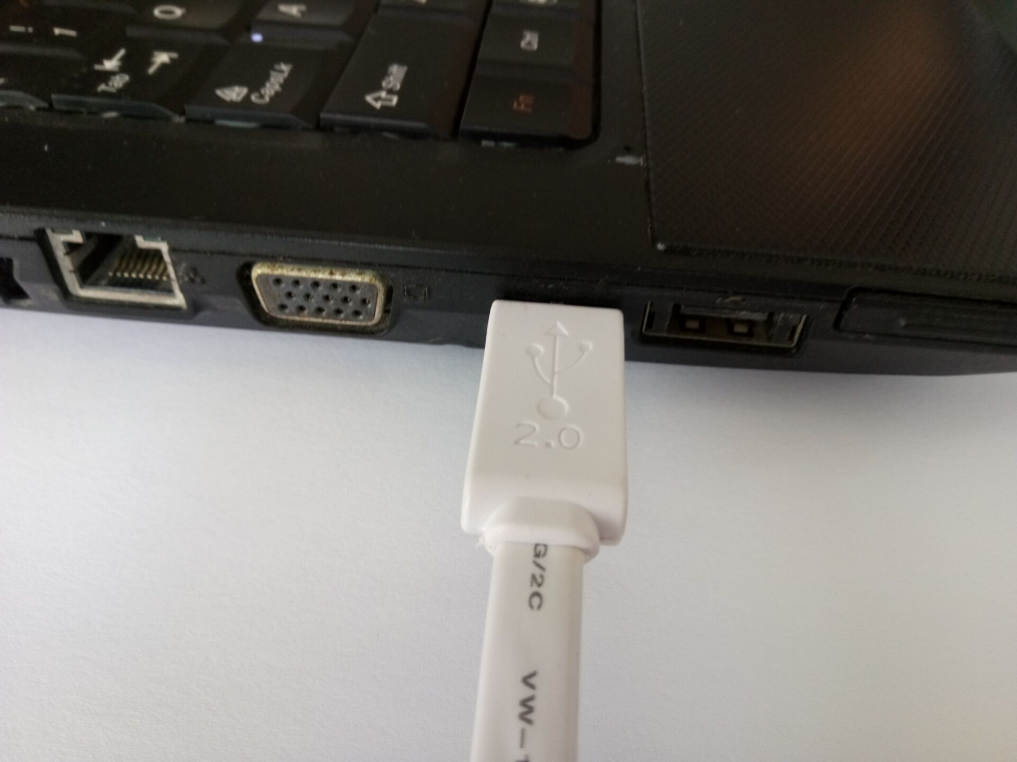  - Open the SWR iLab V8.0 software.  - Click the  to create new experimental template.
  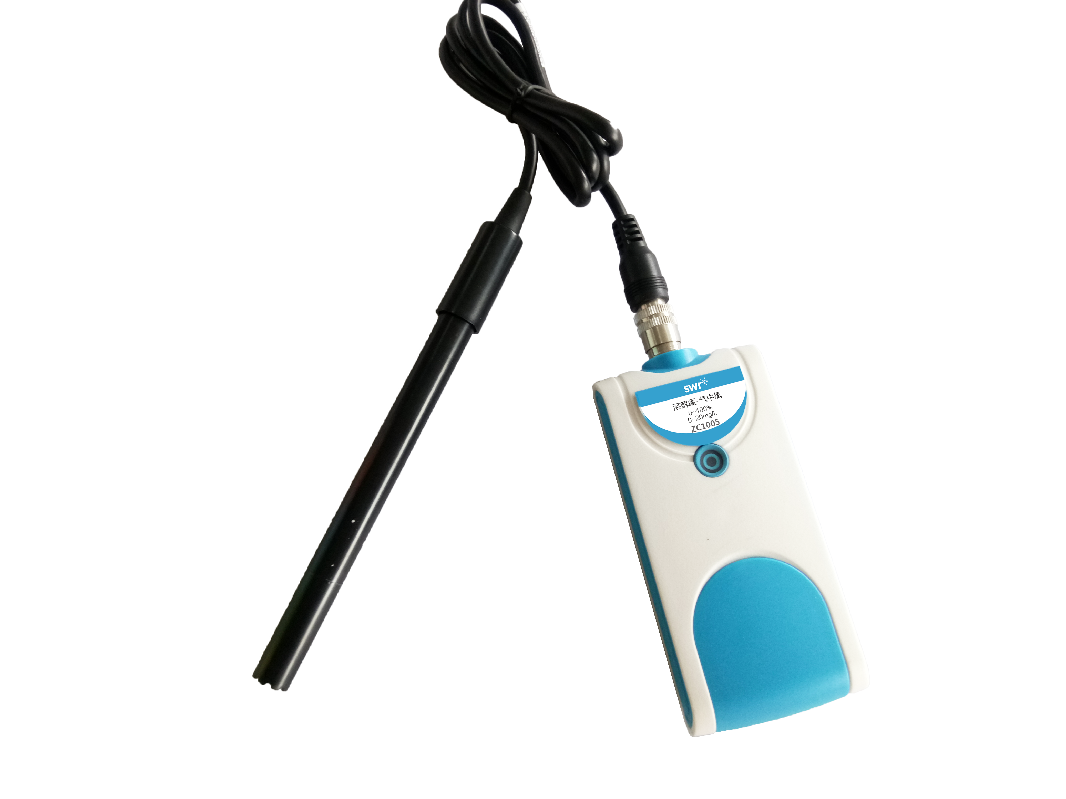
  Measuring range: | 0~20mg/L；0~100％
  Resolution: | 0.01mg/L；0.1%
  Accuracy: | ±0.5mg/L
  Usage:   | 1. According to the measuring requirement, calibrate the O₂ Sensor or demarcate DO Sensor before using.  2. Rinse the electrode using distilled water and clean it using tissue.  3. DO/O₂ Sensor is high stable electrode. Do not use sharp object to touch it in case gas-permeable membrane gets broken.
Address: No.14 Junnong Road, Qinhuai District, Nanjing, China
Website: //www.sinoswr.com Post Code: 210007
Tel: +86-400-828-8387

  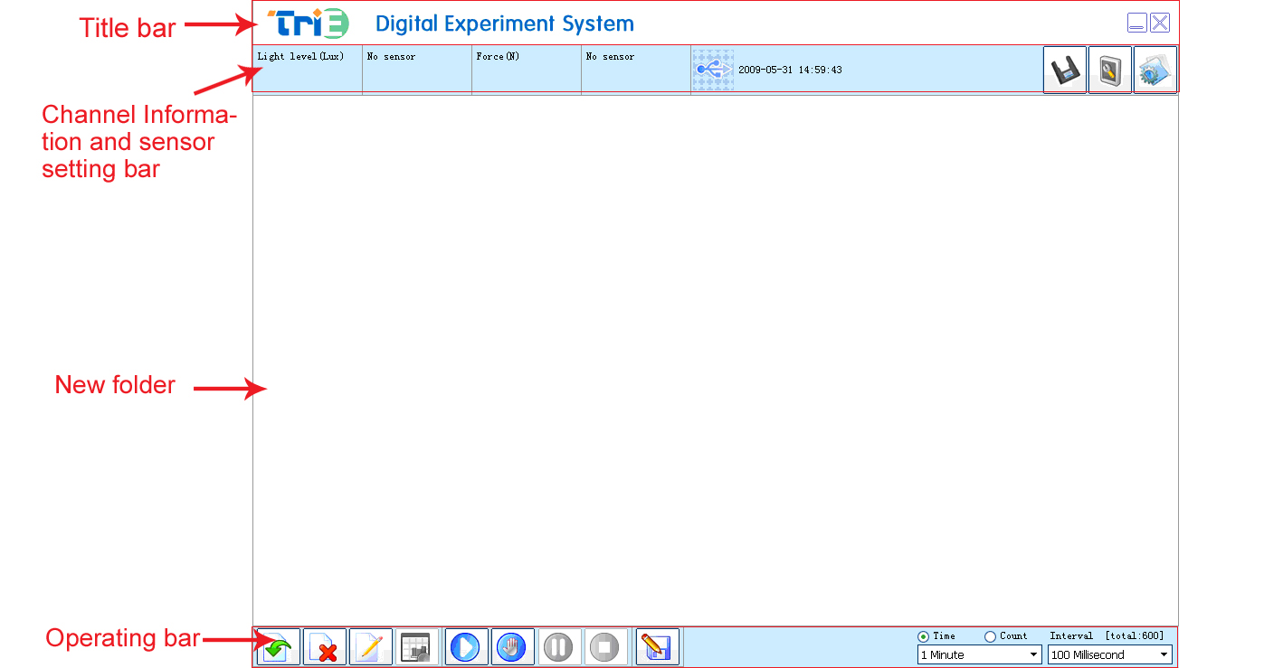 |   1. Explore breathing regulation of saccharomycetes  2. Compare the decomposition of peroxide under different condition.  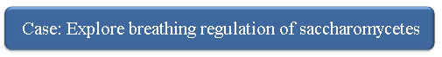  Refer to ‘Instruction Manual for Explore Breathing Regulation of Accharomycetes’ to set up the apparatus.  - Click ‘Rapid experiment’ and create ‘DO-Time’ coordinate. Set collecting time 30min and acquisition interval 500ms.  - Add 7.5g active dry yeast and 150ml glucose fermentation liquor in conical flask. Place in some magneton and the rubber stopper which inserted by DO/O₂ Sensor probe on the conical flask. Adjust it until the probe is just immerse in the solution and it will not affect the rotation of mageton. Place the conical flask on magnetic stirring apparatus to stir at uniform speed.  3. Click  to start collecting. Observe the data change until the experiment stops or click  to stop. Analyze the result.  The experimental result is shown below:  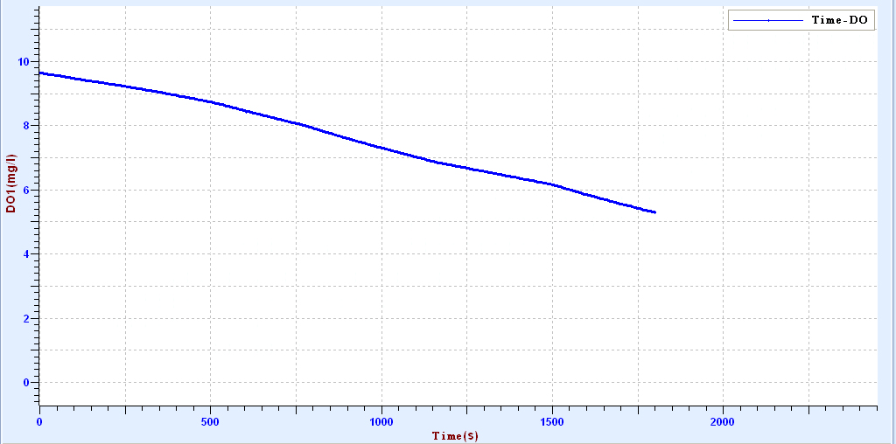
  Device status: | The icon shows blue, it means that the sensor has been recognized by the software.
  Rapid experiment: | Click the button , system will create a new experimental template automatically.
  Start: | Click the  button, the system will start the data acquisition.
  Stop: | Click the button to stop data acquisition.
  Calibration of O₂ Sensor:  1. Open SWR iLab. Enter into the calibration interface. Select O₂ Sensor (as shown in the figure below):  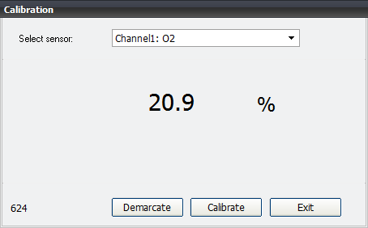  2. Place the probe into air which has known oxygen concentration (normally 20.9%). Insert corresponding value after a while when the reading becomes stable. Click ‘Calibrate’ and ‘OK’. Click ‘Exit’ when it is completed.  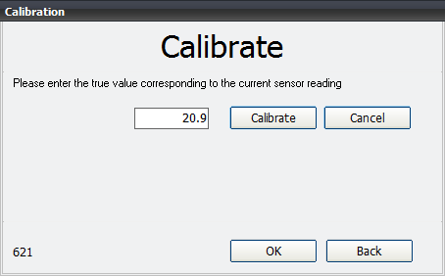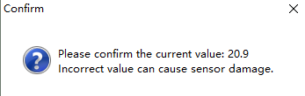  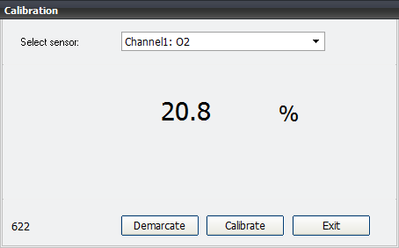  Demarcation of DO Sensor  1. Open SWR iLab. Enter into the calibration interface. Select DO Sensor (as shown in the figure below):  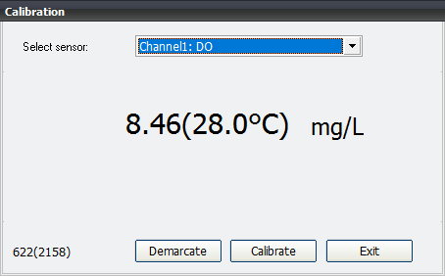  2. Click ‘Demarcate’ to enter demarcation interface.  Immerse DO Sensor probe into anaerobic water. Click ‘Demarcate’ behind ‘first value’ after a while. Place the probe in air. Click ‘Demarcate’ behind ‘second value’ after a while. Click ‘OK’ to get back to demarcation interface.  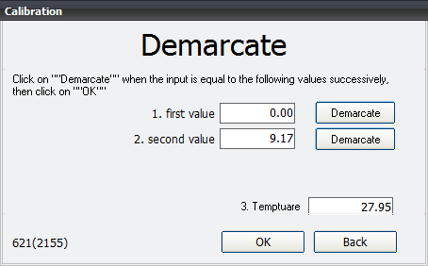  3. Click ‘Exit’ to end demarcation.  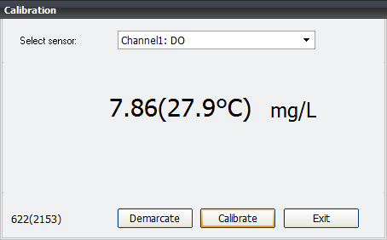  Configuration of anaerobic water:  Configure 250ml Na₂SO₃ whose concentration is 5%. if the solution is 100g, you  can weigh 5g Na₂SO₃. take 95ml water (95g). Dissolve in beaker. You can also  add CoCl₂ as catalyst. |   - The gas-permeable membrane and electrode are getting aging very easily.  When there are alga, sulfide, carbonate and oils in the liquid, the gas-permeable membrane will be jam and broken. Protect it and replace it in time during using.  2. Do not stop stirring the solution during measuring. Normally the speed should be more than 0.2-0.3m/s. The electrolyte should be changed periodically.  3. Do not touch the probe to oil or other organic matter.

