  PH Sensor  ZC1002  Product specification: |   ZC1002 PH Sensor is used to measure the hydrogen ion concentration of a solution and display the pH value of the solution.    Data cable (USB interface)  Datalogger  Computer installed with SWR iLab v8 and above.    - Connect the PH Sensor to computer by USB cable.  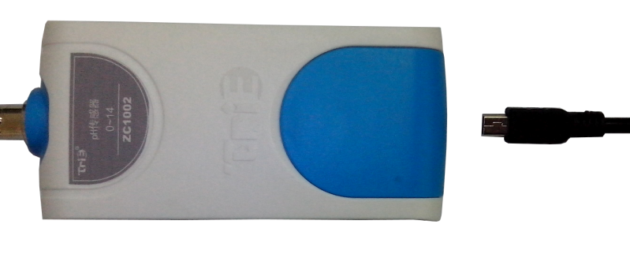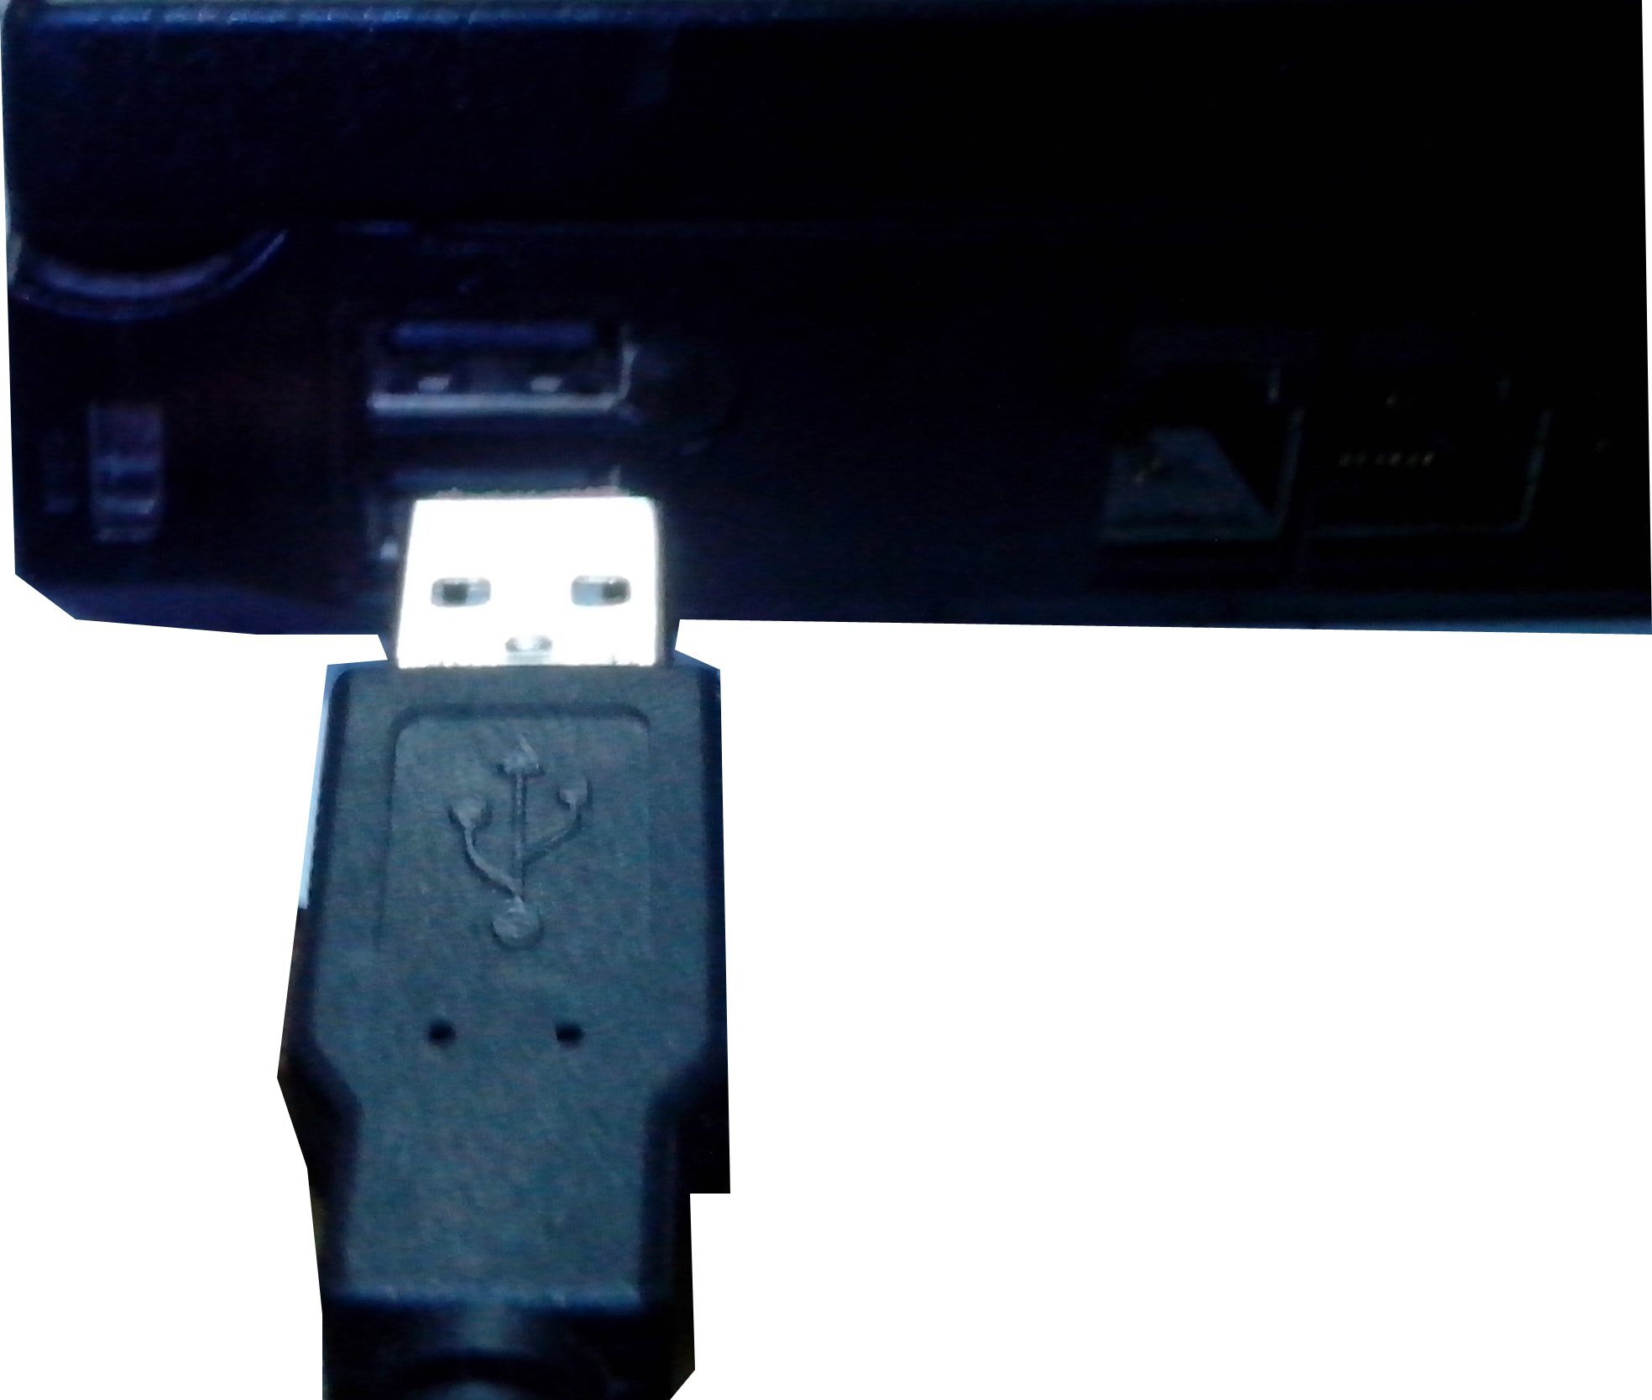  - Open the SWR iLab V8.0.  3. Click  to create new experimental template.
  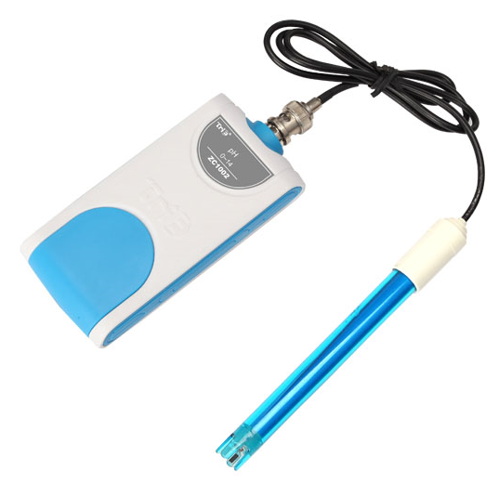
  Measuring range: | 0~14
  Resolution: | 0.01
  Accuracy: | ±1%
  Response time: | ≤2s (25℃)
  Sensing component: | The sensing component is the glass head in the front of probe.
  Usage:   | - Unscrew the pH electrode from protective bottle before using. Connect the electrode to PH Sensor.  - The electrode should be cleaned up by using deionized water or distilled water. Its surface should be dried by using tissue. Do not wipe its glass head.  - Before measuring, it is required to demarcate the pH electrode and clean the probe.  - Screw the pH electrode into the protective bottle carefully after measuring.
Address: No.14 Junnong Road, Qinhuai District, Nanjing, China
Website: //www.sinoswr.com Post Code: 210007
Tel: +86-400-828-8387

  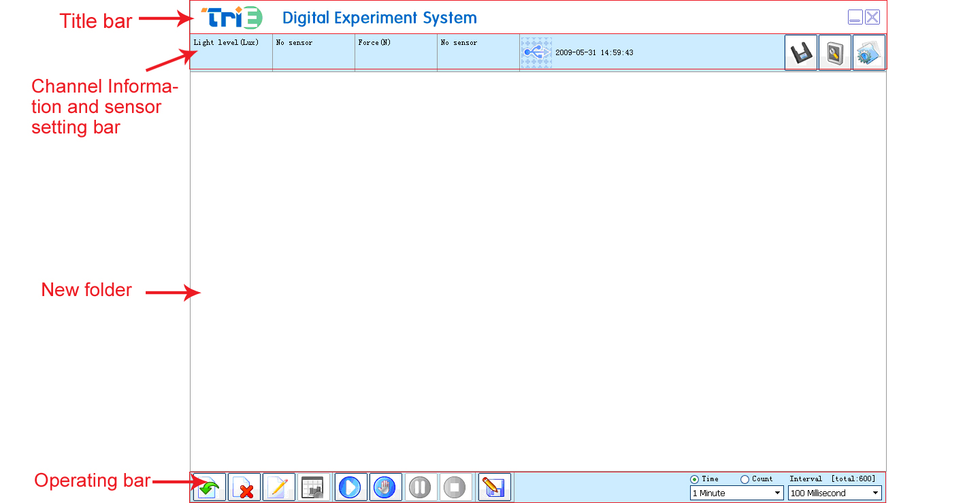 |   Acid-base neutralization drop  pH value of different brine solution  Acidity of phenol  Mechanism of organism maintaining pH stability  Explore impact of pH value on pectinase activity    1. Refer to the Instruction Manual for Titration Experiment Equipment for Acid-base Neutralization. Set up the experimental apparatus.  2. Open SWR iLab v8.0 and create pH-volume coordinate.  - Open syringe control valve to let the solution drop at an appropriate speed. Click ‘Start’ button.  - After titration, close control valve and stop the experiment.  - Calculate the derivation for the curve and select the cross-reference line. Find titration endpoint from catastrophe point. Read the volume V1 of the acid solution consumed when the liquid gets completely neutralized. Calculate the concentration of sodium hydroxide (c2) based using formula c1*v1=c2*v2.  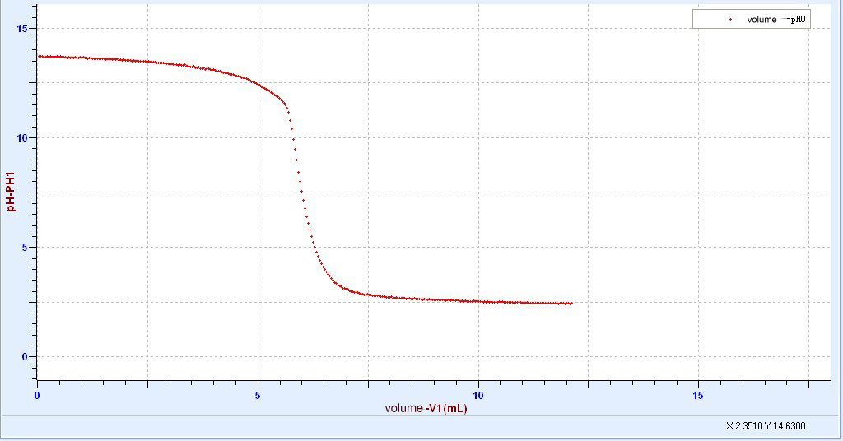  1  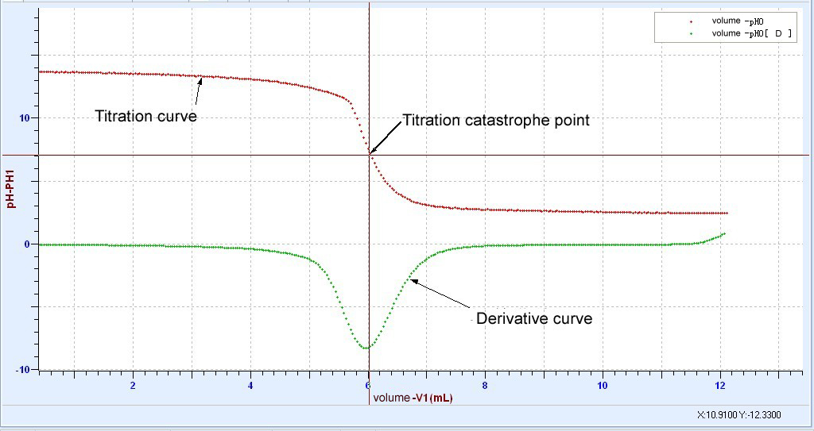  2
  Device status: | The icon shows blue. It means that the sensor has been recognized by the software.
  Rapid  experiment: | Click thebutton. The system will create the experimental template.
  Start: | Click the button. The system will start collecting data.
  Stop: | Click the button to stop data acquisition.
  Zone select: | Click the button to select the data area need to be analyzed.
  Before measuring, it is required to demarcate the pH electrode. When demarcating, the standard buffer solution with the pH value similar to that of the target solution should be used. The pH buffer solution can be prepared by buying buffer solution reagent from the chemical reagent shops or by referring to the standard preparation method. For the details to demarcate the PH Sensor via software, refer to software operating instruction:  - Clean the electrode by using deionized water or distilled water. Rinse the electrode using standard pH 4.00, pH 6.86 or pH 7.00 solution. Immerse it into the standard pH 4.00, pH 6.86 or pH 7.00 solution. Open the software and select the demarcation interface. Select channel to display the pH value. Click the ‘Demarcate’ button. Enter corresponding pH value at the L-Value box and click ‘Demarcate’ button. See the Figure as follows, input ‘4.00’.  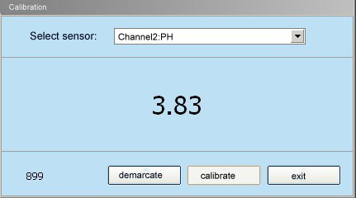  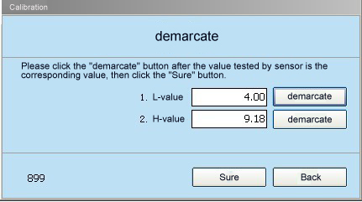  - Take the electrode out and rinse it using deionized water or distilled water. Use the other kind of standard solution to rinse it. Immerse the electrode into the solution. Enter corresponding pH value at H-Valve box, as shown in the Figure above. Input is ‘9.18’. Click the ‘Sure’ button.  - Take the electrode out and rinse it using deionized water or distilled water. Use the testing solution to rinse it and it will be ready to measure the testing solution. |   - Rinse the electrode before every measuring. Do not wipe its glass ball using tissue. Otherwise it may cause damage to the electrode. It is better to clean the electrode using the testing solution.  - Range of measuring temperature: 0~80℃.  - Keep the glass ball of the pH electrode wet in order to maintain the ion exchange process. It is required to preserve the glass ball in the KCI solution. Check the KCI solution’s volume periodically. If the electrode dries, immerse it into the KCI solution for 2 hours to make it wet.  - Protect the glass ball of the pH electrode. Do not knock, collide or rub it. Otherwise it may cause damage to the electrode.  - Keep electrode clean and dry when connecting and unplugging it. If not, it may lead to its insulation failure and make the result not accurate or make the experiment unsuccessful.  - We have found that the conductivity sensor has mild interference to this product. Using other devices with it will not cause this problem .  - The pH electrode has the limited service life, which mainly depends on its protection and testing solution. Do not store and preserve the electrode in the distilled water or the deionized water. Otherwise it may cause the saturated solution on the electrode to move. Never use the pH electrode in the extreme acid-based or alkaline-based solution or at the extreme temperature.  - Do not use the pH electrode in the absolute ethyl alcohol, concentrated sulphuric acid and other dehydration media since they may damage the hydration gel layer on the glass membrane surface. The pH electrode can not either be immersed in the neutral or the alkaline buffer solution. Long-term immersion in such solution may cause the pH glass membrane insensitive to respond.  - This product can automatically compensate temperature. User does not need to make temperature compensation.

