  ZC0025 Relative Pressure Sensor  Specification： |   ZC0025 Relative Pressure Sensor mainly works by measuring relative pressure changes. There’s a membrane in the sensor that can bend as pressure changes. The membrane’s two sides are connected with two input tubes respectively. When the two input pressure change, membrane’s two sides’ pressure will change accordingly. The output voltage generated by the sensor is in linear relation with the two relative pressure’s change.    - USB cable  - A computer installed with a digitized experiment software.    1.With USB cable, connect a relative pressure sensor with a computer.  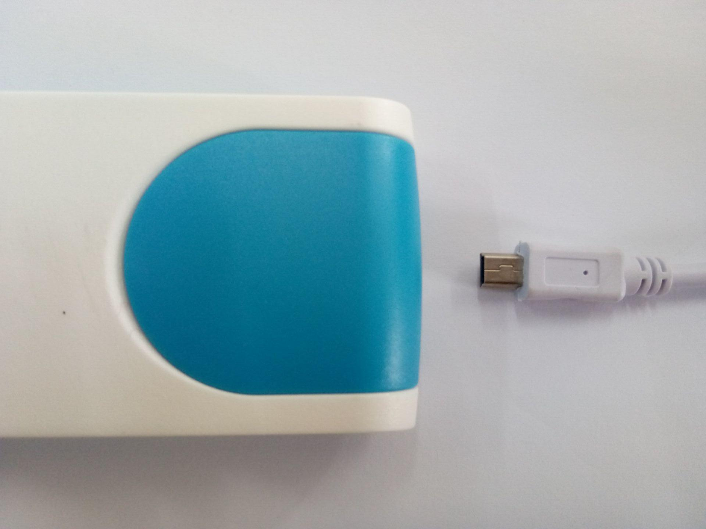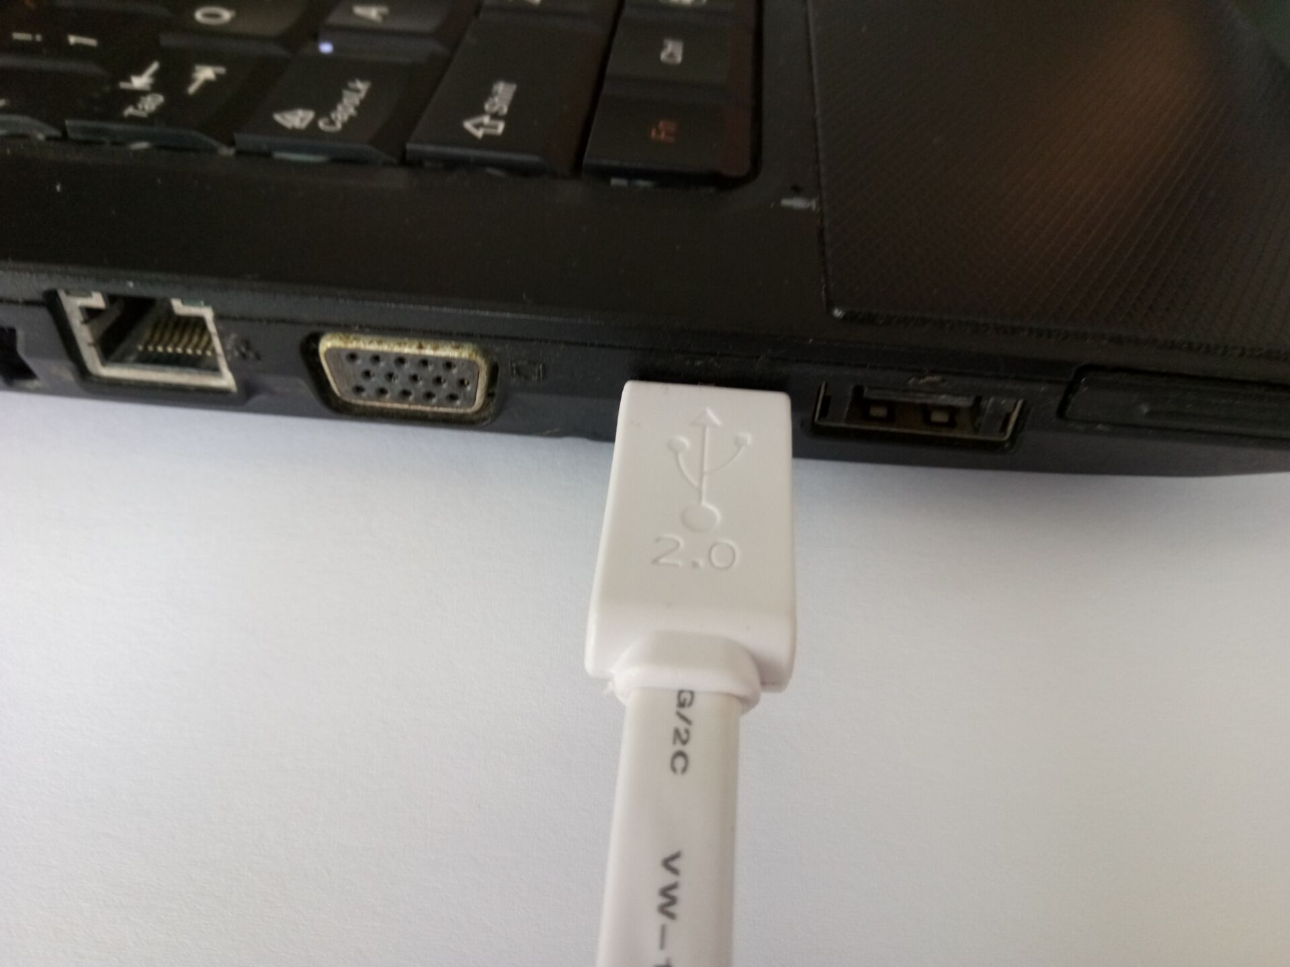  2. Open digitized experiment software.  3.Click  button to establish an experiment.  4.Click “New folder” button to establish a template for experiment.  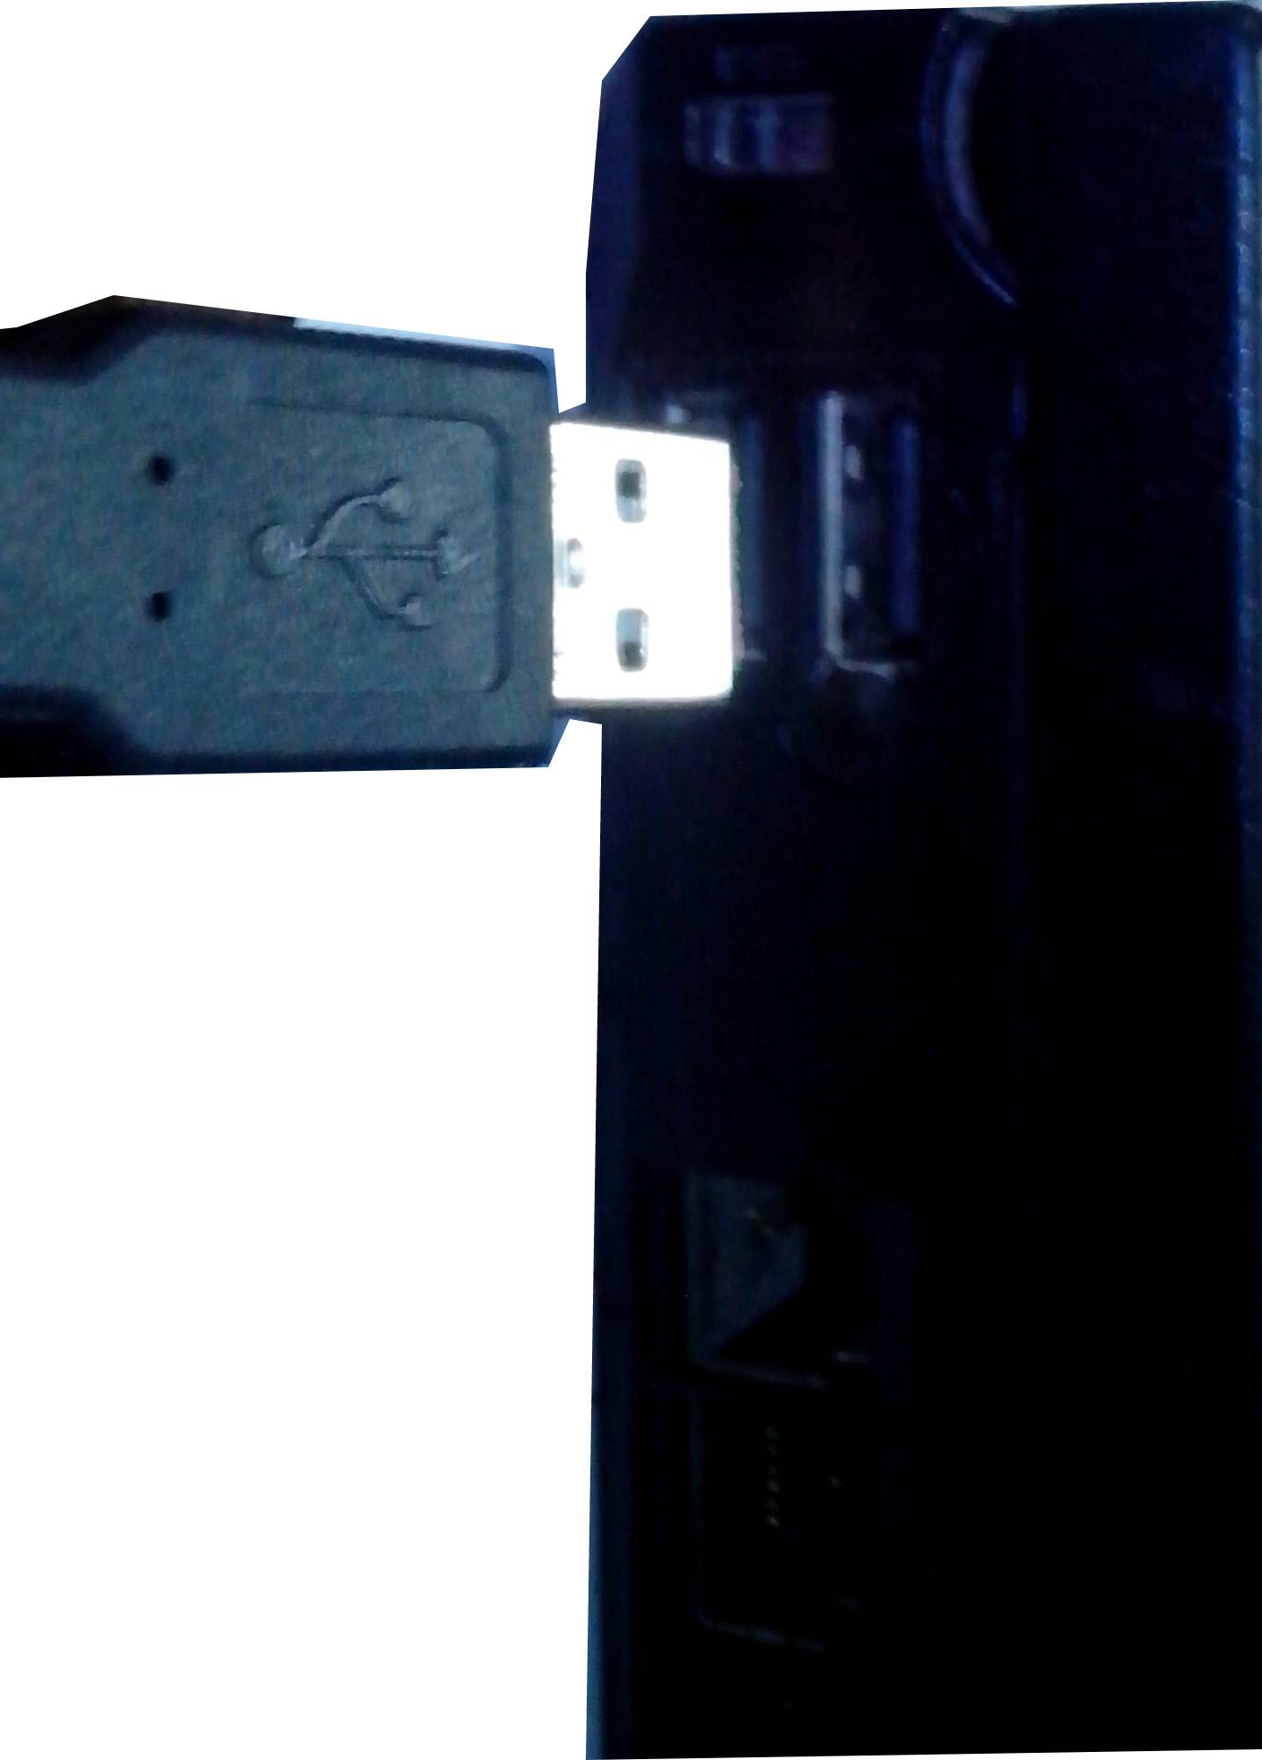  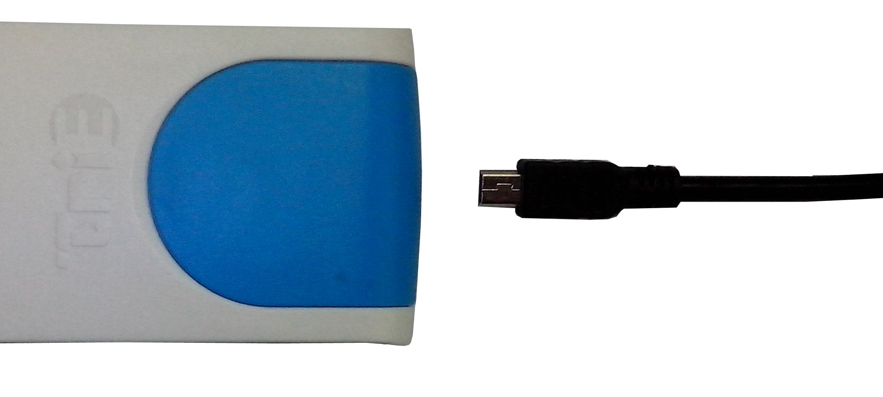
  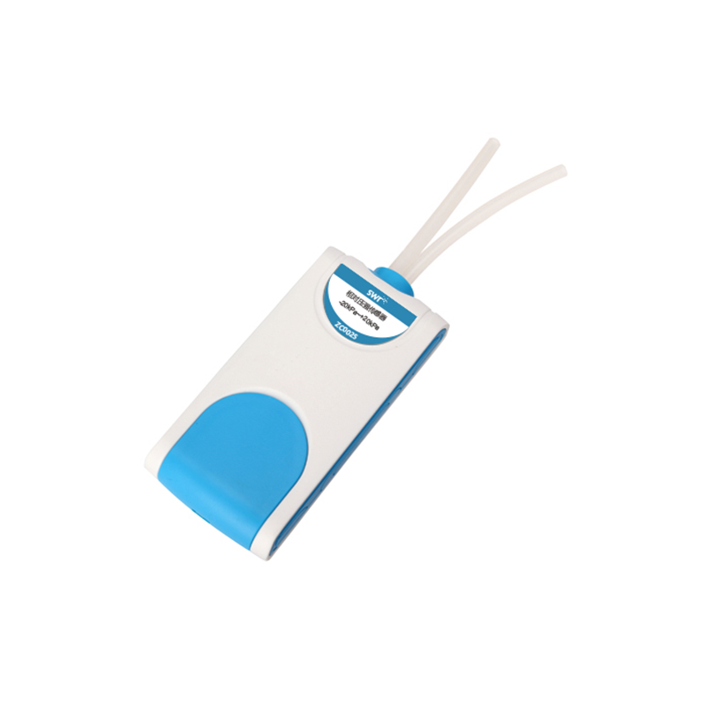
  Measuring range： | -20～20KPa
  Resolution： | 0.01kPa
  Accuracy： | ±5%
  Usage：   | 1.Not appropriate for measuring inflammable and explosive gas;  2.Can’t be directly used to measure liquid pressure;  3.Can also be used to measure steam pressure, but pay attention to avoiding the liquid to flow into the tube.  4.Considering sealed container’s gas tightness, the measuring time shouldn’t be too long.

  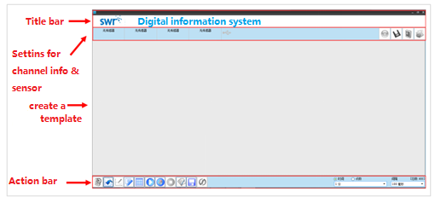 |   Boyle’s Law  Charles Law  Study liquid’s internal pressure.  Plant’s transpiration  Relationship between liquid’s boiling point and pressure.    After connecting the sensor and datalogger, open digital experiment system, click Calibrate button .  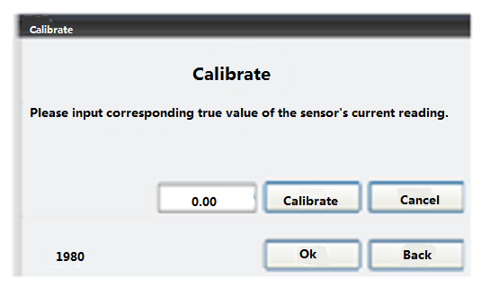  1. Click “Calibrate” .  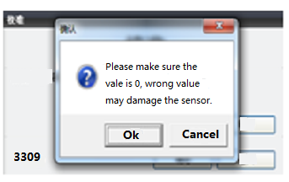  2. Click “Ok”.  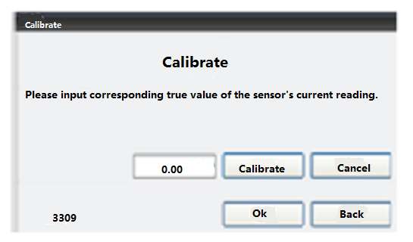  3.Click “Back” to exit.
  Device condition： | The icon displaysing blue means the software can recognize the sensor.
  Quick experiment: | Click “Quick experiment” button , the system will establish a template for experiment automatically.
  Manual collection： | Click “Manual collection” button ,the system will begin to collect data.
  Stop： | Click “Stop” button，the system will stop collecting data.
  Area to be chosen： | Click “Area to be chosen” button，choose the data area that you want be analyze.
  Line manager: | Click “Line manager” button ，conduct a curve fit for data in the chosen area.

- Temperature range for operation: -40℃ to 85℃;
- Temperature range for storing: -55℃ to 125℃;
- Humidity range for use: 0 to 100% RH;
- Pressure sensor can only be used to measure: Non-corrosive gas like air and dry gas.
- The sensor can’t be applied to measure inflammable gas;
- Can be used to supervise liquid’s steam pressure, but make sure not to leak liquid into the probe’s tube.
- In the pressure system, there is always some gas leaked from the container. Therefore the longer the studying time is, the more influence of the gas leakage is. If possible, the experiment should be finished as soon as possible.

