  Gas Pressure Sensor  ZC0024  Product specification: |   ZC0024 Gas Pressure Sensor is used to measure the absolute pressure of air. It is connected to external air by hose placed at front side of the sensor.    Data cable (USB interface).  Computer installed with SWR iLab v8.0 and above.    1. Connect the Gas Pressure Sensor to computer by USB cable.  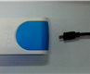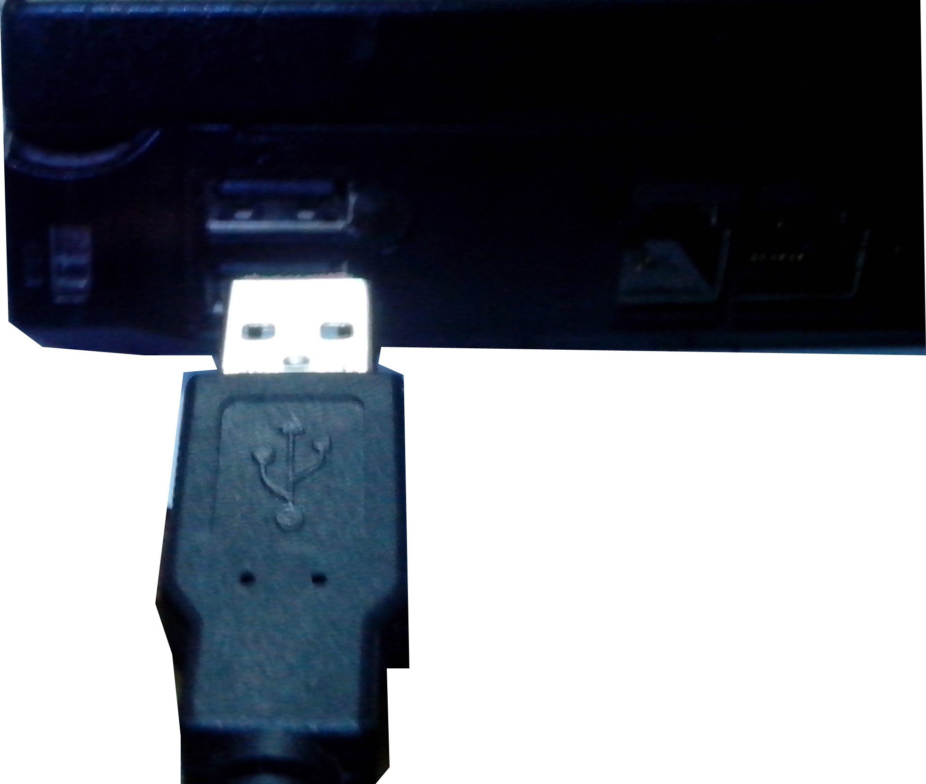  - Open the SWR iLab V8.0.  3. Click the button to create new experiment template.
  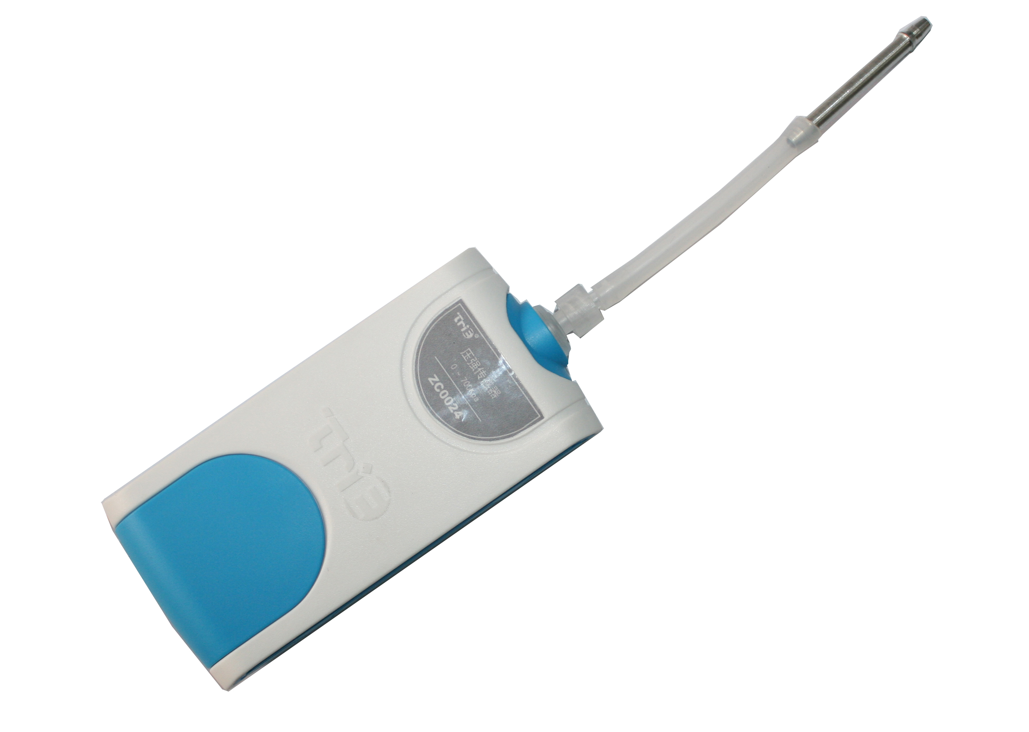
  Measuring range: | 0~700kPa
  Resolution: | 0.2kPa
  Accuracy: | ±0.5kPa
  Matching accessories: | Syringe
  Notes:   | - The Gas Pressure Sensor can not be used to measure flammable gas.  - The sensor can also be used to measure vapor pressure of fluid. Prevent fluid flowing into the hose of probe.  - For the pressure system, there is always air leakage in syringe. Therefore, if an experiment lasts for long time, the influence caused by air leaking will be greater. If possible, complete the test and experiment as soon as possible.
Address: No.14 Junnong Road, Qinhuai District, Nanjing, China
Website: //www.sinoswr.com Post Code: 210007
Tel: +86-400-828-8387

  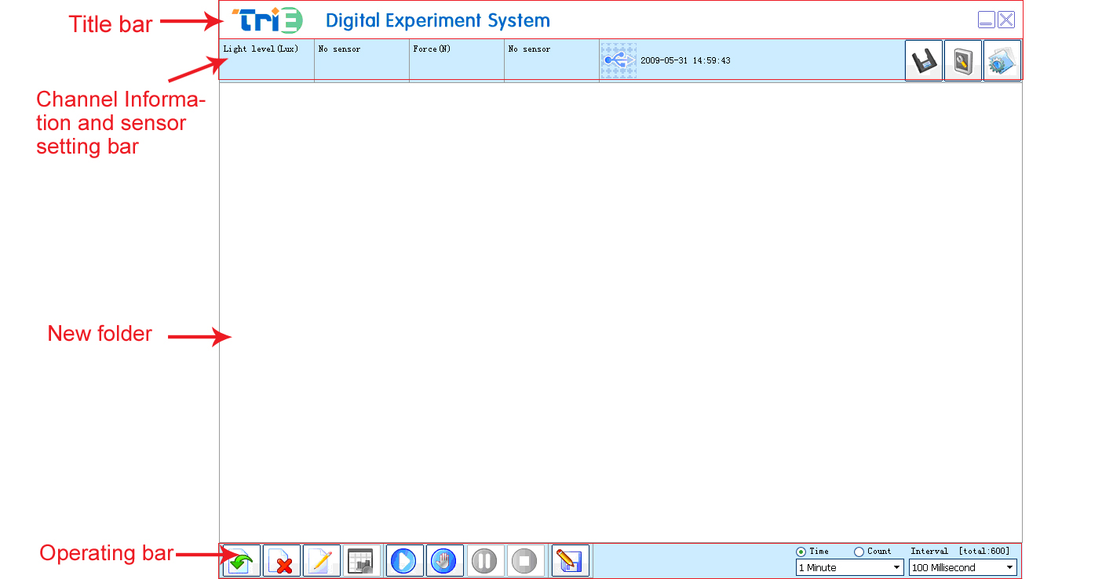 |   Boyle’s law  Charles’s law  The relationship between liquid boiling point and pressure  Measure chemical reaction rate    - Refer to the manual of Boyle’s Law Demonstrator. Set up the experimental apparatus.  - Click ‘Formula edit’ to add a variable ‘Volume’. Its unit is ‘mL’.  - Click the ‘New page’ to create a new folder and select template 6.  - Click on ‘List select’ button in the folder (at upper left corner of the binder). Select ‘OK’.  - Click ‘Manually’ button. Record the first reading group. Push the piston slowly for 5ml. Click ‘Manually’ and record the second reading group. Repeat the step. Insert the volume of compressed gas in the ‘Volume’ column at left side.  - Click the ‘Stop’ button. Observe the curve that the pressure varies with respect to volume.  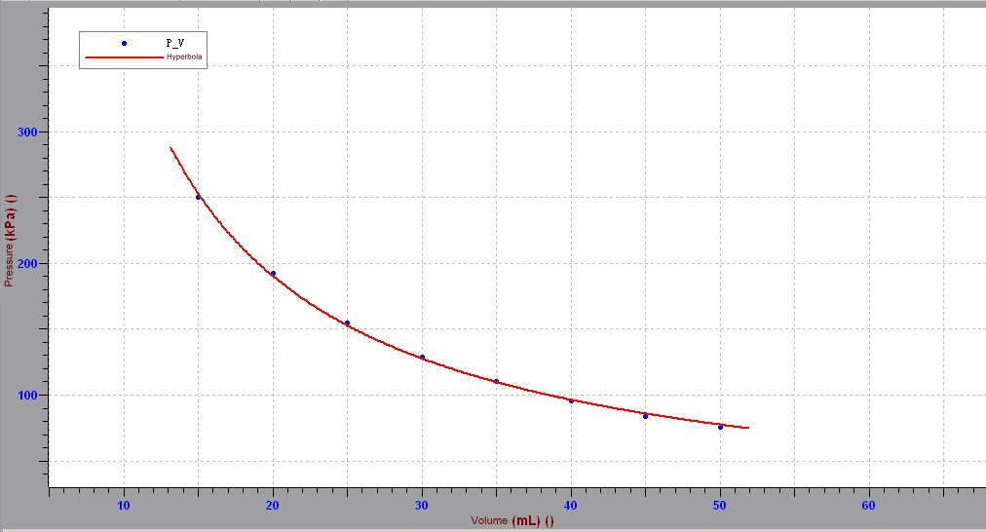  Fig.1
  Device status: | The icon shows blue. It means that the sensor has been recognized by the software.
  Rapid  experiment: | Click the  button. The system will create a new experimental template.
  Start: | Click the button. The system will start collecting data.
  Stop: | Click the  button to stop data acquisition.
  Zone select: | Click the button to select the data area need to be analyzed.
  Curve manager: | Click the 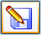 button to make curve fitting for selected data.
  ZC0024 Gas Pressure Sensor needs no calibration. If the measuring value is not accurate, you can calibrate or reset it. Connect sensor with datalogger and open SWR iLab v8.0. Click  calibration button:  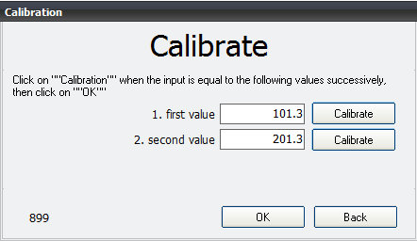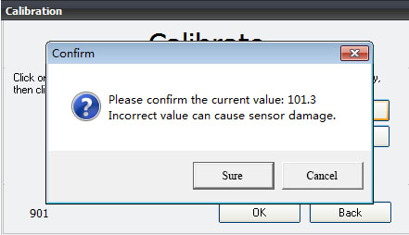  1. Click ‘Calibrate’ 2. Click ‘Sure’  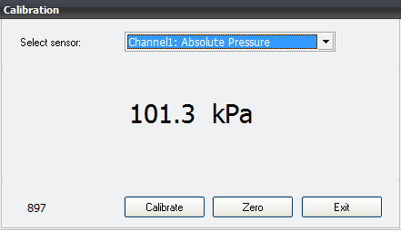  3. Click ‘OK’  Click ‘Exit’. |   ZC0024 Gas Pressure Sensor can achieve better experimental results if it is Combined with TP2025 Boyle’s Law Demonstrator.

