  Magnetic Field Sensor  ZC0020  Product specification: |   ZC0020 Magnetic Field Sensor is used to measure the magnetic field which is parallel to it.    Data cable (USB interface)  Computer installed with SWR iLab v8.0 and above.    - Connect the sensor to computer using USB cable.  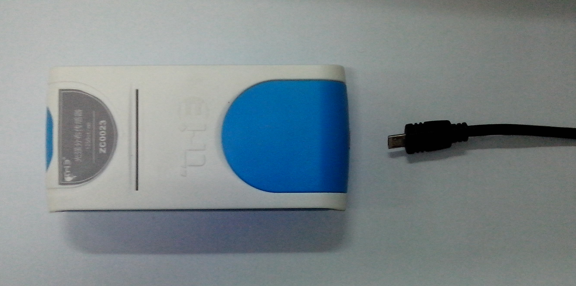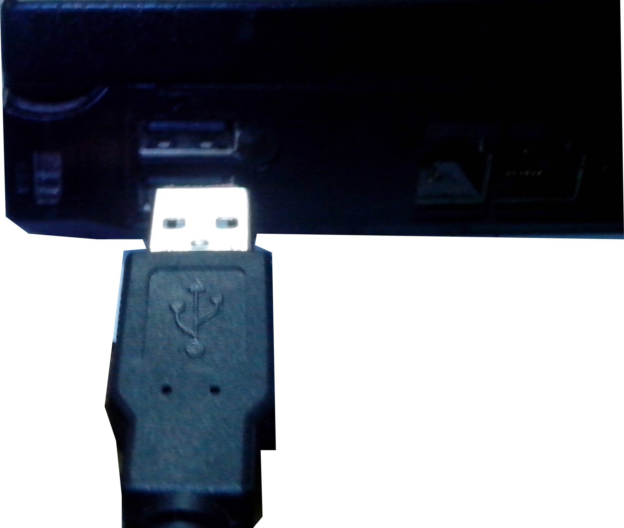  - Open the SWR iLab v8.0.  3. Click  to create new experimental template.
  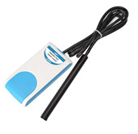
  Measuring range: | –100~100mT
  Resolution: | 0.04mT
  Accuracy: | 0.04mT
  Interval: | 100ms
  Sensing component: | The Hall slice is fixed in the front of probe.
  Notes:   | - This Magnetic Field Sensor is not suitable for measuring very small magnetic field such as geomagnetic field.  - Keep the axial of probe pointing same direction of magnetic field. Otherwise the value of the magnetic induction it measures is only the projection component of the magnetic field in the direction of end surface.  - The sensor’s probe can not bear strong bump.  - Do not plug in and out USB frequently. Minimum plug interval is 2s.
Address: No.14 Junnong Road, Qinhuai District, Nanjing, China
Website: //www.sinoswr.com Post Code: 210007
Tel: +86-400-828-8387

  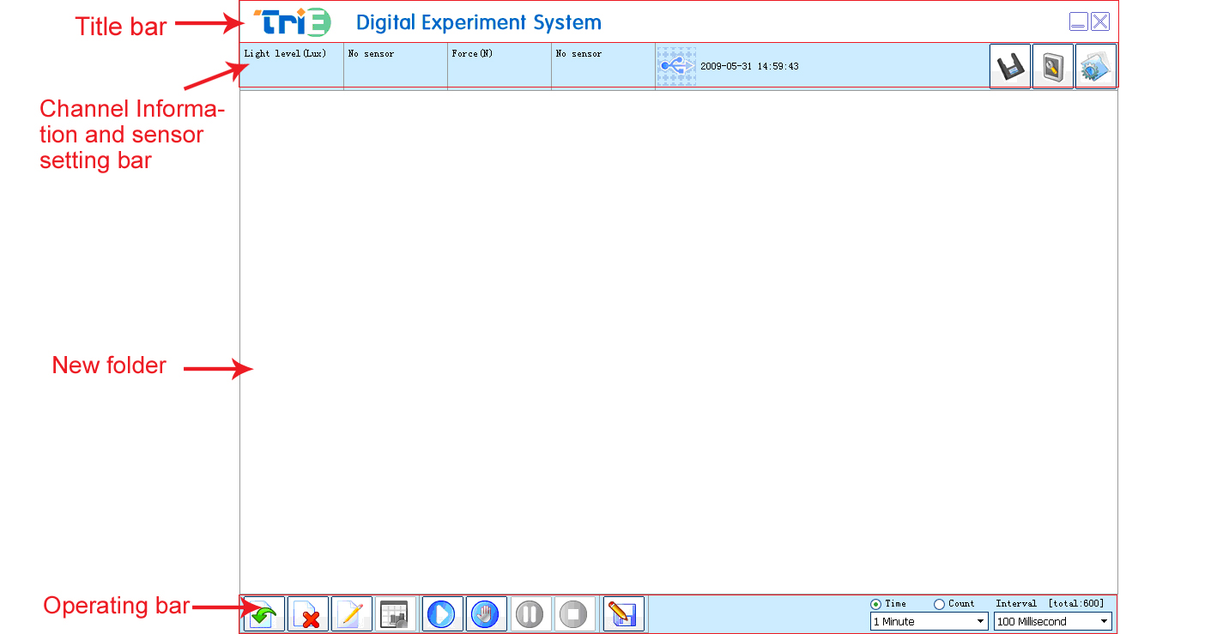 |   Measure the magnetic field of Helmholtz coil  Explore the magnetic field around the permanent magnet  Measure the axial magnetic field of electrified solenoid  Measure the magnetic field around the electrified wire  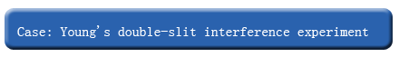  - Refer to the instruction manual of Solenoid. Connect the electric circuit of solenoid.  - Set the Magnetic-Time coordinate.  - Switch on the power supply. Place the probe at 5cm along the axis away from one side of the solenoid coil.  - Click the ‘Manually’ button. Move the probe 1 more cm away from the solenoid. Start collecting data.  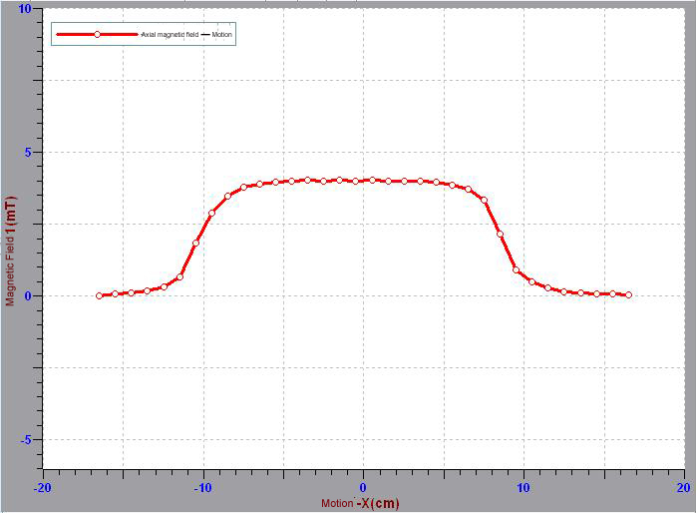  - Repeat the Step 4 till the probe is 5cm away from the other side of solenoid coil. Observe the experimental curve after data acquisition (as shown in Fig.1).
  Device status: | The icon shows blue. It means that the sensor has been recognized by the software.
  Add line: | Click the “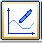”button to set the x axis and y axis of the coordinate.
  Start: | Click the “”button. The system will start. collecting data.
  Stop: | Click the 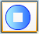button to stop data acquisition.
  Zone select: | Click the button to select the data area need to be analyzed.
  This sensor needs no calibration or demarcation. It is only necessary when obviously error occurs. Connect sensor and datalogger and open SWR iLab V8.0. Place probe away from magnetic field. Click 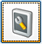 to calibrate.  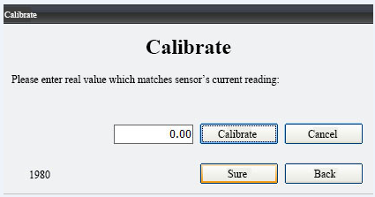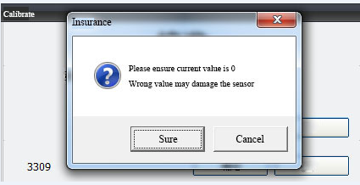  1. Click ‘Calibrate’ 2. Click ‘Sure’  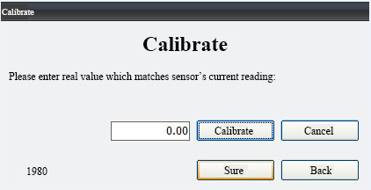  3. Click ‘Sure’  Click ‘Exit’. |   It is very easy to use the ZC0020 Magnetic Field Sensor. You can measure magnetic field as long as finish installing. Actually, the Hall slice is fixed near inner surface in the front end of probe. It is 2.5mm away from outer surface. This sensor can only measure the magnetic field parallel to the axial of probe. When measuring, select optimum direction and position shown in figure below.  The impact of temperature on Hall voltage and internal resistance is very small. In general experiments, the effect of temperature can be ignored.  

