  Light Sensor (Double Range)  ZC0019  Product specification: |   ZC0019 Light Sensor is used to measure the illumination of light.    Data cable (USB interface)  Datalogger  Computer installed with SWR iLab v8.0 and above    1. Connect the sensor to computer using USB cable.  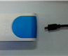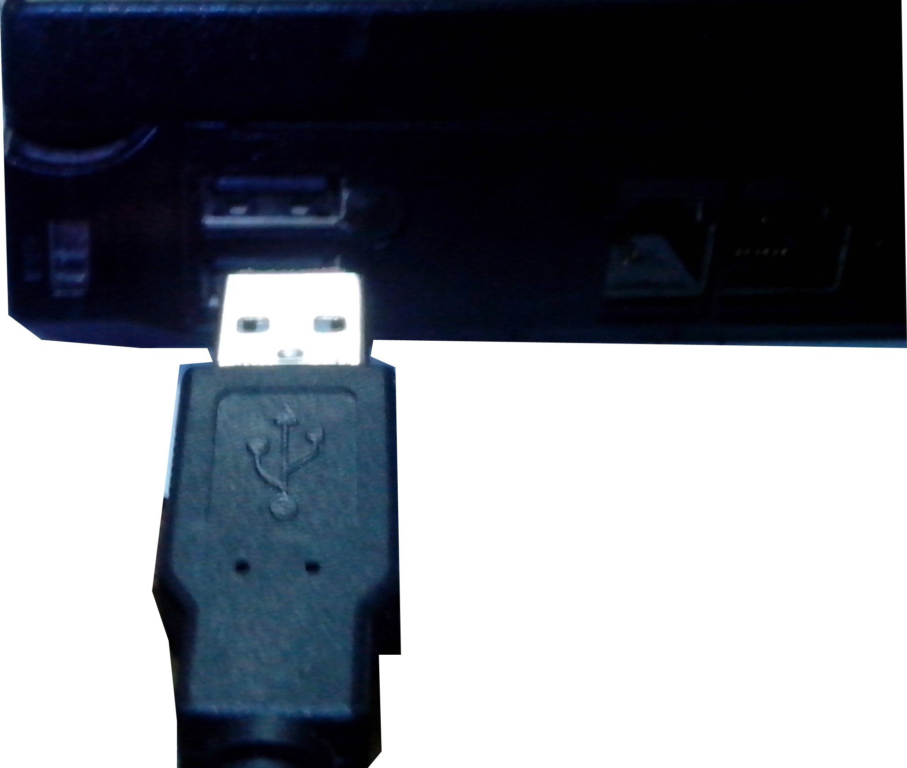  2. Open the SWR iLab v8.0.  3. Click 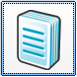 to create new experimental template.
  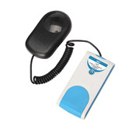
  Measuring range: | Low: 0~600 Lux
  Measuring range: | Medium: 0~6000 Lux
  Measuring range: | High: 0~150000 Lux
  Resolution: | Low: 0.15 Lux
  Resolution: | Medium: 1.5 Lux
  Resolution: | High: 38 Lux
  Accuracy: | Low: ±5%F.S
  Accuracy: | Medium: ±5%F.S
  Accuracy: | High: ±5%F.S
  Sensing component: | The sensing component is the white part under the cover
  Notes:   | - Remove the probe’s black cover before measuring. Be careful when selecting measuring range.  - When measuring, open the SWR iLab V8.0 and point the probe to light.  - Select the proper measuring range when measuring in order to ensure the accuracy of experimental result.
Address: No.14 Junnong Road, Qinhuai District, Nanjing, China
Website: //www.sinoswr.com Post Code: 210007
Tel: +86-400-828-8387

  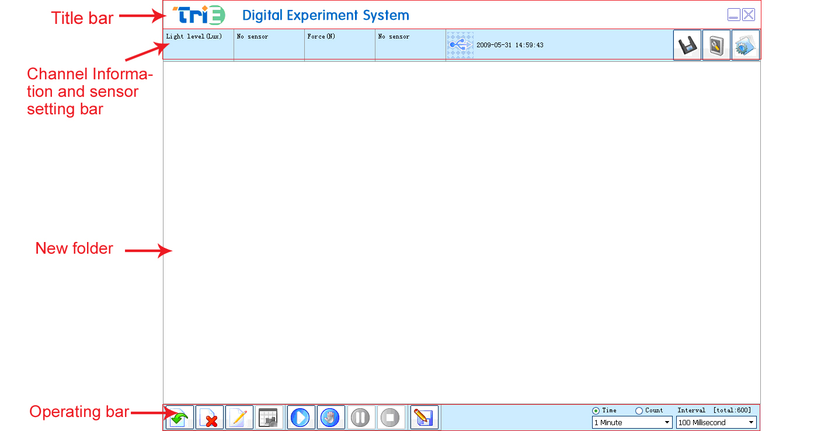 |   Explore the relationship between illumination and distance  Explore the diffraction, interference and polarization of light    - Open SWR iLab v8.0 and edit the distance L. Set up the Light-Distance coordinate and data table.  - Put the Light Sensor 5cm away from the point light source.  - Click the ‘Manually’ button to collect the experimental data.  - Move the Light Sensor 1 more cm away from the light source.  - Repeat Step 3 and 4 till enough data points are collected.  - Click the ‘Stop’ button to complete data acquisition.  - Analyze the experimental result (as shown in Fig.1).  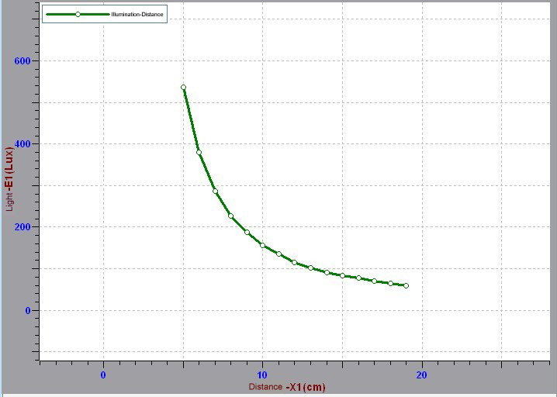  1
  Device status: | The icon shows blue. It means that the sensor has been recognized by the software.
  Rapid  experiment: | Click the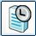button. The system will automatically create the experimental template.
  Start: | Click the 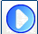button. The system will start collecting data.
  Stop: | Click the 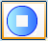button to stop data acquisition.
  Zone select: | Click the button to select the data area need to be analyzed.
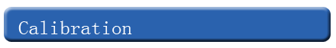  This sensor needs no calibration or demarcation. |   The sensing component of ZC0019 Light Sensor is placed in the front end of probe. when using, remove the black cover and point the white light-sensitive component to light source. The button on the side of Light Sensor is used to shift the measuring range.

