  ZC0012 Surface Temperature Sensor  Specification： |   The sensing component of ZC0012 surface temperature sensor’s probe adopts NTC thermistor, which is sealed in a metal cavity. When measuring, the probe directly connects the object to be measured, so the probe responds very fast. With ceramic technology, NTC thermistor is mainly made from metallic oxide like manganese, cobalt, nickel and copper. All of these metallic oxide is of semiconductor property, so its conducting way is completely similar to semiconductor materials like germanium(Ge) or silicon. When temperature is low, there’re smaller current carriers(electron and hole) in these oxide materials, so its resistance value is relatively high. As temperature rises, there’re more current carriers, so its resistance value reduces. NTC thermistor can be widely used in situations like temperature measurement, temperature compensation and surge current inhibiting.    - USB cable  - A computer installed with a digitized experiment software.    1.With USB cable, connect a surface temperature sensor with a computer.  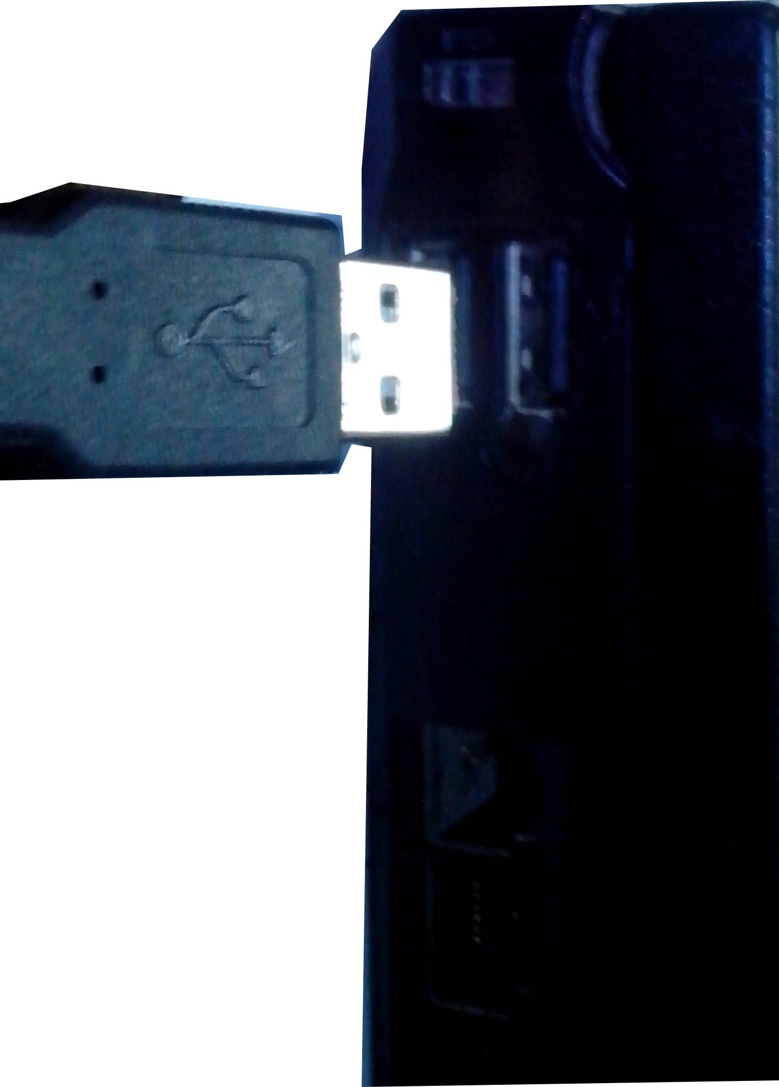  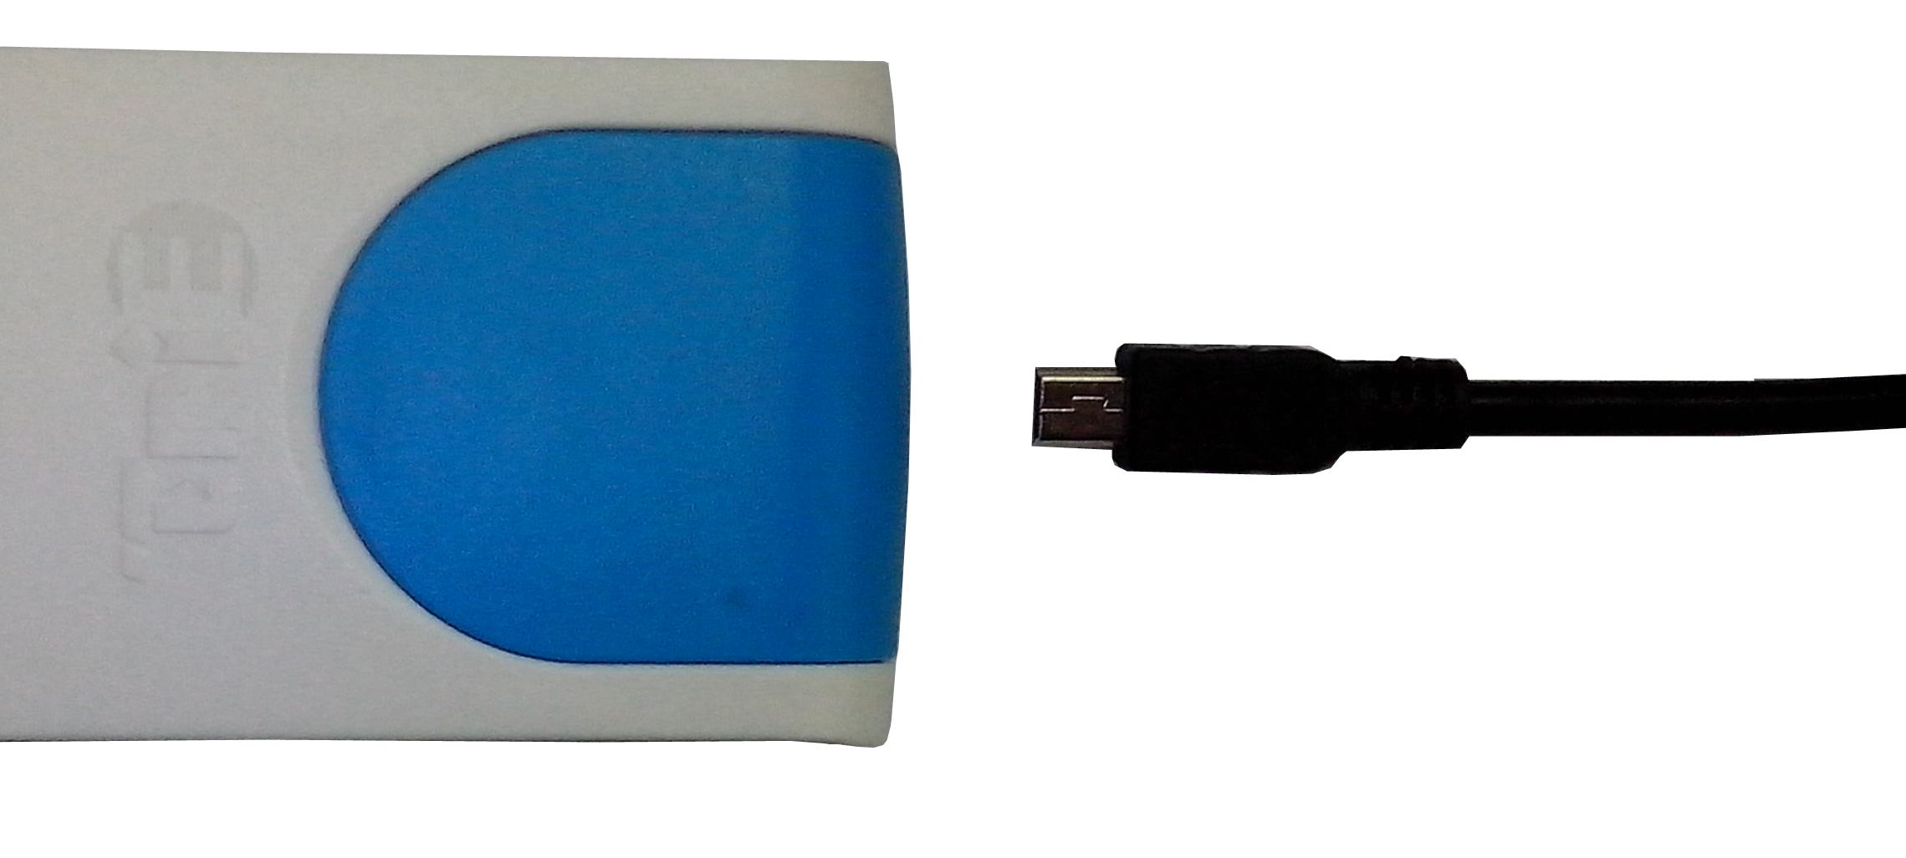  2. Open digitized experiment software.  3.Click  button and choose experiment interface.  4.Click “quick experiment”  button to establish a template for experiment.
  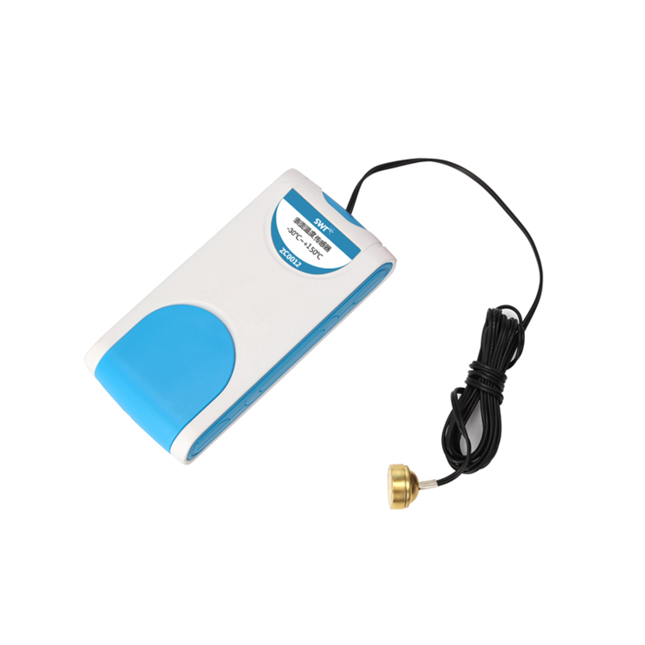
  Measuring range： | -30℃~+150℃
  Resolution： | 0.1℃
  Accuracy： | ±0.6℃
  Sensing component： | The electronic element measuring temperature is at the top of the probe.
  Usage：   | - Any part of the sensor can’t be placed on open fire or heating plates.  - When measuring, make sure the probe cling to the surface of determined objects.

  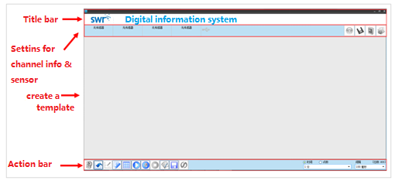 |   1. Function transformation  2.Comparation of different materials’ heat conductivity.    1.When using, there is no need to calibrate.  2.Temperature to be measured should not be higher than the measuring range.
  Device condition： | The icon displaysing blue means the software can recognize the sensor.
  Start： | Click button, then the system begins to collect data.
  Stop： | Click button, then the system stops to collect data.

