  Temperature Sensor  ZC0009  Product specification: |   ZC0009 Temperature Sensor is suitable for the temperature measurement for middle school chemical, biological, physical module.    Data cable (USB interface)  Computer installed with SWR iLab v8.0 and above    1. Connect the Temperature Sensor to computer by USB cable.  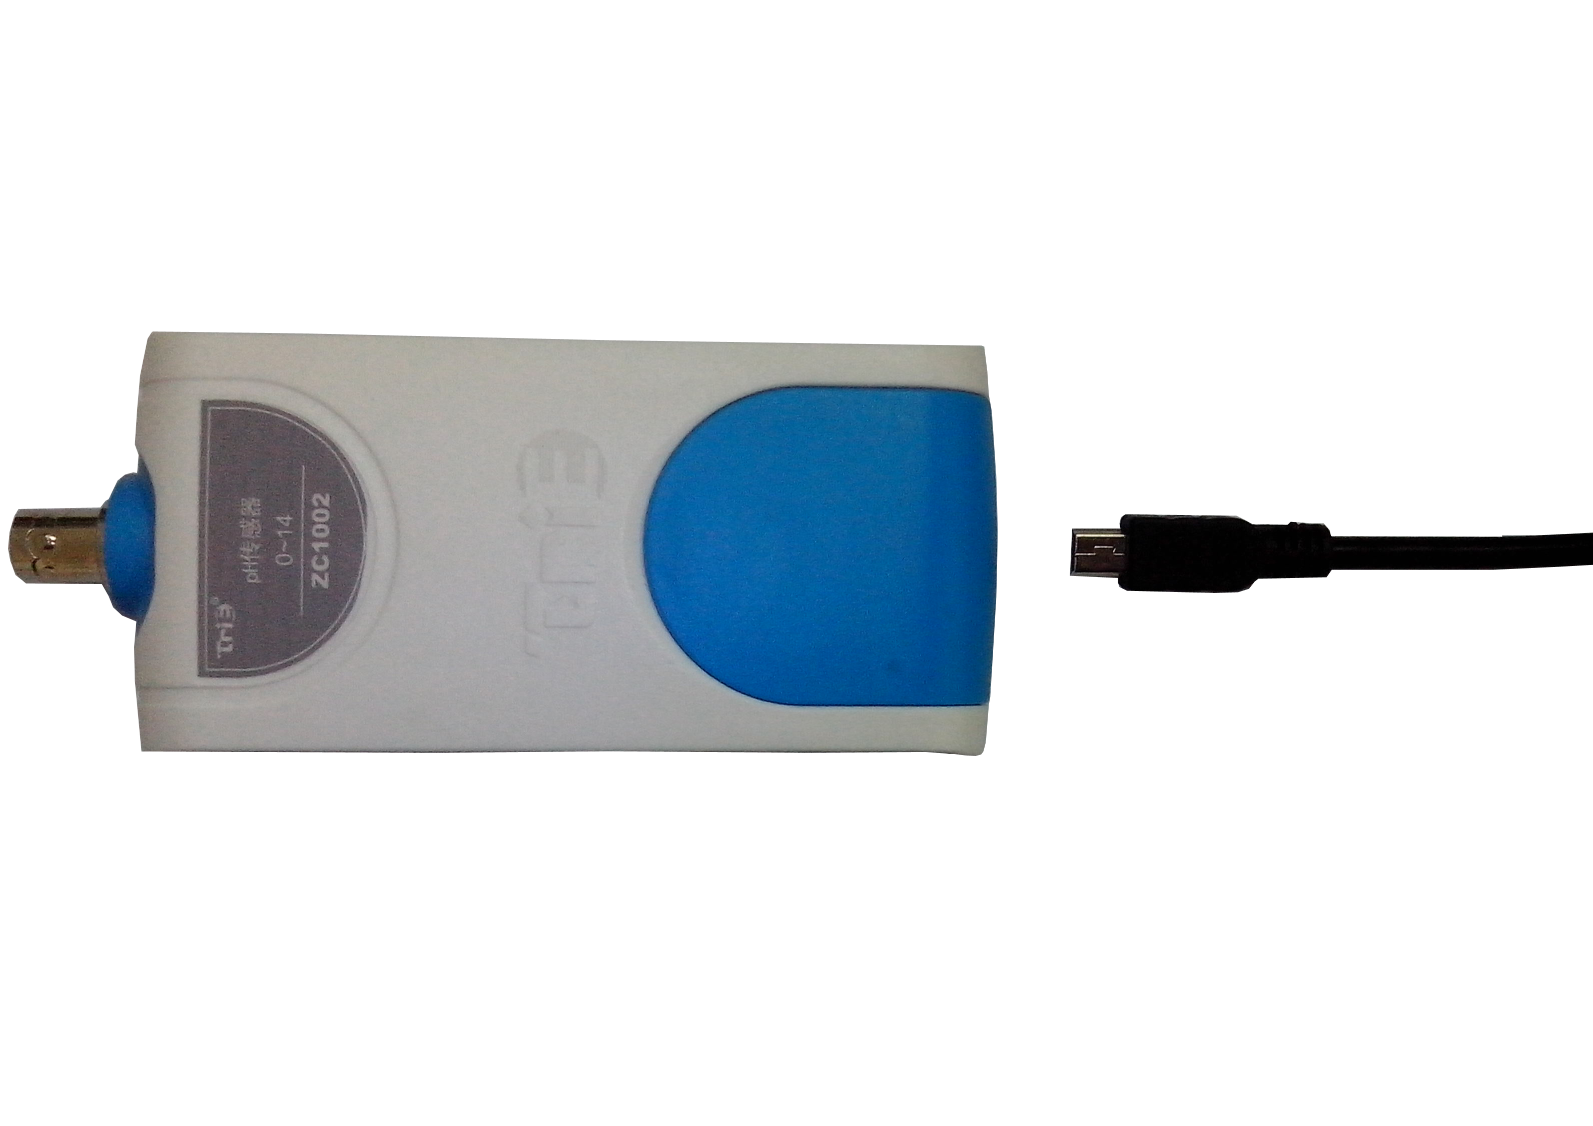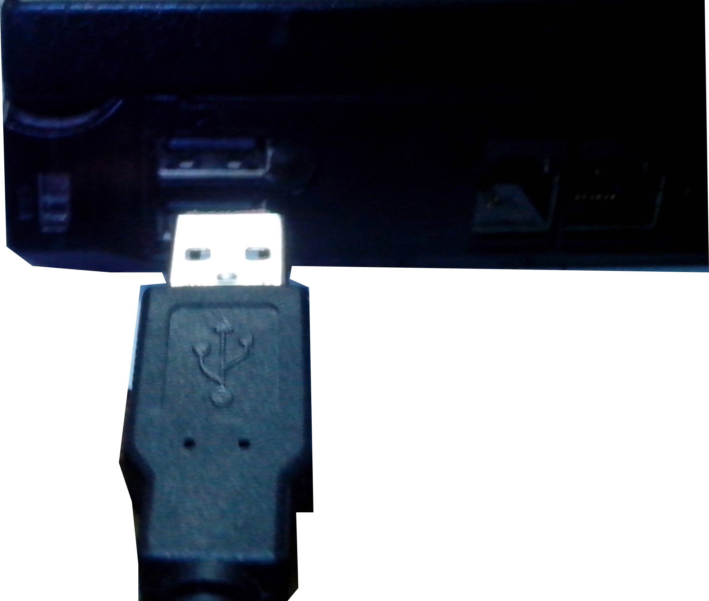  - Open the SWR iLab V8.0.  - Click the  to create new experimental template.
  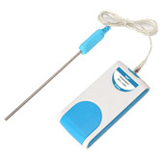
  Measuring range: | -50℃~+150℃
  Resolution: | 0.1℃
  Accuracy: | 0.6℃
  Sensing component: | The NTC electronic element is placed on the top of stainless steel bushing.
  Notes:   | - The Temperature Sensor is suitable for experiment of physical, chemical and biological module.  - Never place the Temperature Sensor probe on or in open fire or heating disc directly.  - Never immerse other parts of the Temperature Sensor other than its stainless steel bar into liquid when measuring its temperature.  4. Clean the Temperature Sensor completely after using. Temperature exceeding 150℃ may damage the sensor.
Address: No.14 Junnong Road, Qinhuai District, Nanjing, China
Website: //www.sinoswr.com Post Code: 210007
Tel: +86-400-828-8387

  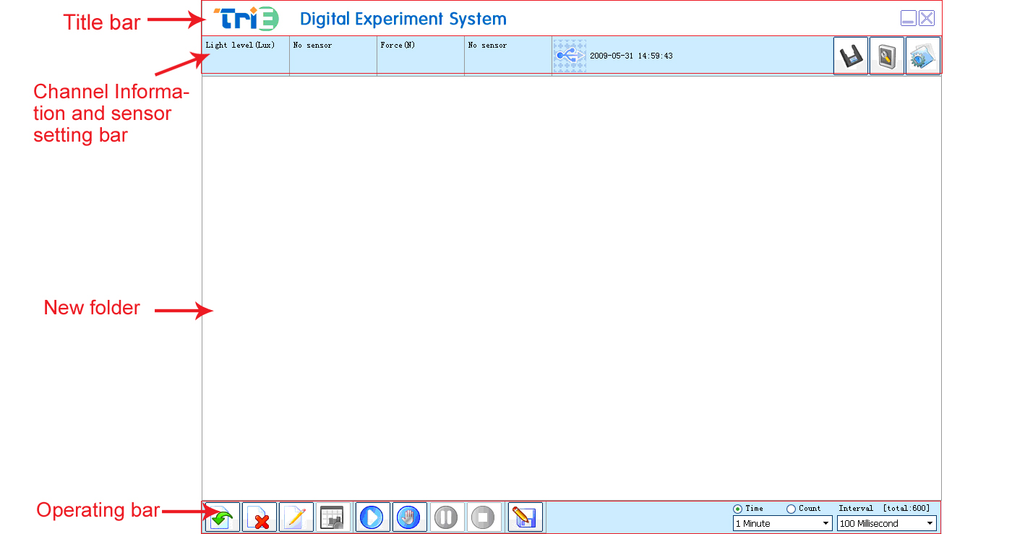 |   Natural cooling of water  Liquid cooling via evaporation  Conversion between work and energy  Explore relationship between boiling point and pressure of liquid  Explore thermoelectricity  Comparison on heat conduction performance of different substances  Explore the regulation of temperature change when a solid melts    - Refer to the Lab Manual. Set up the experimental apparatus.  - Click the ‘Start’ button. Observe the curve of temperature changing with respect to time (as shown in Fig.1).  - When the temperature dropped to the current ambient temperature. Click the ‘Stop’ button.  - Analyze the experimental result after data acquisition.  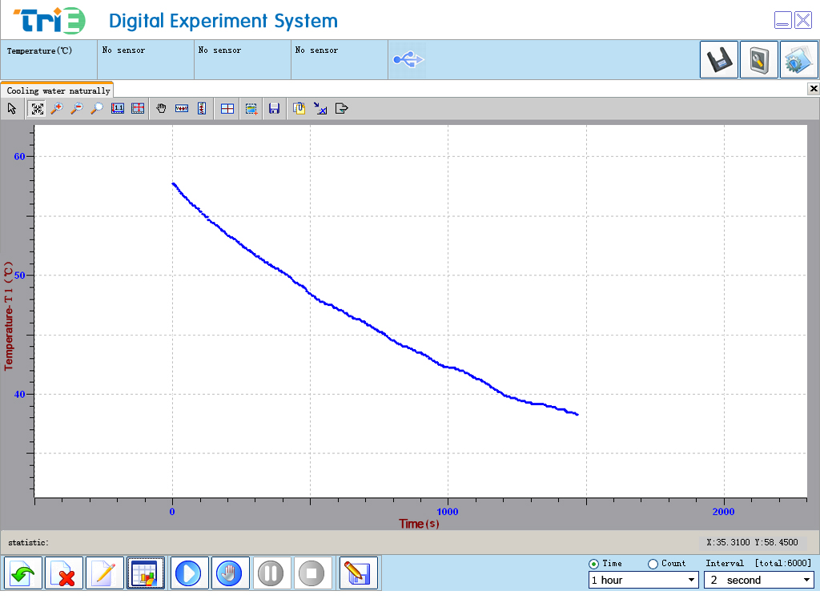  1
  Device status: | The icon shows blue. It means that the sensor has been recognized by the software.
  Start: | Click the button. The system will start collecting data.
  Stop: | Click the button to stop data acquisition.
  This sensor needs no calibration and demarcation. |   ZC0009 Temperature Sensor is suitable for measuring the internal or surface temperature of general solid, liquid and gas.

