  Charge Sensor  ZC0008  Product specification: |   The Charge Sensor can be used to measure electric quantity of a conductor. For example: it can be used to replace traditional gold leaf electroscope and electrometerin static electricity experiment.  The Charge Sensor is installed with an high precision input capacitor. The measured charge will charge capacitor so that voltage across the capacitor is increased. The device calculate voltage or charge by using potential difference between the capacitor.  It designed with alligator clip which covered by plastic. The wires used are red and black (for ground).  There is a reset button equipped on the sensor which is used to discharge the capacitor.    USB cable (USB interface)  Computer installed with SWR iLab v8.0 and above    1. Connect the Voltage Sensor to computer by USB cable.  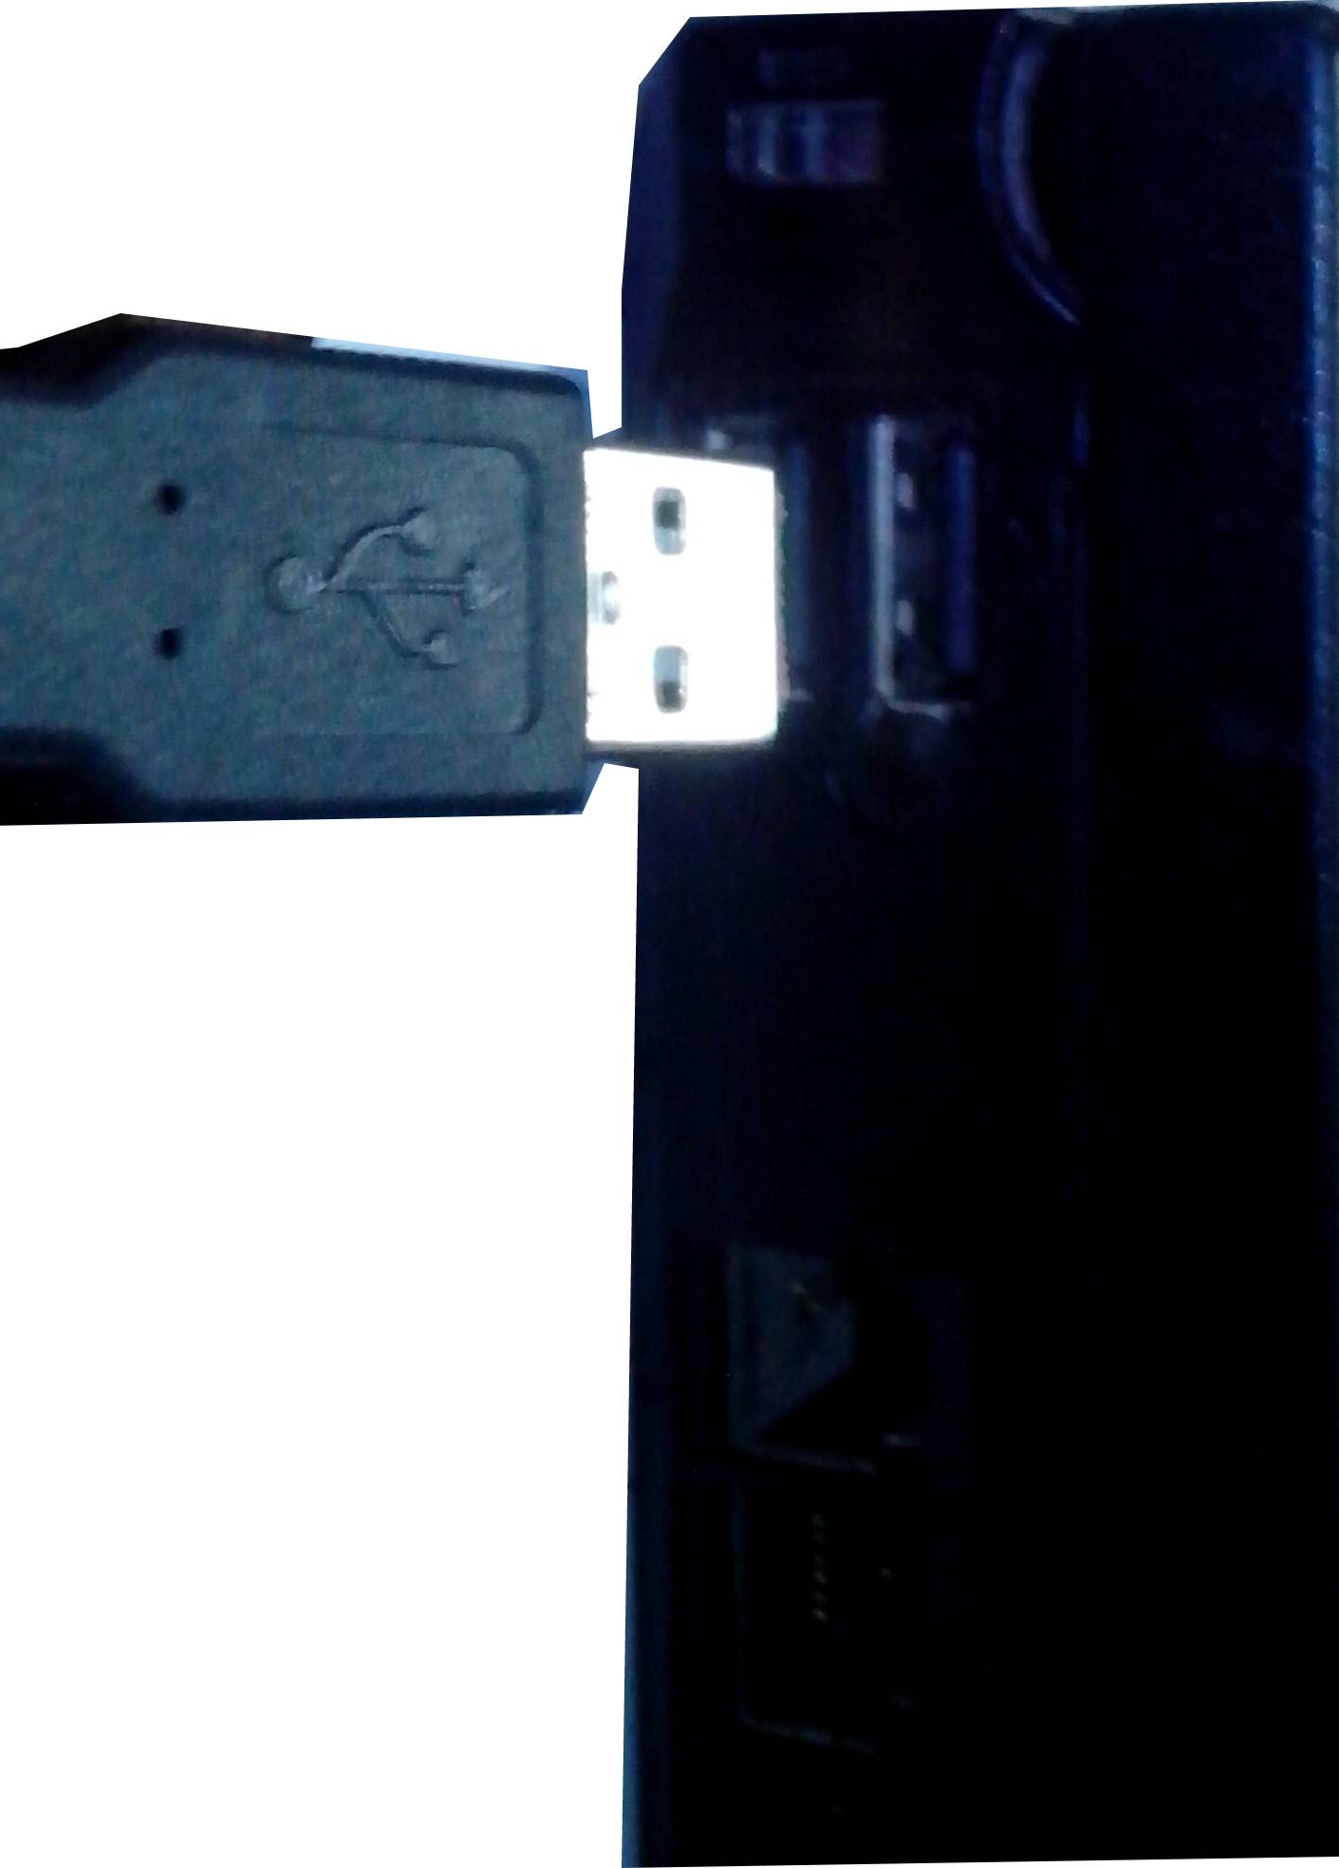  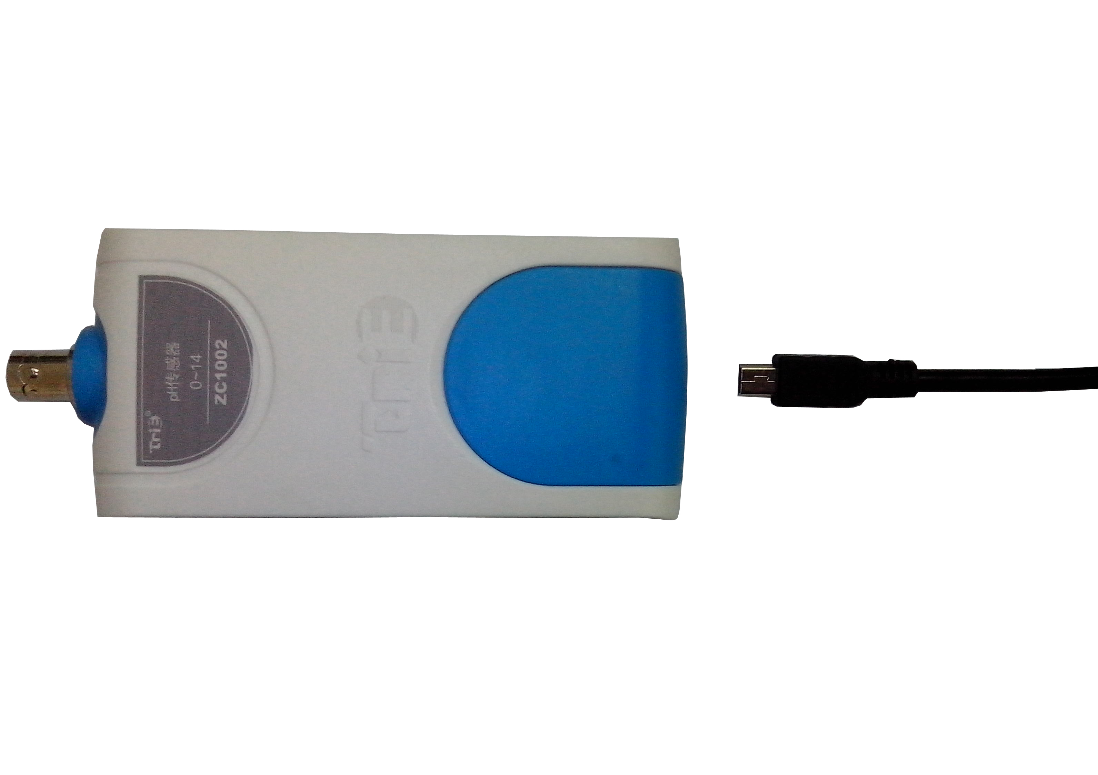  - Open the SWR iLab V8.0.  - Click the  to create new experimental template.
  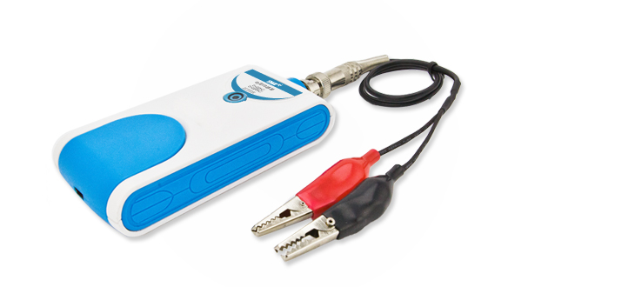
  Measuring range: | -220 nC~+220 nC
  Resolution: | 0.1 nC
  Accuracy: | ±1%F.S
  Notes:   | 1. Charge Sensor is used to measure quantity of charge. It is mainly used to measure electric quantity for electrified body.  2. For those experiment which need high precision charge measuring, fix the sensor to ensure the result is accurate.
    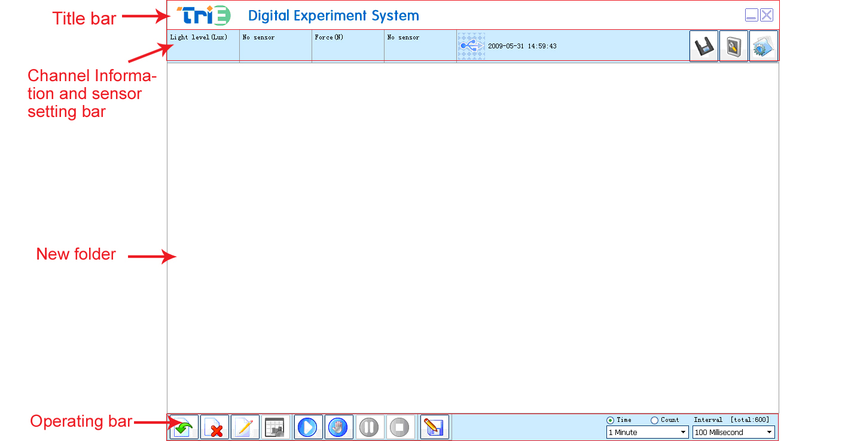 |  |   Compare charge quantity and symbol of different objects  Static electric phenomenon  Charge sharing between conductors  Faraday-ice bucket experiment  Electrostatic screening  Measuring charge quantity and symbol  Charge density on surface of conductor  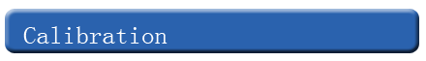  The reset button of ZC0008 Charge Sensor must be pressed before every experiment.    Shielded wire must be used to connect alligator clip and sensor.  Discharge the built-in capacitor before measuring. Press the reset button.  For those experiment which need high precision charge measuring, fix the sensor to ensure the result is accurate.  The air humidity can also affect the accuracy of data measuring. Dry the surrounding air to ensure the accuracy.
  Device status: | The icon shows blue. It means that the sensor has been recognized by the software.
  Start: | Click the button. System will start collecting data.
  Stop: | Click the 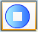 button to stop collecting data.
  Address: No.14 Junnong Road, Qinhuai District, Nanjing, China
  Website: //www.sinoswr.com Post Code: 210007
  Tel: +86-400-828-8387

