  Micro Current Sensor  ZC0006  Product specification: |   ZC0006 Micro Current Sensor is used to measure weak electric current signal in a circuit.    Data cable (USB interface)  Computer installed with SWR iLab v8.0 and above    1. Connect the Micro Current Sensor to computer by USB cable.  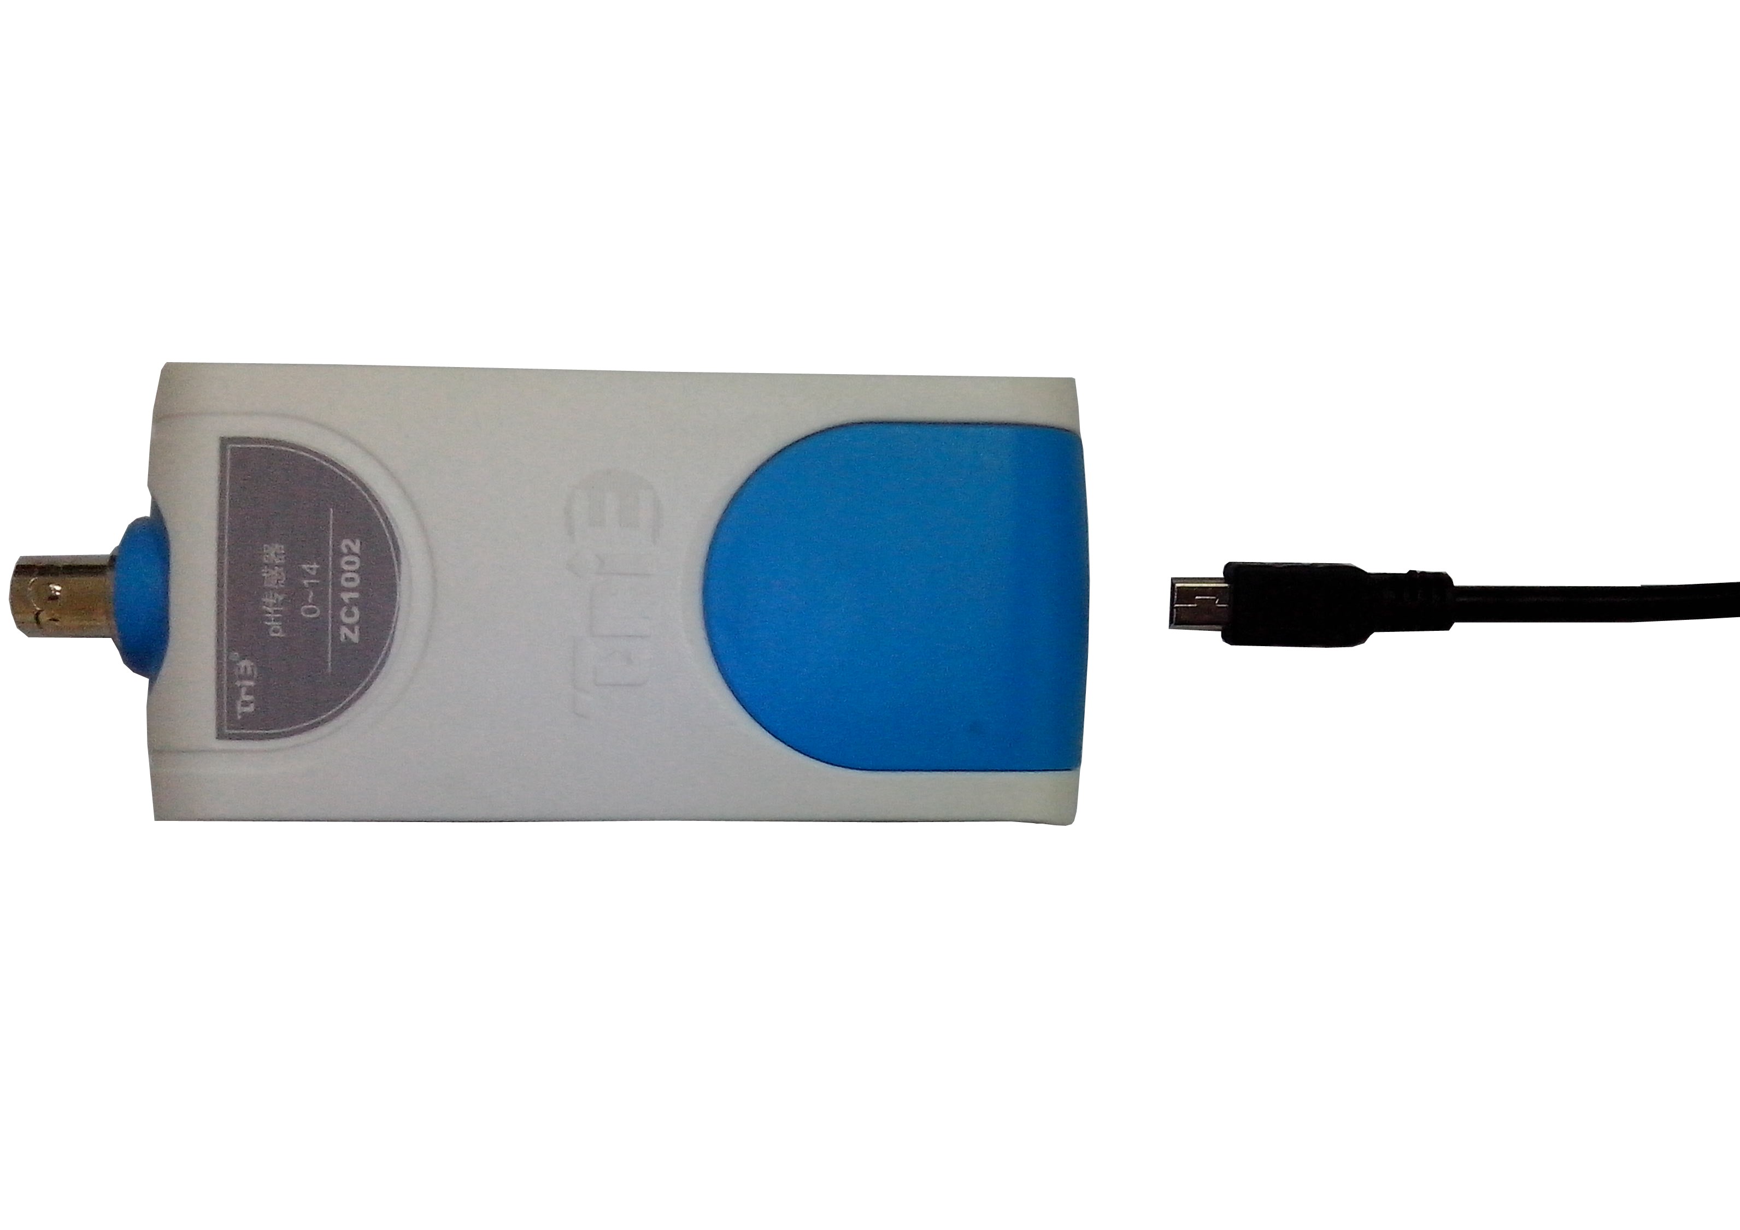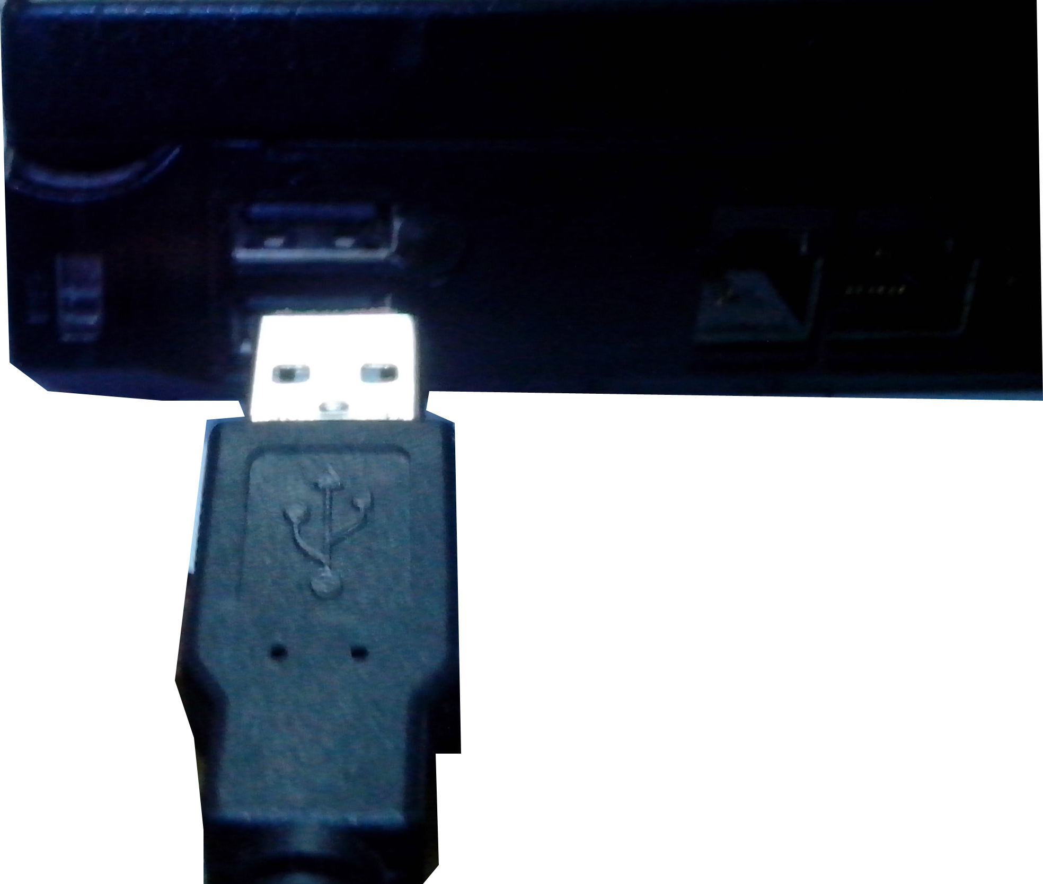  - Open the SWR iLab V8.0 software.  - Click the 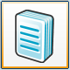 to create new experimental template.
  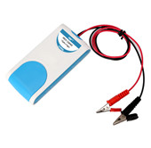
  Measuring range: | -10μA~+10μA
  Resolution: | 0.01μA
  Accuracy: | ±1%FS
  Internal resistance: | 300Ω
  Notes:   | - The Micro Current Sensor needs calibration before use and it should be series connected to the circuit.  - When measuring, make sure the current to be measured does not exceed the measuring range of the sensor.  3.Ground the negative pole of sensor during measuring in order to achieve higher accuracy if it is possible.
Address: No.14 Junnong Road, Qinhuai District, Nanjing, China
Website: //www.sinoswr.com Post Code: 210007
Tel: +86-400-828-8387
  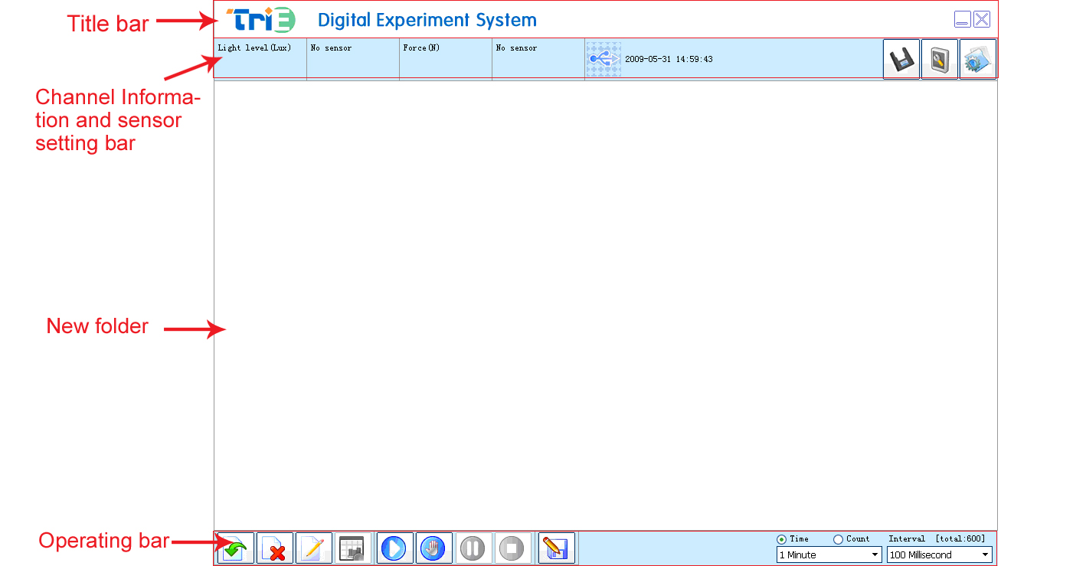 | 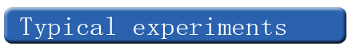  Electromagnetic induction phenomenon  Demonstration of power generation from human body  Voltaic cell  Thermoelectric current phenomenon  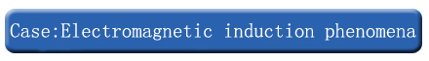  - Set up the experimental apparatus, connect the sensor to datalogger and connect the datalogger with computer.  - Open the SWR iLab and click ‘new’ experiment, click the “Create a folder” button to create a new folder.  - Click “Add line” to add “micro-voltage - time” and “micro-current - time” graph. Set the appropriate acquisition time and acquisition interval. Short connect the micro-voltage sensor and the Micro Current Sensor.  - Click ‘Start’ button. Move the bar magnet to change the magnetic flux passing through the circuit.  - After data acquisition, click the ‘Stop’ button and observe the graph that the induced current and induced voltage varies with time.  - Clear the experimental apparatus.  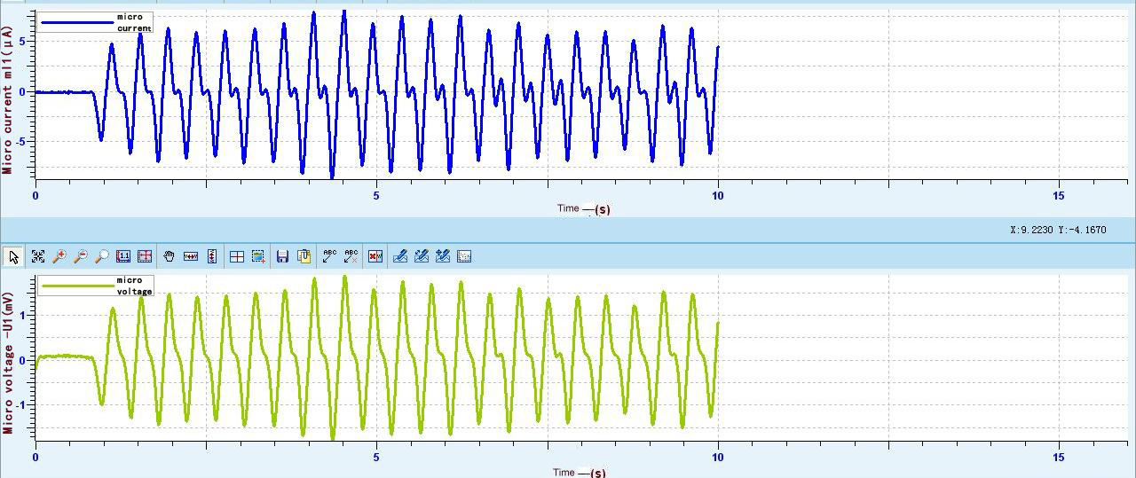  Fig.1
  Device status: | The icon shows blue, it means that the sensor has been recognized by the software.
  Rapid experiment: | Click the 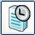button , system will create a new experimental template automatically.
  Start: | Click the 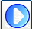 button, the system will start the data acquisition.
  Stop: | Click the 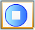button to stop data acquisition.
  Zone select: | Click the button to select the data area under analysis.
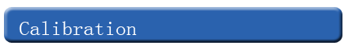  The Micro Current Sensor needs calibration before use. After connecting the sensor to datalogger, open the SWR iLab v8.0 software. Click the 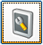 calibration button and short connect the red and black aligator clips.  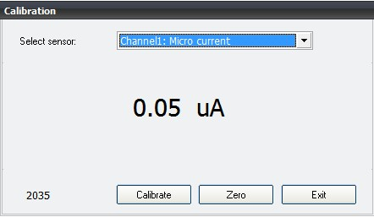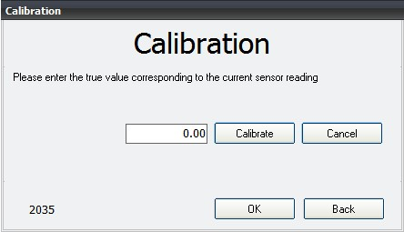  1. Click ‘Calibrate’ 2. Click ‘OK’  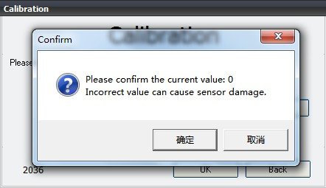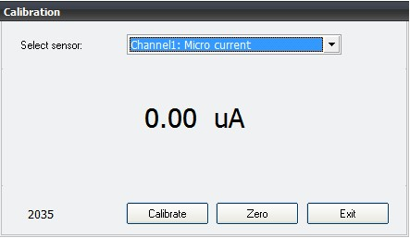  3. Click ‘Sure’ 4. Click ‘Exit’ |   After the experiment, preserve the sensor in a dry place.

