  Current Sensor  ZC0005  Product specification: |   ZC0005 Current Sensor is used to measure the current in circuit. It can be used in DC and AC circuit.    Data cable (USB interface)  Computer installed with SWR iLab v8.0 and above    1. Connect the Current Sensor to computer by USB cable.  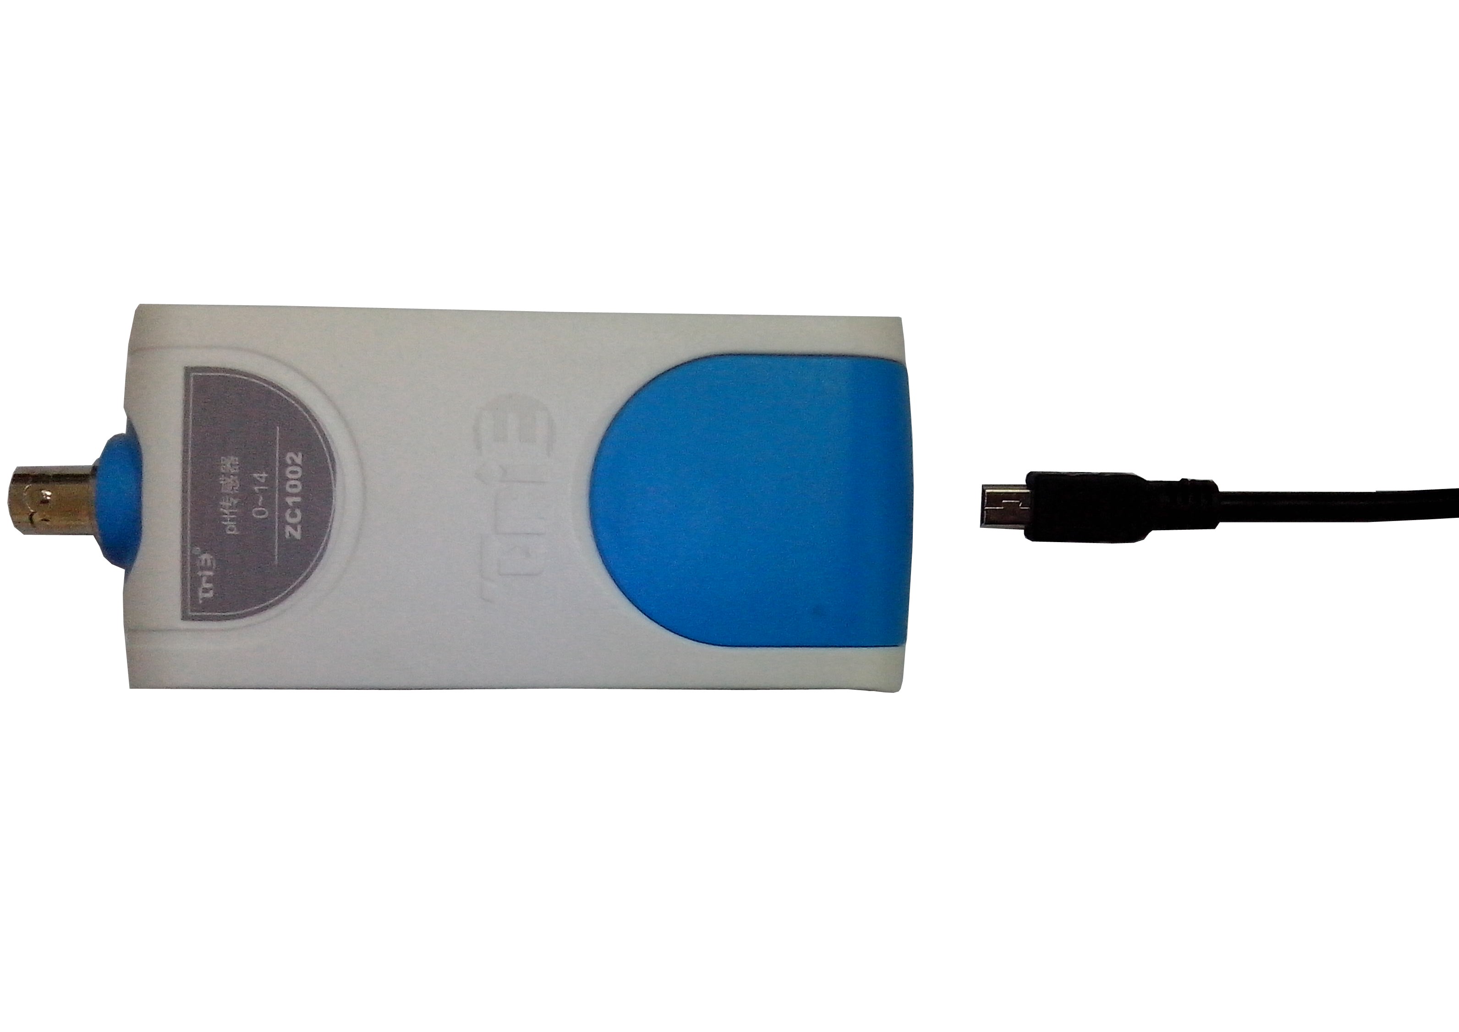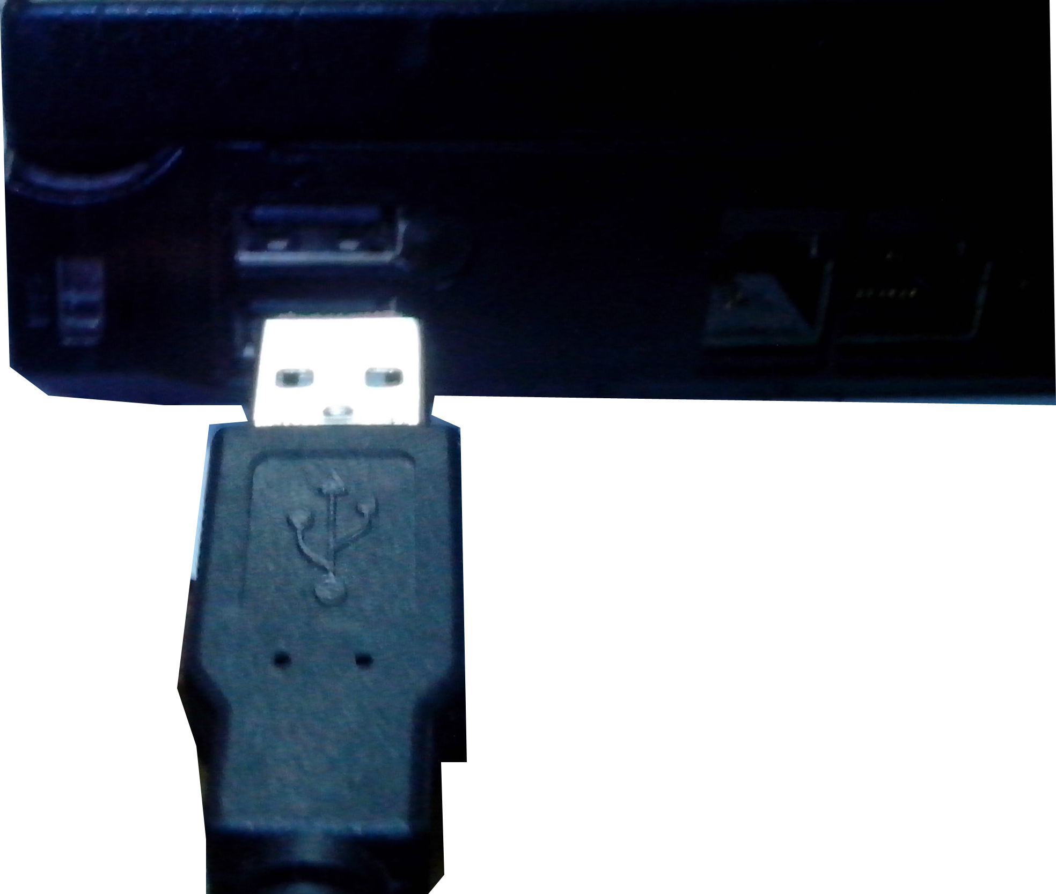  - Open the SWR iLab V8.0.  - Click the  to create new experimental template..
  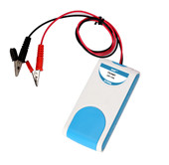
  Measuring range: | -3A~+3A
  Resolution: | 0.002A
  Accuracy: | 0.005A
  Notes:   | - The Current Sensor needs calibration before use. Please refer to the ‘Calibration’ for the method.  - The Current Sensor should be series connected to the circuit.  - The current goes into the sensor from the red conducting wire and goes out from the black conducting wire. It shows a positive current value under this condition. Otherwise, it will show a negative value.  4. When measuring, please do not let the measured current exceeds the range of the sensor.
Address: No.14 Junnong Road, Qinhuai District, Nanjing, China
Website: //www.sinoswr.com Post Code: 210007
Tel: +86-400-828-8387
  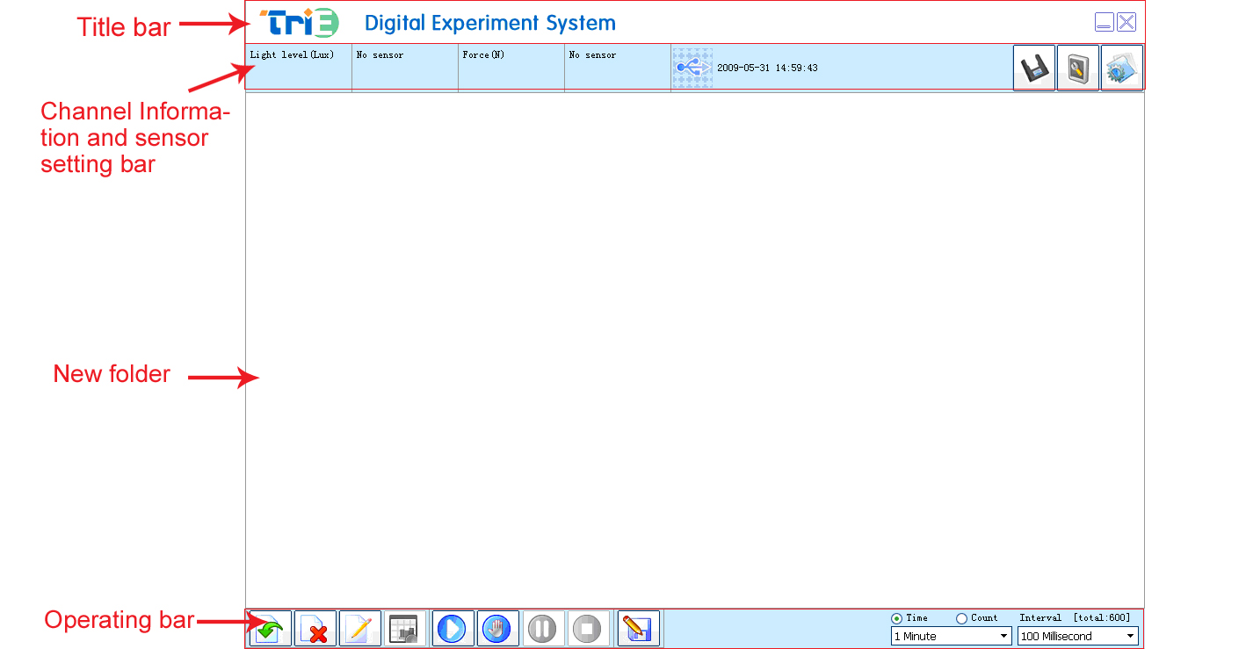 |   Measure the electrodynamic potential and internal resistance of battery  VA characteristics of small bulb, diode and conductor  Ohm’s law  Series and parallel connection of resistor  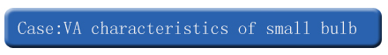  - Refer to【TM3001-EX09】Measure VA Characteristics of Small Bulb by Current-Limiting Approach. Set up the experimental apparatus.  - Calibrate the voltage sensor and Current Sensor before measurement. Click the ‘Start’ button.  - Slide the sliding rheostat to change the resistance in order to change the current passing small bulb (as shown in Fig.1).  - Click the ‘Stop’ button and analyze the experimental result after data acquisition,.  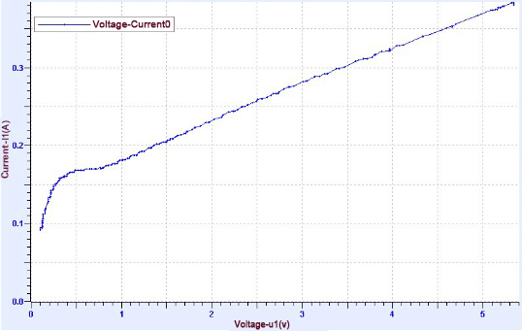  Fig.1
  Device status: | The icon shows blue. It means that the sensor has been recognized by the software.
  Start: | Click the button. The system will start collecting data.
  Stop: | Click the button to stop data acquisition.
  The Current Sensor needs calibration before use. Open SWR iLab v8.0 after connecting the sensor to datalogger. Click  calibration button and short connect the red and black alligator clips.  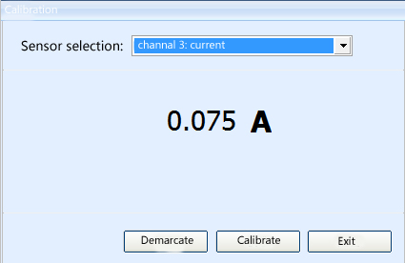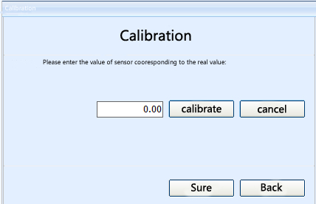  - Click ‘Calibrate’ 2. Click ‘Sure’  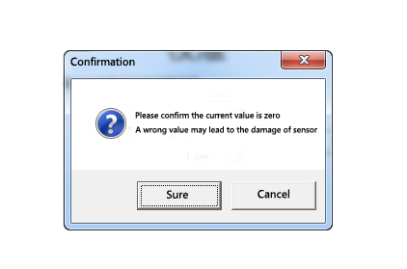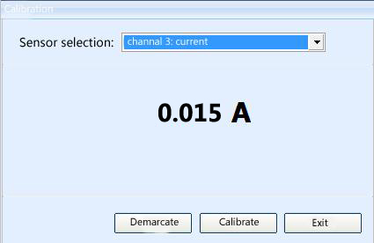  3. Click ‘Sure’ 4. Click ‘Exit’ |   ZC0005 Current Sensor is used with electrics experiment plate TM3001. It can be used to perform lots of electric experiment in middle school.

