  Micro Voltage Sensor  ZC0002  Product specification: |   ZC0002 Micro Voltage Sensor is used to measure the potential difference at the ends of the electronic components.    Data cable (USB interface)  Datalogger  Computer installed with SWR iLab v8.0 and above    1. Connect the Micro Voltage Sensor to computer by USB cable.  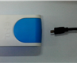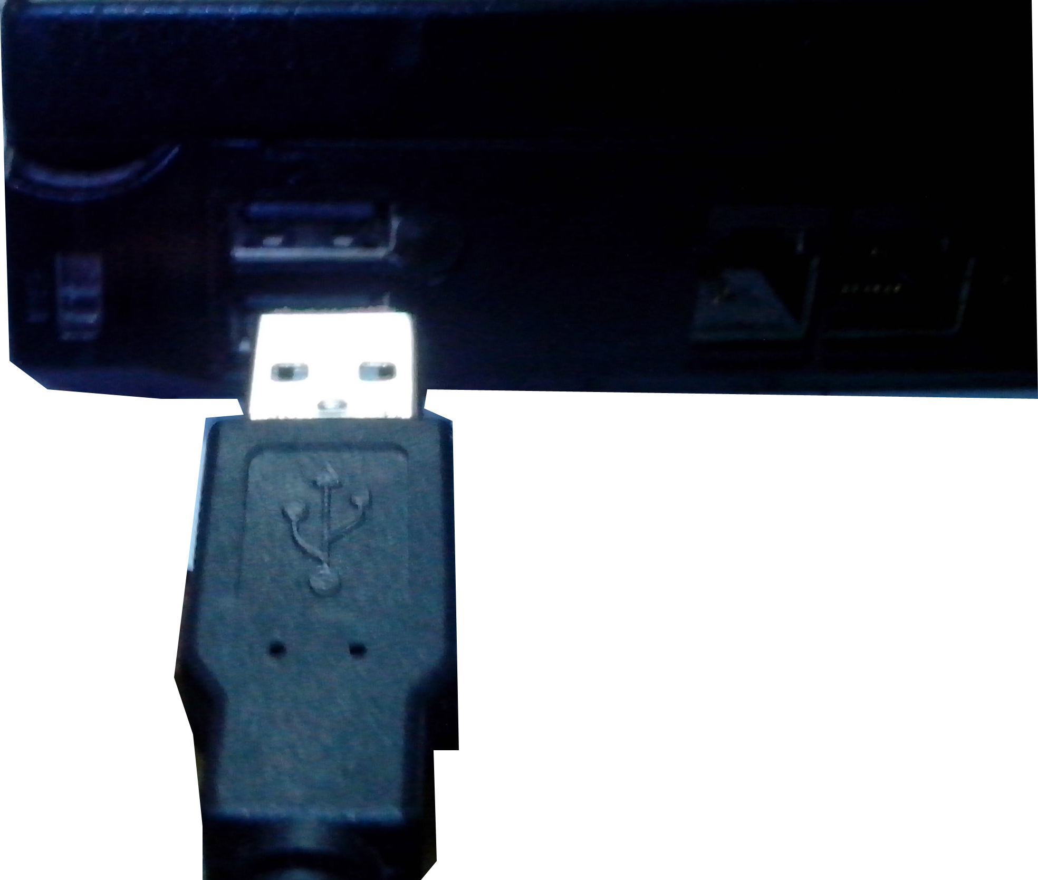  - Open the SWR iLab V8.0.  - Click the 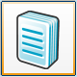 to create new experimental template.
  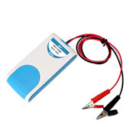
  Measuring range: | -60mV~+60mV
  Resolution: | 0.03mV
  Accuracy: | ±0.5mV
  Notes:   | - The Micro Voltage Sensor needs calibration before use.  - The Micro Voltage Sensor should be parallel connected to circuit.  - The red conducting wire is connected to the high-voltage terminal and the black conducting wire is connected to the low-voltage terminal so that measured value is positive. Otherwise it will be negative.  - When measuring, please do not make the measured voltage exceeds the range of the sensor.
Address: No.14 Junnong Road, Qinhuai District, Nanjing, China
Website: //www.sinoswr.com Post Code: 210007
Tel: +86-400-828-8387
  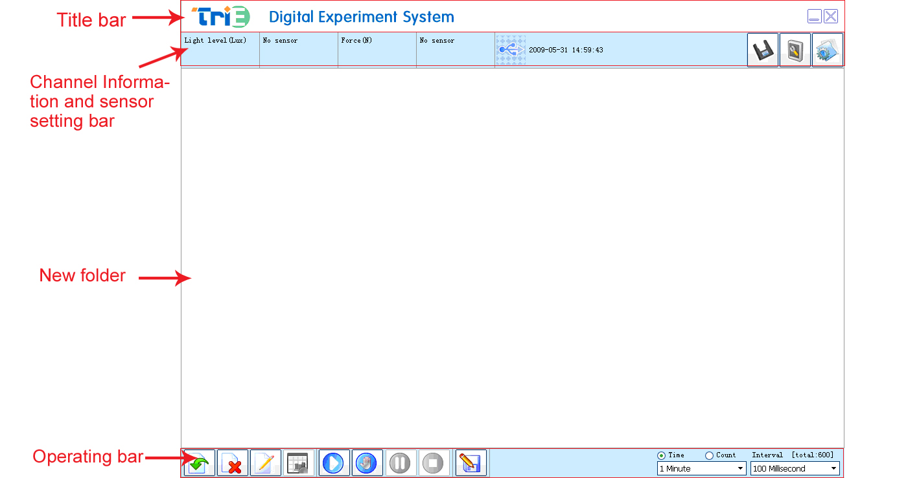 |   Lenz's law  Electromagnetic induction phenomenon  LC oscillation  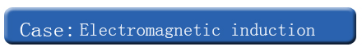  - Connect the experimental apparatus properly. Calibrate the current sensor and voltage sensor.  - Open the SWR iLab. Click ‘new’ to create an experiment.  - Click ‘New page’ button to create a new folder.  - Click “Add line” button to add the Voltage-Time and Current-Time coordinate. Set proper acquisition time and interval.  - Click ‘Start’ button to collect data. During this period, move the bar magnet to change magnetic flux that goes across the closed circuit.  - After collecting, observe the induced electromotive force and induced current change with respect to time.  - Clear the experimental apparatus.  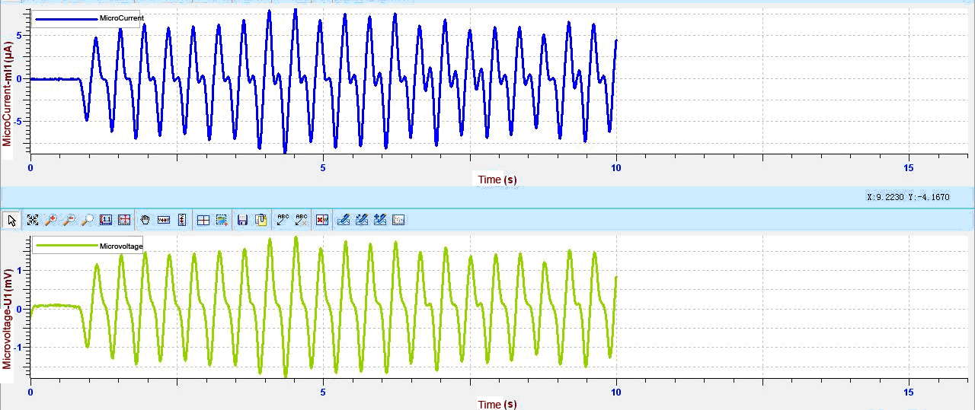  Fig.1
  Device status: | The icon shows blue. It means that the sensor has been recognized by the software.
  Rapid experiment: | Click the 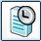 button. System will create a new experimental template.
  Start: | Click the button. System will start collecting data.
  Stop: | Click the 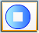 button to stop collecting data.
  Zone select: | Click the button to select the data area need to be analyzed.
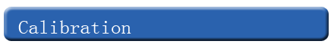  ZC0002 Micro Voltage Sensor needs calibration before use. After connecting the sensor to datalogger, open the SWR iLab v8.0. Click the 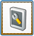 calibration button and short connect the red and black alligator clips.  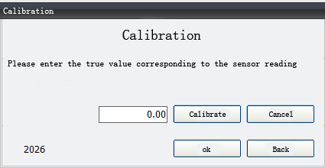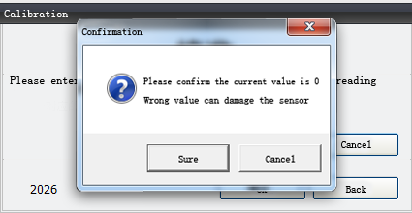  1. Click ‘Calibrate’ 2. Click ‘Sure’  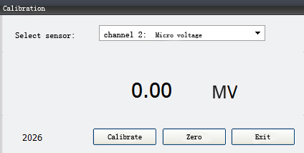  3. Click ‘OK’ 4. Click ‘Exit’ |   - The Micro Voltage Sensor should parallel connect in the circuit. Calibrate the Micro Voltage Sensor before making measurement.  - Never let the voltage under measurement exceeds the measuring range of sensor when measuring.  - If possible, ground the negative pole (the black alligator clip) of the sensor to obtain higher measuring accuracy.

