  Voltage Sensor  ZC0001  Product specification: |   ZC0001 Voltage Sensor is used to measure the potential difference at the ends of the electronic components.    Data cable (USB interface)  Computer installed with SWR iLab v8.0 and above    1. Connect the Voltage Sensor to computer by USB cable.  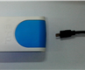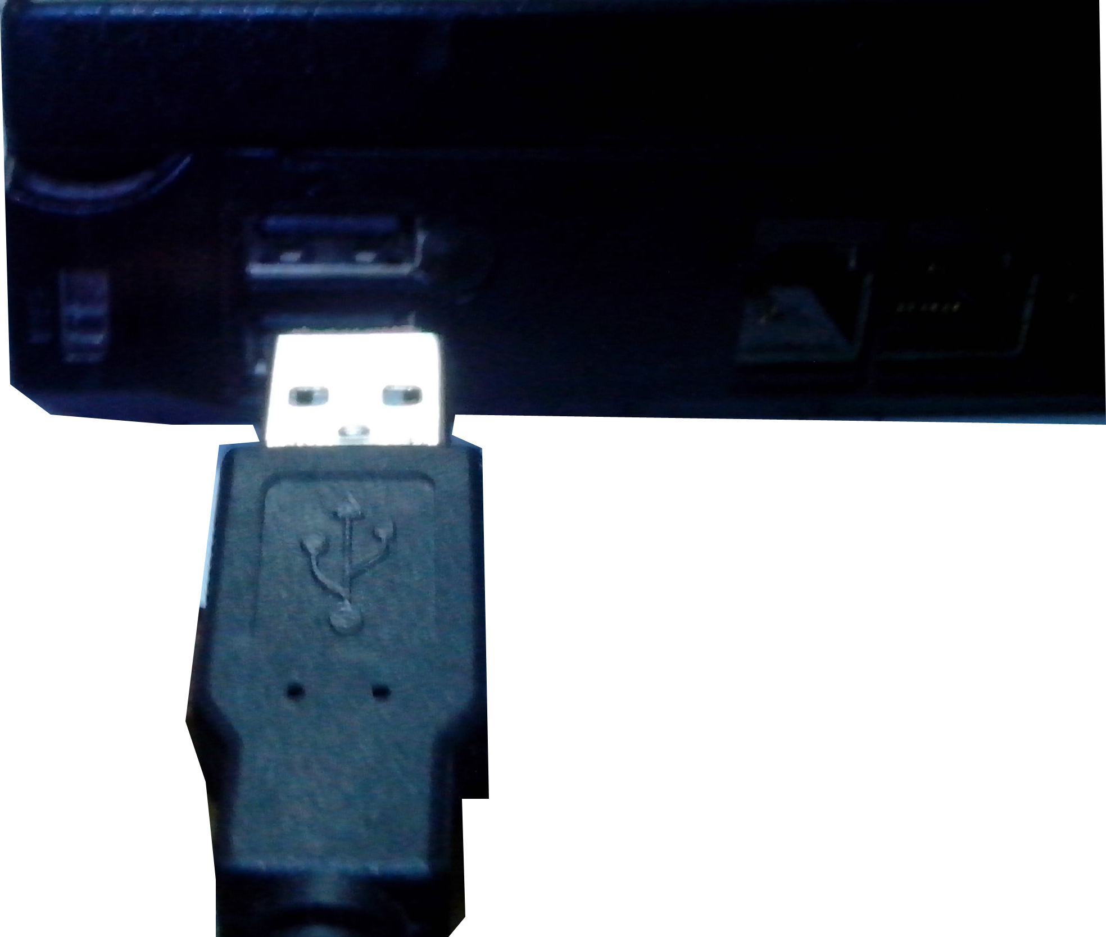  - Open the SWR iLab V8.0.  - Click the  to create new experimental template.
  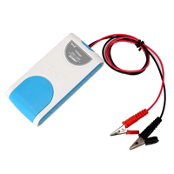
  Measuring range: | -25V～＋25V
  Resolution: | 0.01V
  Accuracy: | ±1%F.S
  Notes:   | 1.The Voltage Sensor needs calibration before use.  2.The red conducting wire is connected to the high-voltage terminal and the black conducting wire is connected to the low-voltage terminal so that measured value is positive. Otherwise it will be negative.  3.When measuring, please do not make the measured voltage exceeds the range of the sensor.  4.Do not plug in and out USB frequently. Minimum plug interval is 2s.
Address: No.14 Junnong Road, Qinhuai District, Nanjing, China
Website: //www.sinoswr.com Post Code: 210007
Tel: +86-400-828-8387

  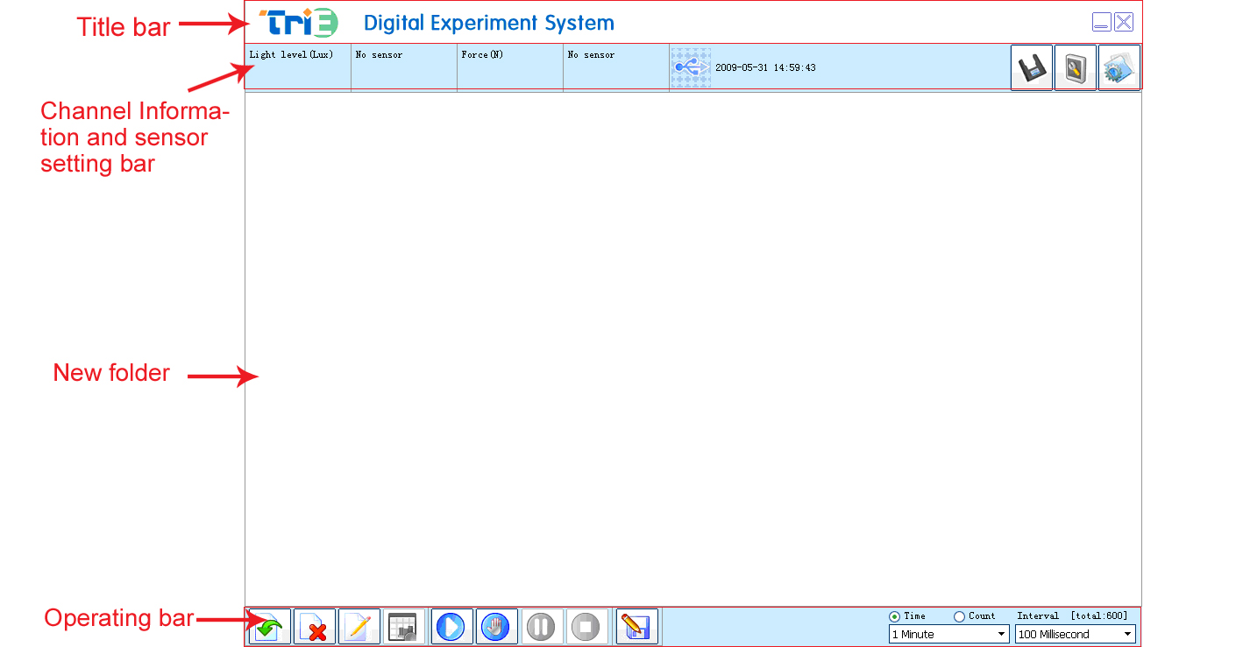 |   1、Measure electrical potential of power supply and internal resistance  2、Measure VA characteristic of small bulb, diode and conductor  3、Ohm’s law  4、Series and parallel connection of resistor  5、LC oscillation  6、Series-parallel connection of capacitor    - Refer to【TM3001-EX05】LC Oscillation Circuit, set up the experimental apparatus.  - Calibrate the Voltage Sensor, then click the ‘Start’ button.  - Set the experimental time is 5s, interval is 1.25ms.  - Move the switch to position 0, now the capacitor is in charging.  - After charging, click the ‘Start’ button to start the experiment, and move the switch to position 1, the LC oscillation experiment starts.  - After data acquisition, click the ‘Stop’ button and analyze the experimental curve (as shown in Fig.1).  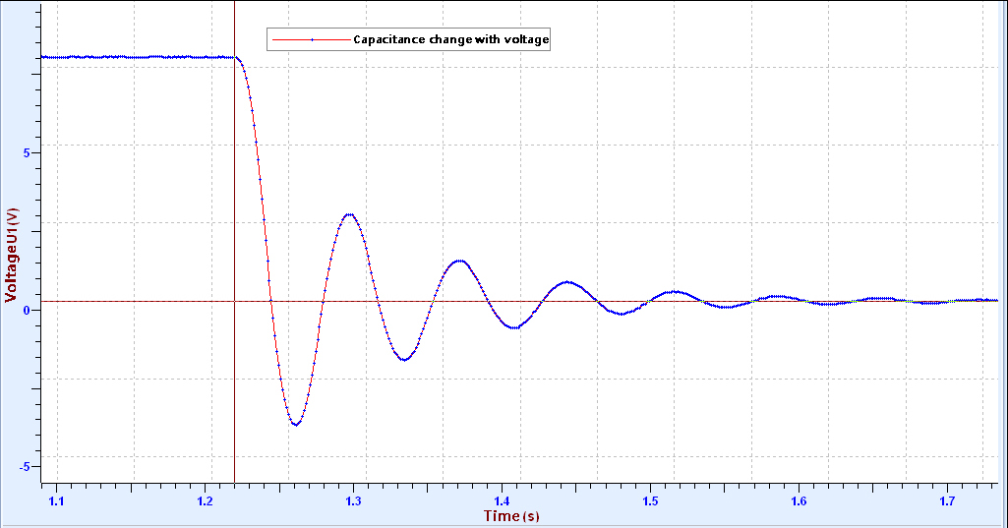
  Device status: | The icon shows blue. It means that the sensor has been recognized by the software.
  Rapid experiment: | Click the  button. System will create a new experimental template.
  Start: | Click the button. System will start collecting data.
  Stop: | Click the  button to stop collecting data.
  ZC0001 Voltage Sensor needs calibration before use. After connecting the sensor to datalogger, open the TriE iLab v8.0. Click the  calibration button and short connect the red and black alligator clips.  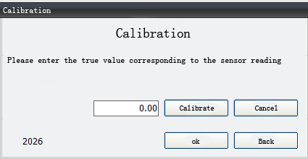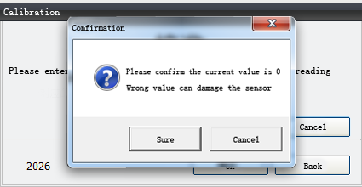  1. Click ‘Calibrate’ 2. Click ‘Sure’  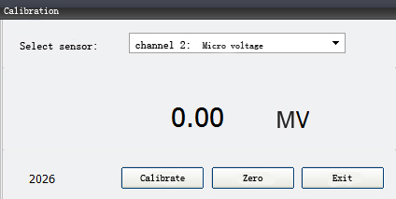  3. Click ‘OK’ 4. Click ‘Exit’ |   ZC0001 Voltage Sensor is used with electrics experiment plate TM3001. It can be used to perform lots of electric experiment in middle school. Connect black wire to circuit first. Connect red wire to circuit. When cut off the circuit, disconnect red wire first.

