
CO Sensor
Product No.: TS2226
Measuring range: 0-1000ppm
Resolution: 1ppm

Address: No.14 Junnong Road, Qinhuai District, Nanjing, China.
Website: //www.sinoswr.com
Post Code: 210007
Tel: +86-400-828-8387

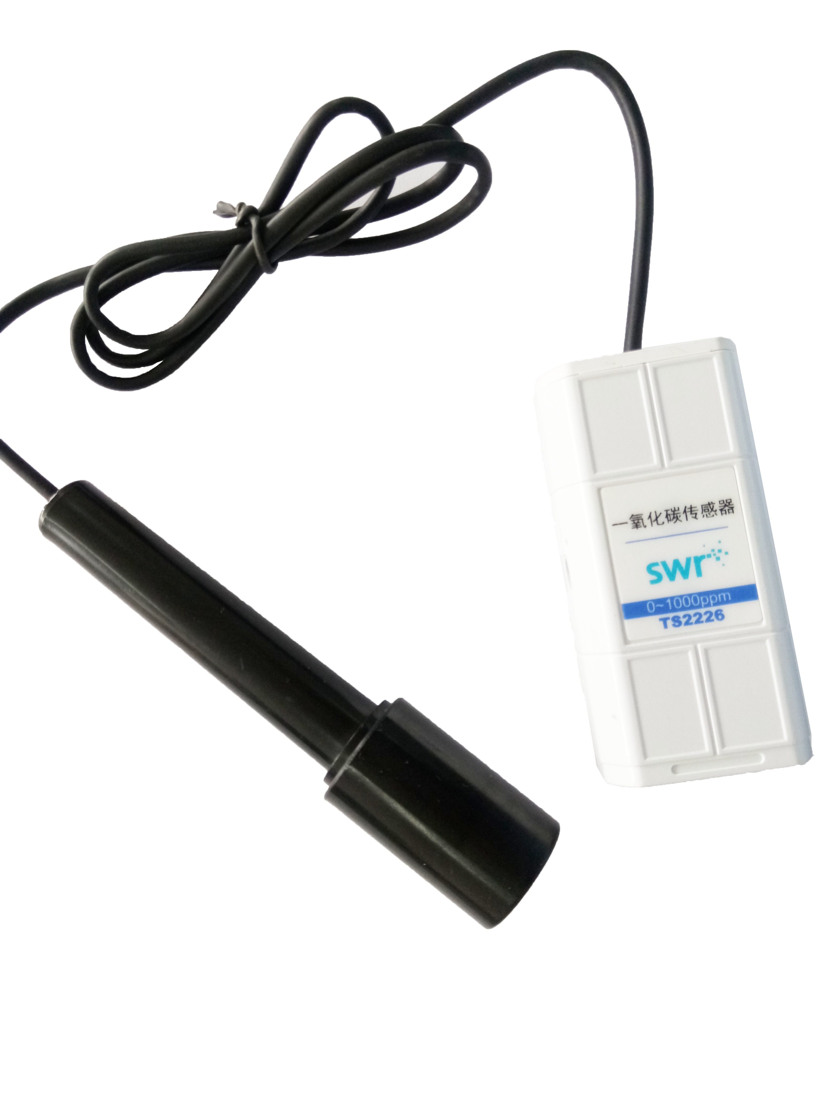
Introduction:
CO Sensor consists of a sensor and an electrode. The electrode is a mixing CO sensitive component containing thermistor. There is solid positive ion electrolyte between two electrodes. When it is exposed in CO, electrochemistry reaction will occur.
When CO Sensor is working, internal circuit heats it up. When the temperature reaches a certain value, the component works as a battery and output voltage signal at both ends of it. The amplitude of signal decides the concentration of CO.
Usage:
1. Connect electrode to sensor, datalogger and computer.
2. Open SWR iLab. CO Sensor has been calibrated before manufacturing. Expose CO Sensor electrode in the air with CO and click ‘Start’ to collect data.
3. After measuring, click ‘Stop’ to finish the experiment.
4. Observe and analyze the experimental result.
Typical experiment:
Produce CO using concentrated sulfuric acid
Detect concentration of CO when coal inadequate combustion
Notes:
1. CO Sensor needs to be preheated before using.
2. Do not touch it to liquid or other organic matter. Use and preserve it in dry place. Otherwise, those matters could damage the electrode.
3. CO Sensor electrode has limited service life according to its working principle.
4. Data display will be delay due to electrochemistry.
5. CO is kind of flammable and combustible gas. It can form explosive mixture with air and explode when it meets open fire or high temperature.
6. The explosion limitation of CO and gas mixture is 12%～75%.
7. The CO Sensor electrode is gas-permeable membrane electrode. Try not to break the membrane during using.

