
Methane Sensor
Product No.: TS2225
Measuring range: 0-50000ppm
Resolution: 1%
Address: No.14 Junnong Road, Qinhuai District, Nanjing, China.
Website: //www.sinoswr.com
Post Code: 210007
Tel: +86-400-828-8387

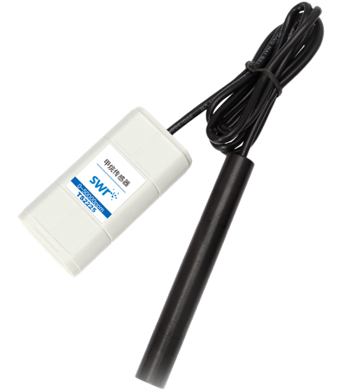
Introduction:
The working principle of Methane Sensor catalytic combustion effect. Two arms of bridge of sensor consist of sensing element and compensating element. The resistance of sensing element increases when it detects combustible gas so that voltage will change. The changing of voltage will increase with concentration of gas. The detecting element is used as reference and compensation of temperature.
Usage:
1. Connect Methane Sensor to datalogger and datalogger to computer.
2. Open SWR iLab. Click ‘New’. Wait until the sensor becoming stable and click ‘Start’ to collect data.
3. Click ‘Stop’ after collecting.
4. Take out the sensor and preserve it in dry place.
Typical experiment:
Produce methane
Combustion reaction of methane
Notes:
Methane is combustible asphyxiant gas. Do not inhale it during experiment.
Do not immerse the electrode in liquid otherwise it will damage the electrode.
Preserve the electrode in dry place.

