
Address: No.14 Junnong Road, Qinhuai District, Nanjing, China.
Website: //www.sinoswr.com
Post Code: 210007
Tel: +86-400-828-8387

ECG Sensor
Product No.: TS2210
Measuring range: -5mV～+5mV
Resolution: 0.0025mV
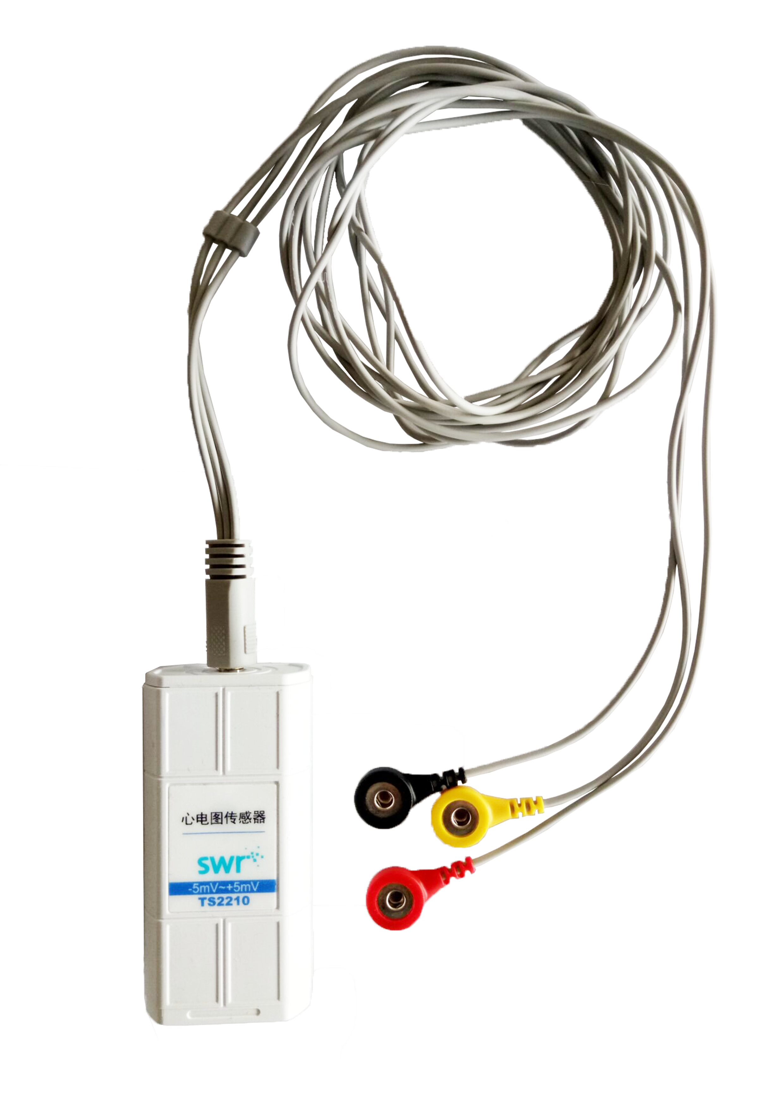
Introduction:
ECG Sensor is used detect the micro voltage produced by heartbeat. Two wires are used to measure the change of voltage and convert them into electric signal. The change of voltage is displayed in wave form.
Electrode Patches:
Electrode patches is silver-gilt solid/ AgCl colloid on the metal. It is a kind of hypoallergenic substance which can be attached on skin. The metal piece provides long touching area and gel provides skin resistance. To ensure good effective, the touched skin should be wet. Use tissue to wipe out oil and dead skin (alcohol is suggested). When electrode patches falls off, it should not be used again.
Position of electrode patches:
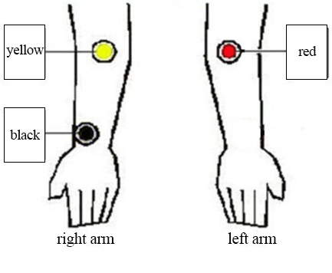
There are three electrode wires on the ECG Sensor. Each of them has electrode patch with different colors. The red one is the anode. The yellow one is cathode. The reference point (isopotential line) is black.
Experimental Case:
Measure the human electrocardiogram
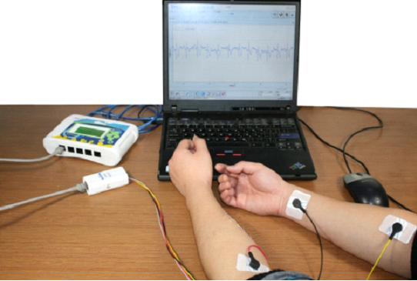
Product General Assembly
1. Connect apparatus as shown above. Connect ECG Sensor to datalogger and datalogger to computer.
2. Open SWR iLab to create new experiment. Add ‘ECG-Time’ coordinate. Set experiment time 30s and acquisition interval 5ms.
3. Attach electrode patches on arms as shown above. Be careful of the color of electrode patches.
4. Click ‘Start’ to collect data.
5. Click ‘Stop’ to stop experiment. Observe experimental result.
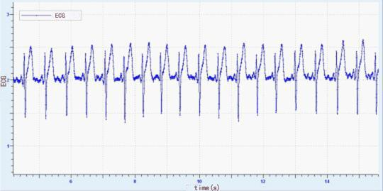
ECG
Notes:
- After all electrode patches are connected well with all wires, it can only start collecting the data after at least 15 seconds. Because it will provide some time for reference electrode to establish wave form. The time delay relies on physical property of individual and the electrode’s output. If collect data before this time, it may occur a straight line or various unknown value.
- A good contact between the electrode patches and skin is the key point to obtain a good result. It is better keep the skin which will be attached wet enough. Clean the skin to remove the oil and dead skin by tissue or alcohol. Clean the skin gently by an abrasive substance.
- Cough, sneeze, laugh, walk and talk will affect the readings. When doing experiment, please being relax and calm down.
- When testing the excise effect, remove the electrode and keep it still. After exercising, reconnect the electrode. Click ‘Curve duplication’ in ‘Analysis’. it will record data without clear the previous result.
- The electrode patches can not be reused. In order to keep the electrode wet, do not open the pack.
- This product is designed to certify ECG wave form but can not be used for medical diagnosis. Information produced by most signals is pointless to any medical purpose.
- If the electrode pack is opened, please keep it in a dry and cool place.

