
Address: No.14 Junnong Road, Qinhuai District, Nanjing, China.
Website: //www.sinoswr.com
Post Code: 210007
Tel: +86-400-828-8387

Conductivity Sensor
Product No.: TS2203
Low range: 0～3000μS/cm
Resolution: 0.7μS/cm
Accuracy: ±1μS/cm
High range: 0～30 000μS/cm
Resolution: 8μS/cm
Accuracy: ±1μS/cm
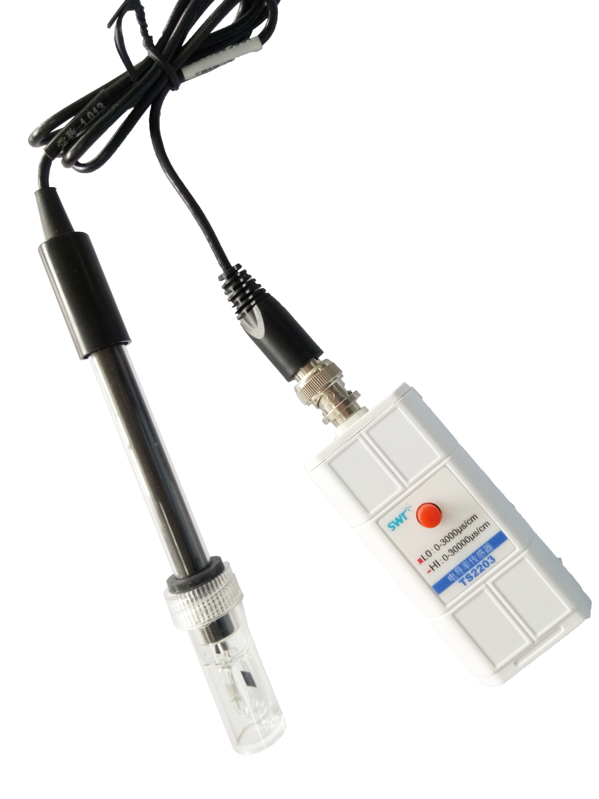
Introduction:
Conductivity Sensor is used to measure the solution’s conductivity and its change. It can not distinguish the kind of ion, but it can determine the concentration of ion in solution. Conductivity of solution depends on ability of current conduction of solution in two poles. This ability depends on quantity of charge carrier, moving speed and electric charge on single carrier.
There are two pieces of platinum gauze electrodes built-in the glass base of the electrode. The area (S) and distance (L) of platinum gauze electrodes are fixed. The structure of electrode is sintering two pieces of platinum gauze on the inner wall of parallel glass tube. The measuring principle is placing two pieces of parallel counter electrode into the liquid to be measured. Apply electrical potential on both ends of them and measure the current passing through counter electrode. The resistance of solution between counter electrode can be calculated.
R=ρ*L/S
Where R is resistance and ρ is resistivity.
Resistivity is reciprocal of resistance:
G=1/R
R=ρ*L/S
Where R is resistance. The unit is Ohm (Ω), G is conductance. The unit is Simens (S).
G=λ*S/L
Where λ is conductivity.
The conductivity of common solution:
Solution | Conductivity (μS/cm) | Solution | Conductivity (μS/cm)
Distilled water | 0.5-5 | Rain | 20-100
Drinking water | 50-200 | Tube water | 100-1500
Demarcation:
1. Click the ‘Calibrate’ button in the software interface to open the calibration interface and select the Conductivity Sensor.
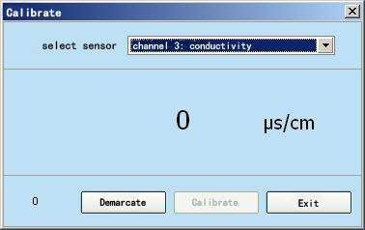
2. Put the conductivity electrode into the standard solution with the known conductivity, such as the conductivity water. Enter the corresponding value and then click ‘Demarcate’ button after keeping it stable for a while.
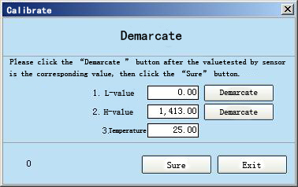
- Enter the current temperature then click ‘sure’ button. Temperature compensation is done.
Usage:
The product has two available measuring ranges. Before using, it needs to change the measuring range according to the indication on tag. The red button is pop-up means low measuring range is activated. Press it will become the high measuring range.
Before using, please dip the conductive electrode into the deionized water or distilled water to ensure the electrode is clean. Dry its surface using tissue.
Connect the sensor, datalogger to computer correctly. Open the datalogger and software. Calibrate the sensor using conductivity water. When measuring, fix the electrode well and the front end of the electrode should be completely dipped into the testing solution.
Typical experiment:
Compare the conductivity of different solution
Reaction of phenol and saturated bromine water
Explore the purity of drinking water
Relationship between cell size and translocation of solute
Experimental case:
Compare the conductivity of different solution
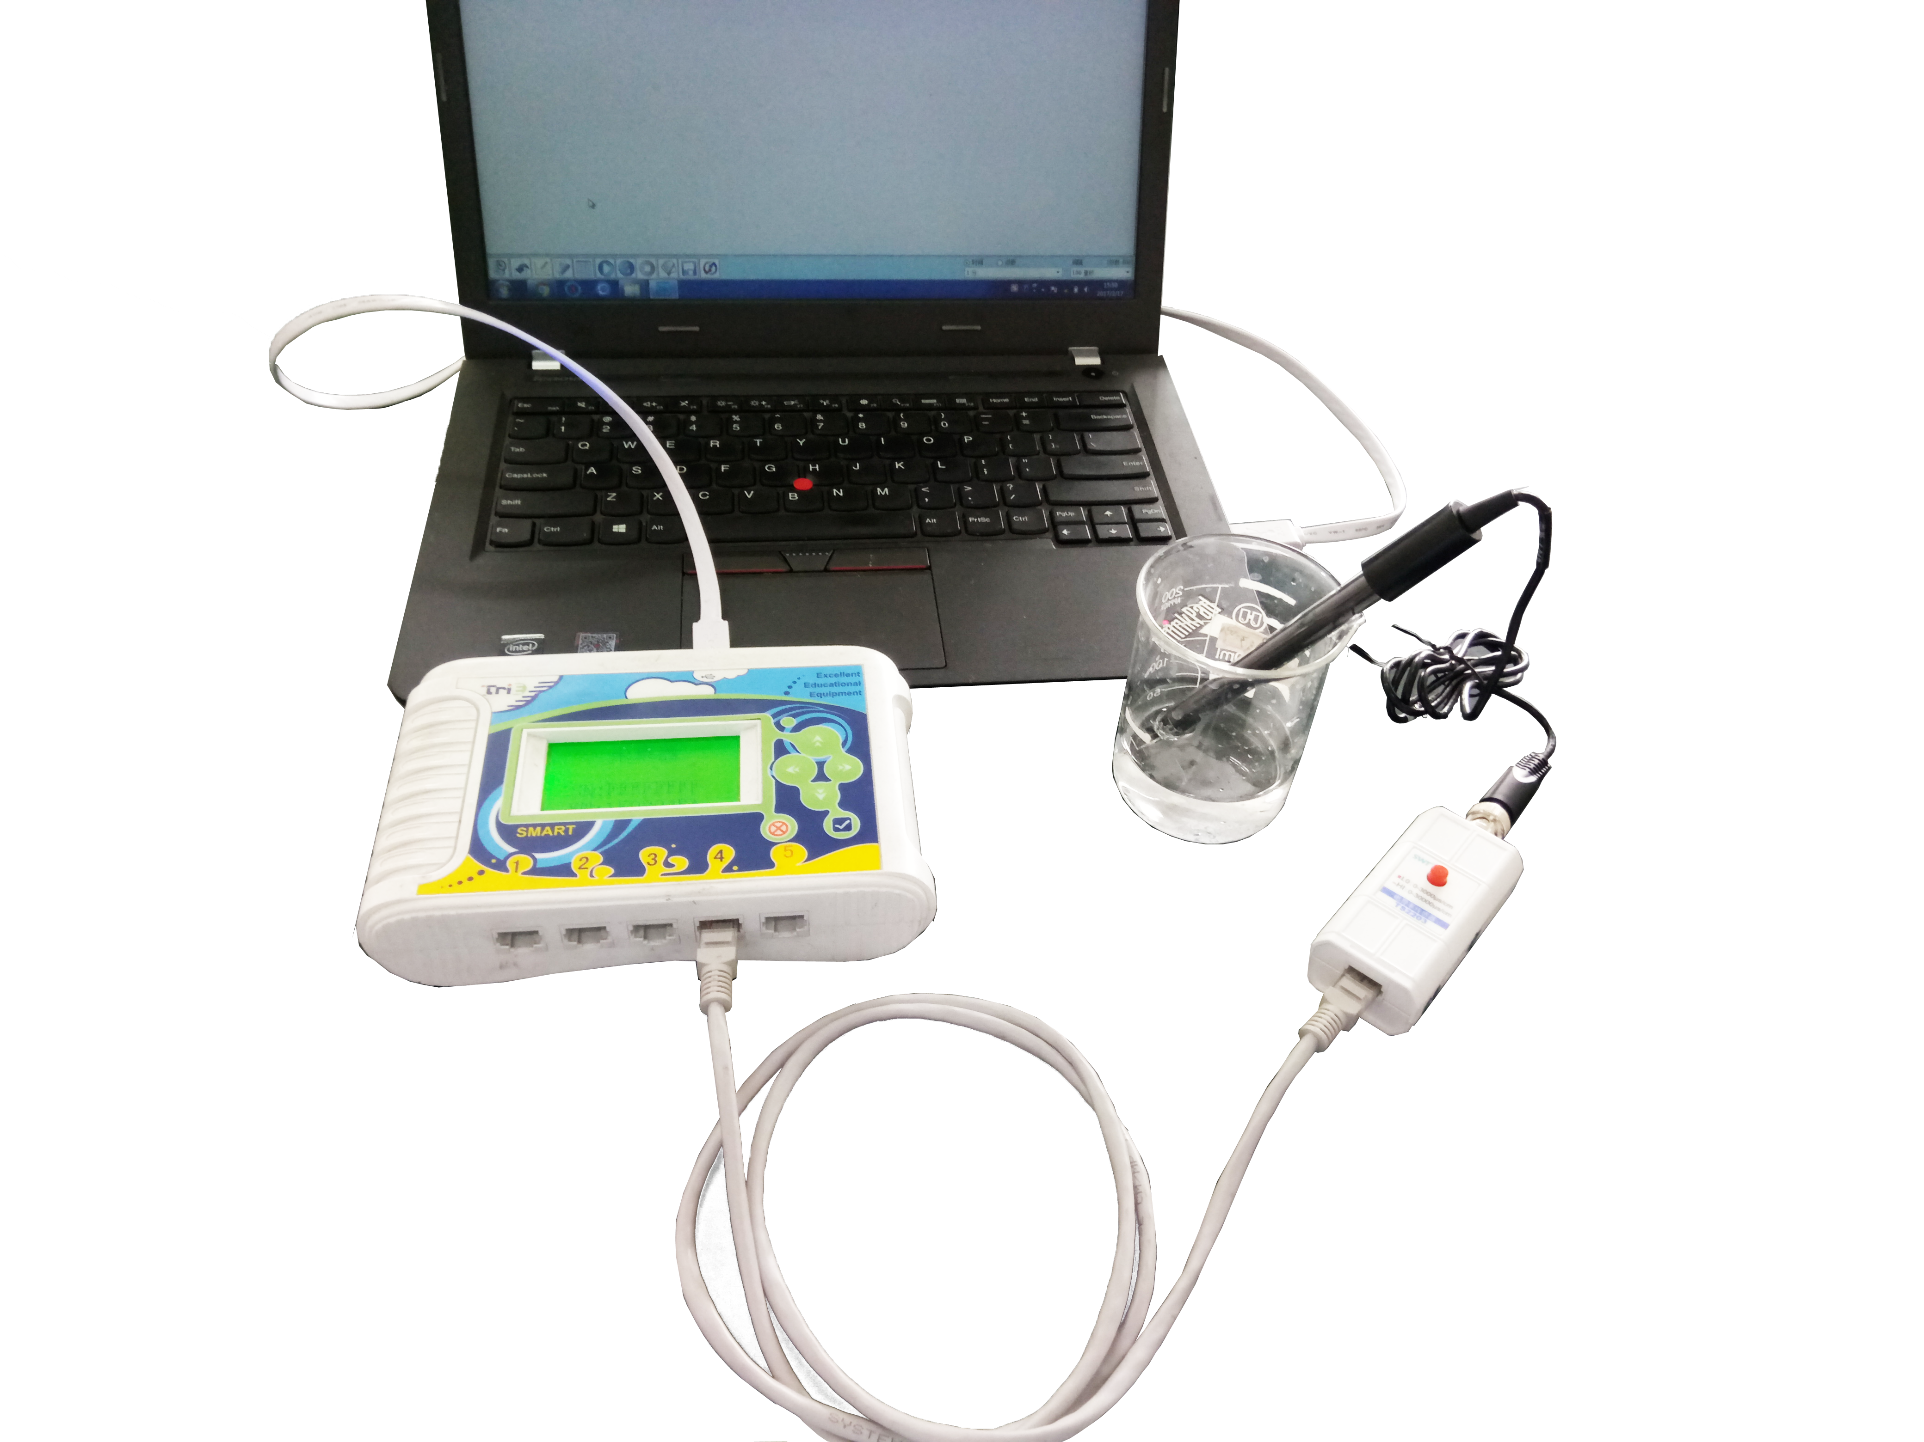
Product General Assembly
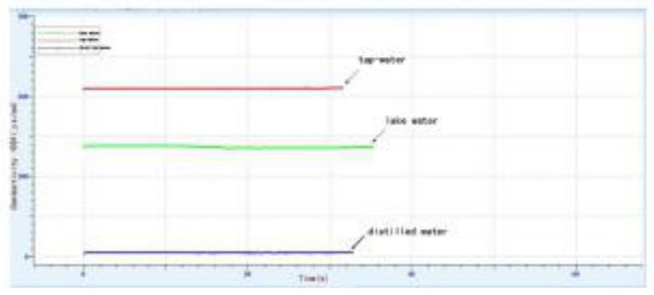
Conductivity of Different Water
Notes:
Clean the electrode completely to prevent from pollution after experiment.
Rinse the electrode after using. Dry it using filter paper and preserve it in dry place. The Conductivity Sensor electrode must be kept clean to avoid sediment and other scales.
Other sensors may affect the product but it will not be significant.
Keep the electrode away from the sticky organic liquid such as heavy oil, glycerol, or ethylene glycol. Do not let the electrode contact the non-polar solvent such as acetone, pentane or hexane.
The water soluble pollutant can be removed by the distilled water via immersion. The oily pollutant can be removed by warm water containing a small amount of detergent via immersion for 15 minutes. The ethanol or the acetone can be used to clean the electrode, but the cleaning time should not exceed 5 minutes. Lime or hydroxide cladding can be removed by immersing it into diluted acid solution for 15 minutes. After cleaning, rinse with the distilled water and then leave it dry for storage.

