
Address: No.14 Junnong Road, Qinhuai District, Nanjing, China.
Website: //www.sinoswr.com
Post Code: 210007
Tel: +86-400-828-8387
Quick-Temperature Sensor
Product No.: TS2120
Measuring range: -25℃～+100℃
Resolution: 0.1℃
Accuracy: ±0.6℃
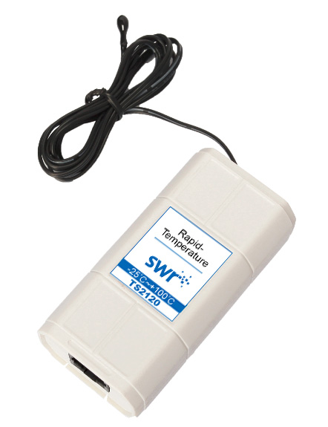
Introduction:
The sensing component of Quick-Temperature Sensor is semiconductor thermistor. When temperature changes, its resistance will also change. The relationship between resistance and temperature is liner within certain temperature range. When it touches to object need to be measured, it has very quick response. The Quick-Temperature Sensor can be used to measure the surface temperature of object, gas and liquid (non-corrosive).
Calibration:
TS2120 Quick-Temperature Sensor has been calibrated before manufacturing. You can calibrate it by using software if obvious error is occurred. Connect the sensor to datalogger. Put the probe into the ice-water mixture or the boiling water at the standard status and keep it still for a while.
Usage:
Semiconductor thermistor is fixed on the top of Quick-Temperature Sensor. Make sure the sensor semiconductor thermistor touching completely to the measured object to ensure the accuracy of measuring result.
Typical experiment:
Natural cooling of water.
Liquid cooling via evaporation.
Conversion between work and energy.
Explore relationship between boiling point and pressure of liquid.
Explore thermoelectricity.
Comparison on heat conduction performance of different substances.
Explore the regulation of temperature change when a solid melts.
Experimental case:
Comprise (expand) gas and temperature changing
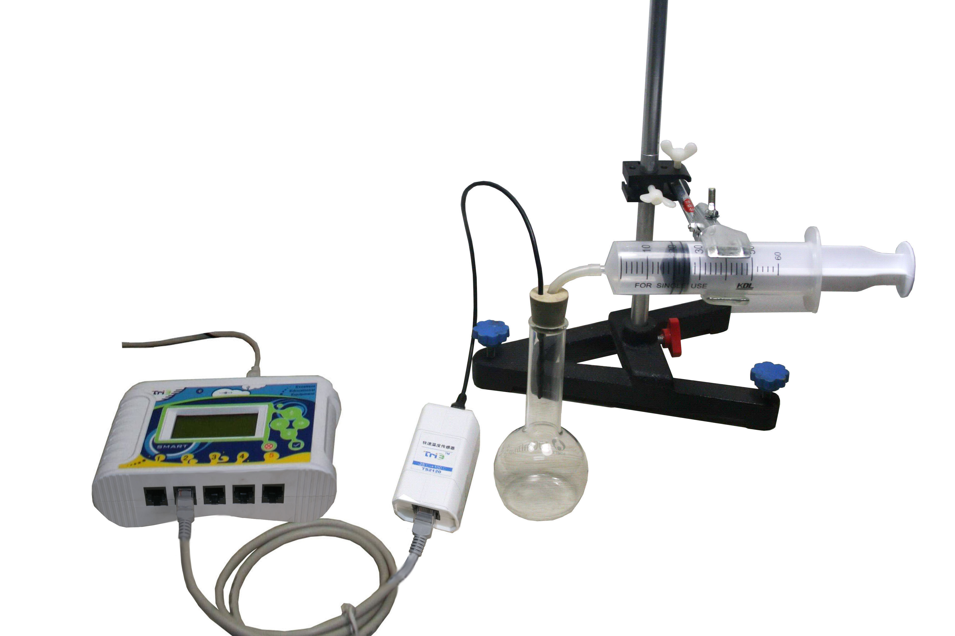
Product General Assembly
Experimental procedures：
- Connect experiment apparatus.
- Open SWR iLab v8.0. Click ‘new’ to create new experimental template.
- Click ‘new page’ to add new folder.
4. Click ‘add line’ to add ‘Temperature-Time’ coordinate. Set proper experiment time and acquisition interval.
5. Click ‘Start’ and push the syringe to compress gas Quickly.
6. Wait until the temperature is stable and click ‘Start’. Pull the syringe Quickly.
7. Click ‘Curve duplication’ to display two graphs in one figure.
8. Observe and analyze the experimental result.
9. Clear up experimental apparatus.
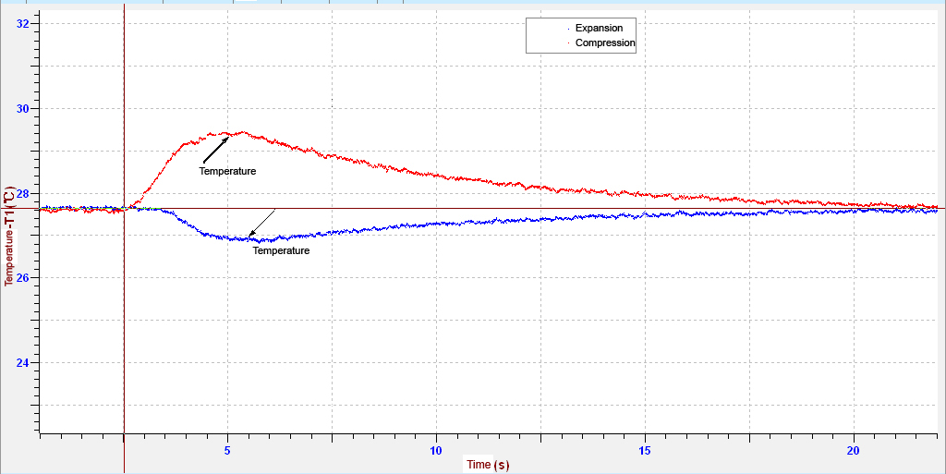
Temperature Changes with Respect to Time
Notes:
1. Never put any part of the sensor on open fire or heating disc directly.
2. Clean the sensor completely after using.
3. The temperature higher that 150℃ may damage the sensor.

