
G-M Sensor
Product No.: TS2113
Measuring range: 0～40000c/min
Resolution: 1c/min
Accuracy: ±2%
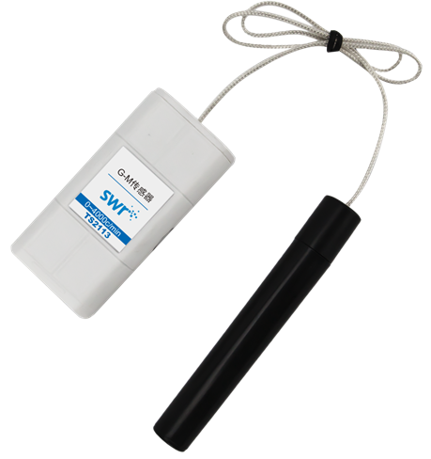
Address: No.14 Junnong Road, Qinhuai District, Nanjing, China.
Website: //www.sinoswr.com
Post Code: 210007
Tel: +86-400-828-8387

Introduction:
G-M Sensor is used to study radioactivity experiment. It is able to count active particles which passes through the probe. It is mainly used to measure intensity of γ-ray, β-ray and x-ray. The G-M Sensor tube wall is very thin. Be careful when using it. Do not knock on the probe in case damage it. Do not allow any foreign matter gets inside the probe.
The core component in G-M Sensor is G-M counter. It is sealed and has low pressure gas inside. High voltage is provided to G-M counter by sensor circuit so that strong electric field is formed in G-M counter. When incident particles get inside G-M counter, it militate with the gas inside counter and produce ion pair. They are accelerated by electric field and crash on other gas atom. Eventually it will form electric pulse. In the G-M counter, incident particles is only a trigger for discharging. Therefore, its output voltage pulse has nothing to do with the property and energy of the incident ion. G-M Sensor can not be used to measure the energy of the incident particle but only measure the quantity.
Calibration:
Calibration is not required.
Usage:
G-M Sensor is not complicated. It is only required to connect all relative device. The G-M Sensor probe tube wall is very thin. Be careful when using it, do not knock on the probe in case damage it.
Typical experiment:
- Measure radioactive source count rate
- Measure background counting rate
- Radioactive shield
- Study relationship between radioactive intensity and distance
- Measure radioactivity of building materials.
Experimental case:
Radioactive shield
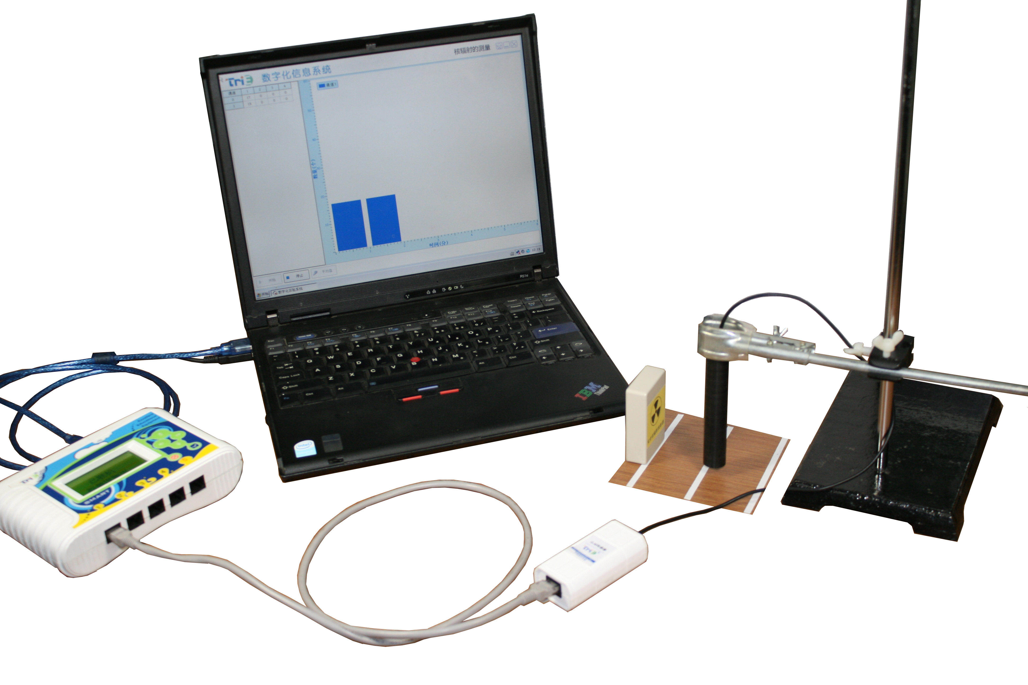
Product General Assembly
Experimental procedures：
- Connect experiment apparatus. Connect G-M Sensor to datalogger and datalogger to computer.
- Open SWR iLab v8.0. Click ‘New’ to create new experimental template. Click ‘rapid experiment’.
- Place G-M Sensor probe 0cm away from radioactive source.
- Set experiment time ‘10min’ and acquisition interval ‘100ms’. Click ‘Start’.
- Click ‘OK’ when the experiment is completed. Click ‘Curve duplication’ in ‘Curve manager’.
- Place G-M Sensor probe 5cm away from radioactive source. Click ‘Start’.
- Click ‘OK’ when the experiment is completed. Click ‘Curve duplication’ in ‘Curve manager’.
- Place G-M Sensor probe 10cm away from radioactive source. Click ‘Start’.
- Observe the experimental result.
- Return the radioactive source once the experiment is completed. Wash hand using soap.
- The radioactive affects less when it is placed further away.
Notes:
1. Do not knock on probe otherwise it will be broken easily.
2. Although the radioactive source used in school is normally weak, you still have to be careful with it.
3. Use pliers or other fixture to operate radioactive source. Do not place it near yourself or others.
4. Clean your hands after experiment.
5. Preserve the radioactive source properly. Lock and tag it.

