
Address: No.14 Junnong Road, Qinhuai District, Nanjing, China.
Website: //www.sinoswr.com
Post Code: 210007
Tel: +86-400-828-8387

Light Sensor
Product No.: TS2110
Low range: 0～6000Lux
Resolution: 1.5Lux
Accuracy: ±5%
High range: 0～50000Lux
Resolution: 12.5Lux
Accuracy: ±5%
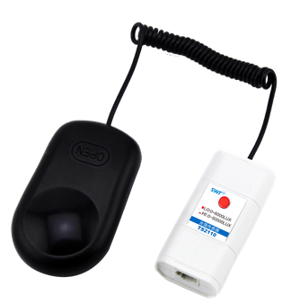
Introduction:
The sensing component in Light Sensor is silicon photocell. It is able to transfer light intensity to voltage signal which is direct proportional to it. The valid spectrum wavelength of Light Sensor is 380nm~730nm, which is ideal visible light section.
The sensing component of Light Sensor is placed in the front end of probe. The red button on Light Sensor is used to shift the measuring range. Press the button and the measuring range will become 0～50000 Lux. Otherwise it will be 0～6000 Lux.
Calibration:
Calibration is not required.
Usage:
The usage of Light Sensor is simple. Connect Light Sensor to datalogger and datalogger to computer. Open relative software to measure the light. Remove the probe’s black cover before measuring. Be careful when selecting measuring range.
Typical experiment:
Explore the relationship between illumination and distance
Explore the diffraction, interference and polarization of light
Experimental case:
Explore the relationship between illumination and distance
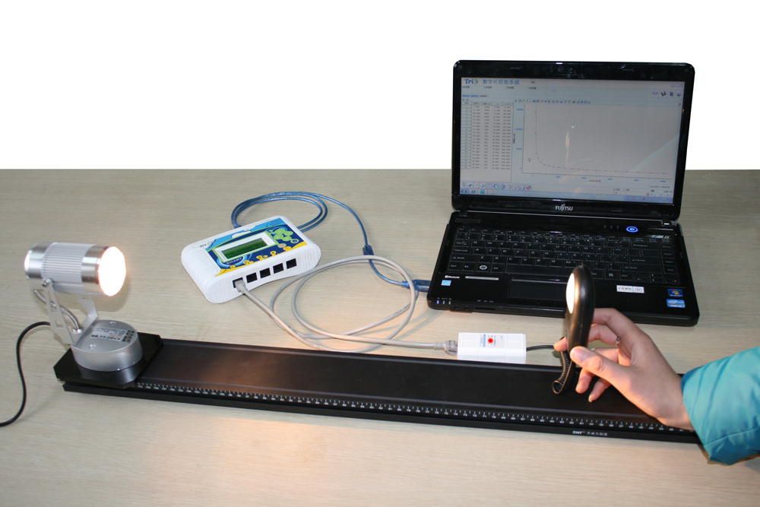
Product General Assembly
Experimental procedures：
1. Connect experiment apparatus.
2. Open SWR iLab v8.0. Click ‘New’ to create new experimental template. Click ‘New page’ and select the sixth template to create new folder.
3. Click ‘add line’ to add ‘Light-Distance’ coordinate. Click ‘list select’ at upper left corner. Set proper collecting time and acquisition interval such as 1min, 100ms.
4. Put the Light Sensor 5cm away from the point light source.
5. Click the ‘Manually’ button to collect the experimental data.
6. Move the Light Sensor 1 more cm away from the light source.
7. Repeat procedure 5 and 6 till enough data points are collected.
8. Click ‘Stop’ button to complete data acquisition.
9. Analyze the experimental result
10. Clear up experimental apparatus.
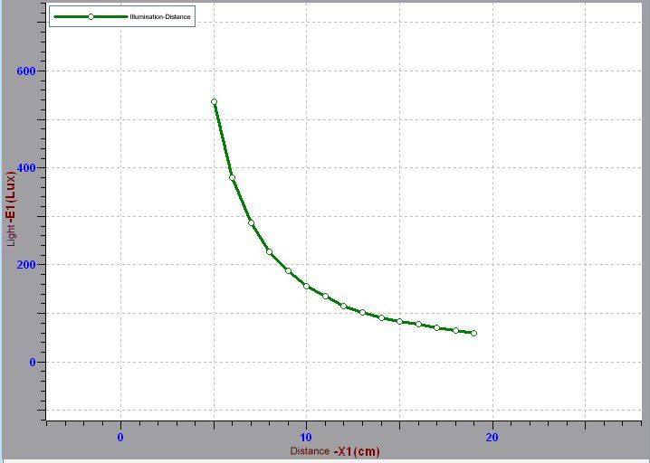
Illumination-Distance Curve
Notes:
1. Keep the probe aim to the light source when using it.
2. Select the proper measuring range when measuring in order to ensure the accuracy of experimental result.

