
Temperature Sensor
Product No.: TS2104
Measuring range: -50～+150℃
Resolution: 0.05℃
Accuracy: ±0.5℃
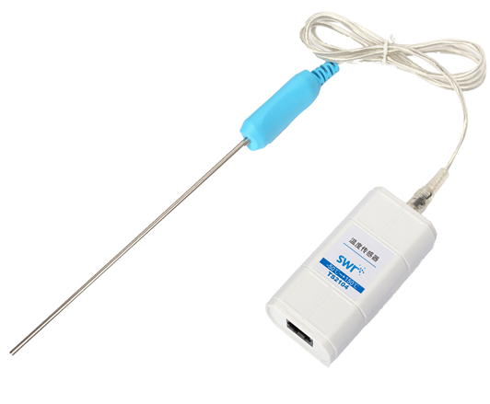

Address: No.14 Junnong Road, Qinhuai District, Nanjing, China.
Website: //www.sinoswr.com
Post Code: 210007
Tel: +86-400-828-8387

Introduction:
Temperature Sensor is designed with stainless rod and built-in rapid temperature probe. Handle of the sensor is made by injection modeling high temperature resistant ABS. It connects to transparent 3.5mm earphone cable. Temperature Sensor has features such as rapid temperature sensing, resistant to corrosion, high temperature, friendly and wonderful appearance. It is suitable for experiment of physical, chemical and biological module.
The sensing component of Temperature Sensor is semiconductor thermistor. When temperature changes, its resistance will also change. The relationship between resistance and temperature is liner within certain temperature range. When it touches to object need to be measured, it has very quick response. The Rapid Temperature Sensor can be used to measure the surface temperature of object, gas and liquid (non-corrosive).
Temperature Sensor is designed with NTC electronic element. When ambient temperature changes, resistance of NTC will also change. The sensor does not require calibration and it is relative high stable. The sensor is widely used in measuring temperature within medium and low range.
Usage:
The NTC electronic element which placed at top of the sensor is the key sensing component. Make sure the sensor probe touching completely to the measured object to ensure the accuracy of measuring result.
Typical experiment:
Natural cooling of water
Liquid cooling via evaporation
Conversion between work and energy
Explore relationship between boiling point and pressure of liquid
Explore thermoelectricity
Comparison on heat conduction performance of different substances
Converge of convex lens
Experimental case:
Natural cooling of water:
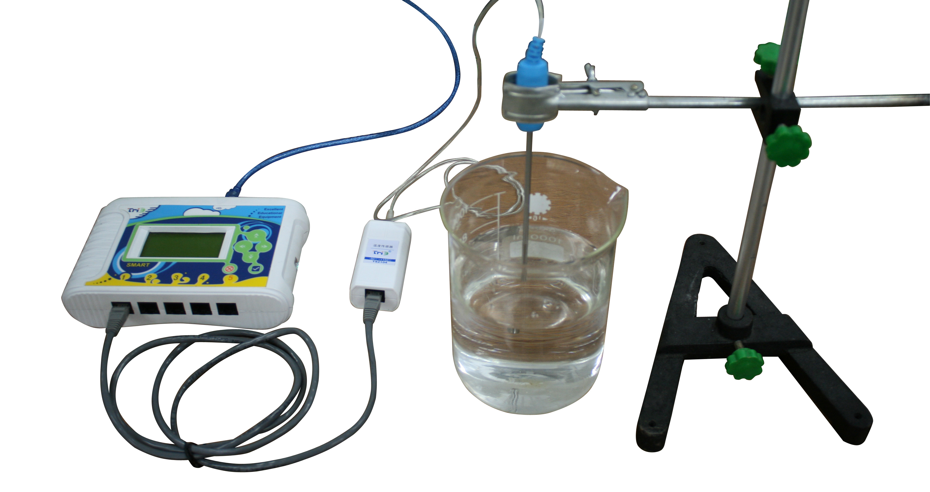
Product General Assembly
Experimental procedures:
- Connect apparatus as shown above.
- Open the SWR iLab V8.0.
- Click ‘rapid experiment’ to create new folder.
- Set proper experiment time and acquisition interval such as 1min, 100ms.
- Fix Temperature Sensor probe in beaker. Pour hot water into beaker.
- Click ‘start’.
- Click ‘stop’ when collecting is completed. Observe temperature change with respect to time.
- Clear up the apparatus.

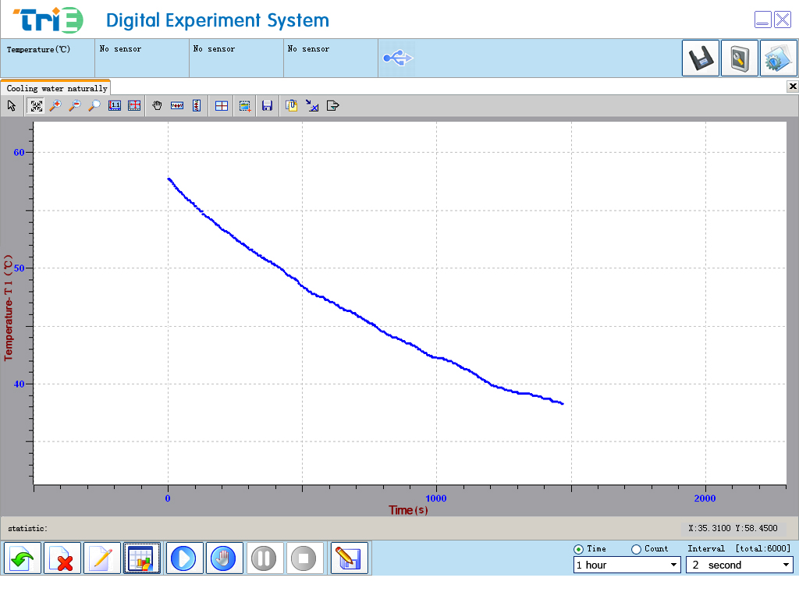
1

Temperature Changes with Respect to Time
Notes:
- Never place the Temperature Sensor probe on or in open fire or heating disc directly.
- Never immerse other parts of the Temperature Sensor other than its stainless steel bar into liquid when measuring its temperature.
- Clean the Temperature Sensor completely after using.
- Temperature exceeding 150℃ may damage the sensor.

