Constant
Introduction to product 1
1. Brief to Super Datalogger 1
2. Features of Super Datalogger 1
Introduction to parts 2
3. Function of ports in Super Datalogger 2
4. USB cable 4
5. Data cable (network cable) 5
6. Deconcentrator 5
Specification 6
Connect Super Datalogger to computer 7
7. Connect via cable: connect to computer via USB cable 7
8. Blue tooth connection: wireless connect to computer via Bluetooth 8
Connect Super Datalogger to sensor 8
Data collection by experiment software 9
Independently collect data 10
Case 11

Introduction to product

1. Brief to Super Datalogger
TS1010 Super Datalogger is designed and manufactured by Jiangsu SWR Science & Technology Co., Ltd. It is used to connect to network sensors, convert and transfer data. It is suiTab.for primary school science, physics, chemistry and biology for junior high school and some digital experiment for senior high school.
It can be used to replace most of datalogger sold by SWR because it is an update of old version. It can be connected to computer via cable or Bluetooth. It also can collect data with sensors independently. It accepts exporting data to computer after data collected by sensors.

2. Features of Super Datalogger
- Small size, easy to carry, fast data collecting.
- Built-in 16M ROM.
- Built-in double Bluetooth model and supports Bluetooth 2.0 and 4.0.
- Six kinds of sensors in datalogger. Easy to collect, convert and transfer data.
- It is designed with sleep mode. When power supply is not enough during collecting independent, device will automatically shift to sleep mode to save power.
- After it is used independently and connect to computer, once setup is completed, it will auto collect and save data.
- The device will not shift to sleep mode when it is connect to computer via Bluetooth. When Bluetooth is turned off, it will stop collecting automatically and start sleep timing.
- User can use up to four sensors simultaneously during one experiment. These four input ports are same. User can also use deconcentrator to extend amount of sensors can be connected to eight.

Introduction to parts

3. Function of ports in Super Datalogger
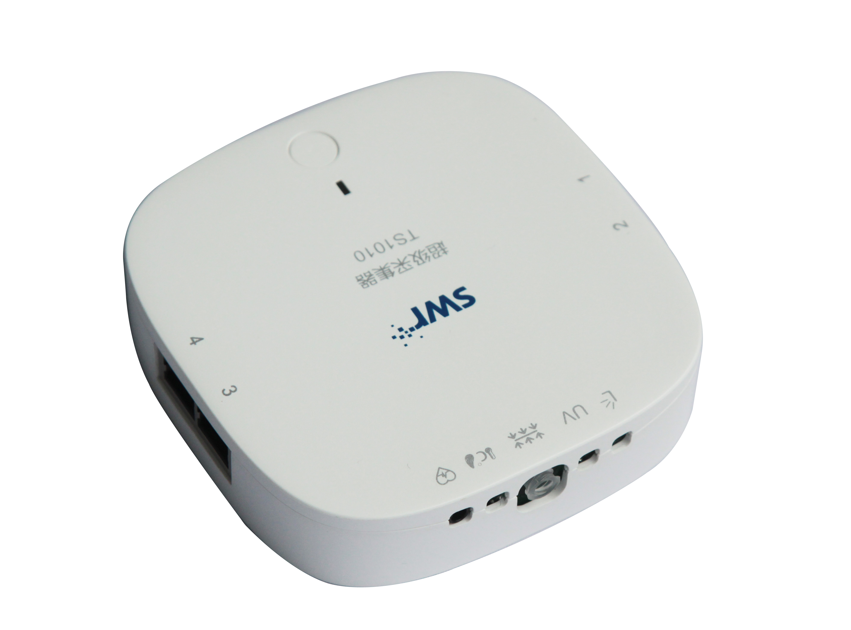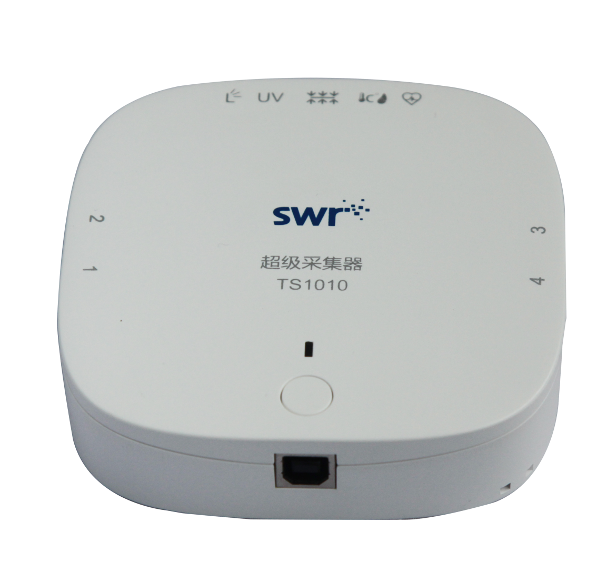
①1
②
③
④
⑤
Fig.1: Super Datalogger
① Indicator: refer to Tab.1.
② Network cable port (RJ45): used to connect to network sensor via network cable or deconcentrator.
③ Position of built-in sensors: from left to right, sensors are temperature, turbidity, UV, light, pressure and heart rate sensor.
④ Power switch: hold to turn on/off.
⑤ USB port: used to connect to computer via USB cable for power supply and data transfer.
Function of indicator
Red 1S blink | Low battery warning
Green lighting | Switched on (USB connect, default condition and not connected to software)
Green 0.5s blink | USB data transfer
Green BLN blink | Connect USB to software (no data collecting)
Blue lighting | Switched on (Bluetooth connected and not connected to software)
Blue 0.5s blink | Bluetooth data transfer
Blue BLN blink | Connect to software via BLE (no data collecting)
Tab.1: Indicator Functions
Sensor parameter
Built-in sensors | Function | Range | Resolution | Accuracy
Temperature | Measure temperature | -10-85℃ | 0.1℃ | ± 0.4℃
Humidity | Measure humidity | 0-100% | 0.1% | ±4% , 0-80%
UV | Measure ultraviolet ray | 0-150W/m² | 0.05W/m², 365nm wavelength
Light | Measure light intensity | 1-128kLx | 100mLx | ±4%
Pressure | Measure air pressure | 20-400kPa | 0.1kPa | 1.5%
Heart rate | Measure heart rate | 0-200bpm | 1bpm | ±1bpm
External sensors |  | Accept all 3.5 version network sensors
Tab.2
Ports
Data input ports 1, 2, 3, 4 are used to connect sensors and deconcentrators. There is no special position requirement when connecting sensors to ports. When connecting two same sensors such as two voltage sensors, computer will automatically number sensors according to the port number (from low to high).

4. USB Cable
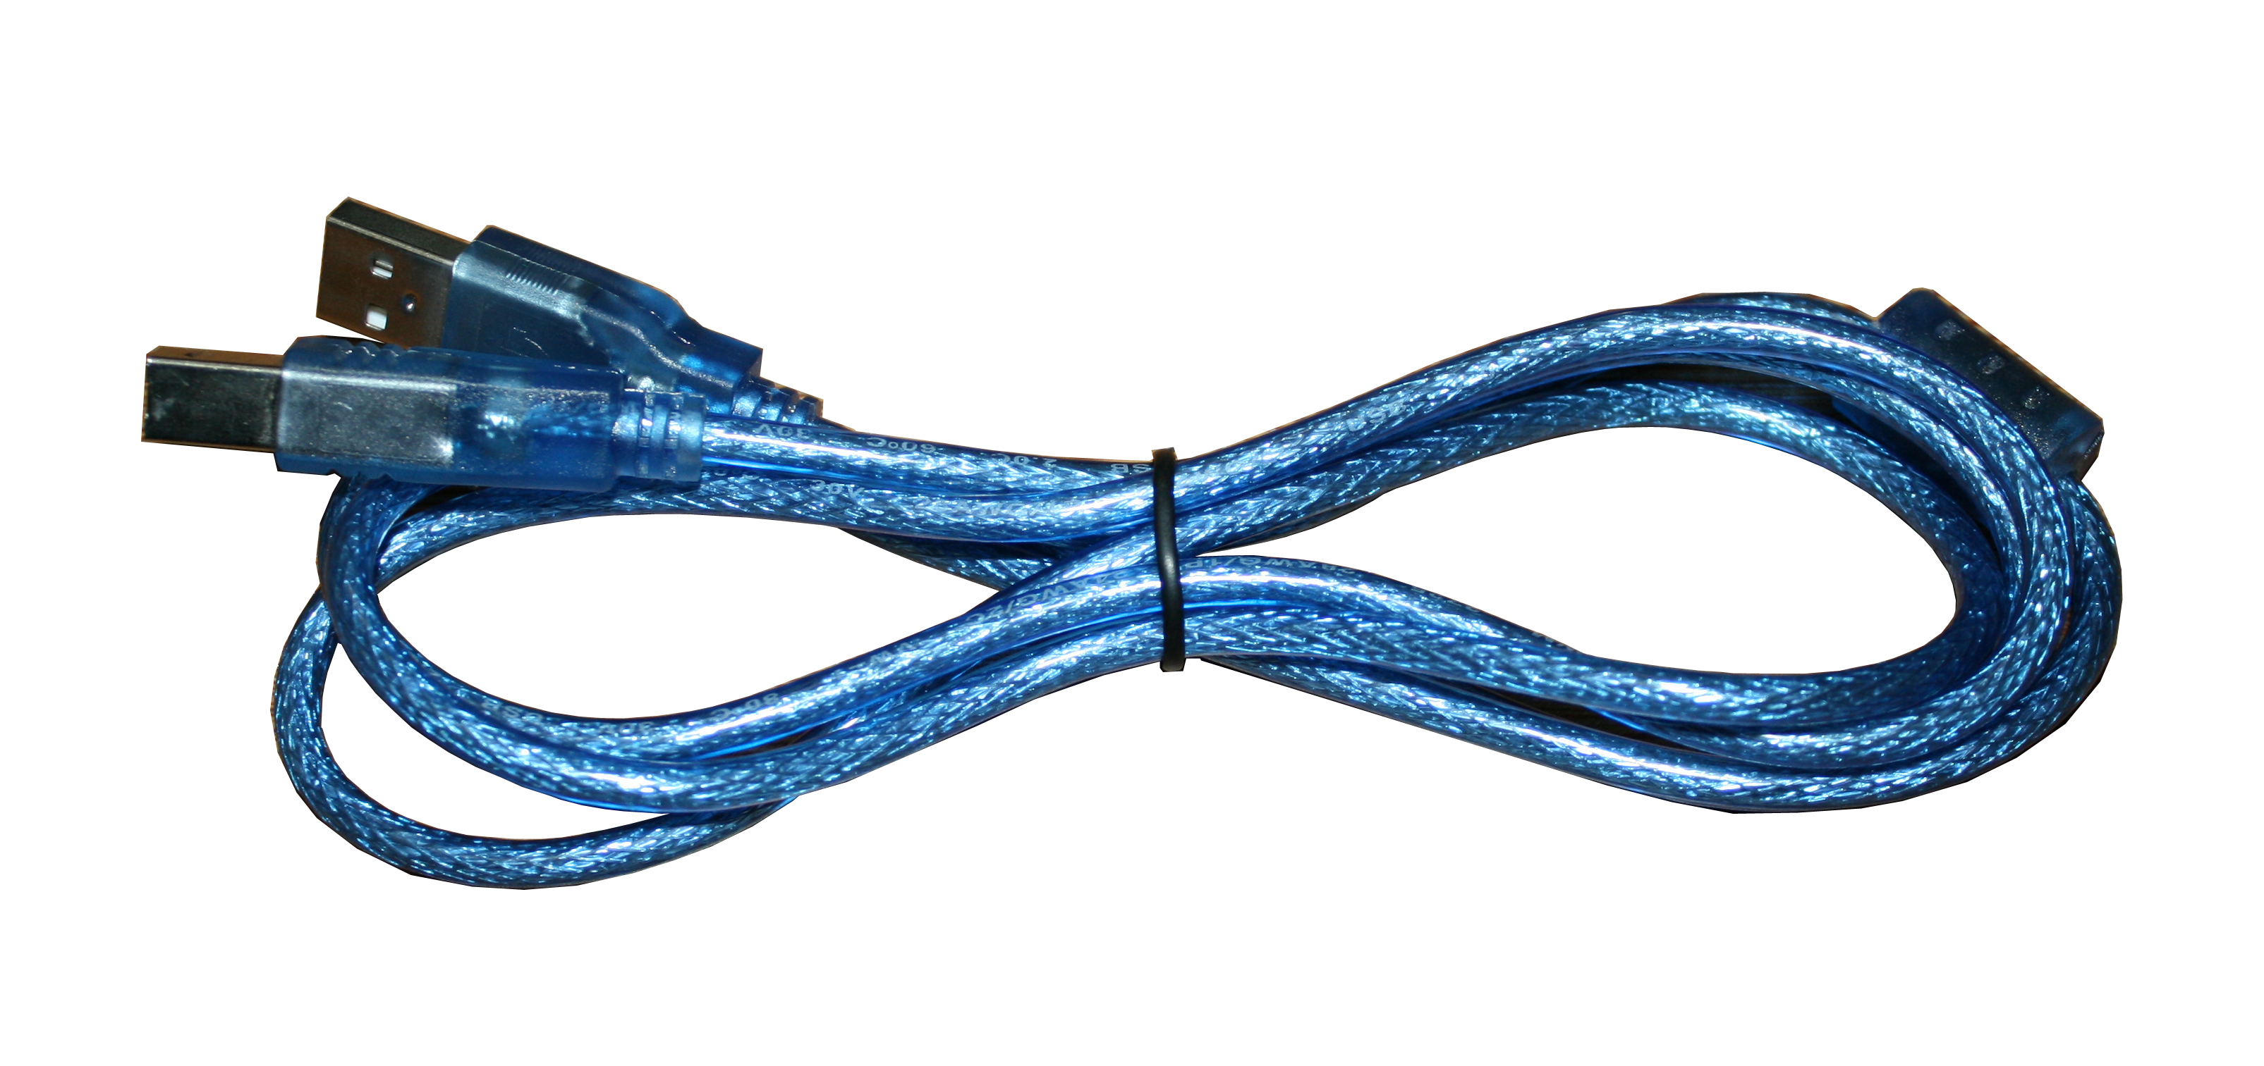
Fig.2: USB Cable
USB cable is used to connect to USB port in computer and output port in Super Datalogger. The collected data should be transfer to computer via USB cable or Bluetooth.

5. Data cable (network cable)
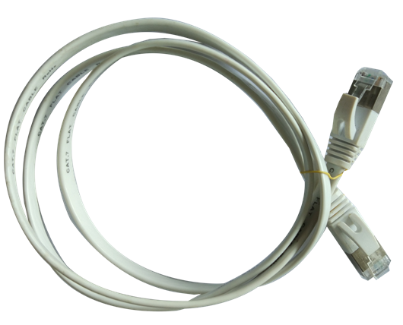
Fig.3: Network Cable
The length of network cable is 100cm. It is used to connect super data logger and sensors to power sensors and transfer data from sensor to datalogger.

6. Deconcentrator
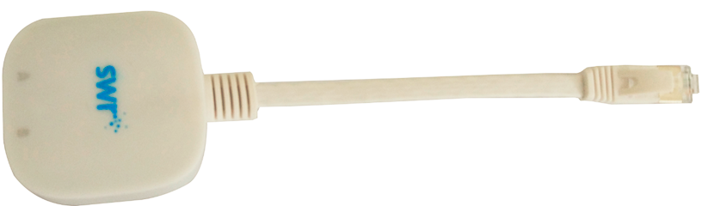
The length of denconcentrator is 15cm. It is used to connect sensor and Super Datalogger so that quantity of sensors connected is increased.
Notes of deconcentrator:
RJ45 port A: sensor port, accept analog and digital sensor
RJ45 port B: sensor port, accept analog sensor only
RJ45 plug: connect TS1010 Super Datalogger sensor port
Digital sensor (only port A accept digital sensors) | TS2224 Heart rate sensor
Digital sensor (only port A accept digital sensors) | TS2107 Motion sensor
Digital sensor (only port A accept digital sensors) | TS2108 Photogate
Digital sensor (only port A accept digital sensors) | TS2113 G-M sensor
Digital sensor (only port A accept digital sensors) | TS2123 Thermal radiation sensor
Digital sensor (only port A accept digital sensors) | TS2201 Thermal couple sensor
Digital sensor (only port A accept digital sensors) | TS2207 Humidity sensor
Digital sensor (only port A accept digital sensors) | TS2212 Titration counter
Digital sensor (only port A accept digital sensors) | TS2206 CO₂ sensor
Tab.3: Deconcentrator

Specification
Parameter
Button | Power button | Working time | Up to 10 hours
Size | 104mm*104mm*26.5mm | Communication mode | USB2.0 Bluetooth 4.0 Bluetooth 2.0
Weight | 128g | Communication rate | 51kB/s
Color | White | Collect speed | 143k/s MAX
Port | USB2.0 B type | RJ45 port | 4 RJ45 ports (connect deconcentrator to extend to 8 ports)
Battery | Three AA alkaline battery (or NI-MH battery) | Built-in | 16M (can be customized)
Tab.4

Connect Super Datalogger to computer
Make sure USB driver is installed in computer. Use microsoft windows XP and above will automatically be installed with driver.

7. Connect via cable: connect to computer via USB cable
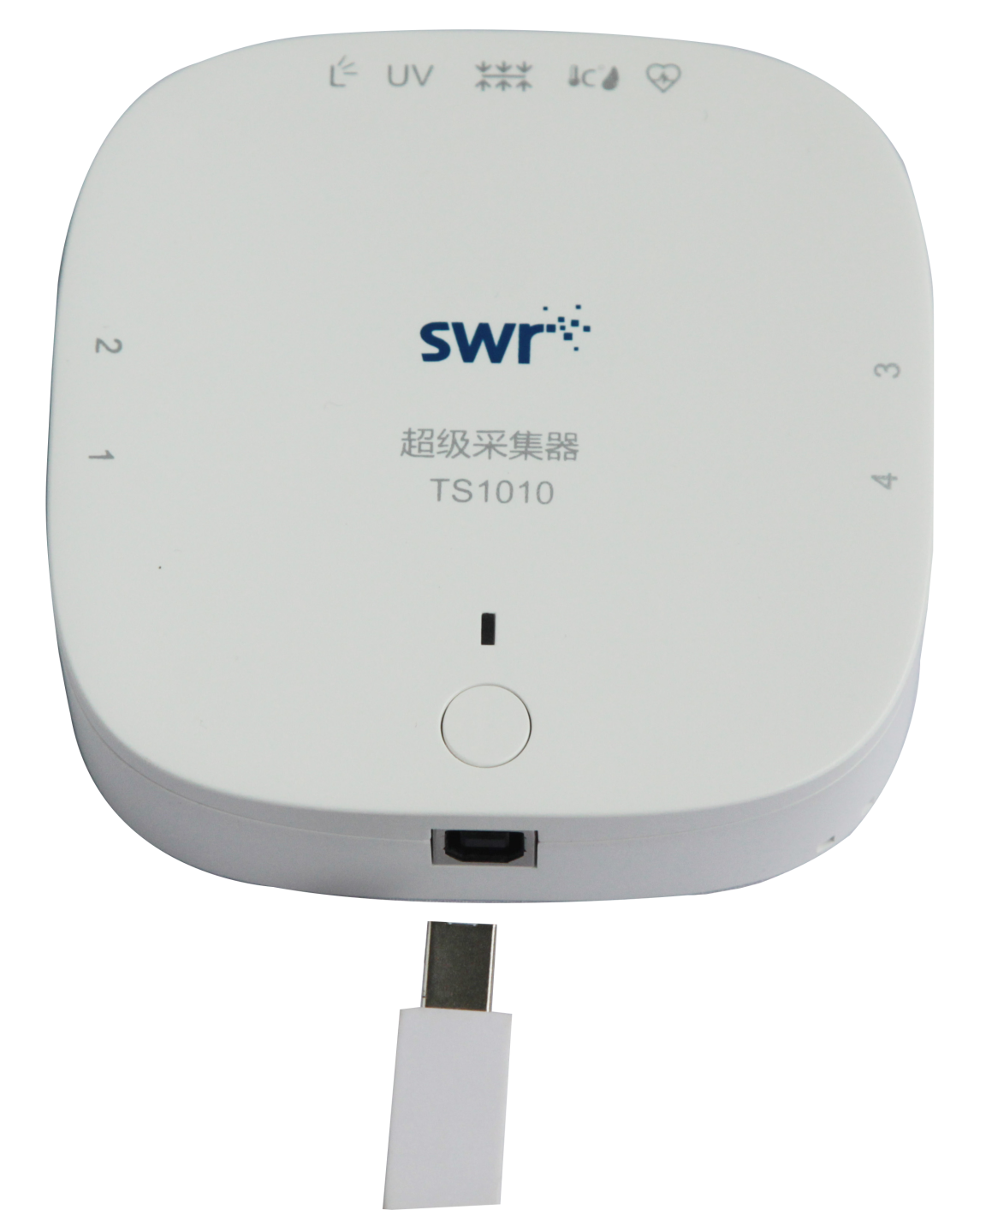
Fig.4: Connect to Computer via USB Cable

8. Blue tooth connection: wireless connect to computer via Bluetooth
Use Bluetooth search to find the number of datalogger Bluetooth (such as: 1010) and match the device. If there is no Bluetooth in your computer, you can plug Bluetooth adapter into USB port in computer as shown in Fig.5. Repeat the mentioned operation to connect Bluetooth.
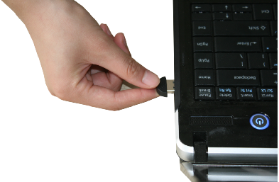
Fig.5: Connect Bluetooth Adapter to Computer

Connect Super Datalogger to sensor
Super Datalogger can be connected to sensors via network cable shown in Fig.6.
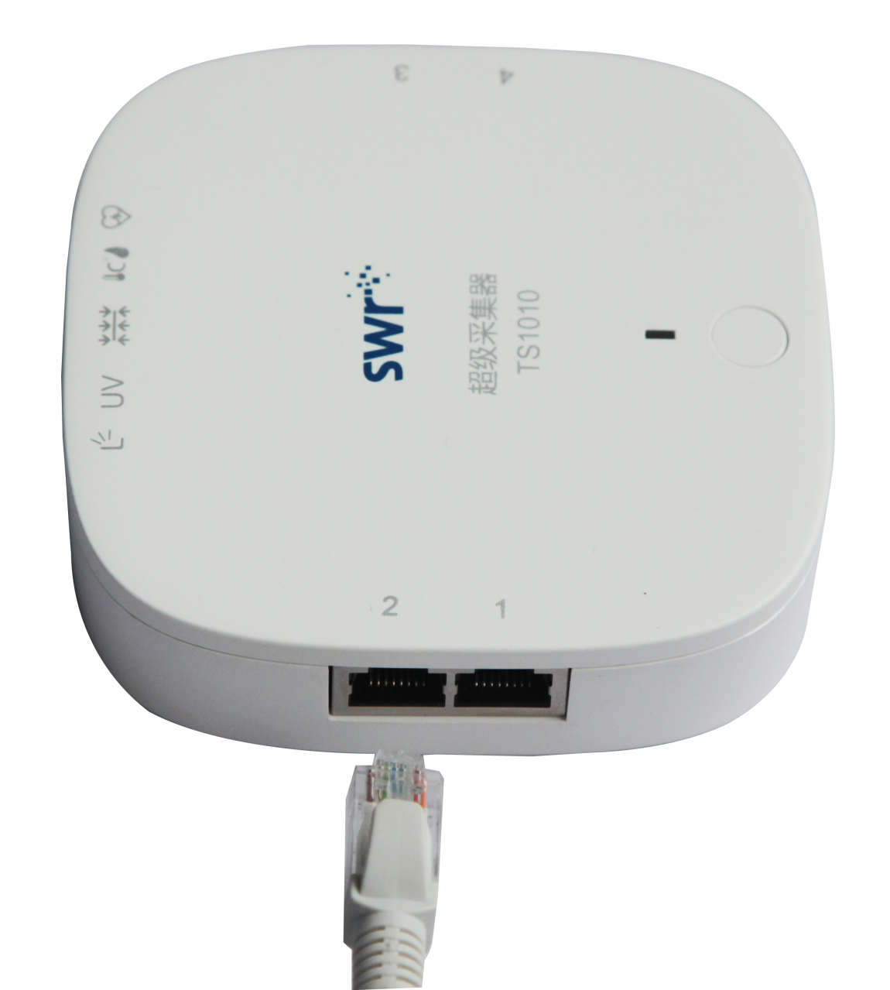
Fig.6: Connect to Sensor Using Network Cable

Data collection by experiment software
First, make sure SWR iLab software and USB driver are installed in computer. Make sure the sensors are connected properly. Open the software and setup for data collection.
Double click SWR iLab icon and you will see the interface shown below:
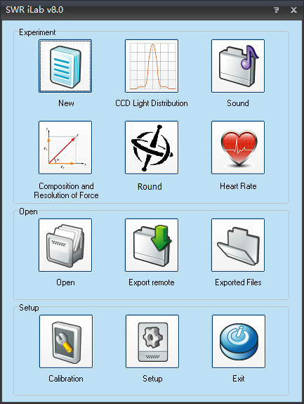
Fig.7
If you need to use Bluetooth, please preset by clicking setup button and choose wireless.
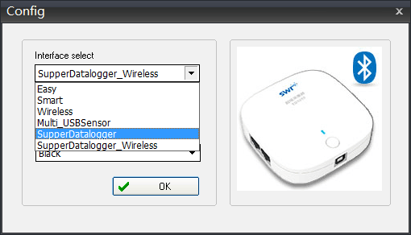
Fig.8
Click new experiment 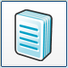 and you can set collecting time, collecting speed and trigger setup here. You can set multiple collecting interface such as folder as well. Such setups are very user friendly which can be done within 1minute. When those setups are completed, click 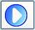 and software will collect data in the way you pre-set. iLab also provides multiple data analyzing tools including multiple kinds of fitting, curve smoothing, integration, derivation and function editing. You can further analyze and calculate collected data by using these tools.

Independently collect data
No requirement for Bluetooth during independently collect.
Connect datalogger to sensor. Hold power button to switch on the device. Connect it to computer and open experiment software. Click export file and new folder. Datalogger will automatically save data from sensor. If need to export data to computer, you should connect it to computer using USB cable. Open experiment software and click export. You can check the exported data by clicking open exported file.

Case
To explore the performance of Super Datalogger in sound level experiment:
Explore the phenomenon of sound synthesis (two 440Hz tuning fork).
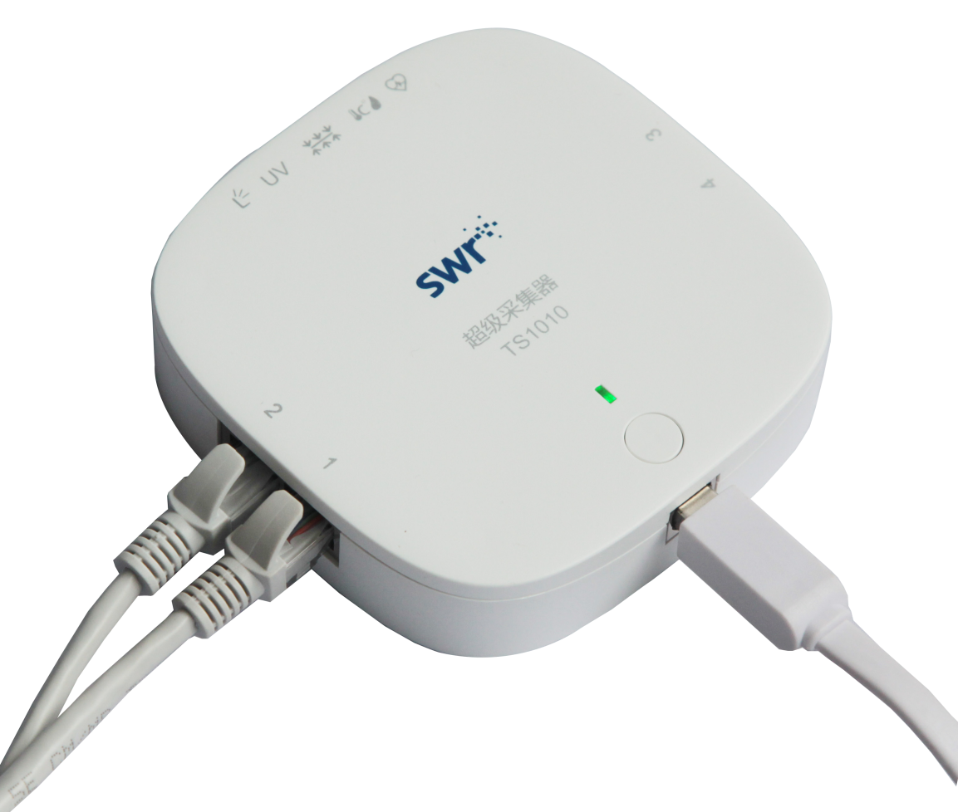
Fig.9
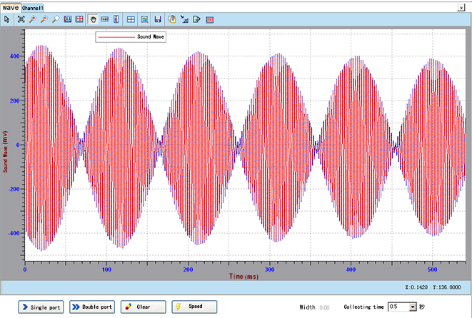
Fig.10: Interference of Sound Wave
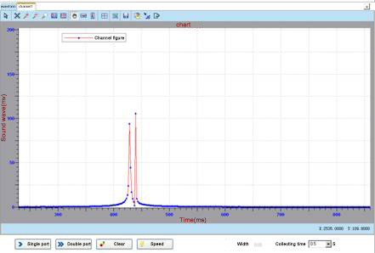
Fig.11: FFT

