Contents
Introduction to product and parts 1
Smart Datalogger 2
Specification 3
How to connect Smart Datalogger to computer 4
Connect Smart Datalogger to TS series sensor 4
Use Smart Datalogger to collect data in computer 5
Use Smart Datalogger to collect data independently 6
Main menu 6
Buttons 7
Easy Log 8
Meter 8
Snapshot 9
Logging 10
Time 11
Data transfer from Smart Datalogger to computer 12
Export data 12
Open the exported file 14
Setup and maintenance 16
System 16
Switch off 17
Format Flsah 18
Language 18
Reset 19
Clean 19
Suitable environment 19
Preserve 19
Special notes: 19
Common problems and solutions 20
Connect Bluetooth adapter to computer 24
Risk warning 25

Introduction to product and parts
Smart Datalogger Quick Guide
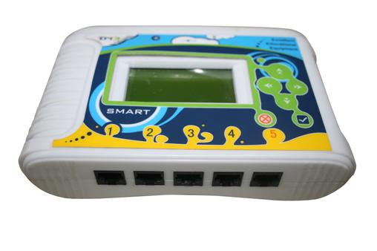
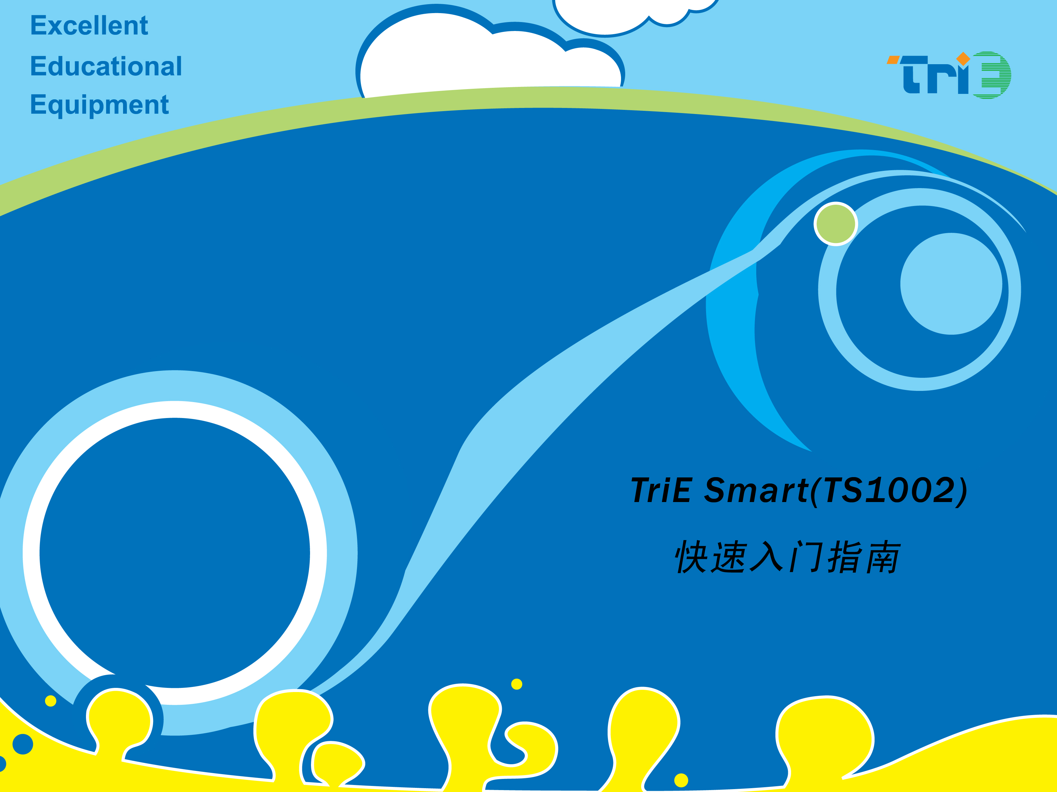

USB Cable Sensor cable

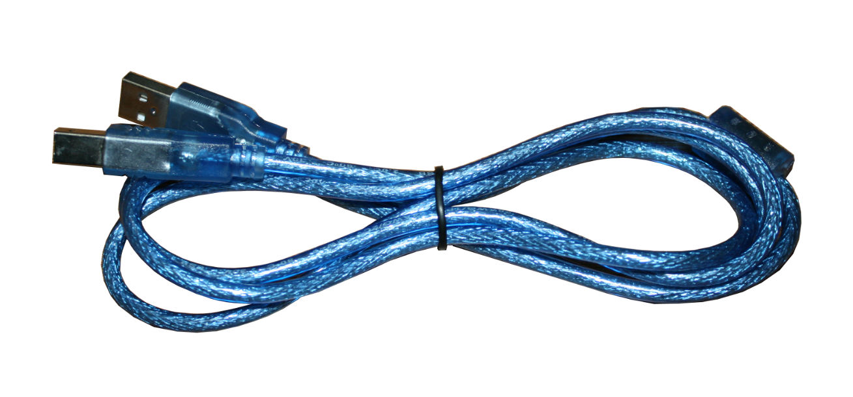
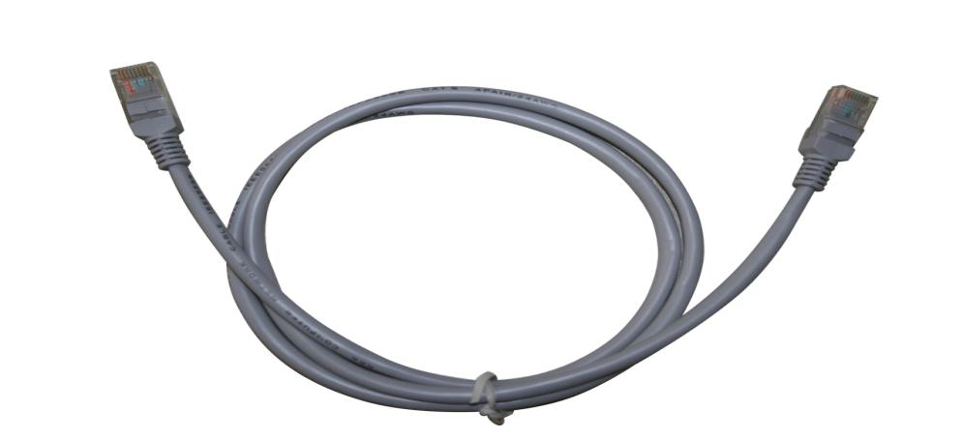

Smart Datalogger

Smart Datalogger is an independent device which does not require computer. It has few usage based on that:
1. Independent data collecting under outdoor condition.
2. Collect data indoor while connecting to computer.
When collects data under outdoor condition, it has the following features:
1. LCD screen and real time data measuring.
2. Allow data storage and export it to computer.
3. Await time more than 150 days which is long enough for working.
4. Moisture proof and corrosion protection film on buttons could prevent buttons from water or corrosive solvent when using outdoor.
SWR Smart Datalogger
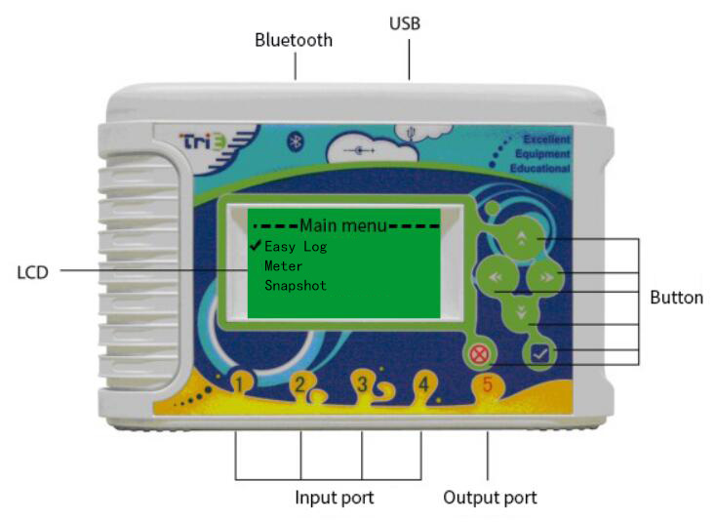

Fig.1

Specification
No. | Part | Specification
1 | Screen | LCD
1 | Screen | 128×64 resolution
1 | Screen | 2.5 inch
2 | Power supply | USB power supply
2 | Power supply | 2000mAh rechargeable lithium battery
2 | Power supply | ≥150 days await time
3 | A/D | 12bit resolution
3 | A/D | 30k collecting speed
4 | Ports | USB2.0
4 | Ports | RJ45 port
4 | Ports | 4 A/D ports
4 | Ports | 1 output port
5 | Storage | RAM 4 Mb
6 | Data transfer | USB
6 | Data transfer | Bluetooth
7 | Built-in Sensor | Built-in temperature sensor
8 | Buttons | Moisture proof and corrosion protection
9 | Size | 166×116×43mm
10 | Weight | 378g
Tab.1

How to connect Smart Datalogger to computer
Smart Datalogger is connected to computer via USB cable as shown in Fig.2. Make sure USB driver is installed in computer. Use microsoft windows XP and above will automatically be installed with driver.
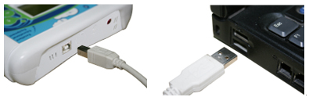

Fig.2

Connect Smart Datalogger to TS series sensor
Smart Datalogger can be connected to TS series sensors using 1394 port data cable as shown in Fig.3.
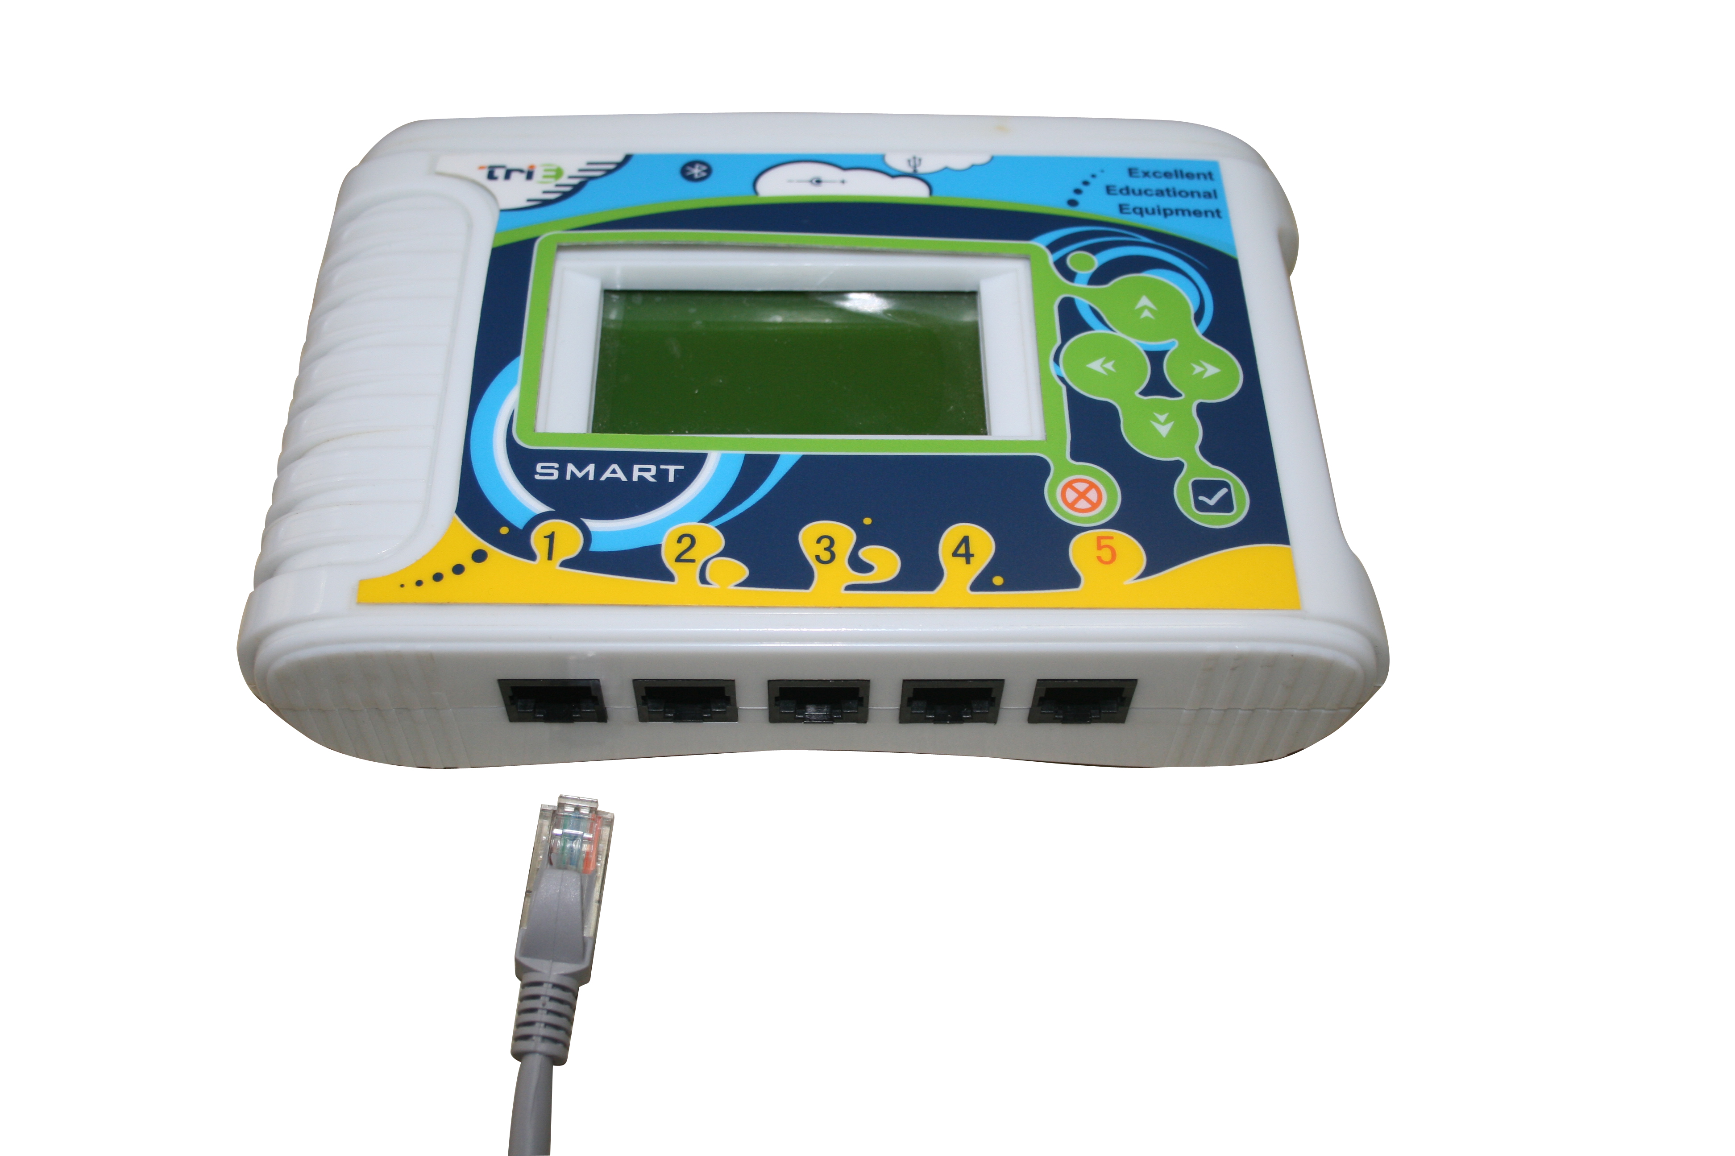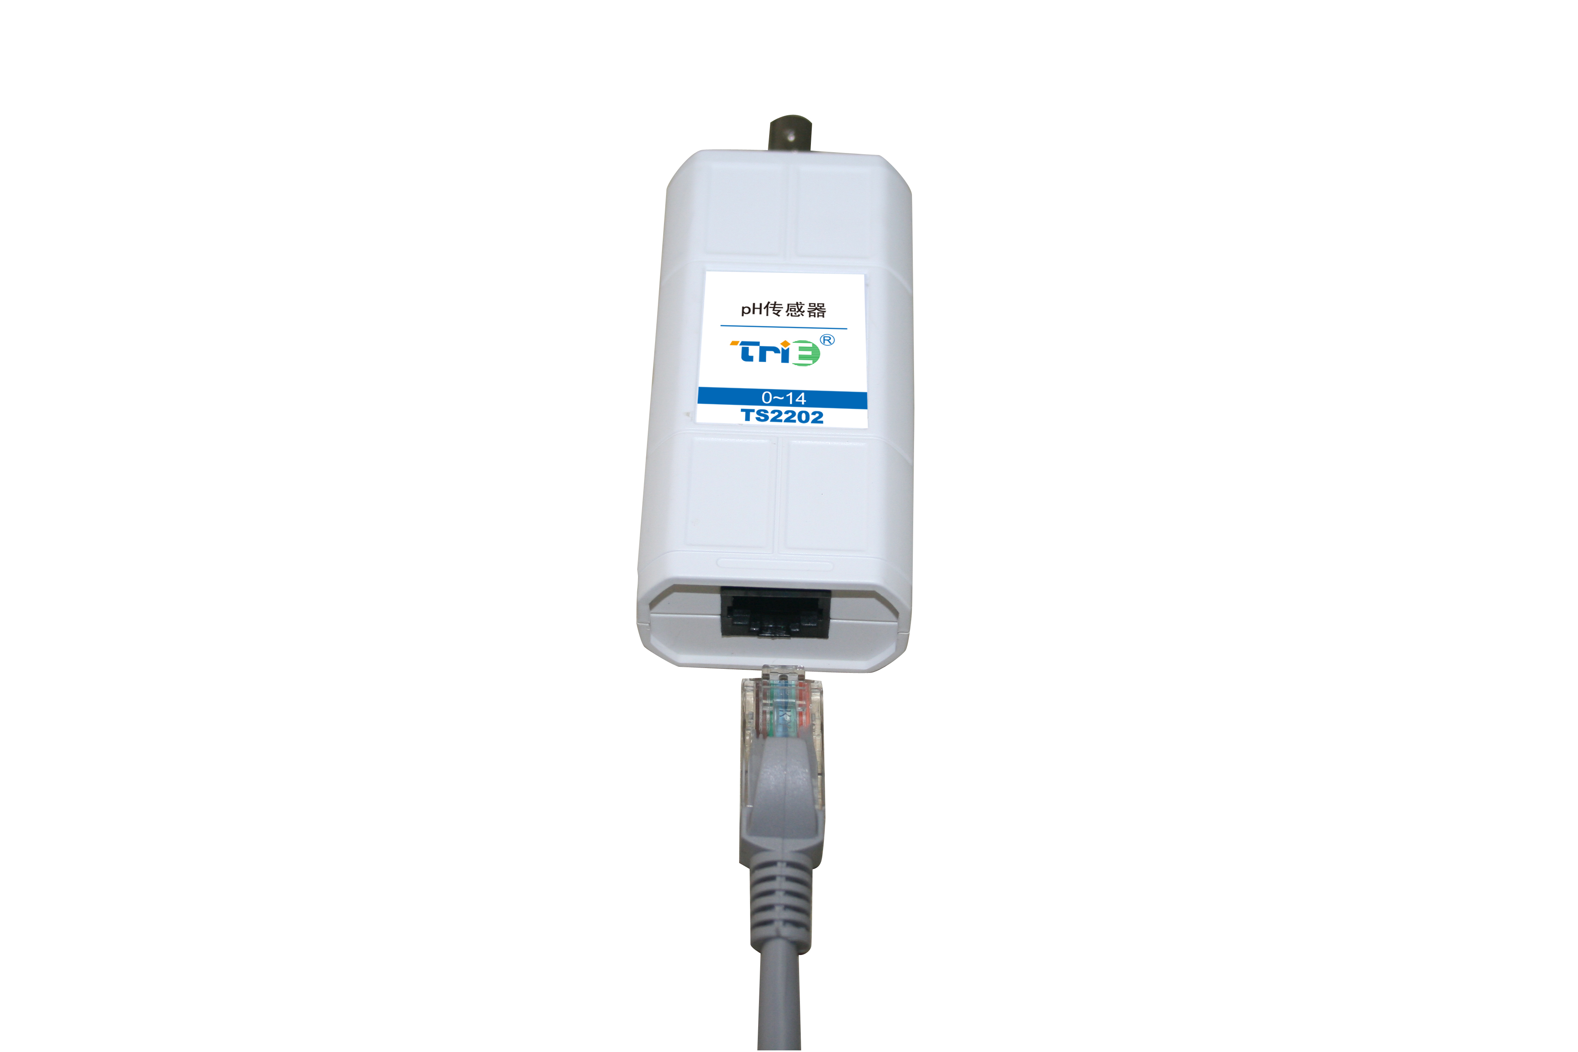

Fig.3
When TS series sensor is connected to Smart Datalogger, you can start collecting data. As mentioned above, there are two methods of collecting.
- Collect using computer
- Use Smart Datalogger to collect independently.
In the first method, Smart Datalogger works as link. It performs as A/D converter for the input signal and sent digital signal to computer. The software will collect, record and analyze data because the datalogger does not store data.
In the second method, Smart Datalogger works independently without computer. It can collect and store data but can not analyze and calculate data. It is able to store and transfer data to computer (by USB cable or Bluetooth) and software will analyze and calculate the data.

Use Smart Datalogger to collect data in computer
First, make sure SWR iLab software and USB driver are installed in computer. Make sure the sensors are connected properly. Open the software and setup for data collection.
Double click SWR iLab icon and you will see the interface shown below:
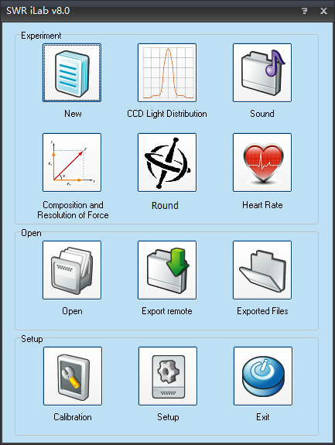
Fig.4
Click new experiment 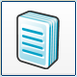 and you can set collecting time, collecting speed and trigger setup here. You can set multiple collecting interface such as folder as well. Such setups are very user friendly which can be done within 1minute. When those setups are completed, click 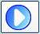 and software will collect data in the way you pre-set. iLab also provides multiple data analyzing tools including multiple kinds of fitting, curve smoothing, integration, derivation and function editing. You can further analyze and calculate collected data by using these tools.
Fig.5 shows a typical experiment software interface.
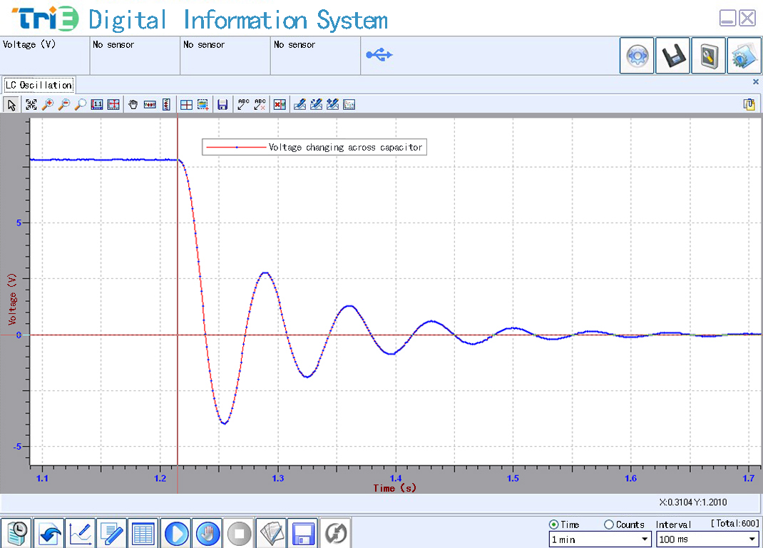
Fig.5
About setup and analyzing tool for the device, you can refer to instruction manual of SWR iLab v8.0.

Use Smart Datalogger to collect data independently
SWR Smart Datalogger can also be used as datalogger under outdoor condition.

Main menu
You can see nine function options from the main menu. They are used to setup data collecting and storage mode. There are maximum three functions you can see from 3-inch screen. Press move up and down to scroll the menu.
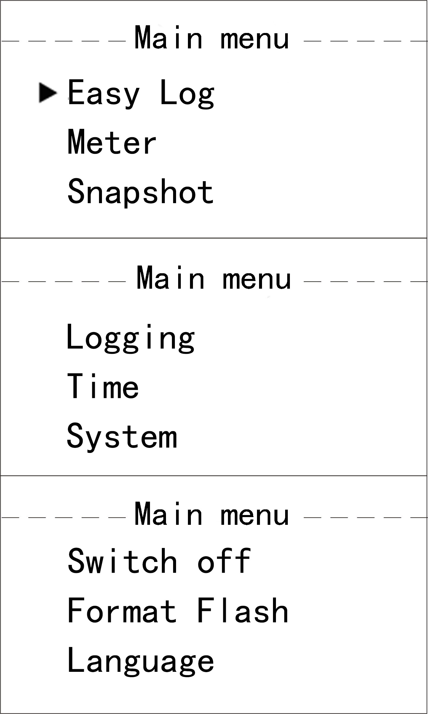
Fig.6

Buttons
SWR Smart Datalogger’s buttons is designed with moisture proof and corrosion protection which is very important to outdoor operation. The function is shown below:
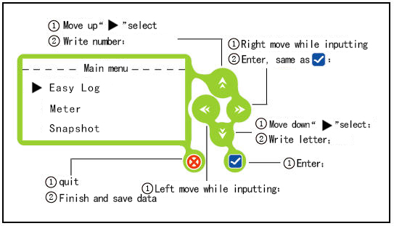
Fig.7

Easy Log
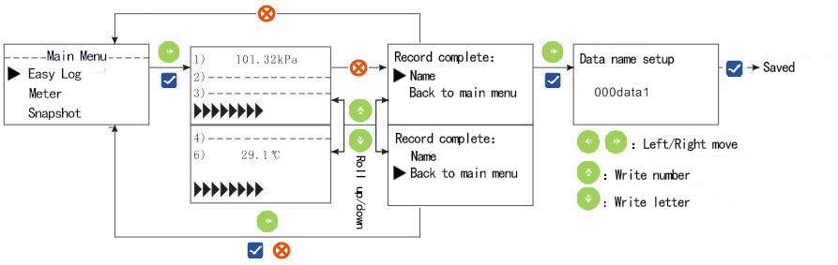
Fig.8
The pattern of arrow and buttons in Fig.8 show what are the interface and effect will be shown on screen when the corresponding button gets pressed.
In the mode of Easy Log, SWR Smart Datalogger will automatically collect data by interval of 100ms and 5000 total collect amount (500s). The numbers and percentages in the lower right corner represent the collection progress. After the collection is completed, the data will be saved. If you choose to withdraw from the collection, you will also be prompted to save the data.
When saving the data, you must name it. Otherwise the data will not be saved. When it is completed, data will be saved in the internal RAM of SWR Smart Datalogger. The storage is 4Mb which can store about 150,000 data (about 300 experiment results). The experiment date will be saved at same time.

Meter
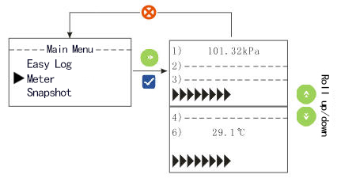
Fig.9
The pattern of arrow and buttons in Fig.9 show what are the interface and effect will be shown on screen when the corresponding button gets pressed.
This mode can only be used to display the data collected by the working sensor. It can not collect and store data. The refresh frequency for this mode is 10times/sec.

Snapshot
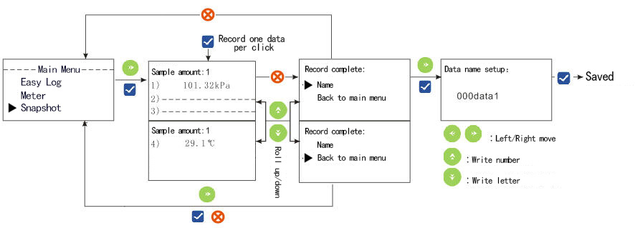
Fig.10
The pattern of arrow and buttons in Fig.10 show what are the interface and effect will be shown on screen when the corresponding button gets pressed.
Snapshot is a way of manually collecting data. SWR Smart Datalogger will start collecting once you press  button. There will be only one data collected once the button gets pressed. The maximum amount of data can be collected is 255.
Snapshot mode provides data saving function. When saving the data, you must name it. Otherwise the data will not be saved. When it is completed, data will be saved in the internal RAM of SWR Smart Datalogger. The storage is 4Mb which is about 150,000 data (about 300 experiment results). The experiment date will be saved at same time.

Logging
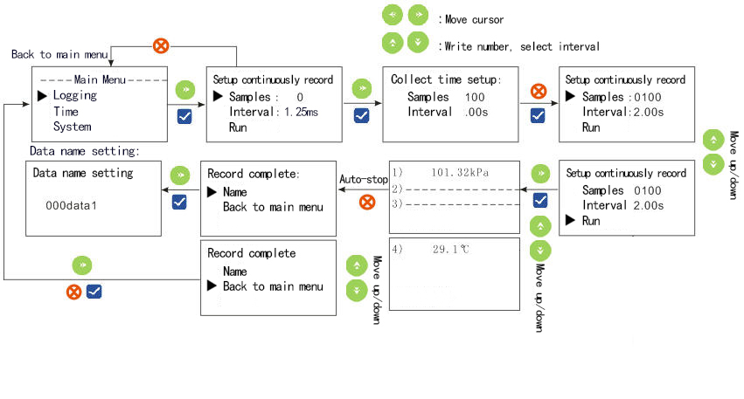
Fig.11
The pattern of arrow and buttons in Fig.11 show what are the interface and effect will be shown on screen when the corresponding button gets pressed.
Logging is a kind of automatic collection method which can preset the collection interval and total collect amount. The collection interval is optional. There are 20 choices, such as 1.25ms, 2.5ms, 5ms, 10ms, 20ms, 50ms, 100ms, 200ms, 500ms, 1s, 2s, 5s, 10s, 20s, 1min, 2min, 5min, 10min, 20min and 1h. You can choose total collect amount from 1~5000. Press “run” after choosing. SWR Smart Datalogger will automatically collect data. The numbers and percentages in the lower right corner of the running interface represent the collection progress. If you want quit when collecting is under procedure, it will still remind you to save data.
When saving the data, you must name it. Otherwise the data will not be saved. When it is completed, data will be saved in the internal RAM of Smart Datalogger. The storage is 4Mb which is about 150,000 data (about 300 experiment results). The experiment date will be saved at same time.

Time
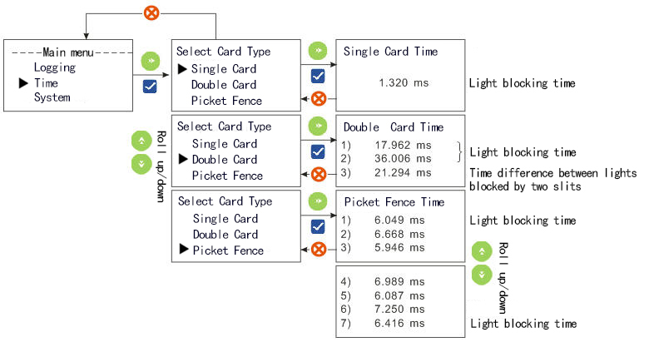
Fig.12
The pattern of arrow and buttons in Fig.12 show what are the interface and effect will be shown on screen when the corresponding button gets pressed.
Time is set for photogate. It can be divided into three kinds which are
1. Single Card:
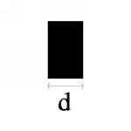
Fig.13
Time period of light gets blocked by single card is recorded by this mode.
2. Double Card:
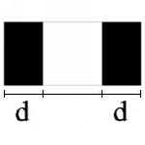
Fig.14
The time period of light gets blocked by two cards and time difference between lights blocked by two cards are recorded by this mode.
3. Picket Fence:
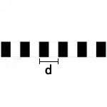
Fig.15
Time period of light blocked by each card is recorded by this mode.
SWR Smart Datalogger only collect data under Time mode. There is no data saved.

Data transfer from Smart Datalogger to computer
After connecting SWR Smart Datalogger to computer via USB cable, SWR iLab software can be used to export data from SWR Smart Datalogger to computer.

Export data

Click 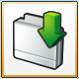 and you will see Fig.16：

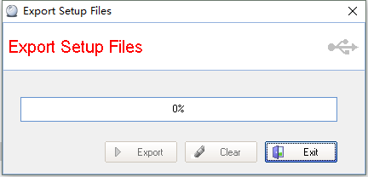
Fig.16
Click export and select browser. Click yes to export data to the place accordingly.
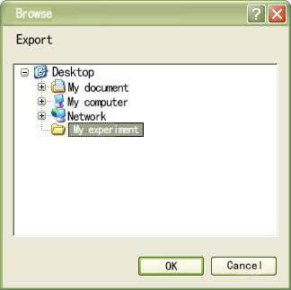
Fig.17
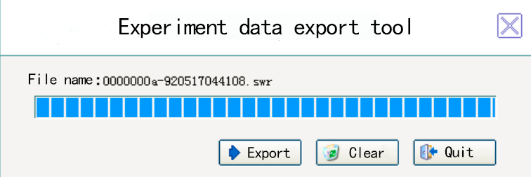
Fig.18
When the data is exported, software will ask you to clear data. Click the clear button shown in Fig.18 will also clear experiment result.
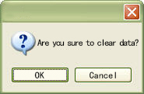
Fig.19
Click yes to clear all data and no to keep them.
Click the back button will return you to the main menu.

Open the exported file
Click 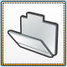:
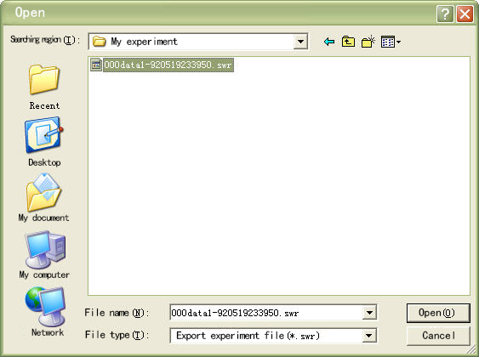
Fig.20
Open the file here (Fig.21 shows the data collected by light sensor for 10s under simple record mode):
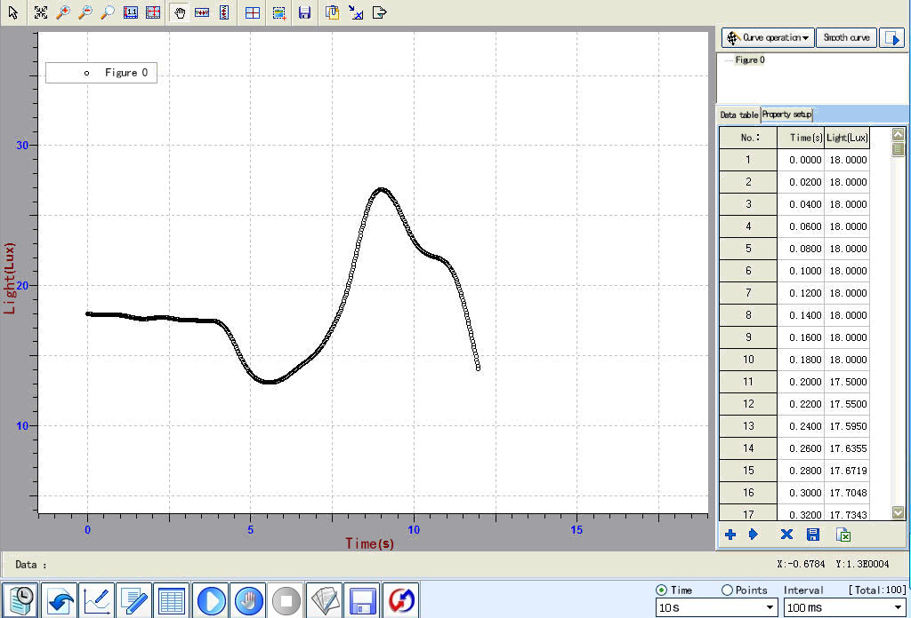
Fig.21

Setup and maintenance

System
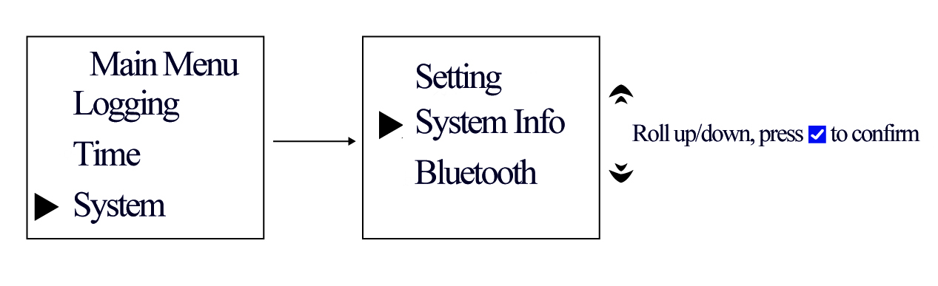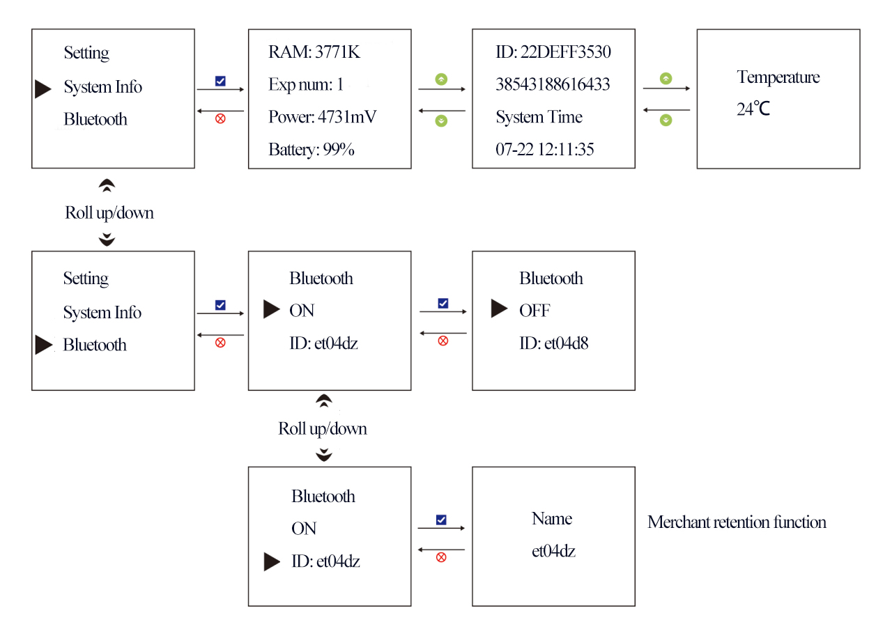
Fig.22
The pattern of arrow and buttons in Fig.22 show what are the interface and effect will be shown on screen when the corresponding button gets pressed.
Note:
- When battery is lower than 50%, please charge the device to ensure the capability for it to work outdoor.
- When battery is ran out, it requires to charge for 8 hours.
- When you take out the battery, the time will be shifted back to manufacture time. You have to set the time again once battery is placed back.
- The manufacturer has set the calibration so do not change anything on that.
- Bluetooth is optional. Please ensure you have installed this function when purchasing it.

Switch off
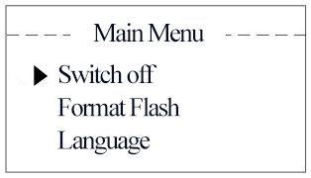
Fig.23
Press button to select switch off mode. At this moment, SWR Smart Datalogger will stop all function and turn off LCD.
When SWR Smart Datalogger is powered by battery only and no operation is applied on it for 3 minutes, it will automatically shifted to sleep mode. Press the button to restart. It is a mode to save battery. User can not change this setup.
When SWR Smart Datalogger is connected to power adapter or USB cable to computer, it will not get into sleep mode automatically.

Format Flash
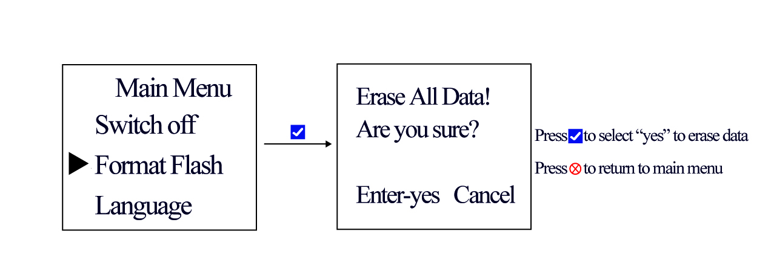
Fig.24
Press button to select the Format Flash, select "yes" and clear the experimental data.

Language
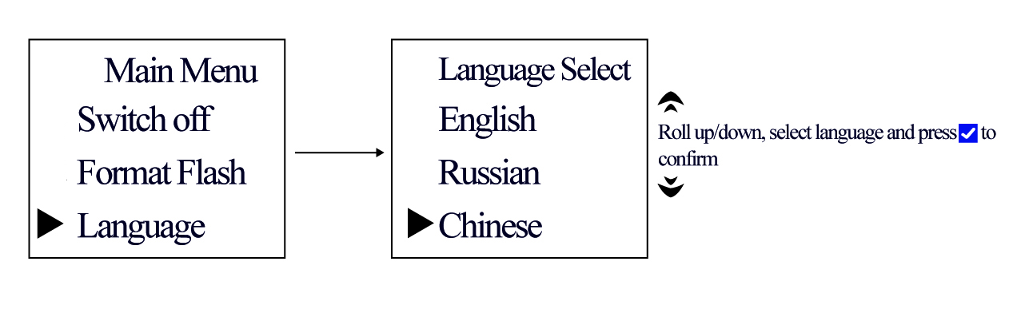
Fig.25

Press button to select the language function, you can switch the language, and SWR Smart Datalogger can support English, Russian and Chinese.

Reset
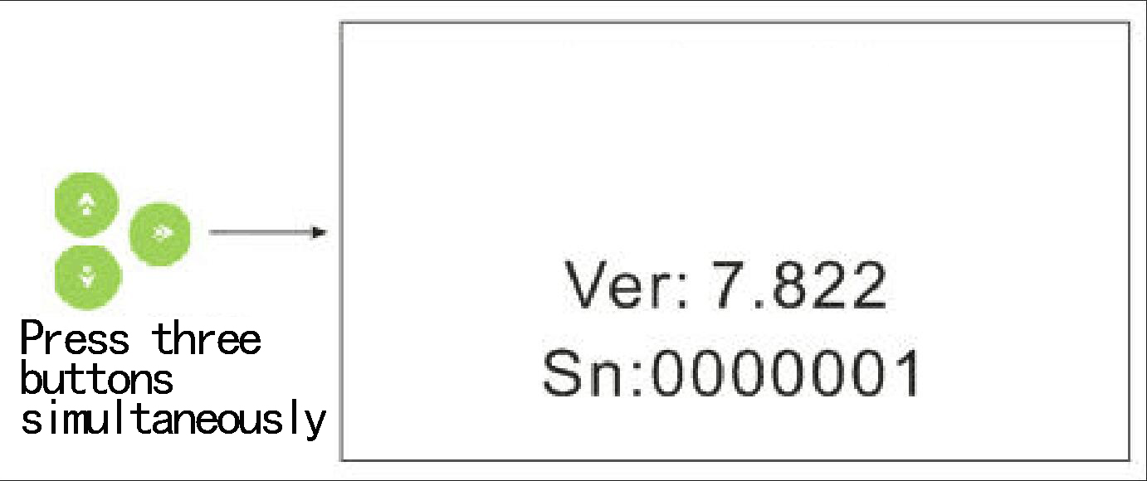
Fig.26
Press move up and down and right buttons simultaneously and the device will be reset.

Clean
- Use wet cloth or tower to clean the splodge on the device.
- Please do not merge the device into water or abluent to clean.

Suitable environment
- Smart Datalogger can be used between 0~40 ºC and 0~95%RH (humidity, without condensate).
- If the device is placed under temperature lower than 0 ºC or above 40 ºC, please make sure it reaches ambient temperature before using. The built-in temperature sensor can sense the working temperature for the device.

Preserve
- Keep the device dry and shaded.
- Keep the battery more than 40% left when you preserving it.

Special notes
- Do not expose the device under the blazing sun for long time.
- Do not merge the device into water or other liquid even if its buttons are water proof.
- Do not move it too close to heat source.
- Do not preserve the device at extremely cold or hot place.
- Do not preserve the device under the following circumstance:
The launched car under extremely hot ambient temperature.
Refrigerate.
Basement,kitchen, bathroom and boiler room.
- Please do not use the device under the following circumstance when working outdoor:
Raining, snowing, hailing and foggy weather.
Ambient temperature above 35 ºC.
Strong winding, thunder and lighting.
Common problems and solutions
1. No response
If there is no response for your operation, please reset the device. Refer to reset.
2. Can not start the device outdoor.
Please check the battery.
3. Can not save data
Please check the device to see if it is under instrument or motion mode. Smart Datalogger can not save data under these modes.
Please make sure the data is named because Smart Datalogger does not save the unnamed data.
If data is named, please connect it to computer the check RAM. If the RAM is full, please clear it for free space.

Wireless connect Smart Datalogger to computer
For those computer which does not installed with Bluetooth, insert the Bluetooth adapter into USB port in computer first. The pattern will be displayed at down right corner of desktop. Right click and select ‘open Bluetooth device’
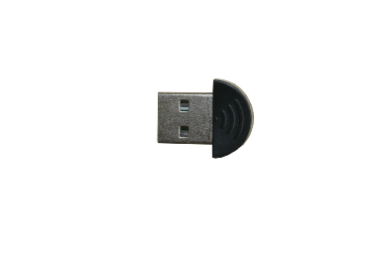
Fig.27: Bluetooth Adapter
Click the pattern at down right corner of desktop. Right click and select ‘open Bluetooth device’.
(For those computer which does not installed with Bluetooth, insert the Bluetooth adapter into USB port in computer first. The pattern will be displayed at down right corner of desktop. Right click and select ‘open Bluetooth device’)
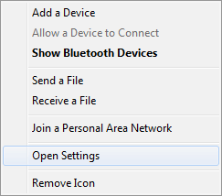
Fig.26
Click ‘open setting’ and select ‘allow Bluetooth device to find this computer’.
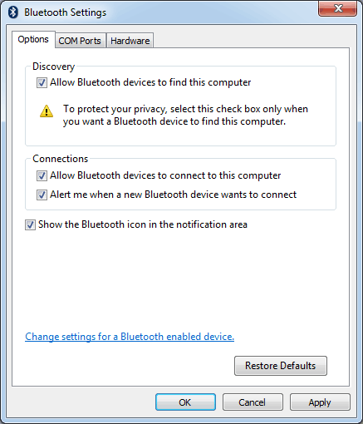
Fig.28
Click next when Bluetooth pattern is shown.
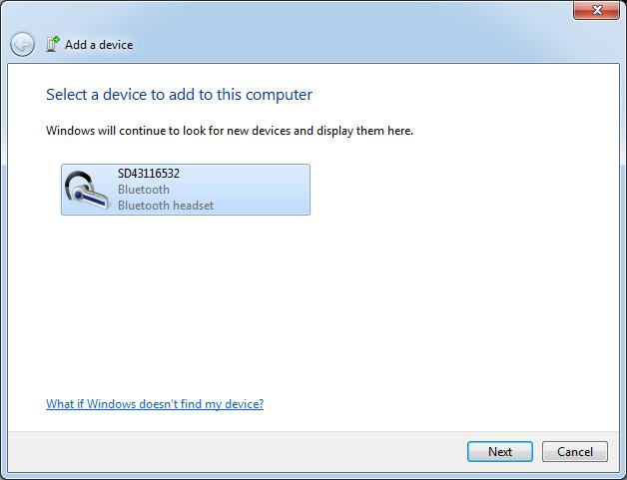
Fig.29
Click next and close after installing.
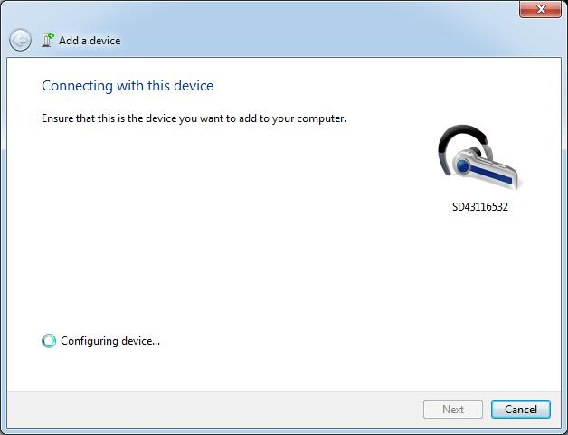
Fig.30
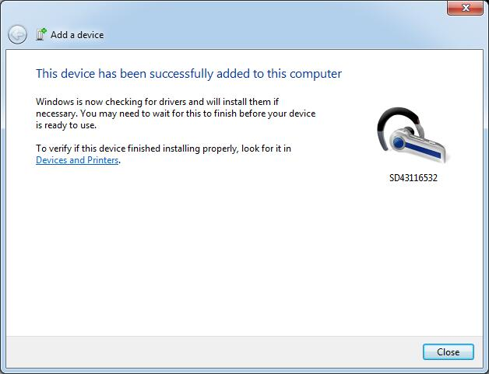
Fig.31
Note
During normal using Bluetooth, if its connection is interrupted, the program will display the disconnect state after 10~12s. When Bluetooth is powered on, the program will reconnect to it after 5~10s.

Connect Bluetooth adapter to computer
For those computer which does not installed with built-in Bluetooth, you have to insert Bluetooth adapter into USB port in computer.
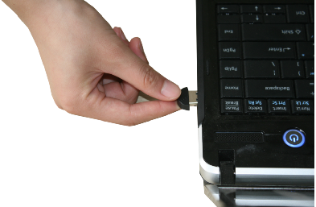
Fig.32: Connect to Computer

Risk Warning
- It can seriously reduce the service life of the equipment when using in damp, corrosive gas, high temperature and other harsh environment.
- Be sure to remove the charger within 4 hours after full charge, so as not to affect the battery life.
- When the equipment power is low, please charge in time to avoid long time in low battery status..
- In case of any failure, please contact our company immediately. Do not disassemble the battery, disassemble the battery and use the sharp tool to penetrate the battery.
- If the equipment is not used for a long time, it should be charged once every 3 months.
- When the temperature rise or other suspicious phenomenon is found in the use of electrical equipment, the power outage will be stopped immediately.

