Contents
Introduction to product and parts 1
Easy Datalogger 2
Data cable (network cable) 3
Introduction to ports position for Easy Datalogger 3
Specification 4
Connection between Easy Datalogger and Computer 5
Connection between Easy Datalogger and Sensors 5
Usage of Easy Datalogger 6
Case 8

Introduction to product and parts

Easy Datalogger
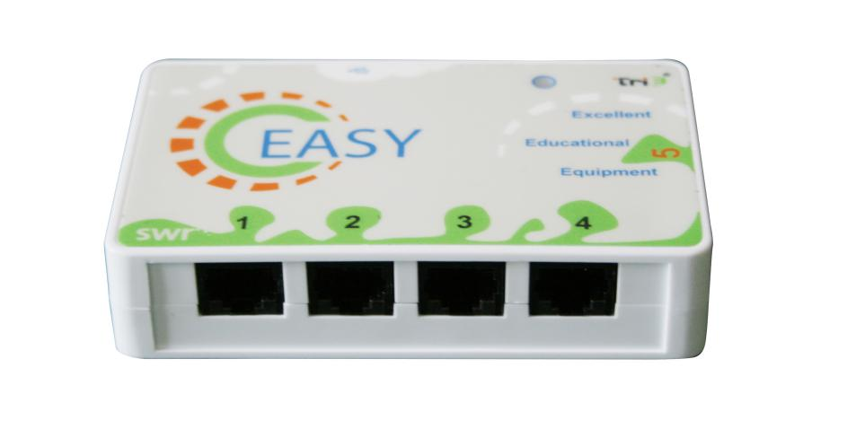
Fig.1: Easy Datalogger
Easy Datalogger is a small, user friendly, rapid data collecting and affordable device. User can use up to four sensors during experiment simultaneously. These four ports are same which are used for input signal. The device supports wire connection and powered by USB cable.
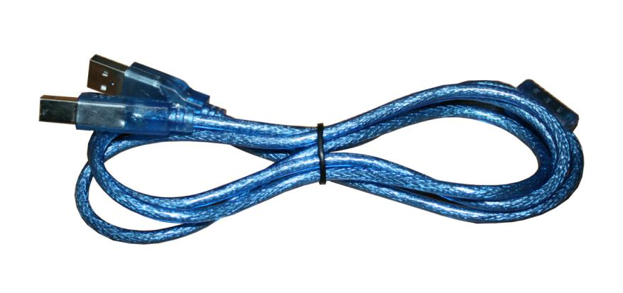
Fig.2: USB Cable
USB cable is used to connect the output port of device to computer. Data can be transfer to computer via this port. Furthermore, USE cable can be used to power datalogger and sensors. Thus, all external sensors need no external power supply.

Data cable (network cable)
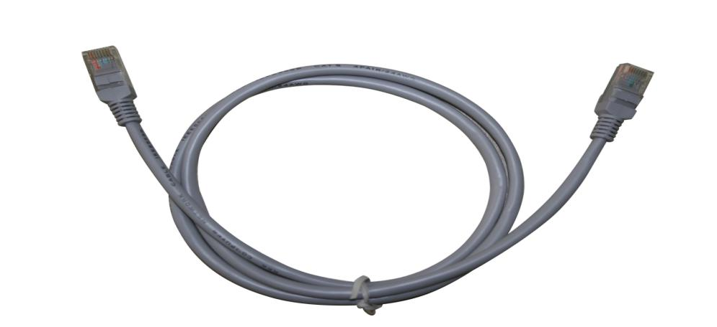
Fig.3: Network Cable
Data cable is 100cm long. It is used to connect datalogger to sensors so that sensors are powered. It also can be used to transfer collected data to datalogger.

Introduction to ports position for Easy Datalogger
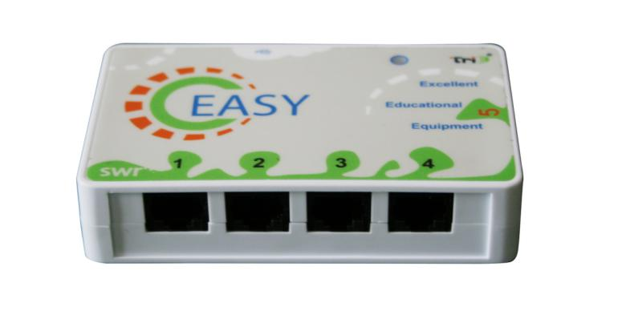
Fig.4: Ports Position for Easy Datalogger
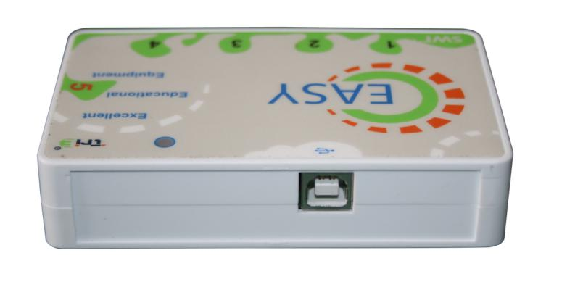
Fig.5: USB Port
Ports:
- USB: it is used to connect USB cable. Data can be transfer to computer via this port.
- Data input port 1, 2, 3, 4: they are used to connect sensors. There are no special requirement in ordering connect sensors to those ports. When connecting two same sensors such as two voltage sensors, computer will automatically number sensors according to the port number (from low to high).
- Data output port 5: the control signal is transfer from this port according the the instruction given by computer. The output signal is transfer to control external circuit.

Specification
No. | Part | Specification
1 | A/D | 12bit resolution
 |  | 30k collecting speed
2 | Ports | USB 2.0 port
 |  | RJ45 port
 |  | Four input ports. Accept both digital and analog signal.
 |  | One output port–return control port
3 | Data transfer | USB
4 | Size | 110×65×25 mm
Tab.1: Specification

Connection between Easy Datalogger and Computer
Easy Datalogger can be connected to computer via USB cable shown in figure6. Make sure that the USB driver is installed in computer. Microsoft windows XP and above are automatically installed with USB driver.
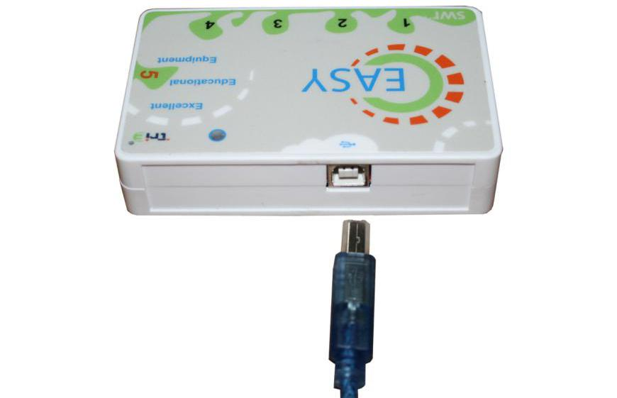
Fig.6: Connect USB Cable to the Device

Connection between Easy Datalogger and Sensors
Easy Datalogger can be connected to sensors via network cable shown in Fig.7.

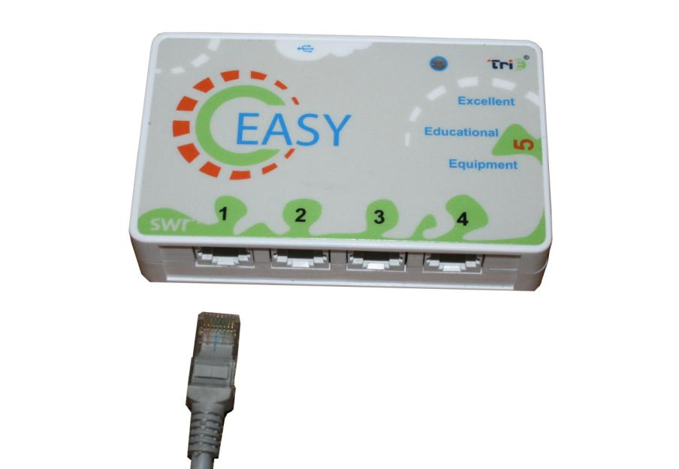
Fig.7: Connect Network cable to the Device

Usage of Easy Datalogger
Data collecting can be started once sensors are connected to datalogger. The device convert the analog signal transfer from sensors to digital signal and hence sent to computer. The signal is collected ,stored and calculated by iLab software.
Collect data using computer:
First, check if digital experiment software and USB driver are installed in computer. Ensure that sensors, Easy Datalogger are connected to computer properly. Open digital experiment software and complete setup and data collecting.
Double click pattern and you will see the figure shown below.
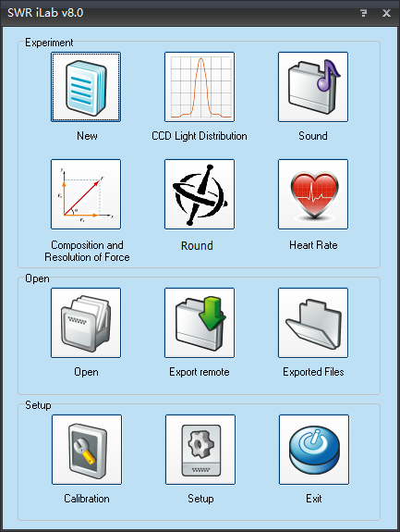
Fig.8: Experiment Software
If you are using iLab for Easy Datalogger for the first time, you need to click setup first and select Easy Datalogger.
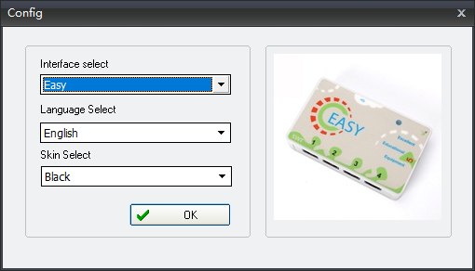
Fig.9
Click new experiment 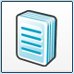 and you can set collecting time, collecting speed and trigger setup here. You can set multiple collecting interface such as folder as well. Such setups are very user friendly which can be done within 1minute. When those setups are completed, click 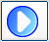 and software will collect data in the way you pre-set. iLab also provides multiple data analyzing tools including multiple kinds of fitting, curve smoothing, integration, derivation and function editing. You can further analyze and calculate collected data by using these tools.

Case
Fig.10 shows the experiment for sound level.
Explore the phenomenon of sound synthesis (two 440Hz tuning fork).

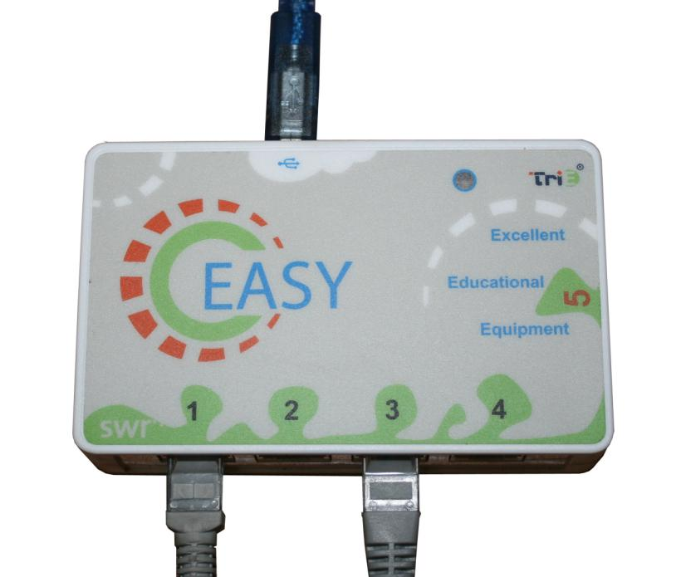
Fig.10

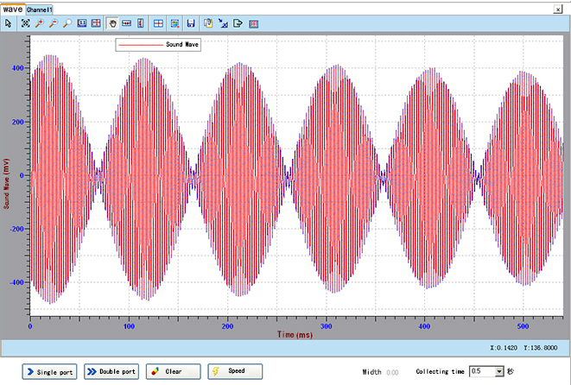
Fig.11: Interference of Sound Wave
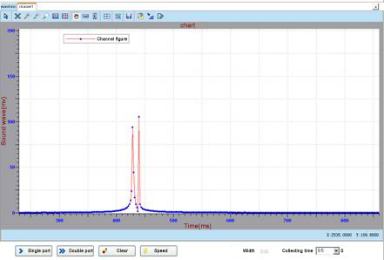
Fig.12: FFT

