Current Sensor
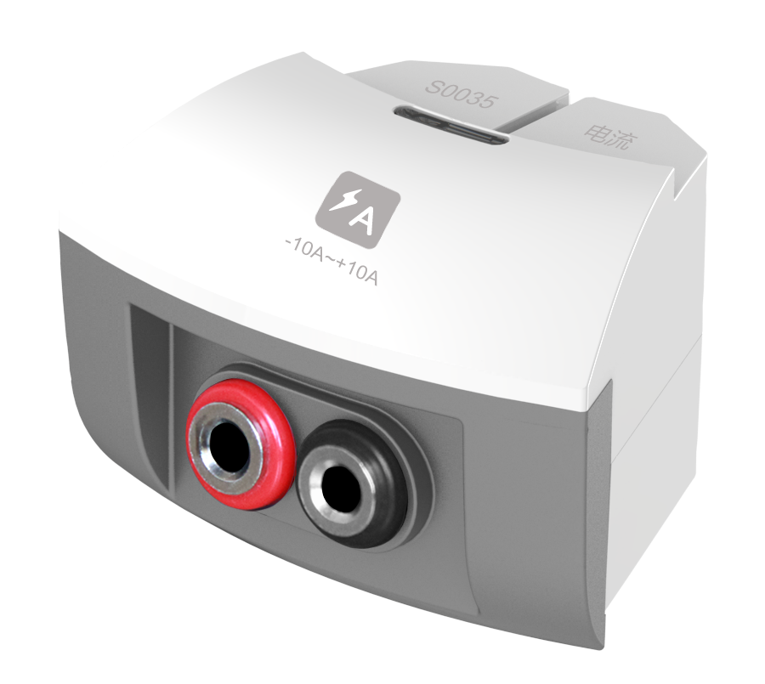
S0035 Current Sensor
Measuring range: -10~10A
Accuracy: ±2%F.S
Resolution: 0.01A

Current Sensor is used to measure the current in circuit. When current passes through resistor, it will form a tiny electric potential difference at both ends of the resistor. After circuit amplifying, it can accurately measure the current in DC circuit or low-voltage, low-frequency AC circuit.
Component
No. | Model | Name | Picture
1 | S0035 | Current Sensor
2 |  | Red alligator clip | 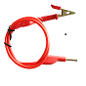
3 |  | Black alligator clip | 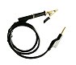
Usage
Connect Current Sensor to any port in SenseDisc.
Connect red and black alligator clips to positive and negative poles in Current Sensor.
Series connect Current Sensor into circuit.
Calibration
Current Sensor needs to be calibrated before using.
Short connect red and black alligator clips.
Open experiment software . Click  and select ‘Current Sensor’. Click ‘Calibrate’ ‘OK’ to complete calibration.
Typical experiment
Series and parallel connection of resistor
Measure the VA characteristic curve of small bulb
Measure the electrodynamic potential and internal resistance of battery
Ohm's Law
Notes
Current Sensor should be series connected to circuit.
Current Sensor needs to be calibrated before using.
The maximum current can be applied to sensor is 10A.

