Photogate
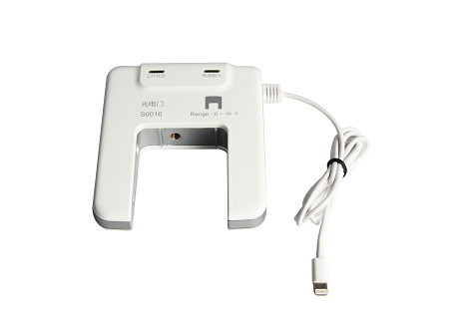
S0016 Photogate
Measuring range: 0~∞s
Accuracy: ±1μs
Resolution: 1μs

Photogate is a digital switch sensor. It is designed with infrared transmitter and receiver on both sides. If the receiver receives infrared ray, Photogate will stay at low (open) state. If the infrared ray is blocked, Photogate will stay at high (close) state.
Component
No. | Model | Name | Picture
1 | S3000 | Universal input | 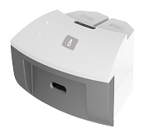
2 | S0016 | Photogate
3 |  | Hand screw | 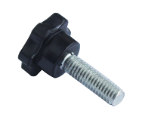
Usage
Connect Photogate to universal input. Connect universal input to any port in SenseDisc.
Photogate requires setup according to experiment type and relative parts. The method is: Open experiment software . Click ‘New’. Click ‘Photogate setup’. Select experiment type and choose interrupt card. Select ‘quantity to be measured’ and insert relative parameters and click ‘finish’. (The setup for each Photogate is different. Please refer to Experiment Guide for SenseDisc for details)
Typical experiment
Explore the relationship between acceleration, pulling force and mass.
Pendulum
Forced vibration
Theorem of momentum
Verify the conservation of mechanical energy.
Explore the freely-falling body motion.
Notes
Photogate needs to be setup before using.
There are multiple methods of installing Photogate. Install it according to experiment requirement. It should be installed accurately and firmly.
Photogate is highly sensitive to infrared ray or heat. Under strong light, errors may occurred so that affects experimental result. Try to avoid using strong light during experiment.

