Force Sensor
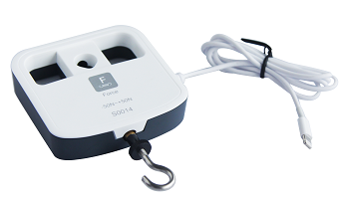
S0014 Force Sensor
Measuring range: -50~50N
Accuracy: ±1%
Resolution: 0.03N

The sensing component of Force Sensor is a resistance strain gauge. It is attached to the metallic cross girder. It measures the force from two directions when the cross girder is deformed. The sensor converts force signal into voltage signal via resistance strain gauge. After circuit amplifying, it can accurately measure force value.
Component
No. | Model | Name | Picture
1 | S3000 | Universal input | 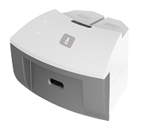
2 | S0014 | Force Sensor
3 |  | Hand screw | 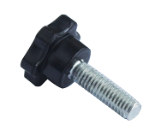
Usage
Connect Force Sensor to universal input. Connect universal input to any port in SenseDisc.
Force Sensor can measure both pulling force and pressure. When pulling force is applied, it shows positive value. When pressure is applied, it shows negative value.
Calibration
Force Sensor needs to be calibrated before using.
Fix the hook on Force Sensor by screwing tightly.
Place the Force Sensor in a direction same as the measured force (for example: place it horizontal if you need to measure force which is horizontal ).
Open experiment software . Click  and select ‘Force Sensor’. Click ‘Calibrate’ ‘OK’ to complete calibration.
Typical experiment
Explore the Hooke’s law.
Newton’s third law.
Overweight and weightlessness.
Explore the simple harmonic motion.
Buoyancy law
Notes
Force Sensor needs to be calibrated before using.
Keep the direction of measured force vertical to the front panel of sensor to ensure the accuracy.
Please keep the force applied to the sensor not exceeding measuring range during measuring. Otherwise it may damage the Force Sensor.
Do not screw the hook too deep. Otherwise it will affect the accuracy.

